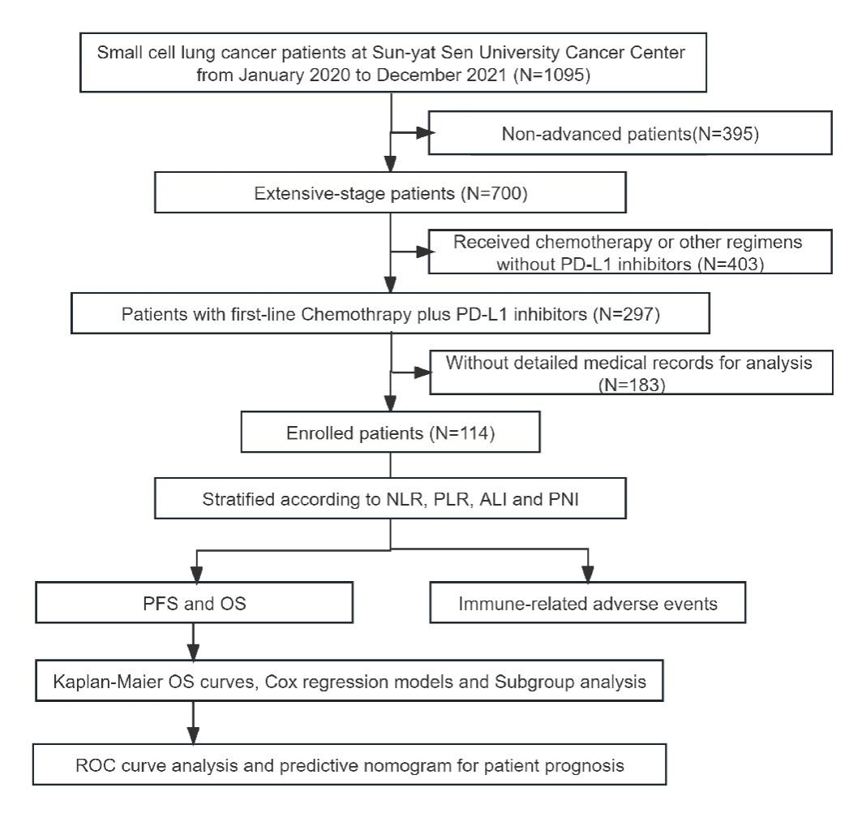

Figure S1. Flowchart of the study design for patient selection.

Abbreviations: PD-L1, programmed death-ligand 1; NLR, neutrophil-to-lymphocyte ratio; PLR, platelet-to-lymphocyte ratio; ALI, advanced lung cancer inflammation index; PNI, prognostic nutrition index; PFS, progression-free survival; OS, overall survival; ROC, receiver operating characteristic.

For those without detailed medical records for analysis, 120/183 lost their visits after less than 4 courses of chemoimmunotherapy in our hospital without any signs of progress, 36/183 underwent initial examinations at other medical facilities before seeking further evaluation at our hospital, and 27/183 lack therapeutic efficacy evaluation or records of adverse events during treatment.

(A)

(B)

Figure S2. Subgroup analysis of progression-free survival and overall survival.

(A) Subgroup analysis of progression-free survival

(B) Subgroup analysis of overall survival

Hazard ratios (HRs) and corresponding 95% CIs were evaluated using Cox proportional hazards regression model.

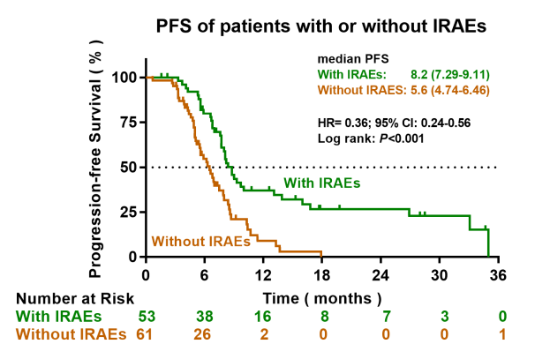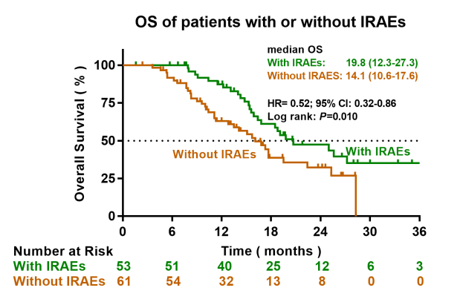
(B)
(A)

Fig S3. The association between immune-related adverse events and clinical outcomes.

(A) PFS curves of ES-SCLC patients with or without IRAEs.

(B) OS curves of ES-SCLC patients with or without IRAEs.

(D)
(C)
(A)
(B)

Fig S4. Median values of peripheral blood markers for patients with or with IRAEs.

(A) Median values of NLR for patients with or with IRAEs.

(B) Median values of PLR for patients with or with IRAEs.

(C) Median values of ALI for patients with or with IRAEs.

(D) Median values of PNI for patients with or with IRAEs.

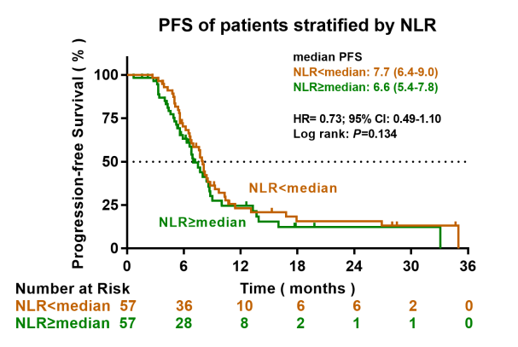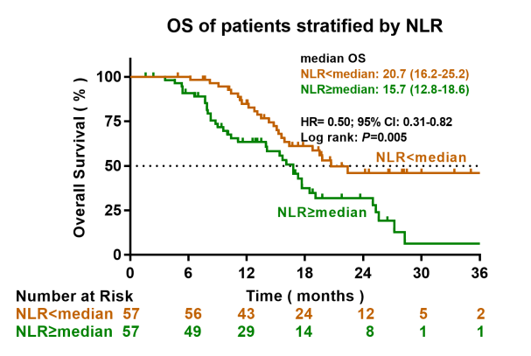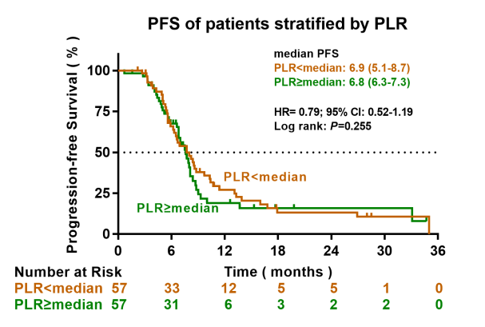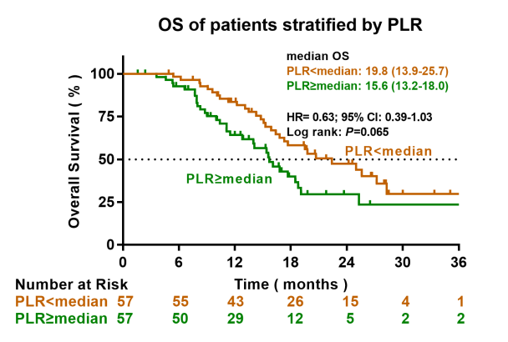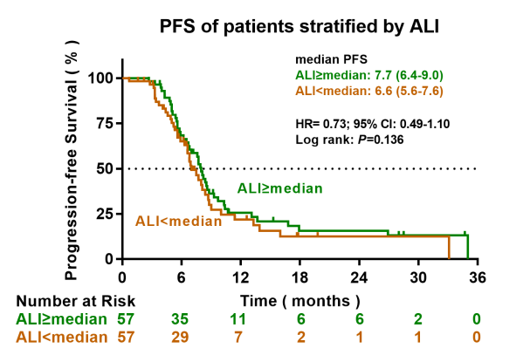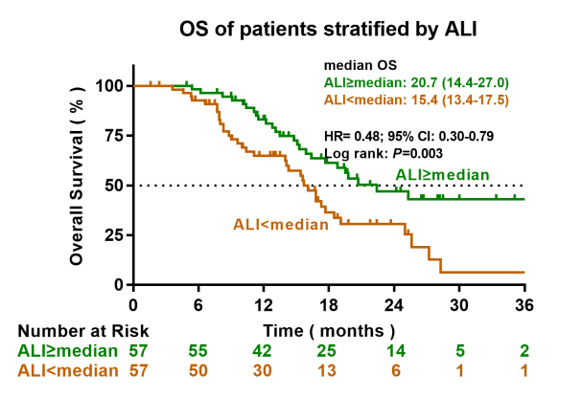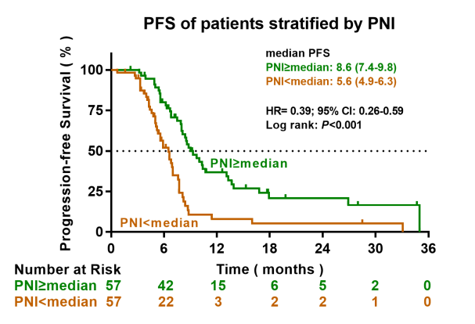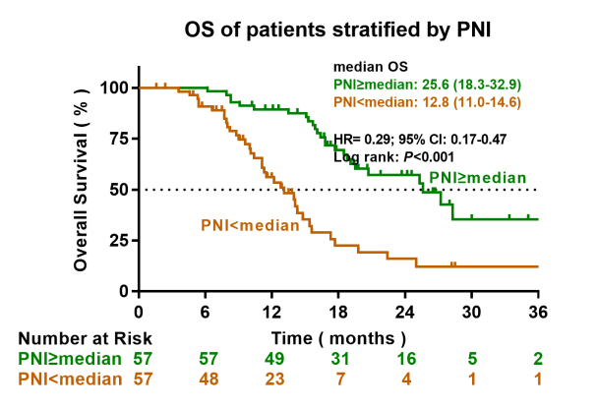
(A)
(D)
(C)
(E)
(F)
(H)
(G)
(B)

Fig S5. Kaplan-Meier analysis was performed when the cutoff value of markers was set at the median.

(A) PFS curves of patients stratified according to NLR.

(B) OS curves of patients stratified according to NLR.

(C) PFS curves of patients stratified according to PLR.

(D) OS curves of patients stratified according to PLR.

(E) PFS curves of patients stratified according to ALI.

(F) OS curves of patients stratified according to ALI.

(G) PFS curves of patients stratified according to PNI.

(H) OS curves of patients stratified according to PNI.

Table S1. Cox regression models on progression-free survival.
Characteristics | NO. | Univariate analysis |  | Multivariate analysis
Characteristics | NO. | Hazard ratio  (95% CI) | P value | Hazard ratio  (95% CI) | P value
Sex
Female | 12
Male | 102 | 0.946 (0.490-1.827) | 0.871
Age (years)
<60 | 44
≥60 | 70 | 0.700 (0.464-1.058) | 0.090
Smoking history
No | 32
Yes | 82 | 1.199 (0.762-1.887) | 0.433
ECOG PS
0-1 | 59
2 | 55 | 1.541 (1.024-2.319) | 0.038
Extrathoracic metastases
No | 26
Yes | 88 | 1.982 (1.176-3.342) | 0.010 | 1.761 (1.033-3.003) | 0.038
Pleura metastases
No | 68
Yes | 46 | 0.905 (0.596-1.375) | 0.641
Lung metastases
No | 90
Yes | 24 | 1.464 (0.912-2.351) | 0.114
Liver metastases
No | 73
Yes | 41 | 1.546 (1.020-2.343) | 0.040
Adrenal gland metastases
No | 101
Yes | 13 | 1.702 (0.902-3.211) | 0.101
Bone metastases
No | 65
Yes | 49 | 1.195 (0.794-1.800) | 0.393
Brain metastases
No | 83
Yes | 31 | 1.339 (0.857-2.092) | 0.200
NLR
<5 | 98
≥5 | 16 | 1.525 (0.845-2.752) | 0.162
PLR
<185 | 76
≥185 | 38 | 1.617 (1.044-2.504) | 0.031
ALI
<18 | 14
≥18 | 100 | 0.458 (0.246-0.853) | 0.014
PNI
<45 | 44
≥45 | 70 | 0.355 (0.230-0.548) | <0.001 | 0.377 (0.243-0.587) | <0.001

P values were calculated with the log-rank test. Statistically significant values are in bold.

Table S2. Cox regression models on overall survival.
Characteristics | NO. | Univariate analysis |  | Multivariate analysis
Characteristics | NO. | Hazard ratio  (95% CI) | P value | Hazard ratio  (95% CI) | P value
Sex
Female | 12
Male | 102 | 1.047 (0.450-2.438) | 0.915
Age (years)
<60 | 44
≥60 | 70 | 0.889 (0.535-1.477) | 0.650
Smoking history
No | 32
Yes | 82 | 0.984 (0.573-1.692) | 0.954
ECOG PS
0-1 | 59
2 | 55 | 1.975 (1.216-3.209) | 0.006 | 2.296 (1.390-3.793) | 0.001
Extrathoracic metastases
No | 26
Yes | 88 | 1.647 (0.907-2.989) | 0.101
Pleura metastases
No | 68 | 1.024 (0.630-1.662) | 0.925
Yes | 46
Lung metastases
No | 90
Yes | 24 | 1.230 (0.681-2.220) | 0.492
Liver metastases
No | 73
Yes | 41 | 2.248 (1.381-3.660) | 0.001 | 2.122 (1.283-3.510) | 0.003
Adrenal gland metastases
No | 101
Yes | 13 | 1.259 (0.600-2.640) | 0.542
Bone metastases
No | 65
Yes | 49 | 1.123 (0.688-1.833) | 0.642
Brain metastases
No | 83
Yes | 31 | 1.456 (0.858-2.471) | 0.164
NLR
NLR<5 | 98
NLR≥5 | 16 | 1.969 (1.049-3.696) | 0.035
PLR
PLR<185 | 76
PLR≥185 | 38 | 1.708 (1.023-2.852) | 0.041
ALI
ALI<18 | 14
ALI≥18 | 100 | 0.282 (0.139-0.573) | <0.001
PNI
PNI<45 | 44
PNI≥45 | 70 | 0.287 (0.175-0.469) | <0.001 | 0.302 (0.180-0.505) | <0.001
P values were calculated with the log-rank test. Statistically significant values are in bold.

Table S3. Median values of peripheral blood markers
Characteristics | Median value |  | P Value
Characteristics | With IRAEs (N=53) | Without IRAEs (N=61) | P Value
NLR | 2.7 | 3.3 | 0.039
PLR | 284 | 258 | 0.505
ALI | 317.32 | 289.53 | 0.096
PNI | 48.85 | 45.15 | <0.001
P values were calculated with the Mann-whitney test. Statistically significant values are in bold.

