Supplementary table 1 The primers used in this article.

Gene | Forward | Reverse
CD95 | 5′-GCTCAGTACGGAGTTGGGGAAGCTC-3′ | 5′-GCAGTCCCTAGCTTTCCTTTCACCTG-3′
NOS2 | 5′-GCTCCGGCCGCAGAGAACTCAG-3′ | 5′-CTTGAGCTCTGGAAGGCTGA-3′
CCL3 | 5′-GCAGGTCTCCACTGCTGCCCT-3′ | 5′-GCTTGGAGCACTGGCTGCTCG-3′
CCL2 | 5′-TCTCGCCTCCAGCATGAAAG-3′ | 5′-CAGATCTCCTTGGCCACAATG-3′
CD206 | 5′-GCCATGAGGCTACCCCTGCTCC-3′ | 5′-GCATAGAGAGTGATAGCAACCCAGTCCG-3′
ARG2 | 5′-GCGGGCGGACGCTGGCG-3′ | 5′-GCAGCGGGACCATGCTCCACTC-3′
GAPDH | 5′-CTCCTCTGACTTCAACAGCGACA-3′ | 5′-GCTGTAGCCAAATTCGTTGTCAT-3′

Supplementary table 2 Sankey analysis of serum CXCL9 and tumor response according to RECIST v1.1.

Serum CXCL9 | Tumor response |  |  | Total | P value
Serum CXCL9 | PR | SD | PD | Total | P value
<ULC | 4 | 19 | 39 | 62  (50.4%)
ULC~2×ULC | 8 | 20 | 10 | 38  (30.9%)
>2×ULC | 16 | 6 | 1 | 23  (18.7%)
Total | 28  (22.8%) | 45  (36.6%) | 50  (40.7%) | 123  (100%) | <0.001
PD, progressive disease; PR, partial response; SD, stable disease; ULC, upper limit of cut-off value.

Supplementary table 3 Pairwise analysis of progression free survival.

 |  | HR | CI | P value | Adjusted P value
<ULC | ULC~2×ULC | 0.49787 | 0.28103 - 0.88202 | 0.0276 | 0.0827
<ULC | >2×ULC | 0.10364 | 0.052864 - 0.20319 | 0.0001 | 0.0003
ULC~2×ULC | >2×ULC | 0.1813 | 0.065668 - 0.50054 | 0.0108 | 0.0323
CI, Confidence Interval; HR, Hazard Ratio; ULC, Upper limit of cut-off value.

A B
Post-treatment
Pre-treatment
Non-responder
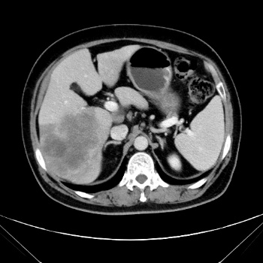
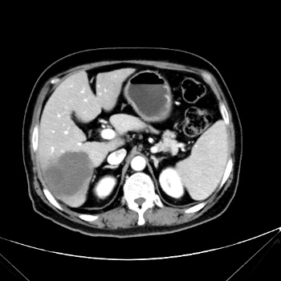
Responder

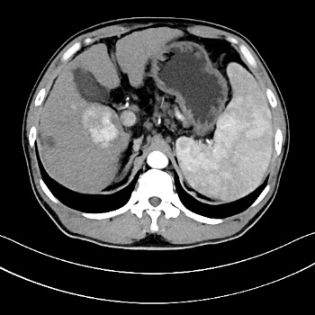
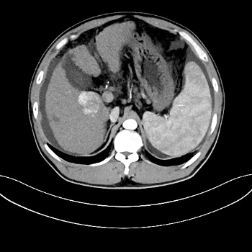

Figure S1. Representative image of abdominal contrast-enhanced CT from responders and non-responders.

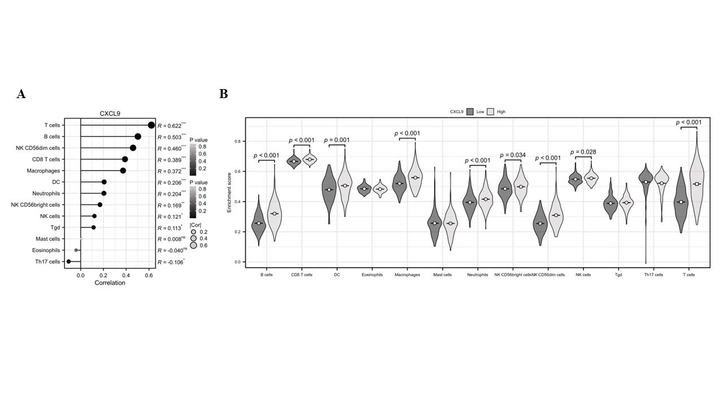
Figure S2. (A) Correlation analysis was performed between the immune infiltration matrix data in HCC tumor tissues from the high CXCL9 and low CXCL9 groups, ssGSEA algorithm was adopted. (B) Enrichment scores of infiltrations of different immune cells in HCC, ssGSEA algorithm was adopted. The data were obtained from the TCGA database (https://portal.gdc.cancer.gov).

A
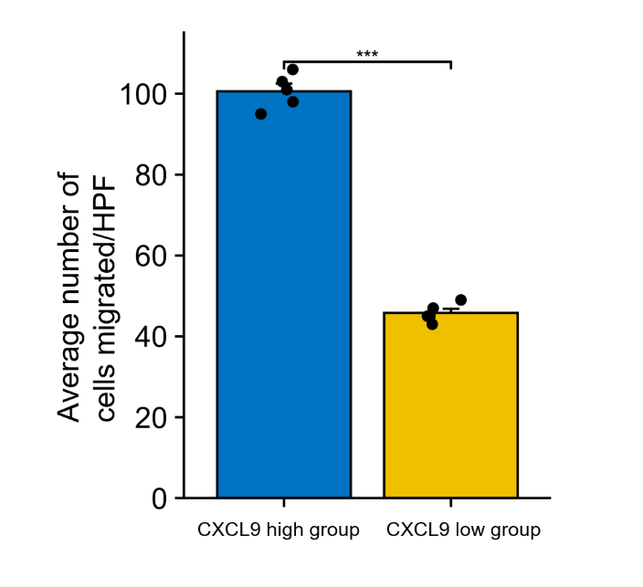

Figure S3. Neutrophils migration was analyzed in a Transwell plate (8 μm) after stimulation with upper-medium of the high or low CXCL9 secreting HCC. The number of cells that migrated to the bottom chamber was counted using a hemocytometer. ∗∗∗, P < 0.001; HPF, High Power Field.

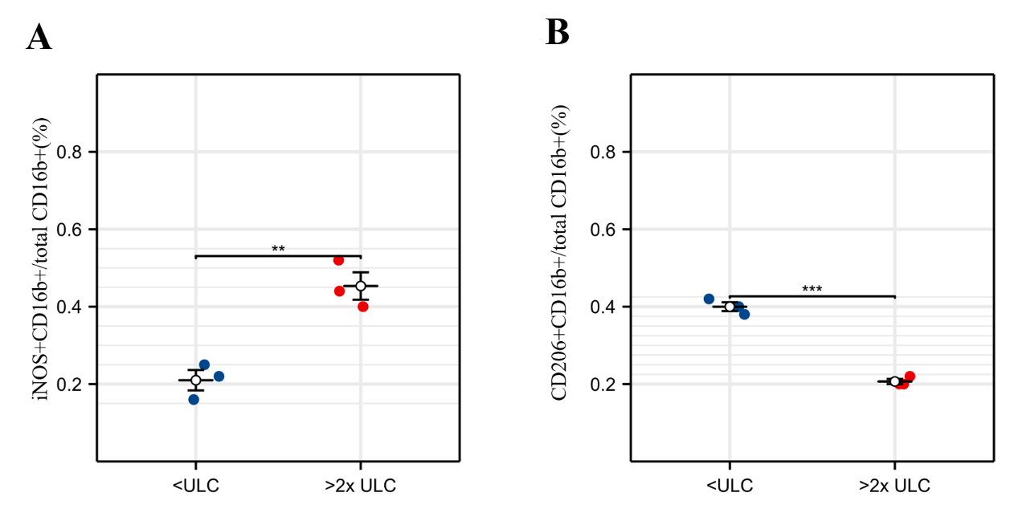

Figure S4. Analysis of CD206+CD16b+ cells, and iNOS+CD16b+ cells staining in tumor samples between serum CXCL9 high and low groups.

