Supplementary TABLE 1 | Primary Antibodies.
Antibody Source Dilution
Mouse anti- F4/80 | HY-P80665, MCE | IF: 1:100
Mouse anti-insulin | 66198-1-Ig, proteintech | IF: 1:100
Rabbit anti-insulin | 15848-1-AP, proteintech | IF: 1:100
Rabbit anti-glucagon | Ab92517, Abcam | IF: 1:100
Rabbit anti-CD 206 | ARG22372, arigobio | IF: 1:100
Rabbit anti-CD 86 | GTX32507, GeneTex | IF: 1:100
Rabbit anti-ACE2 | NBP2-67692, Novus | IF: 1:100  WB: 1:1000
Rabbit anti-NLRP3 | GB114320, Servicebio | IF: 1:100  WB: 1:1000
Rabbit anti-PDX1 | #5679, CST | IF: 1:100  WB: 1:1000
Rabbit anti-NKX6.1 | NBP1-49672SS, Novus | IF: 1:100  WB: 1:1000
Rabbit anti-NFκB | TA5006, Abmart | WB: 1:1000
Rabbit anti-p-NFκB | T55034, Abmart | WB: 1:1000
Rabbit anti-IκBα | T55026, Abmart | WB: 1:1000
Rabbit anti-p-IκBα | TP56280, Abmart | WB: 1:1000
Rabbit anti-CD 9 | HY-P80068, MCE | WB: 1:1000
Rabbit anti-TSG 101 | HY-P80924, MCE | WB: 1:1000
Rabbit anti-ALIX | T57215, Abmart | WB: 1:1000
Rabbit anti-Bax | T40051,Abmart | WB: 1:1000
Rabbit anti-Bcl2 | T40056,Abmart | WB: 1:1000
Rabbit anti-Cleaved Caspase 3 | TA7022, Abmart | WB: 1:1000
Rabbit anti-Caspase 3  Rabbit anti-ASC | TA6311, Abmart  GB113966, Servicebio | WB: 1:1000  WB: 1:1000
Rabbit anti-IL1β | Ab283818, Abcam | WB: 1:1000  IF: 1:100
Mouse anti-Caspase 1 | M025280, Abmart | WB: 1:1000
Rabbit anti-GSDMD | TA4012, Abmart | WB: 1:1000
Rabbit anti-GSDMD | #46451, CST | WB: 1:1000
Mouset anti-18 | M027287, Abmart | WB: 1:1000
Rabbit anti-IL1β | TA5103, Abmart | WB: 1:1000
Rabbit anti-FOXO1 | #2880, CST | WB: 1:1000
Rabbit anti-Mas | NBP1-78444, Novus | WB: 1:1000
Mouse anti-β-actin | 66009-1-lg, Proteintech | WB: 1:1000
Mouse anti-GAPDH | 60004-1-Ig, Proteintech | WB: 1:1000

Supplementary TABLE 2
List of primers used for real-time PCR using SYBR-Green.
Gene Forward sequence(5′to3′) Reverse sequence (5′to3′)
PDX1 | TCCACCACCACCTTCCAGCTCA |  | AATTCCTTCTCCAGCTCCAG
NKX6.1 |  | ACAAACCTCTGGACCCGAAC | AATAGTAAAGGCCCGGCGAG
FOXO1 |  | CAGGACAGCAAATCAAGTTACGG | CCAAGGTATCTCCATCCATGAGG
MAFA |  | GAGGAGGTCATCCGACTGAAA | GCACTTCTCGCTCTCCAGAAT
ACE2 |  | ATCTGTACCCTTTGACTGTTCCC | AGTCATATGAGGAAGGCCAACAG
Bcl-2 |  | GCTACCGTCGTGACTTCGC | CCCCACCGAACTCAAAGAAGG
Bax |  | AGGATGCGTCCACCAAGAAGCT | TCCGTGTCCACGTCAGCAATCA
NFΚB |  | TACCCGAAACTCAACTTCTGTCC | TTGAGATCTGCCCTGATGGTAAC
Caspase-3 |  | TGGTGATGAAGGGGTCATTTATG | TTCGGCTTTCCAGTCAGACTC
Caspase-1 |  | ACTCGTACACGTCTTGCCCTCA | CTGGGCAGGCAGCAAATTC
IL1β |  | CAAAGTGGAGTTTGAGTCTGCAG | TTAGGAAGACACGGATTCCATGG
NLRP3 |  | AGATGAAGGACCCACAGTGTAAC | AGGGCATTGCTTCGTAGATAGAG
GSDMD |  | CCTGGGTCTTGCTAGAAGAATGT | CAAGGTTTCTGGCCTAGACTTGA
IL18 |  | TGACCCTCTCTGTGAAGGATAGT | GTCCTGGAACACGTTTCTGAAAG
ASC |  | GTTCAAGATGAAGCTGCTGACAG | GCCATACGACTCCAGATAGTAGC
β-actin |  | ATTGTTACCAACTGGGACG | CTGGGTCATCTTTTCACG

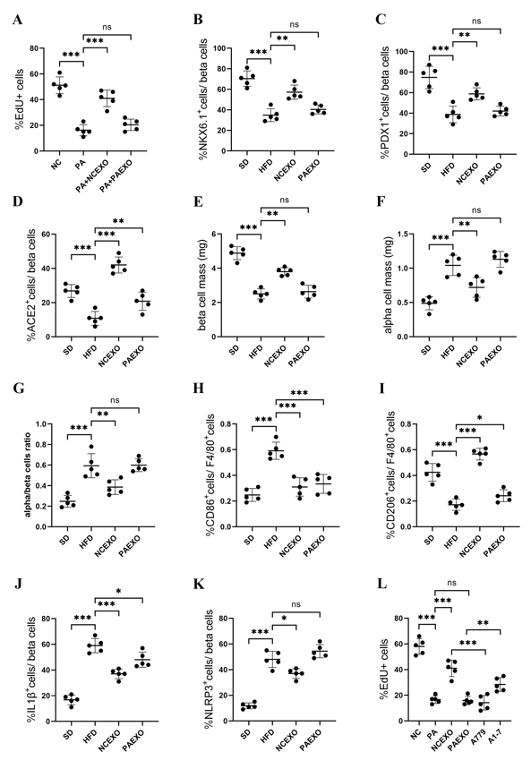

Supplementary Figure 1. (A) EdU⁺ cell count analysis. (B-D) The ratio of NKX6.1, PDX1, ACE2 immunopositive cells. Assessment of the (E) pancreatic islets β-cell mass, (F) pancreatic islets α-cell mass, (G) α/β-cell ratio. (H-K) The ratio of CD86, CD206, IL1β, NLRP3 immunopositive cells. (L) EdU⁺ cell count analysis. *P < 0.05, **P < 0.01 and ***P < 0.001
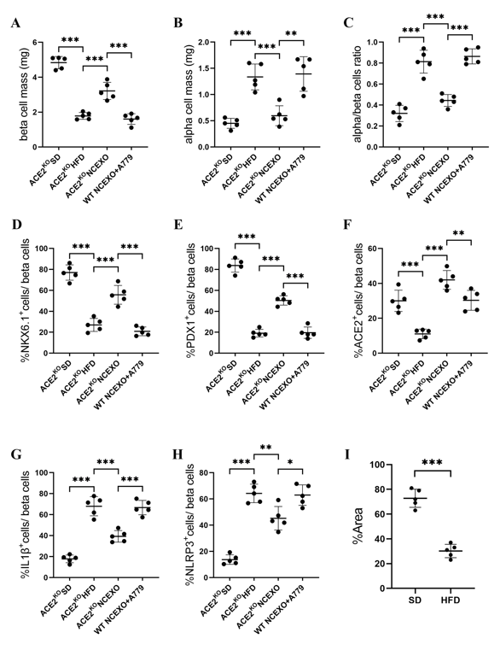
Supplementary Figure 2. Assessment of the (A) pancreatic islets β-cell mass, (B) pancreatic islets α-cell mass, (C) α/β-cell ratio. (D-H) The ratio of NKX6.1, PDX1, ACE2, IL1β, NLRP3 immunopositive cells. (I) The average optical density of ACE2⁺ immunopositive cells. *P < 0.05, **P < 0.01 and ***P < 0.001

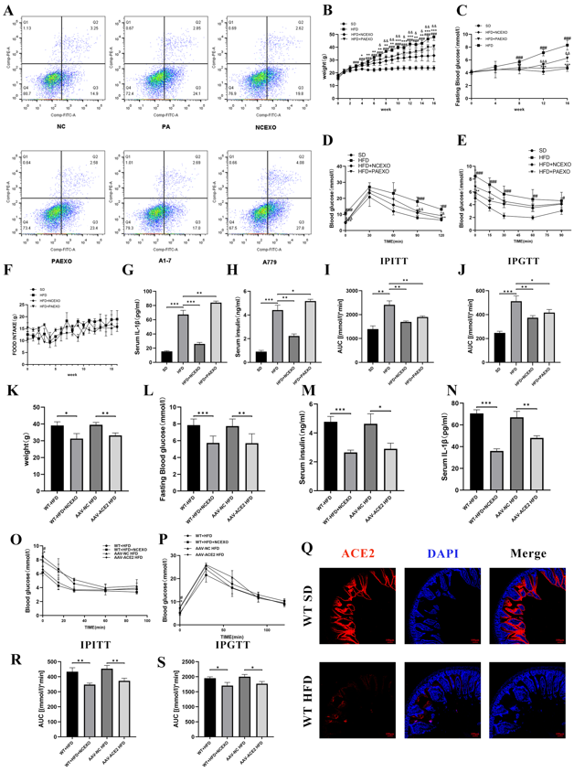
Supplementary Figure 3. Early preventative treatment of NCEXO improves the metabolic status of HFD mice. (A) Flow cytometry was used to quantify rates of apoptosis in treated cells. (B) Body weight. (C) FBG. (D) IPITT and (E) IPGTT. ( #P < 0.05, ##P < 0.01 and ###P < 0.001 HFD group vs SD group; *P < 0.05, **P < 0.01 and ***P < 0.001 NCEXO group vs HFD group; &P < 0.05,&&P < 0.01 and &&&P < 0.001 PAEXO group vs HFD group in (B)(C)(D)(E)). (F) Food intake of experimental mice. (G) IL-1β and (H) Serum insulin were measured by Elisa Kits. AUC of IPITT(I) and IPGTT(J). (K) Body weight, (L) FBG, (M) Serum insulin and (N) IL-1β, (O) IPITT and (P) IPGTT of ACE2 overexpressed mice at week 16 after fasting overnight. (Q) Representative images of ACE2 in the mouse small intestinal. Bar = 100μm. AUC of IPITT (R) and IPGTT (S). *P < 0.05, **P < 0.01 and ***P < 0.001

