Experimental Procedures
Materials and reagents.
2′,7′-Dichlorofluorescin diacetate (DCFH-DA) and DiO (DiOC18(3)) were obtained from Solarbio life sciences. MB and DPBF were purchased from Shanghai Macklin Biochemical Co., Ltd (Shanghai, China). All of the aqueous solutions were prepared using purified deionized (DI) water purified with a purification system (Direct-Q3, Millipore, USA). The other solvents and reagents used in this work were purchased from Sinopharm Chemical Reagent (China) and Aladdin-Reagent (China).

Cell culture
4T1 cell line were obtained from the Cell Bank of the Chinese Academy of Sciences and incubated in RPMI-1640 medium supplemented with 10% FBS in a humidified atmosphere.
The cancer stem cells (CSC) were sorted from 4T1 cells and cultured as guided by the previous report[1]. 4T1 cells suspension (10000 cells/ml) were seeded in ultra-low attachment surface 6-well plates (Corning, USA) with serum-free DMEM-F12 medium, containing B27 (1:50), epidermal growth factor, basic fibroblast growth factor (20 ng/mL), N2 additives. Primary cultures of colonospheres were harvested after 7 days in culture and collected after centrifugation, dissociated with Trypsin–EDTA. The expression of CD44 and CD133 on CSC were tested by flow cytometry[2].
The Non-cancer stem cells (nCSC) were also sorted from 4T1 cells. Briefly, 4T1 cells were split in Serum Containing Medium (SCM). This is made up of DMEM/Ham’s F12 (1:1) (Hyclone), 10 % Foetal Bovine Serum(FBS) (Biological Industries), 1 % penicillin/streptomycin (P/S) (100 U/ml) (Hyclone), and 1 % L-glutamine (LG) (Lonza). The adherent cells obtained from the SCM were harvested by trypsinization to obtain single cells and then expanded in SCM medium to obtain more cells. These cells were scored as non-cancer stem cells (nCSC).

Preparation and characterization of biomimetic nano-system (PMC)
The platelet membranes vesicles (PM) and red blood cell membranes (RM) were prepared according to previous work[3, 4]. The preparation method of MnCO₃ NPs (MC) is improved from previous reports[5]. MC (0.5 mg) was dissolved in 1 mL of PBS, and then mixed with 5mg PM and then repeatedly coextruded through 200 nm pores. The resultant PMC particles were centrifuged and washed with PBS several times to remove the excess PV. Red blood cell membrane biomimetic nanoplatform (RMC) was prepared in the same way as PMC. The zeta potential and diameter of nanoparticles were measured by dynamic light scattering (DLS, Nano-Zen 3600, Malvern Instruments, UK). The morphological structures of different formulations and the elemental mapping images were captured by JEOL JEM-2100F TEM. The crystal structure of MnCO3 NPs was characterized by powder XRD (XRD-6000, Japan)[6].

Western blotting for the key proteins in PM and PMC
The PM and PMC were lysed in RIPA lysis buffer and then subjected to western blot analysis. The primary antibodies used included anti-CD62p (Abcam, ab255822) and anti-CD41 (Abcam, ab181582).

Mn²⁺ release study
10mL of PBS containing 15mg PMC was added into culture dish. To investigate the stimuli effect of pH on the release behavior, the release experiment of Mn²⁺ was initially performed under different pH value for 24h. At appropriate time point, 100 μL of different samples were collected for ICP-AES measurement.

In vitro cancer targeting study
4T1 CSC or nCSC were seeded in 24-well plates and cultured for 12 h. Then the PMC and RMC were added the medium (100ug/mL MC), and the cells grown without any particles were used as control. Then the cells were washed three times and then incubated for 4 h at 37 °C, 5% CO2, and then washed with PBS three times. The cells were then fixed with PFA for 30 min at room temperature, stained with DAPI and then imaged by using a confocal laser scanning microscope (CLSM; IX81, Olympus, Japan). The fluorescence intensity was measured by flow cytometer.

ROS and DNA damage detection in vitro
4T1 CSC (8 × 10⁴ per plate) were incubated with six different group: (1) PBS+US (1.0MHz, 1.5W⋅cm−2, 2 min, 50%duty cycle); (2) RT (4Gy); (3) PMC; (4) RMC+US+RT; (5) PMC+US; and (6) PMC+US+RT. The MC concentration was 100 μg/mL. The SDT and RT was conducted 2h after different treatment. Then, DCFH-DA (10 μM) or anti-γH2AX antibody with Secondary antibody, was added and co-incubated for 10 min at 37 °C. Then, cells were detected by a confocal laser scanning microscope (CLSM; IX81, Olympus, Japan).

Clonogenic survival assay
500 4T1 CSC were seeded in eight 6-wells plates incubating for 24 h, then the cells were incubated with six different group: (1) PBS+US (1.0MHz, 1.5W⋅cm−2, 2 min, 50%duty cycle); (2) RT (4Gy); (3) PMC; (4) RMC+US+RT; (5) PMC+US; and (6) PMC+US+RT. The MC concentration was 100 μg/mL. The SDT and RT was conducted 2h after different treatment. To allow formation of colonies, after radiation, the cells were then incubated for another 10 days, without changing the media. To determine the clonogenic survival rate, cultures were first fixed with paraformaldehyde, and then stained with trypan blue. Colonies with greater than 50 cells were counted under the microscope, and the survival fractions (SF) were calculated using the formula SF = colonies counted/cells seeded.

Cytotoxicity in CSC‑enriched 3D tumorsphere cells
Tumorspheres that were developed from 5000 CSC in 24-well ultralow attachment plates were treated with (1) PBS+US (1.0MHz, 1.5W⋅cm−2, 2 min, 50%duty cycle); (2) RT (4Gy); (3) PMC; (4) RMC+US+RT; (5) PMC+US; and (6) PMC+US+RT. The MC concentration was 100 μg/mL. The SDT and RT was conducted 2h after different treatment. After 5 days of incubation, take pictures of the tumorsphere and count the number.

Animal tumor models
Female Balb/c mice aged 4-5 week were purchased from Vital River Company (Beijing, China). 100 μL of 4T1 cell suspension (1×10⁶ cells) were subcutaneous injected into each mouse to establish the tumor models. The animal experiments were carried out according to the guidelines approved by the Ministry of Health in People’s Republic of PR China (Name of the guidelines followed for the welfare of the laboratory animals: “Laboratory Animal-Guideline for ethical review of animal welfare (GB/T 35892-2018)”) and were approved by the Administrative Committee on Animal Research of Wuhan University.

In vivo bio-distribution study
The 4T1 tumor model was used. When tumors reached 300mm³, tumor bearing mice (n = 3) received an intravenous (i.v.) of 100 μL PBS containing RMC or PMC (with a MC dose of 5 mg/kg). Mice were sacrificed at 12 h after injection to collect the tumors and major organs for ICP-AES analysis as mentioned above. Another group of mice was subjected to the same experiment, and the tumor tissue of the mice was removed after experiments for tissue immunofluorescence staining analysis.

In vivo antitumor study.
The 4T1 tumor model was used. When tumors reached 200mm³, tumor bearing mice were divided randomly into six different group (n=5): (1) PBS+US (1.0 MHz, 1.5W⋅cm−2, 2 min, 50% duty cycle); (2) RT (4Gy); (3) PMC; (4) RMC+US+RT; (5) PMC+US; and (6) PMC+US+RT. The MC dose was 5 mg/kg. The US and RT was performed 12 h after intravenous injection. The treatment was conducted in the first two days. Mice body weight was monitored every 2 days. After treatment, all the mice were sacrificed. The blood samples from these mice (≈1 mL) were collected for blood biochemistry analysis. Five main organs (heart, liver, spleen, lung and kidney) and tumors of all mice were harvested, washed with PBS, and fixed with paraformaldehyde for histology analysis. And the tumor tissues were weighed, and fixed in 4% neutral buffered formalin, processed routinely into paraffin, and sectioned at 4 μm. Then the sections were stained with Terminal deoxynucleotidyl transferase-mediated deoxyuridinetriphosphate nick end labeling (TUNEL), Ki67 and CD133 finally examined by using a confocal laser scanning microscope (CLSM; IX81, Olympus, Japan).

Statistical analysis
Data analyses were conducted using the GraphPad Prism 5.0 software. Significance between every two groups was calculated by the student’s t-test. *P < 0.05, **P < 0.01, ***P < 0.005.

Supplementary figures
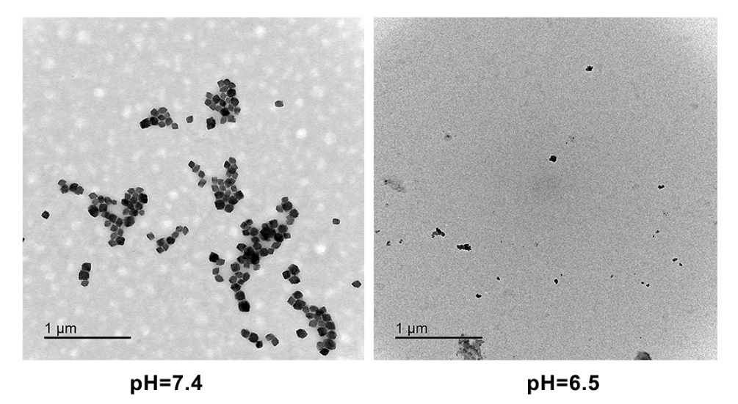
Figure S1. TEM image of MnCO₃ NPs degradation under different pH.

Figure S2. Percentage of manganese ions released from degradation of MnCO₃ NPs at different pH.

Figure S3. The expression of CD133 in different cells.

Figure S4. Comparison of targeting ability of PMC to different cells (nCSC and CSC cells)

Figure S5. Colocalization of Dil (red), CD31 (green) and nucleus (blue) in tumor sections of 4T1 tumor-bearing mice 24 h after intravenous administration of indicated nanoparticles. Scale bars: 20 μm.

References
[1] X. Xie, K. Jiang, B. Li, S. Hou, H. Tang, B. Shao, Y. Ping, Q. Zhang, A small-molecule self-assembled nanodrug for combination therapy of photothermal-differentiation-chemotherapy of breast cancer stem cells, Biomaterials (2022) 121598.
[2] A.A. Ibrahim, M.M. Kareem, T.H. Al-Noor, T. Al-Muhimeed, A.A. AlObaid, S. Albukhaty, G.M. Sulaiman, M. Jabir, Z.J. Taqi, U.I. Sahib, Pt(II)-Thiocarbohydrazone Complex as Cytotoxic Agent and Apoptosis Inducer in Caov-3 and HT-29 Cells through the P53 and Caspase-8 Pathways, Pharmaceuticals (Basel) 14(6) (2021).
[3] D.M. Zhu, W. Xie, Y.S. Xiao, M. Suo, M.H. Zan, Q.Q. Liao, X.J. Hu, L.B. Chen, B. Chen, W.T. Wu, L.W. Ji, H.M. Huang, S.S. Guo, X.Z. Zhao, Q.Y. Liu, W. Liu, Erythrocyte membrane-coated gold nanocages for targeted photothermal and chemical cancer therapy, Nanotechnology 29(8) (2018) 084002.
[4] Y. Chen, G. Zhao, S. Wang, Y. He, S. Han, C. Du, S. Li, Z. Fan, C. Wang, J. Wang, Platelet-membrane-camouflaged bismuth sulfide nanorods for synergistic radio-photothermal therapy against cancer, Biomater Sci 7(8) (2019) 3450-3459.
[5] H. Zhang, X. Pan, Q. Wu, J. Guo, C. Wang, H. Liu, Manganese carbonate nanoparticles‐mediated mitochondrial dysfunction for enhanced sonodynamic therapy, Exploration 1(2) (2021) 20210010.
[6] M.S. Jabir, U.M. Nayef, W.K.A. Kadhim, Polyethylene Glycol-Functionalized Magnetic (Fe3O4) Nanoparticles: A Novel DNA-Mediated Antibacterial Agent, Nano Biomedicine and Engineering 11(1) (2019).

