Supplementary Materials for Enhancement Pattern Mapping for Early Detection of Hepatocellular Carcinoma in Patients with Cirrhosis

Table of Contents
MR imaging data…………………………………………………………..…………………………………………..2
Image normalization…………………………………………………………………...………………………………2
Liver mask…………………………………………………………………...…………………………………..…..2-3
Image registration……………………………………………………………………………………………………3-4

Supplementary data 1.
MR imaging data.
Imaging was acquired from multiple MR scanners: Optima MR450w, 1.5T, (GE Healthcare, Waukesha, WI, USA), TrioTim, 3T, (Siemens), Intera, 1.5T (Philips), Achieva 1.5T (Philips), and Panorama 1T (Philips). Preoperative abdominal MR was obtained using a liver protocol comprised of a pre-contrast phase, a venous phase (60-80 seconds after injection of intravenous contrast material), and a delayed phase (15 minutes after contrast injection). Each series was obtained in the axial plane with a phased array multi-coil. A T1-weighted spoiled gradient echo sequence was performed. The multi-phase MR studies were exported in DICOM format from the picture archiving and communication system to an independent server running 3D Slicer.¹ The 3D Slicer scripting interface was used to iteratively anonymize all data and maintain orientation and resolution information as a compressed NifTI format recommended by the Neuroimaging Informatics Technology Initiative.

Image normalization.
Image intensity harmonization was achieved in two steps: bias correction followed by z-score normalization. All protocol phases were considered independently. N4 bias correction² was applied with 4 levels and a factor of two decrease in resolution at each level. MR images were shifted by 1 to avoid logarithm errors for background pixels with intensity value equal 0. Z-score normalization was achieved by subtracting the volume-wise mean of the image and dividing by the standard deviation of the image volume. Convert3D image-processing tool³ was used for image normalization calculations.

Liver mask.
A 3D neural network was used to generate liver masks to facilitate efficient deformable image registration. Our previous neural network implementations⁴ in computed tomography were adapted to MR data. Briefly, network architecture follows a hybrid DenseNet and U-Net architecture⁵⁻⁷ The architecture is constructed from a composition of convolution and down sampling operations that extract features along a contracting path. Similarly, an expanding path consists of convolution and up-sampling operations with ’long skip’ connections to integrate features from the corresponding down sampling operations. Four resolution levels are used. At a given resolution, the feature-maps of all preceding layers are used as inputs, and its own feature-maps are used as inputs into all subsequent layers. Each convolutional operation uses a 3x3 kernel size and is followed by a batch normalization and a ReLU activation function.
An independent training set of N=34 multi-contrast MR image data sets were registered and labeled in Velocity. Each data set consisted of a pre-contrast, venous phase, and delayed phase image. A manual liver mask for each phase was created using semi-automated segmentation tools in velocity. The liver was contoured using a brush tool on alternating slices. Contouring focused on including only liver tissue and excluded the major branch of the portal vein. Using an interpolation tool within Velocity, the contours from each of these separate slices were joined together to create a continuous liver mask across the whole organ. These contours were then visually inspected and adjusted to ensure no interpolation errors occurred and that minimal venous structures remained in the contoured area.
Training was contrast agnostic⁸ and applied to all 102 images in the training set. The neural network was trained on 64x64x64 patches with a batch size of eight for both training and validation data. Sixteen random patches were selected per image. The Adam optimizer was used for 50 epochs with an initial learning rate of 5e-4 and learning rate drop factor of 0.95 every 5 epochs. Evaluation of the validation set was performed with a frequency of 180 iterations.
Notably, although the patch size for training is 64³, convolution, ReLU, and Normalization layers are agnostic to image size. Test set predictions are applied to the full data resolution. Linear resampling to 256x256 pixels in-plane resolution is needed to fit the entire image in the GPU RAM and CUDA intmax(’int32’) overflow restrictions. Image data was resized to 256x256 pixels in-plane resolution prior to patch extraction for training as well as prior to the test set predictions. Segmentation predictions are resized back the original resolution. The study-level pre-contrast, venous and delayed phase images were split across five-folds for cross validation to evaluate the segmentation accuracy. The Dice Similarity Coefficient (DSC) and 95th-percentile Hausdorff distance (HD95) was used as the metric to evaluate segmentation accuracy. Accuracy results are provided in the appendix. Liver mask predictions were dilated by 15voxels in all directions and used as an ROI for the deformable image registration. All training and test set predictions were performed on an Nvidia Quadro RTX 8000 card with 4608 CUDA cores and 48GB RAM.

Image registration.
All longitudinal data was deformably registered to a common time point for analysis. Cases were deformably registered to the diagnostic scan. Controls were deformably registered to the first available scan. A symmetric normalization (SyN) approach⁹ is a popular variant of diffeomorphic image registration and is used in this study. SyN calculates image gradients only at the midpoint in time of the full diffeomorphic transformation and provides an explicit symmetry of the large deformation diffeomorphic metric mapping formulation.¹⁰ The registration consisted of a rigid registration step, an affine registration step, a diffeomorphic step. Multi-resolution is applied in all steps. The default gradient descent was used in the optimization of the affine and diffeomorphic registration. A Gaussian regularization kernel with an isotropic width of 3 voxels was used as an estimate of the Green’s kernel for the deformation operator. Liver masks were used at all resolutions for both the fixed and moving image of the deformable image registration.
The observed liver segmentation accuracy is provided as supplementary material to the analysis. Summary statistics of the five-fold cross validation liver mask segmentation accuracy for the data used to train our neural network is presented in Table A1. The mean DSC, 0.92, and HD95, 11.52mm, accuracy results are seen comparable to reported liver segmentation results in crowd sourcing challenges ¹¹. Outliers in the prediction accuracy are seen with 0.78 DSC and 205.08mm HD95. A representative example of the dilated liver mask used to guide the image registration is shown in Figure A1.

EPM sensitivity to ROI placement.
The EPM values are expected to depend on the background liver tissue labels used in the algorithm (Figure A1), which plots the EPM values generated using two methods for labeling the background liver tissue. The first approach utilizes manual ROI as a label of the background liver tissue. The ROI placement is described in the manuscript within the Region of interest (ROI) Placement section. The second approach utilizes the liver mask generated by the neural network as a label of the background liver tissue. The automatically generated liver mask is described in the Liver Mask section of the supplementary material above. The EPM values calculated using the two methods are correlated with a Pearson correlation coefficient of 0.80. Thus, we expect a similar interpretation of the analysis using both approaches.

For completeness, repeat ROC analysis for EPM RMSD using automatically generated liver mask was conducted. The automated analysis corresponds to differentiating cases and controls on pre-diagnostic and single timepoint scans shown in Figure 4(a) in the main text. A sensitivity, specificity, and accuracy of 0.61, 0.92, and 0.80 is achieved at the optimal threshold of EPM RMSD 0.38. These values are comparable to results obtained using manual ROI selection for the background liver ROI. Similarly, we repeated ROC analysis using automatically generated liver background labels for EPM RMSD on diagnostics and single timepoint scans. The automated analysis in differentiating cases and controls on diagnostic and single timepoint scans corresponds to Figure 4(b). A sensitivity, specificity, and accuracy of 0.79, 0.84, and 0.81 was achieved at the optimal threshold of EPM RMSD 0.32. Again, these values are comparable to results obtained using manual ROI selection for the background liver ROI. However, since both methods do not produce the exact same value, EPM generated by manually placed ROI are presented in the main text. Here, the rationale is that a human observer manually selected the ROI and avoids any potential liver labeling errors from segmentation inaccuracy.

Figure A1. EPM values generated using two methods for labeling the reference background tissue is shown. EPM generated using manually placed ROI for the background liver tissue is seen to be correlated with the EPM generated using the background liver tissue labeled by a neural network is shown. The Pearson correlation coefficient is 0.80.
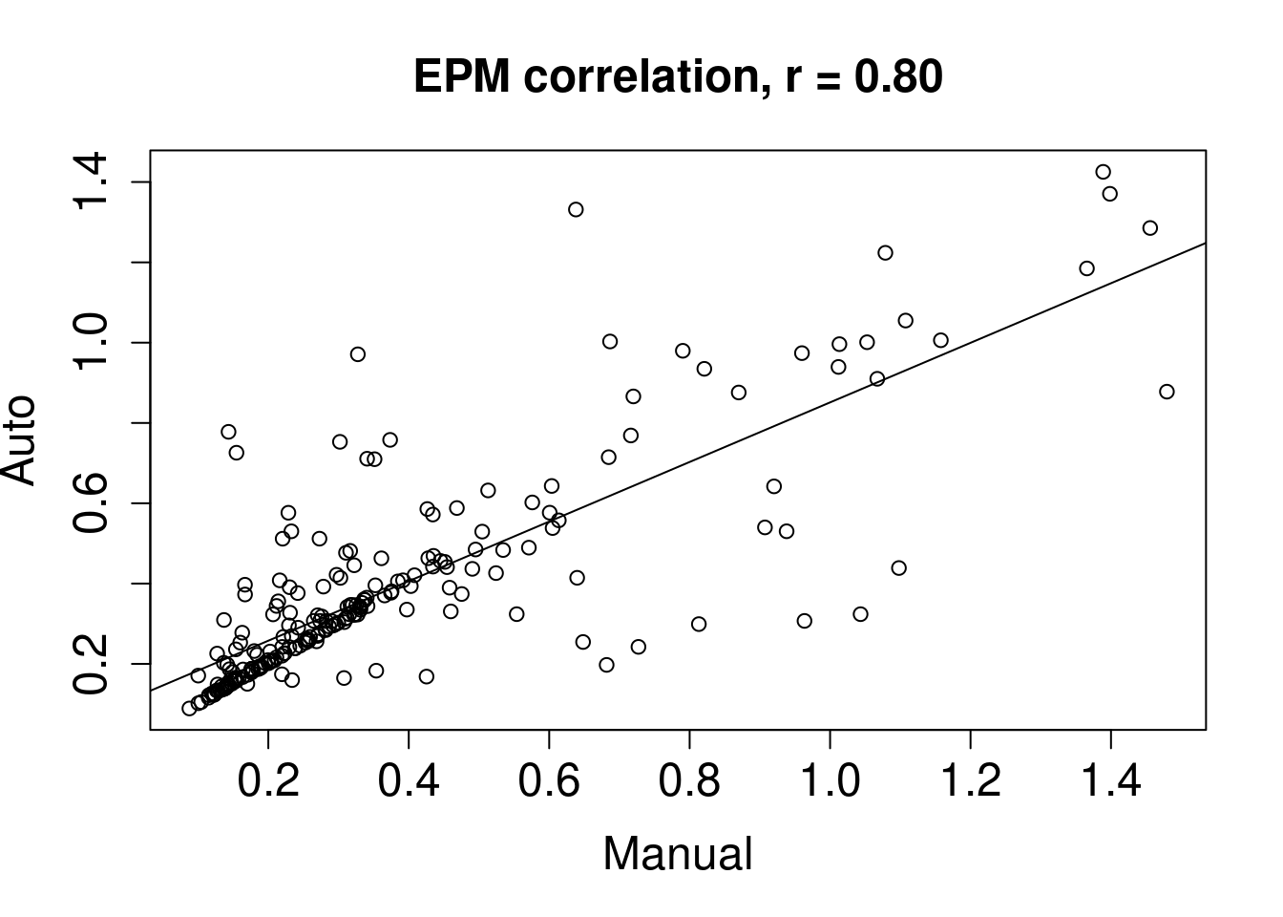

Table A1. Summary statistics of liver segmentation accuracy
 | Mean | Median | Standard Dev | Min | Max
Dice Similarity Coefficient | 0.92 | 0.93 | 0.04 | 0.78 | 0.96
95th – percentile Hausdorff Distance | 11.52mm | 2.62mm | 36.21mm | 0mm | 205.08mm

Figure A2. Representative example of axial image of liver mask used to guide image registration. Registration results are illustrated. The fixed image is the diagnostic time point for cases and the single timepoint scan for controls. Each phase of the multi-phase MR dataset is registered to the fixed image.
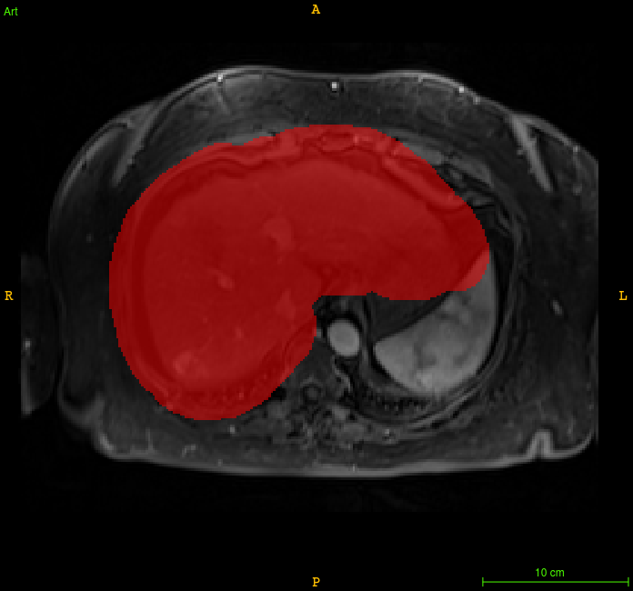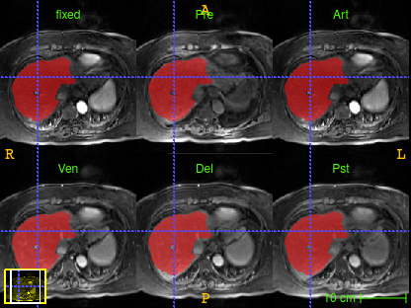

References:
1. Kikinis R, Pieper SD, Vosburgh KG. 3D Slicer: A Platform for Subject-Specific Image Analysis, Visualization, and Clinical Support. 2014:
2. Tustison NJ, Avants BB, Cook PA, et al. N4ITK: improved N3 bias correction. IEEE Trans Med Imaging. Jun 2010;29(6):1310-20. doi:10.1109/TMI.2010.2046908
3. Yushkevich PA, Piven J, Hazlett HC, et al. User-guided 3D active contour segmentation of anatomical structures: significantly improved efficiency and reliability. Neuroimage. Jul 1 2006;31(3):1116-28. doi:10.1016/j.neuroimage.2006.01.015
4. Morshid A, Elsayes KM, Khalaf AM, et al. A machine learning model to predict hepatocellular carcinoma response to transcatheter arterial chemoembolization. Radiol Artif Intell. Sep 2019;1(5)doi:10.1148/ryai.2019180021
5. Huang G, Liu Z, van der Maaten L, Weinberger K. Densely Connected Convolutional Networks. 2017.
6. Ronneberger O, Fischer P, Brox T. U-Net: Convolutional Networks for Biomedical Image Segmentation. Springer International Publishing; 2015:234-241.
7. Kamnitsas K, Ferrante E, Parisot S, et al. DeepMedic for Brain Tumor Segmentation. Springer International Publishing; 2016:138-149.
8. Thakur S, Doshi J, Pati S, et al. Brain extraction on MRI scans in presence of diffuse glioma: Multi-institutional performance evaluation of deep learning methods and robust modality-agnostic training. Neuroimage. Oct 15 2020;220:117081. doi:10.1016/j.neuroimage.2020.117081
9. Fuentes D, Contreras J, Yu J, et al. Morphometry-based measurements of the structural response to whole-brain radiation. Int J Comput Assist Radiol Surg. Apr 2015;10(4):393-401. doi:10.1007/s11548-014-1128-3
10. Beg MF, Miller MI, Trouvé A, Younes L. Computing Large Deformation Metric Mappings via Geodesic Flows of Diffeomorphisms. International Journal of Computer Vision. 2005/02/01 2005;61(2):139-157. doi:10.1023/B:VISI.0000043755.93987.aa
11. Bilic P, Christ PF, Vorontsov E, et al. The liver tumor segmentation benchmark (lits). arXiv preprint arXiv:190104056. 2019;

