Ergothioneine protects against UV-induced oxidative stress through the PI3K/AKT/Nrf2 signaling pathway

Yongchao Li^{1#}, Jinfeng Gao^{2#}, Shuhua Liu¹, Shijian Chen³, Xiaoyue Wei³, Yalun Guan¹, Xuejiao Li¹, Yunfeng Li¹, Zhongqiang Huang¹, Ge Li¹, Yuhong Zhao³, Pinghua Liu^{4*}, Yu Zhang^{1*}

1. Guangdong Provincial Key Laboratory of Laboratory Animals, Guangdong Laboratory Animals Monitoring Institute, Guangzhou 510663, China

2. Guangdong Quality Supervision And Testing Station for Medical and Health Care Appliances, Institute of Biological and Medical Engineering, Guangdong Academy of Sciences, Guangzhou 510632, China

3. School of Pharmacy, Guangdong Pharmaceutical University, Guangzhou, Guangzhou 510006, China

4. Department of Chemistry, Boston University, Boston, MA 02215, USA

#The authors contributed equally to this work.

* Correspondance: Yu Zhang, zhangyugzh@hotmail.com; Pinghua Liu, pinghua@bu.edu.

Methods and Materials

Hydroxyproline (Hyp) assay kit
The Hyp content of the mouse skin was measured using a hydroxyproline assay kit (Nanjing Jiancheng, China) according to the manufacturer’s instructions. Briefly, the mouse skin was weighed first, then add NaOH hydrolysate buffer, kept in a water bath at 95℃ for 20 min, and the pH value between 6.0 and 6.8. Finally, the hydrolysate supernatant was mixed with the detection reagents, and a Multiskan Microplate Reader (Thermo Fisher; USA) was used to detect the absorbance at 550 nm. Finally, a formula was used to calculate the content of each skin component.
The Hyp content in the skin is calculated as follows:
Hyp (μg/mg wet weight) =[(A₀-A_{b})/(A_{s}-A_{b})] × C_{s} × (V/m)
where A₀ is the absorbance of the sample. A_{b} is the absorbance of the blank. A_{s} is the absorbance of the standard. C_{s} is the concentration of the standard. V is the total volume of the sample, and m is the wet weight of the skin sample.

Malondialdehyde (MDA) assay kit
The malondialdehyde (MDA) level in mouse skin was measured using the MDA detection kit (Beyotime, China) according to the manufacturer’s instructions. Briefly, mouse skin was frozen in liquid nitrogen and ground, and the skin protein lysate was extracted using PBS treatment solution. Protein concentration was measured using the BCA assay kit (Thermo Fisher, USA). The skin lysate and the standards were mixed with MDA work solution first, the absorbance values were detected using a Multiskan Microplate Reader (Thermo Fisher, USA) at 562 nm and 532 nm, and the concentration of MDA in mouse skin was calculated based on the MDA standard curve.

Superoxide dismutase (SOD) assay kit
The SOD activity of mouse skin was detected using a SOD activity detection kit (Beyotime, China), according to the SOD manual. Briefly, frozen tissue was ground in liquid nitrogen, PBS treatment solution was added to extract skin lysate, and the protein concentration was measured using BCA assay kit (Thermo Fisher, USA). Blank 1 was composed of SOD solution, WST-8 enzyme work solution, and reaction work solution. Blank 2 was composed of SOD solution and WST-8 enzyme work solution. Blank 3 consisted of skin lysate, SOD solution, and WST-8 enzyme work solution. The skin lysate sample was mixed with the WST-8 enzyme work solution and reaction work solution. The blanks and sample mixtures were maintained at 37℃ for 30 min, then absorbance was detected using a Multiskan Microplate Reader (Thermo Fisher, USA) at 562 nm and 450 nm, respectively. Protein concentration was analyzed according to the BCA standard curve, and SOD enzyme activity units were calculated according to absorbance.
SOD activity in the skin is calculated as follows:
Inhibition percentage (%) =[(A_{b1}-A₀)/(A_{b1}-A_{b2})] * 100
SOD activity (U/mg protein) = [inhibition percentage/ (1-the inhibition percentage)] / m

where A_{b1} is the absorbance of blank 1, A_{b2} is the absorbance of blank 2, A₀ is the absorbance of the sample, and m is the protein content of the sample.

Supplementary Figure 1

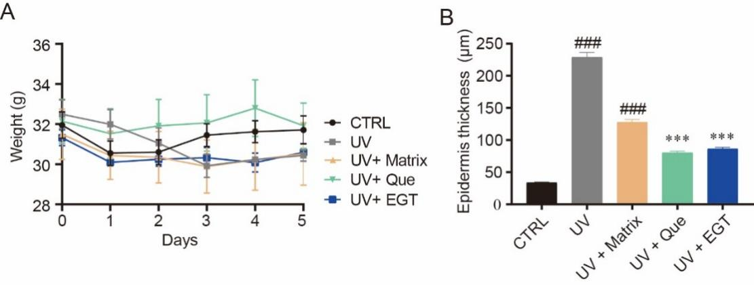

Supplementary Figure 1 EGT could decrease epidermis thickness without significant weight alteration in mice exposed UV irradiation. The data were the mouse weight (A) and the epidermis thickness (B). Control group vs UV group or UV + Matrix group: ###P ＜ 0.001. Que group or EGT group vs UV + Matrix group: ***P ＜ 0.001.

Supplementary Figure 2

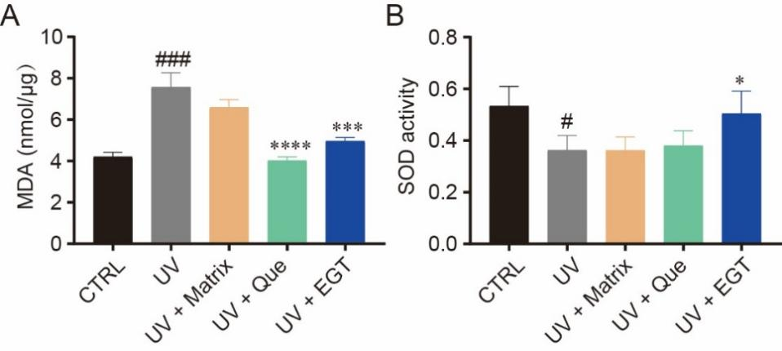

Supplementary Figure 2 Ergothioneine significantly decreased MDA level (A), and increased SOD activity (B) in skin. Control group vs UV group or UV + Matrix group: #P ＜ 0.05, ###P ＜ 0.001. Que group or EGT group vs UV + Matrix group: *P ＜ 0.05, ***P ＜ 0.001, ****P ＜ 0.0001.

Supplementary Figure 3

Supplementary Figure 3 EGT could downregulate Tnfα mRNA significantly in mouse skin exposed to UV. Control group vs UV group or UV + Matrix group: ###P ＜ 0.001, ####P ＜ 0.0001. Que group or EGT group vs UV + Matrix group: *P ＜ 0.05.

Supplementary Figure 4

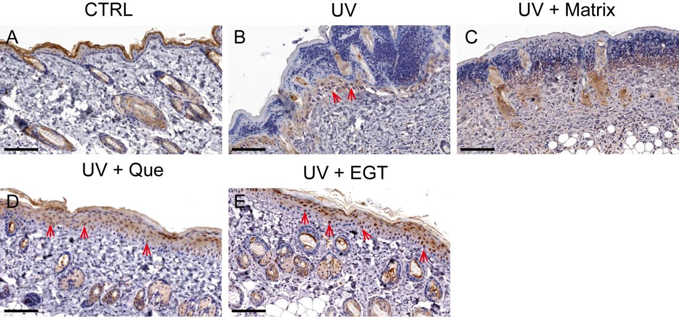
Supplementary Figure 4 Ergothioneine promotes Nrf2 protein expression. The arrows indicates nuclear Nrf2. The Nrf2 protein in the skin of control group control group mice (A), UV group (B), UV+Matrix group (C), UV+Que group (D), UV+EGT group (E). The scale bar was 50 μm.

Supplementary Figure 5

Supplementary Figure 5 EGT could upregulate the expression of Nrf2 target genes. The relative mRNA levels of Gpx2 (A), HO-1 (B), Nqo1 (C), and Txnrd1 (D).
Control group vs UV group or UV+ Matrix group: #P ＜ 0.05, ##P ＜ 0.01. Que group or EGT group vs UV+ Matrix group: *P ＜ 0.05, **P ＜ 0.01, ***P ＜ 0.001.

Supplementary Figure 6

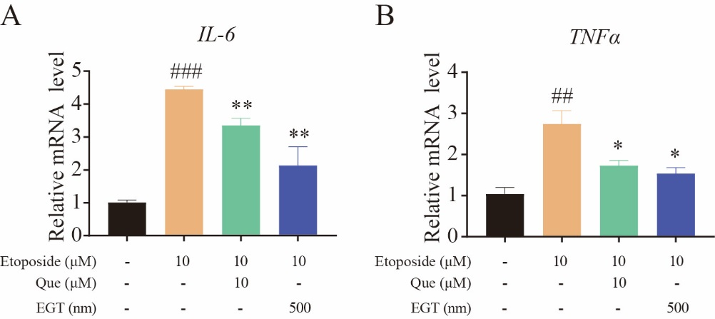

Supplementary Figure6 EGT could reduce mRNA levels of IL-6 and TNFα in HaCaT cells treated with etoposide. Control group vs etoposide group, ###P ＜ 0.001. Etoposide group vs Que or EGT groups, *P ＜ 0.05, **P ＜ 0.01, ***P ＜ 0.001.

Supplementary table1 Antibodies information
Antibody | Producer and Cat No.
Anti-Collagen I antibody | abcam; ab260043
Anti-Collagen III antibody | abcam; ab184993
Anti-MMP1 antibody | abcam; ab137332
Anti-MMP3 antibody | abcam; ab52915
Anti-MMP9 antibody | abcam; ab228402
Keap1 (D1G10) R | CST; 7705S
Nrf2 antibody | GeneTex; GTX103322
Anti-PI3 Kinase p85 alpha antibody | abcam; ab191606
Anti-PI3 Kinase p85 alpha (phospho Y607) antibody | abcam; ab182651
p38 alpha MAPK14 antibody M | Snata cruz; 81621
Phospho-p38 MAPK antibody M | CST; 9216S
Gapdh Antibody | Affinit; AF7021
anti-rabbit IgG HRP-linked Antibody | CST; 7074S
anti-mouse IgG HRP-linked Antibody | CST; 7076S

