Supporting Information
AMP-coated TiO₂ doped ZnO nanomaterials enhanced antibacterial activity by generating higher levels of hydroxyl radicals.
Qianyu Bai^{1,} *, Yichi Zhang^{1,} *, Runqiu Cai¹, Haiyan Wu¹, Huiqun Fu², Xuemei Zhou^{2*}, Jie Chai³, Xuepeng Teng³ and Tianlong Liu ^{1*}

¹ China agriculture university, College of Veterinary Medicine, National Key Laboratory of Veterinary Public Health and Safety, Yuanmingyuan West Road No.2, Beijing.
² 101 Institute of the Ministry of Civil Affairs, Beijing, China.
³ Shandong Cancer Hospital and Institute, Shandong First Medical University and Shandong Academy of Medical Sciences, Jinan, 250117, China

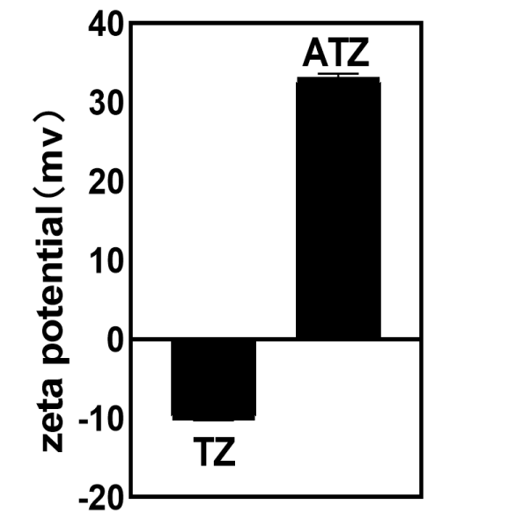
Figure S1. Zeta potential of TZ and ATZ nanoparticles. TZ NPs has a negative surface charge of -10.17mV and a potential value of -10.17 ±0.05mV, while ATZ NPs has a positive surface charge of 33.04mV and a potential value of 33.04±0.46mV. The potential change of nanoparticles confirmed the successful adsorption of AMP.

