Supplemental Table 1 Primers used in the present study
Gene name | Primer sequence (5’-3’)
AKR1C1 | Forward Primer: TCCAGTGTCTGTAAAGCCAGG
 | Reverse Primer: CCAGCAGTTTTCTCTGGTTGAA
CELF6 | Forward Primer: CCCATCGGGGTCAATGGATTC
 | Reverse Primer: GCCCGTTATTGTAGAGCGTGT
CRYAB | Forward Primer: CCTGAGTCCCTTCTACCTTCG
 | Reverse Primer: CACATCTCCCAACACCTTAACTT
FOSB | Forward Primer: GCTGCAAGATCCCCTACGAAG
 | Reverse Primer: ACGAAGAAGTGTACGAAGGGTT
KIF20A | Forward Primer: TGCTGTCCGATGACGATGTC
 | Reverse Primer: AGGTTCTTGCGTACCACAGAC
MAOA | Forward Primer: GAATCAAGAGAAGGCGAGTATCG
 | Reverse Primer: GGCAGCAGATAGTCCTGAAATG
MXRA5 | Forward Primer: CATCCCCGATGGAGCTTTAAG
 | Reverse Primer: TCAATGTGCAGCCTCATTAAGTT
OAS2 | Forward Primer: CTCAGAAGCTGGGTTGGTTTAT
 | Reverse Primer: ACCATCTCGTCGATCAGTGTC
PLK1 | Forward Primer: CACCAGCACGTCGTAGGATTC
 | Reverse Primer: CCGTAGGTAGTATCGGGCCTC
SYT12 | Forward Primer: GTTCCCCAATTACGACTACAGG
 | Reverse Primer: TCAATGCTGAGACTGCCTTTG
CACNA1C | Forward Primer: AATCGCCTATGGACTCCTCTT
 | Reverse Primer: GCGCCTTCACATCAAATCCG
DDIT3 | Forward Primer: GGAAACAGAGTGGTCATTCCC
 | Reverse Primer: CTGCTTGAGCCGTTCATTCTC
DUSP2 | Forward Primer: TGCCCCAACCACTTTGAGG
 | Reverse Primer: AGTCAATGAAGCCTATGGCCT
FOS | Forward Primer: CCGGGGATAGCCTCTCTTACT
 | Reverse Primer: CCAGGTCCGTGCAGAAGTC
GADD45A | Forward Primer: GAGAGCAGAAGACCGAAAGGA
 | Reverse Primer: CAGTGATCGTGCGCTGACT
HSPA6 | Forward Primer: CATCGCCTATGGGCTGGAC
 | Reverse Primer: GGAGAGAACCGACACATCGAA
JUN | Forward Primer: AACAGGTGGCACAGCTTAAAC
 | Reverse Primer: CAACTGCTGCGTTAGCATGAG
CCNB1 | Forward Primer: AATAAGGCGAAGATCAACATGGC
 | Reverse Primer: TTTGTTACCAATGTCCCCAAGAG
CCNB2 | Forward Primer: CCGACGGTGTCCAGTGATTT
 | Reverse Primer: TGTTGTTTTGGTGGGTTGAACT
ESPL1 | Forward Primer: GCTACTTAGTGTCTACCCCACA
 | Reverse Primer: CAGCAGCATTCCGCAGTAAGA
RACGAP1 | Forward Primer: ATGATGCTGAATGTGCGGAAT
 | Reverse Primer: CGCCAACTGGATAAATTGGACTT
GAPDH | Forward Primer: CTGGGCTACACTGAGCACC
 | Reverse Primer: AAGTGGTCGTTGAGGGCAATG
Supplemental Figure 1. Size distribution and polydispersity index of Cu-CDs
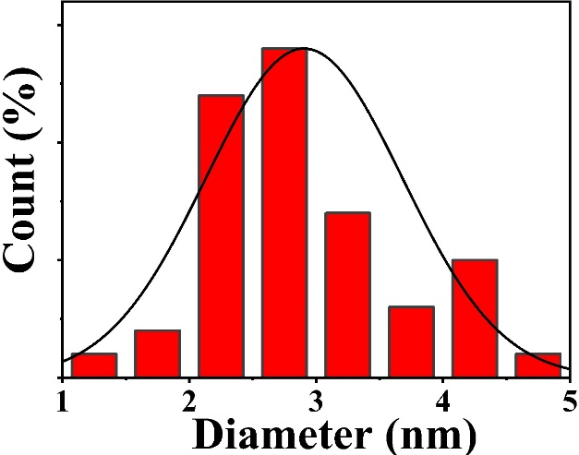
Supplemental Figure 2. High-resolution XPS spectra of Cu-CDs
A: C1s. B: N1s. C: S2p. D: O1s
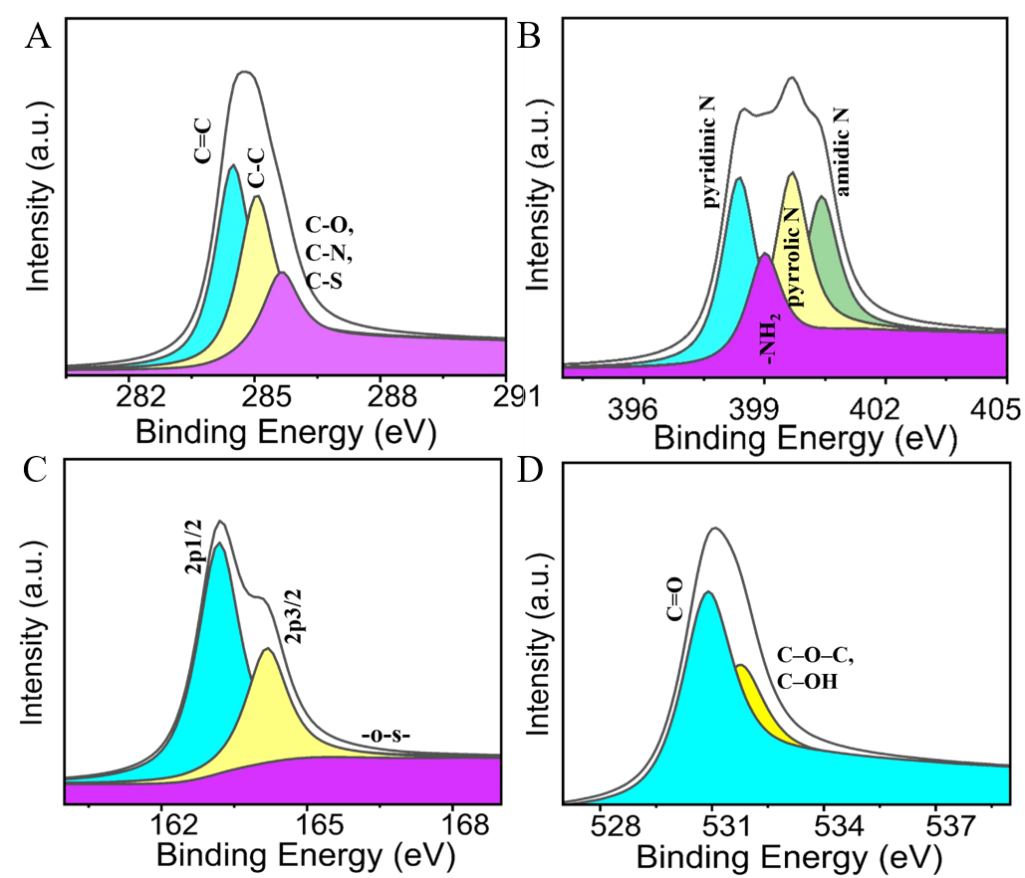
Supplemental Figure 3. Effect of Cu-CDs treatments on the blood physiological parameters and histological damages of C57/BL6 mice
A: Quantitative number of WBC. B: Quantitative number of RBC. C: Quantitative result of HGB. D: Quantitative result of PLT. E: Quantitative result of MCH. F: Quantitative result of MCHC. G: Masson trichrome staining. H: PAS staining. ns represents P>0.05.
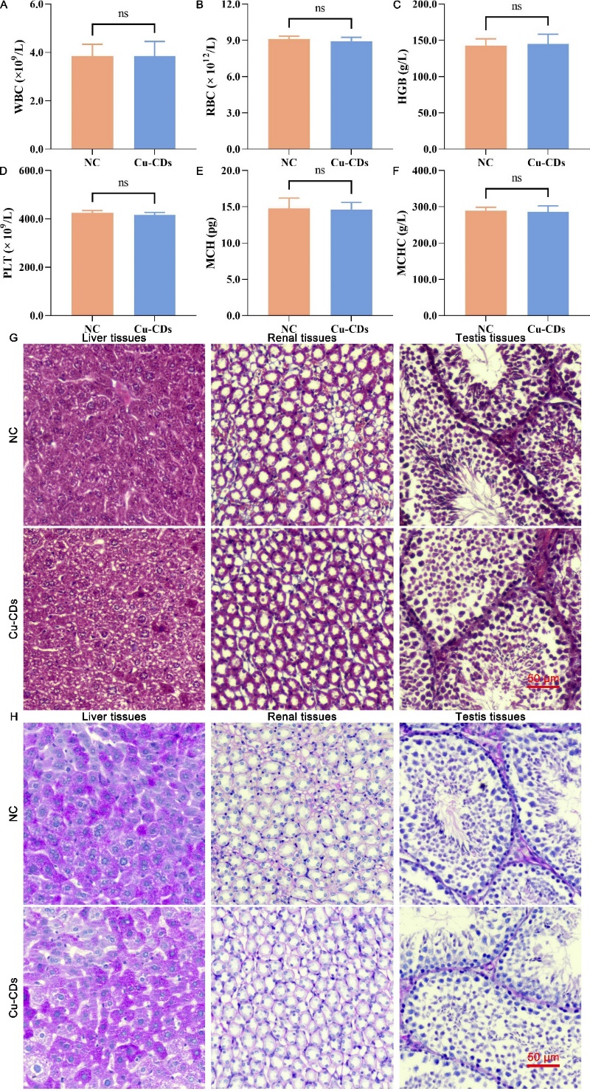
Supplemental Figure 4. Effect of Cu-CDs treatments on cellular viability of MDA-MB-231 cells
* represents P<0.05, with ** representing P<0.01, and *** representing P<0.001.
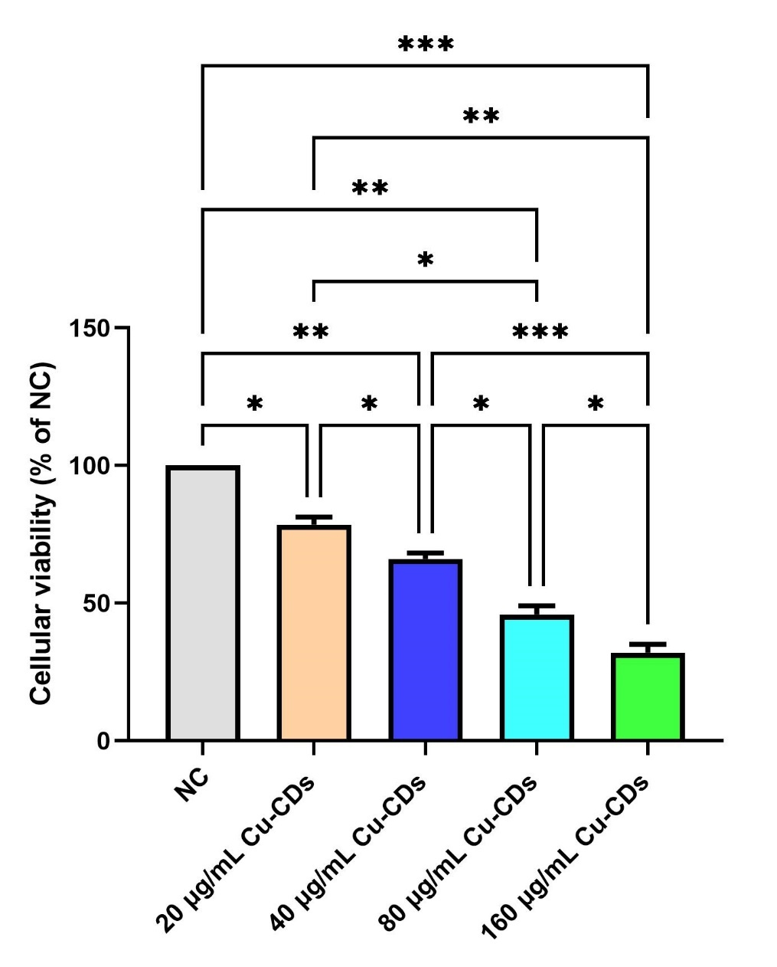
Supplemental Figure 5. Effect of Cu-CDs treatments on the expression levels of apoptosis-related proteins
A: Western blot analysis of apoptosis-related proteins. B: Protein expression level of Bax relative to ACTIN. C: Protein expression level of Bcl-2 relative to ACTIN. * represents P<0.05 with **** representing P<0.0001.
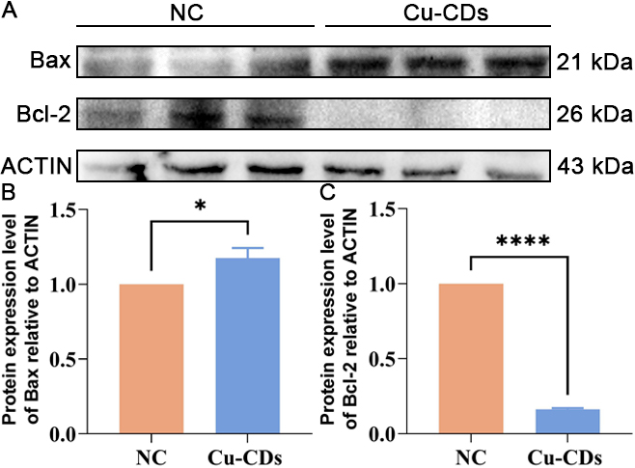
Supplemental Figure 6. Accuracy validation of DEGs in the Cu-CDs treated MDA-MB-231 cells
A: Expression levels of DEGs in breast cancer tissues and normal breast tissues based on the GEPIA database. BRCA represents breast invasive carcinoma. T and N represent cancer and normal tissue groups. B: Gene count of DEGs in MDA-MB-231 cells between the NC and Cu-CDs groups. C: Relative expression levels of DEGs in MDA-MB-231 cells between the NC and Cu-CDs groups. * represents P<0.05, with ** representing P<0.01, and *** representing P<0.001.
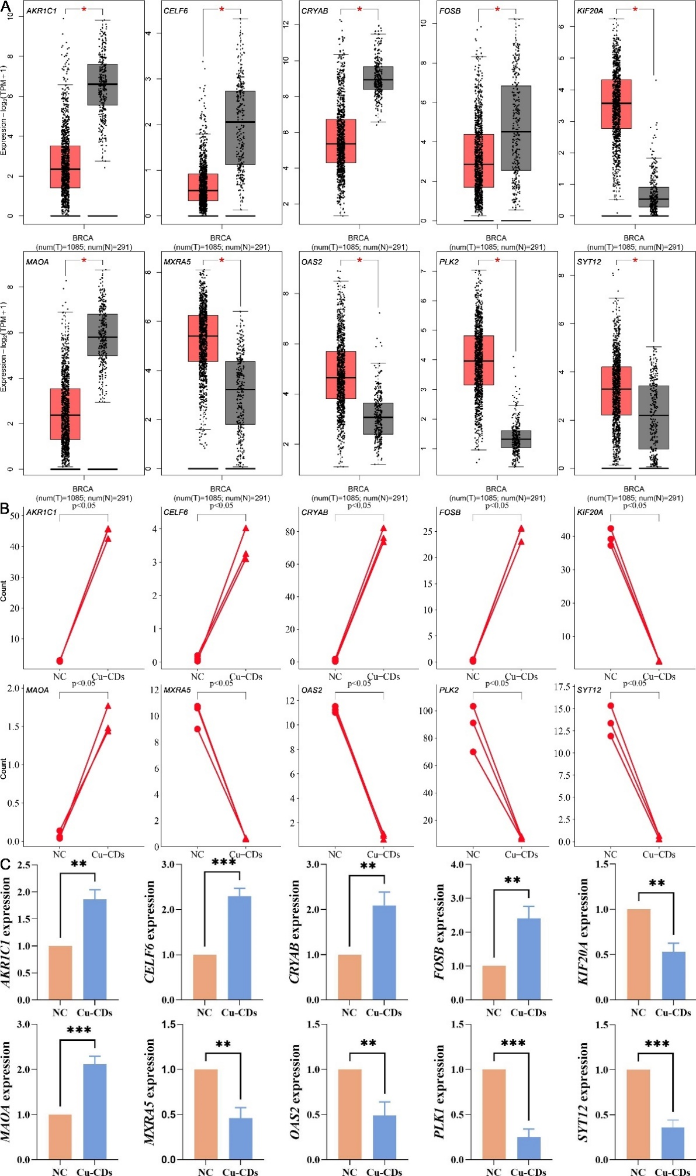
Supplemental Figure 7. Expression levels of MAPK signaling pathway-related genes in the Cu-CDs treated MDA-MB-231 cells
A: Expression level of CACNA1C in the Cu-CDs treated MDA-MB-231 cells. B: Expression level of DDIT3 in the Cu-CDs treated MDA-MB-231 cells. C: Expression level of DUSP2 in the Cu-CDs treated MDA-MB-231 cells. D: Expression level of GADD45A in the Cu-CDs treated MDA-MB-231 cells. E: Expression level of HSPA6 in the Cu-CDs treated MDA-MB-231 cells. F: Expression level of JUN in the Cu-CDs treated MDA-MB-231 cells. * represents P<0.05, with ** representing P<0.01, and *** representing P<0.001.
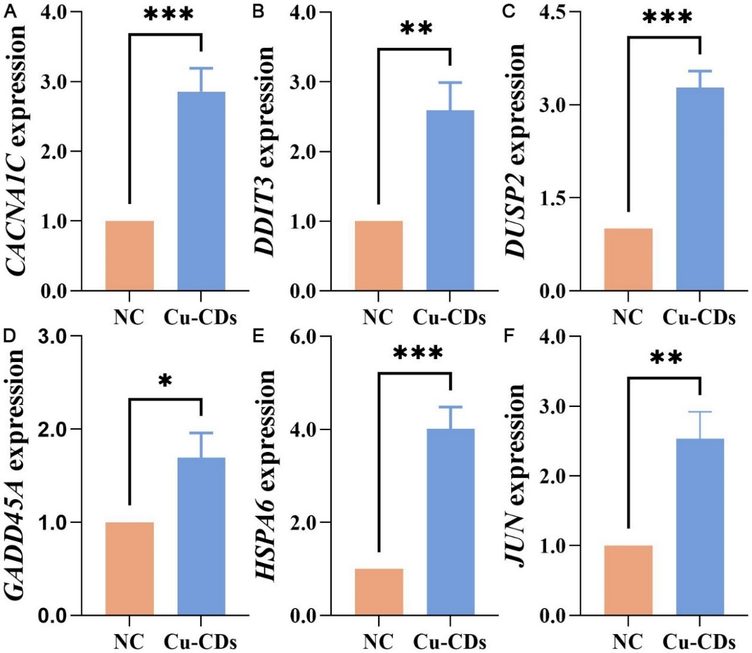

Supplemental Figure 8. Accuracy validation of hub genes in the Cu-CDs treated MDA-MB-231 cells
A: Expression levels of hub genes in breast cancer tissues and normal breast tissues based on the GEPIA database. B: Gene count of hub genes in the Cu-CDs treated MDA-MB-231 cells. C: Relative expression levels of hub genes in the Cu-CDs treated MDA-MB-231 cells. * represents P<0.05, with ** representing P<0.01, and *** representing P<0.001.
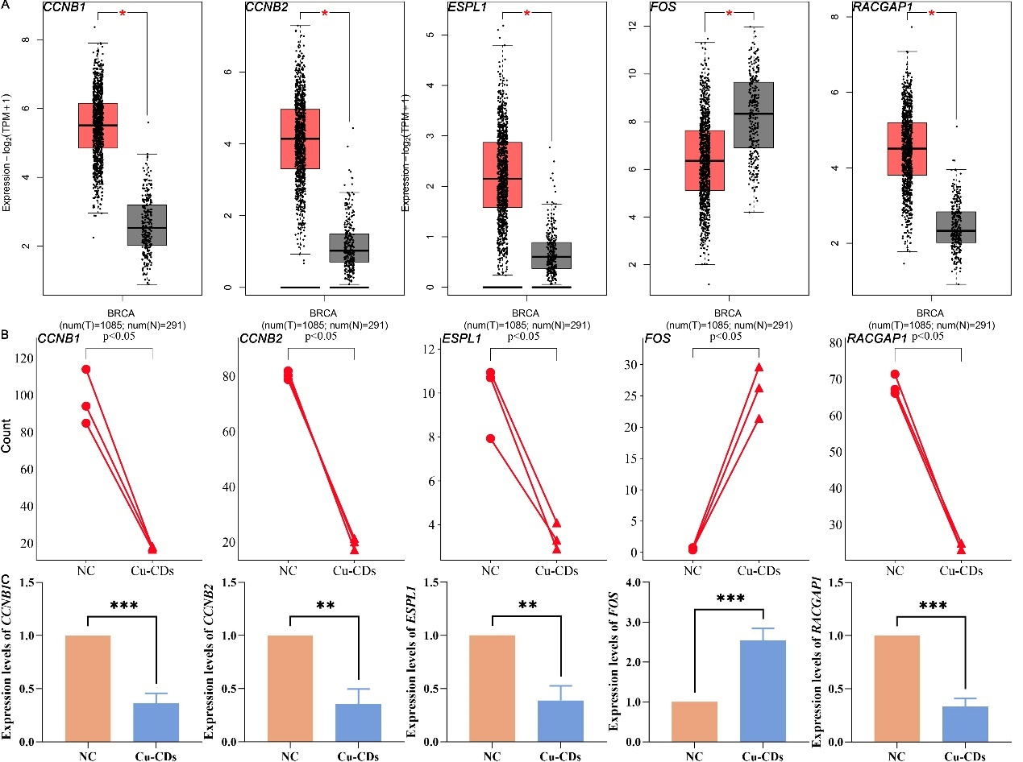

Supplemental Figure 9. Association between the expression level of hub genes and survival of breast cancer patients based on the Kaplan-Meier plotter database
A: Association between the expression level of hub genes and OS of breast cancer patients. B: Association between the expression level of hub genes and RFS of breast cancer patients
