Cost-effectiveness analysis of the Oncotype DX Breast Recurrence Score® test from a US societal perspective

Additional methods
Clinical expert survey
Probability of adjuvant chemotherapy assignment in the model was informed by a survey of 9 breast cancer experts in the US. The experts were recruited based on the following inclusion criteria:
- Practicing healthcare professional working in the USA
- At least 5 years’ experience in treating patients living with HR+/HER2- early-stage breast cancer
- Experience of using the Oncotype DX test to guide decisions on the use of adjuvant chemotherapy
- Hold the position of Vice President, Department Head, Assistant/Associate Professor or equivalent, or above
- Published at least three medical articles in well-known journals
- Hold affiliation/membership in at least 3 local, regional, or national medical organizations
The experts were asked to estimate the proportion of patients who would be assigned to adjuvant chemotherapy conditional on age and clinical risk (based on the subgroups used in the exploratory analyses of TAILORx¹) for N0, and according to menopausal status for N1. The choice of patient factors was motivated by the patient subgroups in the TAILORx exploratory analysis for N0² and RxPONDER study for N1,³ which were the pivotal phase III trials which informed the probability of distant recurrence for these subgroups in the model. For each subgroup, the experts estimated the proportion assigned adjuvant chemotherapy without RS (based on clinical-pathological risk factors alone) and with RS, stratified into low, intermediate, and high RS in line with cut-points defined in TAILORx and RxPONDER. Although all 9 experts provided estimates, two of the respondents reported that they would not assign any patients to adjuvant chemotherapy without assessing their RS in line with NCCN guidelines. Considering that the estimates provided by these two respondents did not represent the required counterfactual for the model, it was decided to exclude these data from the analysis. Their responses to other questions related to the distribution of treatment regimens in the adjuvant and metastatic settings were considered to be valid and were included in the analysis. The estimated proportion of patients allocated to adjuvant chemotherapy for each subgroup is reported in Table S1. The mean values across all responses were used as inputs in the model, and in some cases the estimates were highly uncertain due to variation in clinical practice. Scenario analyses were conducted to test the impact of this uncertainty on the model results and estimates in the published literature.^{4,5}
Table S1. Chemotherapy allocation with and without chemotherapy based on the clinical expert survey.
Subgroup | % (range) assigned chemotherapy
 | w/o RS | Low RS† | Intermediate RS† | High RS†
Overall N0 | 26.5 (1-72) | 4.4 (0-11) | 21.7 (1-49) | 88.4 (74-100)
N0 age≤50 low clin. risk | 24.3 (0-80) | 2.1 (0-10) | 26.4 (0-100) | 91.1 (85-100)
N0 age≤50 high clin. risk | 59.6 (5-100) | 12.9 (0-50) | 48.6 (15-100) | 96.8 (90-100)
N0 age>50 low clin. risk | 11.4 (0-50) | 1.4 (0-10) | 11.4 (0-40) | 83.6 (60-100)
N0 age>50 high clin. risk | 49.3 (5-100) | 10.0 (0-30) | 28.6 (0-100) | 92.9 (85-100)
N1 premenopausal | 76.4 (40-100) | 43.2 (0-93) | 72.5 (20-100) | 93.9 (80-100)
N1 postmenopausal | 35.7 (10-70) | 4.3 (0-10) | 20.0 (0-70) | 88.2 (70-100)
† N0: low RS: ≤10; intermediate RS: 11-25; N1: low RS: ≤13; intermediate RS: 14-25; N0 and N1: high RS: >25

Micrometastatic subgroup analysis inputs
The distribution of patients in the micrometastatic (N1mi) subgroup according to RS result was informed using the SEER database.⁶ Due to a lack of published studies for the N1mi population, chemotherapy allocation and distant recurrence probabilities for N0 were applied to the N1mi analysis in line with advice from US clinical experts. Scenario analyses were conducted to gauge the impact of using N1 inputs, reflecting US clinical guidelines which stipulate that clinical practice in N1mi should follow that of N1.⁷ For specific data sources please refer to the description of clinical inputs for N0 in the manuscript (or N1 for scenario analyses which apply N1 data sources for N1mic).
The RxPONDER study initially recruited patients with N1mi tumours, meaning that in practice a small proportion of patients in this study were N1mi, rather than N1 only. RxPONDER did not report outcomes for this small subset of patients which could inform the N1mi subgroup analysis in this article. The small number of N1mi patients recruited in RxPONDER was unlikely to have an impact on the N1 analysis, and this was not considered to be a source of bias or a limitation of the data source.
Mortality
Disease-related mortality obtained from the literature was adjusted for background mortality using national life tables, which are shown in Table S2.
Table S2. US life table for females, 2017
Age | Annual rate
18 | 0.000336
19 | 0.000379
20 | 0.000425
21 | 0.000472
22 | 0.000515
23 | 0.000551
24 | 0.000582
25 | 0.000612
26 | 0.000646
27 | 0.000684
28 | 0.000729
29 | 0.000779
30 | 0.000833
31 | 0.000887
32 | 0.000939
33 | 0.000988
34 | 0.001034
35 | 0.001085
36 | 0.001143
37 | 0.001205
38 | 0.001271
39 | 0.001345
40 | 0.001429
41 | 0.001524
42 | 0.001630
43 | 0.001748
44 | 0.001881
45 | 0.002029
46 | 0.002195
47 | 0.002386
48 | 0.002605
49 | 0.002851
50 | 0.003118
51 | 0.003403
52 | 0.003714
53 | 0.004052
54 | 0.004415
55 | 0.004813
56 | 0.005233
57 | 0.005647
58 | 0.006043
59 | 0.006441
60 | 0.006886
61 | 0.007391
62 | 0.007931
63 | 0.008508
64 | 0.009142
65 | 0.009874
66 | 0.010717
67 | 0.011660
68 | 0.012711
69 | 0.013894
70 | 0.015285
71 | 0.016878
72 | 0.018607
73 | 0.020466
74 | 0.022522
75 | 0.024929
76 | 0.027729
77 | 0.030855
78 | 0.034321
79 | 0.038211
80 | 0.042771
81 | 0.047992
82 | 0.053678
83 | 0.059810
84 | 0.066584
85 | 0.074258
86 | 0.083053
87 | 0.093123
88 | 0.104540
89 | 0.117305
90 | 0.131392
91 | 0.146753
92 | 0.163331
93 | 0.181064
94 | 0.199886
95 | 0.218908
96 | 0.237815
97 | 0.256265
98 | 0.273894
99 | 0.290328
100 | 0.307747

Utility inputs
A targeted literature review to identify HRQoL inputs did not identify US-specific studies. The main source of utilities for the recurrence-free and distant recurrence health states were obtained from a study of 361 breast cancer patients in Sweden.⁸ Local recurrence was modelled using a one-off utility decrement based on Campbell et al.⁹ The utility level in acute myeloid leukemia was obtained from the NICE appraisal of liposomal cytarabine-daunorubicin for untreated acute myeloid leukemia.¹⁰ A utility decrement from Campbell et al. was applied to all patients receiving chemotherapy to reflect the loss in utility associated with treatment administration and AEs.⁹ Utility inputs from Sweden and the UK were deemed to be applicable to the US setting, in the absence of US-specific inputs, as breast cancer outcomes in these resource-rich countries were assumed to be similar to the US.
Health state cost inputs
The distribution of adjuvant chemotherapy regimens by nodal status and assumptions for the use of supportive treatments (growth factors) was obtained from discussions with breast oncologists in the US. Dosage schedules from NCCN were combined with Medicare drug prices to estimate the total cost of treatment for each chemotherapy regimen. These estimates build upon previous work carried out with the help of clinical experts to estimate the cost of chemotherapy.¹¹ The cost of distant recurrence was modelled in terms of the subsequent lines of treatment used for the treatment of metastatic breast cancer, in consultation with clinical experts. The unit costs of treating AML and CHF were obtained from literature.¹² Costs were presented in 2021 US dollars (USD), with costs published in previous years adjusted for inflation.
A summary of chemotherapy, endocrine therapy and CDK4/6 inhibitor costs and shown in Table S3, Table S4 and Table S5. Drug unit costs are reported in Table S6. The cost of treatment regimens in metastatic breast cancer is shown in Table S7.
Table S3. Early breast cancer chemo-endocrine therapy cost
parameter | Value/unit cost | Cost per model cycle | Source
Body surface area (m²) | 1.75 | - | Assumption
Mean weight (kg) | 66 | - | Assumption
Vial sharing | 0% | - | Assumption
% with G-CSF for Anthracycline | 71% | - | Clinical expert opinion
% with G-CSF for Taxane | 41% | - | Clinical expert opinion
% with G-CSF for  Dose-dense AC | 89% | - | Clinical expert opinion
Early BC chemotherapy
AC followed by P | N0: 18.9%  N1: 47.8% | Acquisition: $17,337;  admin: $3,086 | Distributions: clinical expert opinion; calculations: Table S4 and Table S6
AC followed by weekly P | N0: 16.7%  N1: 21.1% | Acquisition: $7,918; admin: $6,931
TC | N0: 56.1%  N1: 21.1% | Acquisition: $5,189; admin: $2,176
EC | N0: 0.6%  N1: 0.0% | Acquisition:  $17,311;  admin: $3,619
AC followed by T | N0: 5.0%  N1: 5.6% | Acquisition:  $9,362;  admin: $3,863
TAC | N0: 0.6%  N1: 0.0% | Acquisition:  $11,550;  admin: $2,802
AC | N0: 0.6%  N1: 0.0% | Acquisition: $9,027; admin: $2,126
CMF | N0: 0.6%  N1: 0.0% | Acquisition: $572; admin:  $5,298
Weekly P + carboplatin | N0: 0.6%  N1: 2.2% | Acquisition:  $6,600;  admin: $6,689
T + carboplatin | N0: 0.6%  N1: 2.2% | Acquisition:  $9,950;  admin: $2,802
Early BC endocrine therapy
Aromatase inhibitor monotherapy | 40% | Acquisition + admin: $33.16 | Distributions: Clinical expert  calculations: see unit costs in Table S6
Tamoxifen monotherapy | 40% | Acquisition + admin: $75.83
Exemestane monotherapy | 20% | Acquisition + admin:  $416.01
Chemotherapy AE cost | See Table 1 in main body of manuscript | - | -
Drug unit costs | See Table S6 | - | -

Table S4. Details of chemotherapy regimens in early breast cancer
Treatment | Dose per admin (mg) | No. of doses | Acquisition cost
AC followed by P
Doxorubicin 60 mg/m² | 105.00 | 4 | $95.39
Cyclophosphamide 600 mg/m² | 1050.00 | 4 | $1,282.73
Paclitaxel 175 mg/m² | 306.25 | 4 | $160.87
Neulasta 6mg/0.6ml | 6.00 | 8 | $17,773.01
AC followed by weekly P
Doxorubicin 60 mg/m² | 105.00 | 4 | $95.39
Cyclophosphamide 600 mg/m² | 1050.00 | 4 | $1,282.73
Paclitaxel 80 mg/m² | 140.00 | 12 | $220.08
Neulasta 6mg/0.6ml | 6.00 | 4 | $8,886.50
TC
Cyclophosphamide 600mg/m² | 1050.00 | 4 | $1,282.73
Docetaxel 75mg/m² | 131.25 | 4 | $252.91
Neulasta 6mg/0.6ml | 6.00 | 4 | $8,886.50
EC
Cyclophosphamide 830mg/m² | 1452.50 | 8 | $3,498.36
Epirubicin 100mg/m² | 175.00 | 8 | $1,174.27
Neulasta 6mg/0.6ml | 6.00 | 8 | $17,773.01
TAC
Cyclophosphamide 500mg/m² | 875.00 | 6 | $1,574.26
Docetaxel 75mg/m² | 131.25 | 6 | $379.37
Doxorubicin 50mg/m² | 87.50 | 6 | $117.07
Neulasta 6mg/0.6ml | 6.00 | 6 | $13,329.76
AC
Doxorubicin 60 mg/m² | 87.50 | 4 | $78.05
Cyclophosphamide 600 mg/m² | 875.00 | 4 | $1,049.51
Neulasta 6mg/0.6ml | 6.00 | 4 | $8,886.50
CMF
Cyclophosphamide oral 100 mg/m2 | 175.00 | 84 | $473.93
Methotrexate 40 mg/m2 | 70.00 | 12 | $36.29
5-fluorouracil 600 mg/m2 | 1050.00 | 12 | $61.34
Weekly P + carboplatin
Paclitaxel 80 mg/m2 | 140.00 | 12 | $220.08
Carboplatin AUC 6 | 550.00 | 4 | $2,726.90
Neulasta 6mg/0.6ml | 6.00 | 4 | $8,886.50
T + carboplatin
Docetaxel 75 mg/m2 | 131.25 | 6 | $379.37
Carboplatin AUC 6 | 550.00 | 6 | $4,090.35
Neulasta 6mg/0.6ml | 6.00 | 6 | $13,329.76

Table S5. Cost per month of CDK4/6 inhibitors

Treatment | Dose per admin (mg) | No. of doses | Acquisition cost
Abemaciclib 150mg | 150.00 | 56 | $12,055.56
Palbociclib 125mg | 125.00 | 21 | $17,556.21
Ribociclib 125mg | 600.00 | 21 | $9,787.68

Table S6. Drug unit costs

Drug | Cost per vial/tablet | Dosage | Source
Doxorubicin hcl injection | $2.17 | 10 mg | Medicare
Cyclophosphamide 100 mg inj | $29.15 | 100 mg | Medicare
Cyclophosphamide 25mg oral | $0.81 | 25 mg | Medicare
Paclitaxel injection | $0.13 | 1 mg | Medicare
Docetaxel injection | $0.48 | 1 mg | Medicare
Methotrexate sodium inj | $0.22 | 5 mg | Medicare
Methotrexate sodium inj | $2.16 | 50 mg | Medicare
Fluorouracil injection | $1.70 | 500 mg | Medicare
Fulvestrant injection | $15.98 | 25 mg | Medicare
Tamoxifen | $0.42 | 20 mg | eMedNY
Anastrozole | £0.18 | 1 mg | eMedNY
Exemestane | £2.29 | 25 mg | eMedNY
Oral everolimus | $5.92 | 0.25 mg | Medicare
Leuprolide | £18.32 | 1 mg | Medicare
Goserelin | £525.21 | 3.6 mg | Medicare
Capecitabine, oral, 150 mg | $0.59 | 150 mg | Medicare
Capecitabine, oral, 500 mg | $0.92 | 500 mg | Medicare
Alpelisib | $306.47 | 300 mg | Medicare (part D for ref)
Abemaciclib | $215.28 | 150 mg | Medicare (part D for ref)
Letrozole | $0.20 | 2.5 mg | eMedNY
Palbociclib | $836.01 | 125 mg | eMedNY
Ribociclib | $155.36 | 200 mg | eMedNY
Injection, pegfilgrastim 6mg | $2,221.63 | 6 mg | Medicare
Injection, epirubicin hcl, 2 mg | $1.67 | 2 mg | Medicare
Carboplatin injection | $2.48 | 2 mg | Medicare
Eribulin mesylate injection | $121.29 | 0.1 mg | Medicare

Table S7. Cost of treatment regimens in metastatic breast cancer
Drug/dosage | 1st line | 2nd line | 3rd line | Acquisition cost per model cycle | Admin cost per model cycle | Total per cycle cost
Chemotherapy
Capecitabine | 24% | 18% | 58% | $102.19 | $165.93 | $268.12
Paclitaxel | 14% | 12% | 18% | $80.43 | $1,066.64 | $1,147.08
Bevacizumab + paclitaxel | 0% | 4% | 3% | $9,356.48 | $1,450.42 | $10,806.89
AC followed by T | 38% | 4% | 0% | $9,361.97 | $3,862.57 | $13,224.54
TC | 24% | 0% | 2% | $5,188.98 | $2,176.03 | $7,365.01
Alpelisib + fulvestrant | 0% | 61% | 17% | $8,900.84 | $226.39 | $9,127.23
Eribulin | 0% | 0% | 3% | $5,336.63 | $1,066.64 | $6,403.27
CDK4/6 inhibitors
Abemaciclib 150mg x 56 per month | 33.3% | 0% | 0% | $12,055.56 | $0.00 | $12,221.49
Palbociclib 125mg x 21 per month | 33.3% | 0% | 0% | $17,556.21 | $0.00 | $17,722.14
Ribociclib 125mg x 21 per month | 33.3% | 0% | 0% | $9,787.68 | $0.00 | $9,953.61
Endocrine therapy
Aromatase inhibitor monotherapy | 40% | 32% | 0% | $33.16 | $0.00 | $33.16
Tamoxifen monotherapy | 27% | 13% | 0% | $75.83 | $0.00 | $75.83
Fulvestrant monotherapy | 7% | 5% | 38% | $2,237.06 | $423.22 | $2,237.06
Fulvestrant + aromatase inhibitor | 0% | 13% | 8% | $2,270.22 | $423.22 | $2,270.22
Exemestane monotherapy | 0% | 0% | 0% | $416.01 | $0.00 | $416.01
Ovarian suppression with endocrine therapy | 27% | 25% | 4% | $1,781.78 | $362.76 | $1,781.78
Everolimus + tamoxifen | 0% | 6% | 2% | $1,153.82 | $0.00 | $1,153.82
Everolimus + exemestane | 0% | 6% | 48% | $1,493.99 | $0.00 | $1,493.99

Societal cost inputs
The analysis considered a wider set of costs of breast cancer to society beyond direct healthcare costs. A targeted literature review was conducted to identify the impact of breast cancer and its treatments on patient out-of-pocket (OOP) costs and lost productivity in the US. The key inputs and assumptions are outlined in Table S8. The cost of out-of-pocket payments by chemotherapy regimen was obtained from Giordano et al.¹³ It was assumed that the OOP costs are applied in the first cycle for all patients assigned to adjuvant chemotherapy or experiencing a distant recurrence.¹⁴ The cost of the work days was estimated based on the median weekly salary reported by U.S. Department of Labor.¹⁵
Table S8. Societal cost inputs in the economic model
Cost category | Values
OOP cost | Mean cost (USD)
AC followed by P | $3,650
AC followed by weekly P | $3,650
TC | $3,285
AC | $3,081
CMF | $2,753
Weighted average | $3,551
Lost productivity cost | Mean no. of days lost | Mean lost productivity cost (USD)
Adjuvant chemotherapy | 36.5 | $7,373
Distant recurrence | 84.4 | $17,049

Scenario analysis results
Base case input parameter values, ranges and distributions are shown in Table S9 below.
Table S9. Base case parameter values, ranges, and distributions
Parameter | Base case | DSA range | PSA SE and distribution | Source
RS distribution, N0 population
0-10 | 17% | Not varied | Dirichlet (1619,6711,1389) | TAILORx (Sparano et al., 2018)
11-25 | 69% | Not varied | Dirichlet (1619,6711,1389) | TAILORx (Sparano et al., 2018)
26-100 | 14% | Not varied | Dirichlet (1619,6711,1389) | TAILORx (Sparano et al., 2018)
RS distribution, combined N1 population
0-13 | 38.1% | Not varied | Dirichlet (2147,2871,554) | RxPONDER (Kalinsky et al., 2021)
14-25 | 50.9% | Not varied | Dirichlet (2147,2871,554) | RxPONDER (Kalinsky et al., 2021)
26-100 | 11% | Not varied | Dirichlet (2147,2871,554) | RxPONDER (Kalinsky et al., 2021)
RS distribution, premenopausal N1 population
0-13 | 34.4% | Not varied | Dirichlet (640,1015,182) | RxPONDER (Kalinsky et al., 2021)
14-25 | 54.6% | Not varied | Dirichlet (640,1015,182) | RxPONDER (Kalinsky et al., 2021)
26-100 | 11% | Not varied | Dirichlet (640,1015,182) | RxPONDER (Kalinsky et al., 2021)
RS distribution, postmenopausal N1 population
0-13 | 39.9% | Not varied | Dirichlet (1492,1837,366) | RxPONDER (Kalinsky et al., 2021)
14-25 | 49.1% | Not varied | Dirichlet (1492,1837,366) | RxPONDER (Kalinsky et al., 2021)
26-100 | 11% | Not varied | Dirichlet (1492,1837,366) | RxPONDER (Kalinsky et al., 2021)
RS distribution, N1mi population
0-17 | 58.3% | Not varied | Dirichlet (1644,998,178) | SEER (Roberts et al, 2017)
18-30 | 35.4% | Not varied | Dirichlet (1644,998,178) | SEER (Roberts et al, 2017)
31-100 | 6.3% | Not varied | Dirichlet (1644,998,178) | SEER (Roberts et al, 2017)
Probability of chemotherapy, N0 population by RS result
0-10 | 4% | 4%, 5% | Beta (α =92; β=1997) | Expert opinion
11-25 | 22% | 17%, 26% | Beta (α =75; β=271) | Expert opinion
26-100 | 88% | 71%, 100% | Beta (α = 15; β = 2) | Expert opinion
Probability of chemotherapy, N0 age≤50 low clin. risk population by RS result
0-10 | 2% | 2%, 3% | Beta (α = 94; β = 4382) | Expert opinion
11-25 | 26% | 21%, 32% | Beta (α = 70; β = 196) | Expert opinion
26-100 | 91% | 73%, 100% | Beta (α = 15; β = 1) | Expert opinion
Probability of chemotherapy, N0 age≤50 high clin. risk population by RS result
0-10 | 13% | 10%, 16% | Beta (α = 84; β = 564) | Expert opinion
11-25 | 49% | 39%, 58% | Beta (α = 49; β = 52) | Expert opinion
26-100 | 97% | 77%, 100% | Beta (α = 8; β = 0) | Expert opinion
Probability of chemotherapy, N0 age>50 low clin. risk population by RS result
0-10 | 1% | 1%, 2% | Beta (α = 95; β = 6668) | Expert opinion
11-25 | 11% | 9%, 14% | Beta (α = 85; β = 660) | Expert opinion
26-100 | 84% | 67%, 100% | Beta (α = 15; β = 3) | Expert opinion
Probability of chemotherapy, N0 age>50 high clin. risk population by RS result
0-10 | 10% | 8%, 12% | Beta (α = 86; β = 777) | Expert opinion
11-25 | 29% | 23%, 34% | Beta (α = 68; β = 170) | Expert opinion
26-100 | 93% | 74%, 100% | Beta (α = 13; β = 1) | Expert opinion
Probability of chemotherapy, N1 population by RS result
0-13 | 16% | Weighted average of premenopausal and post-menopausal |  | Expert opinion
14-25 | 39% |  |  | Expert opinion
26-100 | 90% |  |  | Expert opinion
Probability of chemotherapy, premenopausal N1 population by RS result
0-13 | 43% | 35%, 52% | Beta (α = 54; β = 71) | Expert opinion
14-25 | 73% | 58%, 87% | Beta (α = 26; β = 10) | Expert opinion
26-100 | 94% | 75%, 100% | Beta (α = 12; β = 1) | Expert opinion
Probability of chemotherapy, postmenopausal N1 population by RS result
0-13 | 4% | 3%, 5% | Beta (α = 92; β = 2052) | Expert opinion
14-25 | 20% | 16%, 24% | Beta (α = 77; β = 307) | Expert opinion
26-100 | 88% | 71%, 100% | Beta (α = 15; β = 2) | Expert opinion
Probability of chemotherapy, N1mi population by RS result
0-17 | 18% | 16.1%, 19.9% | Beta (α = 296; β = 1348) | SEER (Roberts et al, 2017)
18-30 | 47% | 43.8%, 50.2% | Beta (α = 469; β = 529) | SEER (Roberts et al, 2017)
31-100 | 79% | 72.9%, 85.1% | Beta (α = 141; β = 37) | SEER (Roberts et al, 2017)
N0 DRFI with ET (by RS result)
RS 0-10, (9-year distant recurrence-free) | 96.8% | 95.4%, 98.2% | Beta (α = 611; β = 20) | TAILORx (Sparano et al., 2018)
RS 11-25, (9-year distant recurrence-free) | 94.5% | 93.5%, 95.5% | Beta (α = 1964; β = 144)
RS 26-100, (9-year distant recurrence-free) | 59.2% | Estimated based on chemotherapy distant recurrence free survival data |  | Estimated based on, LN0 hazard ratio and distant recurrence free interval with chemotherapy
N1 DRFI with ET (by RS result)
RS 0-25, premenopausal (5-year distant recurrence-free) | 93.9% | 93%,95% | Beta (α = 1387;β = 90) | RxPONDER (Kalinsky et al., 2021)
RS 0-25, postmenopausal (5-year distant recurrence-free) | 96.6% | 96%,97% | Beta (α = 2635;β = 93) | RxPONDER (Kalinsky et al., 2021)
RS 26-100, all patients (10-year DRFS) | 68.6% | 45%,84% | Beta (α = 14;β = 6) | TransATAC bespoke analysis (National Institute for Health and Care Excellence, 2018b)
DRFI with CET (by RS result)
RS 0-25, N1 premenopausal (5-year distant recurrence-free) | 96.3% | 96%,97% | Beta (α = 2406;β = 92) | RxPONDER SABCS 2021 presentation
RS 0-25, N1 postmenopausal (5-year distant recurrence-free) | 95.8% | 95%,97% | Beta (α = 2098;β = 92) | RxPONDER SABCS 2021 presentation
RS 0-10, N0 hazard ratio with chemotherapy | 1.00 | Not varied | Not varied | Assumption
RS 11-25, N0 hazard ratio with chemotherapy | 0.91 | 0.71, 1.180 | Log normal (se = 0.13) | Sparano et al.
RS 26-100, N0 hazard ratio with chemotherapy | 0.27 | 0.12, 0.62 | Log normal (se = 0.42) | TAILORx (Geyer et al., 2018)
RS 0-17, combined N1 hazard ratio with chemotherapy | 1.02 | 0.54, 1.93 | Log normal (se = 0.32) | Albain et al., 2010
RS 18-30, combined N1 hazard ratio with chemotherapy | 0.72 | 0.39, 1.31 | Log normal (se = 0.31) | Albain et al., 2010
RS 31-100, combined N1 hazard ratio with chemotherapy | 0.59 | 0.35, 1 | Log normal (se = 0.27) | Albain et al., 2010
RS 0-25, N1 premenopausal hazard ratio with chemotherapy | 0.64 | 0.43,0.95 | Log normal (se = 0.13) | RxPONDER SABCS 2021 presentation
RS 0-25, N1 postmenopausal hazard ratio with chemotherapy | 1.12 | 0.82,1.52 | Log normal (se = 0.18) | RxPONDER SABCS 2021 presentation
Other transition probabilities
Probability of local recurrence prior to distant recurrence | 10.5% | 8.8%,12.3% | Beta (α = 86;β =732) | De bock et al., 2009
Reduction in DR rate in years 10-15 | 50% | Not varied | Not varied | Assumption in NICE DG34 (National Institute for Health and Care Excellence, 2018b)
Reduction in DR rate in years 10-15 | 50% | Not varied | Not varied | Clinical expert
60-month probability of AML | 0.28% | 0.22%, 0.34% | Beta (α = 96;β =34127) | Petrelli et al., 2012
Annual probability of CHF | 0.2% | 0.1%, 0.3% | Beta (α = 59;β =29467) | Wang et al., 2019
Probability of death, recurrence-free | Derived from US life table |  |  | See Table S2
Probability of death AML | 35.28% | 28.22%, 42.33% | Beta (α = 62; β =113) | NICE Technology Appraisal Guidance TA552
Annual probability of death CHF | 14.5% | 10.5%, 16.5% | Beta (α = 69.93; β =448.07) | Wang et al., 2019
Median overall survival, distant recurrence (months) | 46.7 | 37.4,56.0 | Lognormal (µ=46.7;σ = 0.1) | MONARCH 2 trial (Sledge et al., 2020)
Health state utility values
Recurrence-free | 0.824 | 0.785,0.857 | Beta (α = 353;β = 75) | Lidgren et al. (Lidgren et al., 2007)
Distant recurrence | 0.685 | 0.620,0.735 | Beta (α = 171;β = 79) | Lidgren et al. (Lidgren et al., 2007)
AML | 0.26 | 0.208, 0.312 | Beta (α = 71; β = 202) | Younis et al., 2011
CHF | 0.71 | 0.621, 0.799 | Beta (α = 72.38; β = 29.57) | Fryback et al., 1993
Utility decrements
Local recurrence | 0.108 | 0.028,0.188 | Beta (α = 6;β = 53) | Campbell et al. (Campbell et al., 2011)
Chemotherapy | 0.038 | 0.030,0.046 | Beta (α = 92;β = 2338) | Lidgren et al. (Lidgren et al., 2007)
Unit costs
Recurrence-free first year | $753.90 | $603.12, $904.69 | Gamma (θ = 96; k = 8) | Kunst et al., 2019
Recurrence-free second year | $680.84 | $544.68, $817.01 | Gamma (θ = 96; k = 7) | Kunst et al., 2019
Recurrence-free third year | $607.92 | $486.33, $729.50 | Gamma (θ = 96; k = 6) | Kunst et al., 2019
Recurrence-free fourth year | $534.86 | $427.88, $641.83 | Gamma (θ = 96; k = 6) | Kunst et al., 2019
Recurrence-free fifth year | $461.70 | $369.36, $554.04 | Gamma (θ = 96; k = 5) | Kunst et al., 2019
AML | $21,349.50 | $17,079.60, $25,619.40 | Gamma (θ = 96; k = 222) | Wang et al., 2019
CHF one-off | $35,769.44 | $28,615.55, $42,923.33 | Gamma (θ = 96; k = 372) | Wang et al., 2019
CHF (ongoing cost per six month cycle) | $3,423.86 | $2,739.09, $4,108.64 | Gamma (θ = 96; k = 36) | Wang et al., 2019
Terminal care | $31,394.14 | $25,115.31, $37,672.97 | Gamma (θ = 96; k = 327) | Kunst et al., 2019
Test cost Oncotype DX | $3873 | Not varied | Not varied | Medicare, 2021
One-off cost of chemotherapy, N0 | $11,561.51 | - | - | Micro costed, see Table S3
One-off cost of chemotherapy, N1 | $15,760.54 | - | - | Micro costed, see Table S3
Per-cycle cost of endocrine therapy | $126.80 | - | - | Micro costed, see Table S3
Distant recurrence cost | $45,432.84 | - | - | Micro costed based on Table S5 and Table S7 and length of treatment in Kurosky et al, 2017, TA563 and Johnston et al, 2019
Local recurrence cost adjusted for % of patients | $2,754.72 | - | - | Wang et al. adjusted for proportion of patients with distant recurrence who experienced a local recurrence from de Bock et al.

Additional results
Patient characteristics were similar across the N0 and N1 cohorts (Table S10 below). The proportion of premenopausal patients was similar, and the proportion of younger patients (age≤50) was higher in the TAILORx study. There was a higher proportion of patients classified as high risk based on tumour size and grade, although this may have been driven by differences in the definition of low risk between studies.
The racial composition of the TAILORx and RxPONDER studies was similar. There was a larger proportion of patients with unknown race in the RxPONDER study, which limited the comparisons somewhat. The proportion of patients recruited into TAILORx and RxPONDER who self-identified as being black, with was lower than in a recent real-world US study in the same population.⁶
Table S10. Patient characteristics in the model cohort (RS 0-25)
Category | N0† |  | N1†
Subgroup | RS ≤25 | RS >25 | RS ≤25
N | 8330 | 1389 | 5081
Race: white | 7027 (84%) | 1162 (84%) | 3295 (66%)
Race: black | 578 (7%) | 115 (8%) | 251 (5%)
Race: Asian | 354 (4%) | 51 (4%) | 324 (7%)
Ethnicity: Hispanic | NR | NR | 622 (12%)
Ethnicity: non-Hispanic | NR | NR | 3426 (68%)
Ethnicity: unknown | NR | NR | 970 (19%)
Age <50 years, n (%) | 2645 (32%) | 409 (29%) | 1224 (24%)
Premenopausal | 2893 (35%) | 407 (29%) | 1665 (33%)
Low clinical risk | 6026 (72%)‡ | 589 (42%) | 4182 (82%)‡
High clinical risk | 2042 (25%) | 770 (55%) | 836 (16%)
Unknown clinical risk | 262 (3%) | 30 (2%) | 63 (1%)
† Patient characteristics based on TAILORx (N0) and RxPONDER (N1) studies
‡ Low clinical risk definitions: TAILORx (N0): low histologic grade and tumour size ≤3cm, intermediate histologic grade and tumour size≤2cm, high histologic grade and tumour size ≤1cm; RxPONDER (N1): low histologic grade and tumour size ≤2cm
NR = not reported
Scenario analysis results
Table S11. Scenario analysis results, combined N0 population
Scenario | Δ Cost | Δ QALYs | ICER
Base case | -$13,395 | 0.25 | Dominant
Chemotherapy allocation
Chemotherapy % based on Clalit | -$10,659 | 0.21 | Dominant
Chemotherapy % based on SEER | -$8,148 | 0.17 | Dominant
Chemotherapy % w/o Oncotype DX: 1% | -$15,114 | 0.28 | Dominant
Chemotherapy % w/o Oncotype DX: 72% | -$10,336 | 0.20 | Dominant
Chemotherapy % RS 11-25: 1% | -$16,325 | 0.29 | Dominant
Chemotherapy % RS 11-25: 49% | -$9,523 | 0.20 | Dominant
Distant recurrence and chemotherapy benefit
Reduction in distant recurrence rate after year 10: 25% | -$14,189 | 0.26 | Dominant
Reduction in distant recurrence rate after year 10: 75% | -$12,061 | 0.24 | Dominant
Reduction in distant recurrence rate after year 15: 25% | -$13,876 | 0.26 | Dominant
Reduction in distant recurrence rate after year 15: 75% | -$12,623 | 0.25 | Dominant
Chemotherapy benefit RS>25: HR=0.12 | -$26,665 | 0.48 | Dominant
Chemotherapy benefit RS>25: HR=0.62 | -$919 | 0.07 | Dominant
Cost inputs
Cost of the Oncotype DX test decreased by 10% | -$13,783 | 0.25 | Dominant
Cost of the Oncotype DX test increased by 10% | -$13,008 | 0.25 | Dominant
Drug cost with vial sharing | -$13,359 | 0.25 | Dominant
Cost of chemotherapy from Waintraub et al. | -$13,392 | 0.25 | Dominant

Table S12. Scenario analysis results, combined N1 population
Scenario | Δ Cost | Δ QALYs | ICER
Base case | -$2,526 | 0.08 | Dominant
Chemotherapy allocation
Chemotherapy % based on Clalit | -$4,903 | 0.11 | Dominant
Chemotherapy % based on SEER | -$990 | 0.06 | Dominant
Chemotherapy % w/o Oncotype DX, premenopausal: 40% | -$940 | 0.07 | Dominant
Chemotherapy % w/o Oncotype DX, premenopausal: 100% | -$3,552 | 0.09 | Dominant
Chemotherapy % w/o Oncotype DX, postmenopausal: 10% | -$274 | 0.06 | Dominant
Chemotherapy % w/o Oncotype DX, postmenopausal: 70% | -$5,530 | 0.11 | Dominant
Chemotherapy % RS≤13, premenopausal: 0% | -$3,595 | 0.10 | Dominant
Chemotherapy % RS≤13, premenopausal: 93% | -$1,294 | 0.07 | Dominant
Chemotherapy % RS 14-25, premenopausal: 20% | -$4,579 | 0.11 | Dominant
Chemotherapy % RS 14-25, premenopausal: 100% | -$1,451 | 0.07 | Dominant
Chemotherapy % RS>25, premenopausal: 80% | -$2,243 | 0.08 | Dominant
Chemotherapy % RS>25, premenopausal: 100% | -$2,649 | 0.09 | Dominant
Chemotherapy % RS 14-25, postmenopausal: 0% | -$3,943 | 0.10 | Dominant
Chemotherapy % RS 14-25, postmenopausal: 70% | $1,017 | 0.04 | $24,307
Chemotherapy % RS>25, postmenopausal: 70% | -$1,782 | 0.07 | Dominant
Chemotherapy % RS>25, postmenopausal: 100% | -$3,008 | 0.09 | Dominant
Distant recurrence and chemotherapy benefit
Reduction in distant recurrence rate after year 10: 25% | -$2,500 | 0.08 | Dominant
Reduction in distant recurrence rate after year 10: 75% | -$2,454 | 0.08 | Dominant
Reduction in distant recurrence rate after year 15: 25% | -$2,494 | 0.08 | Dominant
Reduction in distant recurrence rate after year 15: 75% | -$2,509 | 0.08 | Dominant
Chemotherapy benefit RS>25: HR=0.35 | -$5,023 | 0.12 | Dominant
Chemotherapy benefit RS>25: HR=1.00 | $989 | 0.03 | $30,170
Cost inputs
Cost of the Oncotype DX test decreased by 10% | -$2,913 | 0.08 | Dominant
Cost of the Oncotype DX test increased by 10% | -$2,139 | 0.08 | Dominant
Drug cost with vial sharing | -$2,518 | 0.08 | Dominant
Cost of chemotherapy from Waintraub et al. | -$4,031 | 0.08 | Dominant
Interpretation of sensitivity analyses
The base case model ICER was sensitive to chemotherapy benefit and distant recurrence rate estimates across RS subgroups informed by NSABP B-20 (N0) and RxPONDER/SWOG-8814 (N1). The results were sensitive to the discount rate applied to outcomes, with a larger number of QALYs accumulated in the Oncotype DX test arm in future model years with a lower discount rate. The model was also sensitive to changes in the percentage assigned chemotherapy based on the clinical expert survey. However, the Oncotype DX test was expected to be dominant in all scenario analyses, apart from two scenarios for N1 which resulted in an ICER in the northeast quadrant (the Oncotype DX was more effective but also more costly than clinical-pathological risk alone), even when conservative values were applied in the model. The analysis which assumed no chemotherapy benefit for patients with N1 tumours and RS>25, based on the upper value of the hazard ratio reported in Albain et al, resulted in an ICER around $30,000 per QALY. The scenario which assumed that 70% of postmenopausal women with intermediate RS (14-25) were assigned to chemo-endocrine therapy after testing (compared to 20% in the base case informed by the clinical expert survey) reported an ICER of around $24,000 per QALY gained. In both analyses the ICER was below the accepted threshold for cost-effectiveness in the US.
In the probabilistic sensitivity analysis, the strategy with the Oncotype DX test generated 0.26 and 0.08 QALYs for N0 and N1, respectively, with a cost saving of $13,884 and $2,239 per patient compared to clinical-pathological risk alone for N0 and N1, respectively, which was in line with the results in the deterministic analysis. Around 97% and 79% of the points in the scatter diagram were in the dominant south-east quadrant for N0 and N1 (cost saving and utility increasing). Around 99% and 95% of the points were in the cost-effective range, corresponding to an ICER<$100,000 per QALY.
For the N1 premenopausal subgroup, the PSA confirmed the conclusions from the deterministic analysis. The ICER was $5,928,915 in the PSA, compared to $879,157 in the deterministic analysis. The difference in the results was driven by high uncertainty in the inputs, and by the fact that the incremental QALYs was close to zero (0.004 in the deterministic analysis and 0.0007 in the PSA), meaning the ICER was very sensitive to small changes in incremental QALYs. Clinical-pathological risk alone was the cost-effective strategy in 70.8% of the PSA runs assuming a threshold for willingness-to-pay of $100,000 per QALY gained.
Summary of subgroup analyses
The results of subgroup analyses are presented below in Table S13. However, there is substantial uncertainty in the estimate for the pre-menopausal N1 subgroup given the uncertainty in the clinical evidence and the lack of generalizable estimates for the impact of the Oncotype DX test on chemotherapy assignment in clinical practice for this subgroup.
Table S13. Summary of subgroup analysis results
Subgroup | Δ Cost | Δ QALYs | ICER per QALY
Overall N0 | -$13,395 | 0.25 | Dominant
N0 age≤50 low clin. risk | -$2,832 | 0.11 | Dominant
N0 age≤50 high clin. risk | -$15,921 | 0.38 | Dominant
N0 age>50 low clin. risk | -$4,162 | 0.11 | Dominant
N0 age>50 high clin. risk | -$24,784 | 0.44 | Dominant
Overall N1 | -$2,526 | 0.08 | Dominant
N1 premenopausal | $3,716 | <0.01 | $879,157
N1 postmenopausal | -$6,416 | 0.14 | Dominant
N1mi (N0 inputs) | -$6,800 | 0.15 | Dominant
N1mi (N1 inputs) | -$1,664 | 0.08 | Dominant
N1mi subgroup analysis results
The results of the N1mi analysis were consistent with the results from the N1 and N0 analyses, with the Oncotype DX test expected to be more effective and less costly than using clinical-pathological factors alone (Table S14). A breakdown of the cost components is reported in Table S15.

Table S14. Incremental cost-effectiveness of the Oncotype DX test compared to clinical risk alone, N1mi subgroup
Comparator | Oncotype DX | Clinical risk alone
Absolute values
Total cost (healthcare payer perspective) | $48,474 | $52,024
Total cost (societal perspective) | $61,899 | $68,699
Total QALYs | 14.21 | 14.06
Total life-years | 17.80 | 17.63
Incremental values vs. clinical risk alone
Total cost (healthcare payer perspective) | -$3,550
Total cost (societal perspective) | -$6,800 | –
QALYs | 0.15 | –
Life-years | 0.18 | –
ICER per QALY (societal and healthcare payer perspective) | Dominant | –
ICER per life-year (societal and healthcare payer perspective) | Dominant | –
Table S15. Breakdown of cost for the Oncotype DX test compared to clinical-pathological risk alone, N1mi population.
 | Oncotype DX | Clinical risk alone | Incremental cost
MGA cost | $3,873 | $0 | $3,873
Chemo-endocrine therapy | $2,974 | $4,211 | -$1,237
Short-term AEs | $194 | $326 | -$132
Recurrence-free | $8,732 | $8,611 | $122
Local recurrence | $191 | $224 | -$34
Distant recurrence | $31,213 | $36,775 | -$5,562
AML | $32 | $55 | -$23
CHF | $386 | $663 | -$277
Terminal care | $879 | $1,159 | -$280
Patient out-of-pocket (OOP) expenses* | $547 | $918 | -$372
Lost productivity cost* | $12,878 | $15,757 | -$2,879
* Included in societal cost perspective analysis only

N0 subgroup analysis results
Table S16. Incremental cost-effectiveness of the Oncotype DX test compared to clinical risk alone, N0 age≤50 low clinical risk subgroup
Comparator | Oncotype DX | Clinical risk alone
Absolute values
Total cost (healthcare payer perspective) | $52,752 | $53,916
Total cost (societal perspective) | $67,649 | $70,482
Total QALYs | 16.54 | 16.43
Total life-years | 20.86 | 20.72
Incremental values vs. clinical risk alone
Total cost (healthcare payer perspective) | -$1,164 | –
Total cost (societal perspective) | -$2,832 | –
QALYs | 0.113 | –
Life-years | 0.137 | –
ICER per QALY (healthcare perspective) | Dominant
ICER per QALY (societal perspective) | Dominant | –
ICER per life-year (healthcare prespective) | Dominant | –
ICER per life-year (societal perspective) | Dominant | –
Table S17. Breakdown of cost for the Oncotype DX test compared to clinical risk alone, N0 age≤50 low clinical risk subgroup
 | Oncotype DX | Clinical risk alone | Incremental cost
MGA cost | $3,873 | $0 | $3,873
Chemo-endocrine therapy | $4,363 | $3,962 | $401
Short-term AEs | $341 | $299 | $42
Recurrence-free | $10,129 | $10,040 | $88
Local recurrence | $193 | $226 | -$33
Distant recurrence | $31,693 | $37,133 | -$5,440
AML | $67 | $59 | $8
CHF | $811 | $715 | $96
Terminal care | $1,284 | $1,483 | -$200
Patient out-of-pocket (OOP) expenses* | $960 | $840 | $119
Lost productivity cost* | $13,937 | $15,725 | -$1,787
* Included in societal cost perspective analysis only
Table S18. Incremental cost-effectiveness of the Oncotype DX test compared to clinical risk alone, N0 age≤50 high clinical risk subgroup
Comparator | Oncotype DX | Clinical risk alone
Absolute values
Total cost (healthcare payer perspective) | $100,015 | $110,663
Total cost (societal perspective) | $133,720 | $149,641
Total QALYs | 15.40 | 15.02
Total life-years | 19.51 | 19.05
Incremental values vs. clinical risk alone
Total cost (healthcare payer perspective) | -$10,648 | –
Total cost (societal perspective) | -$15,921 | –
QALYs | 0.384 | –
Life-years | 0.462 | –
ICER per QALY (healthcare perspective) | Dominant
ICER per QALY (societal perspective) | Dominant | –
ICER per life-year (healthcare prespective) | Dominant | –
ICER per life-year (societal perspective) | Dominant | –

Table S19. Breakdown of cost for the Oncotype DX test compared to clinical risk alone, N0 age≤50 high clinical risk subgroup
 | Oncotype DX | Clinical risk alone | Incremental cost
MGA cost | $3,873 | $0 | $3,873
Chemo-endocrine therapy | $7,995 | $8,018 | -$23
Short-term AEs | $730 | $734 | -$4
Recurrence-free | $9,256 | $8,966 | $290
Local recurrence | $444 | $527 | -$84
Distant recurrence | $72,686 | $86,654 | -$13,968
AML | $135 | $139 | -$3
CHF | $1,647 | $1,686 | -$39
Terminal care | $3,248 | $3,939 | -$691
Patient out-of-pocket (OOP) expenses* | $2,054 | $2,064 | -$10
Lost productivity cost* | $31,651 | $36,915 | -$5,263
* Included in societal cost perspective analysis only
Table S20. Incremental cost-effectiveness of the Oncotype DX test compared to clinical risk alone, N0 age>50 low clinical risk subgroup
Comparator | Oncotype DX | Clinical risk alone
Absolute values
Total cost (healthcare payer perspective) | $43,055 | $45,239
Total cost (societal perspective) | $54,508 | $58,670
Total QALYs | 14.31 | 14.20
Total life-years | 17.91 | 17.78
Incremental values vs. clinical risk alone
Total cost (healthcare payer perspective) | -$2,185 | –
Total cost (societal perspective) | -$4,162 | –
QALYs | 0.109 | –
Life-years | 0.130 | –
ICER per QALY (healthcare perspective) | Dominant
ICER per QALY (societal perspective) | Dominant | –
ICER per life-year (healthcare prespective) | Dominant | –
ICER per life-year (societal perspective) | Dominant | –
Table S21. Breakdown of cost for the Oncotype DX test compared to clinical risk alone, N0 age>50 low clinical risk subgroup
 | Oncotype DX | Clinical risk alone | Incremental cost
MGA cost | $3,873 | $0 | $3,873
Chemo-endocrine therapy | $3,019 | $2,468 | $551
Short-term AEs | $199 | $141 | $58
Recurrence-free | $8,813 | $8,722 | $90
Local recurrence | $158 | $198 | -$40
Distant recurrence | $25,855 | $32,492 | -$6,636
AML | $33 | $24 | $9
CHF | $401 | $287 | $115
Terminal care | $703 | $909 | -$206
Patient out-of-pocket (OOP) expenses* | $559 | $395 | $164
Lost productivity cost* | $10,894 | $13,035 | -$2,141
* Included in societal cost perspective analysis only
Table S22. Incremental cost-effectiveness of the Oncotype DX test compared to clinical risk alone, N0 age>50 high clinical risk subgroup
Comparator | Oncotype DX | Clinical risk alone
Absolute values
Total cost (healthcare payer perspective) | $99,163 | $116,095
Total cost (societal perspective) | $132,549 | $157,333
Total QALYs | 13.26 | 12.82
Total life-years | 16.71 | 16.19
Incremental values vs. clinical risk alone
Total cost (healthcare payer perspective) | -$16,932 | –
Total cost (societal perspective) | -$24,784 | –
QALYs | 0.443 | –
Life-years | 0.518 | –
ICER per QALY (healthcare perspective) | Dominant
ICER per QALY (societal perspective) | Dominant | –
ICER per life-year (healthcare prespective) | Dominant | –
ICER per life-year (societal perspective) | Dominant | –
Table S23. Breakdown of cost for the Oncotype DX test compared to clinical risk alone, N0 age>50 high clinical risk subgroup
 | Oncotype DX | Clinical risk alone | Incremental cost
MGA cost | $3,873 | $0 | $3,873
Chemo-endocrine therapy | $6,136 | $6,799 | -$663
Short-term AEs | $534 | $606 | -$73
Recurrence-free | $7,963 | $7,612 | $350
Local recurrence | $468 | $583 | -$115
Distant recurrence | $76,441 | $95,665 | -$19,224
AML | $83 | $97 | -$14
CHF | $1,004 | $1,172 | -$168
Terminal care | $2,661 | $3,559 | -$898
Patient out-of-pocket (OOP) expenses* | $1,502 | $1,706 | -$204
Lost productivity cost* | $31,884 | $39,533 | -$7,648
* Included in societal cost perspective analysis only

N1 subgroup analysis results
Table S24. Incremental cost-effectiveness of the Oncotype DX test compared to clinical risk alone, premenopausal N1 subgroup
Comparator | Oncotype DX | Clinical risk alone
Absolute values
Total cost (healthcare payer perspective) | $98,050 | $93,998
Total cost (societal perspective) | $130,394 | $126,678
Total QALYs | 15.51 | 15.51
Total life-years | 19.64 | 19.64
Incremental values vs. clinical risk alone
Total cost (healthcare payer perspective) | $4,052 | –
Total cost (societal perspective) | $3,716 | –
QALYs | 0.004 | –
Life-years | 0.002 | –
ICER per QALY (healthcare perspective) | $959,951
ICER per QALY (societal perspective) | $880,545 | –
ICER per life-year (healthcare perspective) | $1,732,022 | –
ICER per life-year (societal perspective) | $1,588,751 | –

Table S25. Breakdown of cost for the Oncotype DX test compared to clinical risk alone, premenopausal N1 subgroup
 | Oncotype DX | Clinical risk alone | Incremental cost
MGA cost | $3,873 | $0 | $3,873
Chemo-endocrine therapy | $11,347 | $13,182 | -$1,836
Short-term AEs | $797 | $940 | -$143
Recurrence-free | $9,338 | $9,336 | $2
Local recurrence | $411 | $396 | $15
Distant recurrence | $67,260 | $64,751 | $2,509
AML | $150 | $178 | -$28
CHF | $1,821 | $2,160 | -$338
Terminal care | $3,052 | $3,055 | -$2
Patient out-of-pocket (OOP) expenses* | $2,328 | $2,747 | -$419
Lost productivity cost* | $30,016 | $29,933 | $83
* Included in societal cost perspective analysis only
Table S26. Incremental cost-effectiveness of the Oncotype DX test compared to clinical risk alone, postmenopausal N1 subgroup
Comparator | Oncotype DX | Clinical risk alone
Absolute values
Total cost (healthcare payer perspective) | $68,035 | $71,312
Total cost (societal perspective) | $88,609 | $95,025
Total QALYs | 13.87 | 13.74
Total life-years | 17.41 | 17.26
Incremental values vs. clinical risk alone
Total cost (healthcare payer perspective) | -$3,277
Total cost (societal perspective) | -$6,416 | –
QALYs | 0.135 | –
Life-years | 0.152 | –
ICER per QALY (societal and healthcare payer perspective) | Dominant | –
ICER per life-year (societal and healthcare payer perspective) | Dominant | –
Table S27. Breakdown of cost for the Oncotype DX test compared to clinical risk alone, postmenopausal N1 subgroup
 | Oncotype DX | Clinical risk alone | Incremental cost
MGA cost | $3,873 | $0 | $3,873
Chemo-endocrine therapy | $4,484 | $6,763 | -$2,278
Short-term AEs | $261 | $439 | -$178
Recurrence-free | $8,455 | $8,348 | $107
Local recurrence | $297 | $322 | -$25
Distant recurrence | $48,621 | $52,754 | -$4,132
AML | $42 | $72 | -$30
CHF | $503 | $870 | -$368
Terminal care | $1,499 | $1,744 | -$245
Patient out-of-pocket (OOP) expenses* | $763 | $1,284 | -$520
Lost productivity cost* | $19,811 | $22,429 | -$2,618
* Included in societal cost perspective analysis only
External validation
The output from the model was checked against independent real-world data sources which were not used as inputs in the model. The most relevant studies which were assumed to be representative of US clinical practice were studies informed using data from the SEER registry (Choi et al. for N0 and Roberts et al. for N1).^{5,6} Both SEER studies used breast cancer-specific mortality (BCSM) as their primary outcome. In addition, Roberts et al. reported overall survival. The proportion of patients who died due to distant recurrence or other causes was estimated using the model and compared against BCSM outcomes reported in the SEER studies for N0 (Table S28), BCSM and OS for N1 (Table S29). For N0, the simulated BCSM in the model compared well against the observed BCSM in SEER. There was a divergence in the BCSM for patients with RS>25 who were assigned to ET only (a small proportion of patients, as only 11.6% of patients with high RS were expected to forego chemotherapy). This was driven by the probability of distant recurrence in this subgroup, which was estimated based on the DRFI and chemotherapy benefit from NSABP B-20, which was highly uncertain. The uncertainty in this input has been tested separately in scenario analyses, the DSA, and the PSA. For N1, the BCSM estimates compared well against SEER for patients with low and intermediate RS. The BCSM estimates for patients with high RS, and overall mortality estimates across all subgroups were lower compared to the data in SEER. This may be explained by the use of older RS cut-points by Roberts et al., limiting the comparison. The poorer outcomes in the SEER study may be explained by improvements in distant recurrence-free survival and overall survival in breast cancer since the end of follow-up in the SEER study, which recruited in 2004-2012. These trends in improved outcomes were more likely to be captured in the RxPONDER study, which was the source to inform distant recurrence outcomes for N1 in our model. It may be possible that the RxPONDER study recruited patients with better prognosis compared to the US breast cancer population. If it is the latter, the results from our model can be considered to be conservative, as increasing the probability of distant recurrence and death would increase cost-savings for the Oncotype DX test and increase incremental QALYs over a lifetime.
Table S28. Comparison of BCSM estimated in the model and in SEER (N0)
 | 5-year BCSM |  | 9-year BCSM
Subgroup | Model | SEER | Model | SEER
ET-treated
RS ≤10 | 0.6% | 0.5% | 1.5% | 1.2%
RS 11-25 | 1.0% | 0.7% | 2.6% | 2.4%
RS >25 | 8.1% | 4.6% | 20.6% | 8.4%
CET-treated
RS ≤10 | 0.6% | NR | 1.5% | NR
RS 11-25 | 0.9% | NR | 2.4% | NR
RS >25 | 2.4% | 3.3% | 6.4% | 7.3%
BCSM = breast cancer-specific mortality

Table S29. Comparison of BCSM estimated in the model and in SEER (N1)
 | 5-year BCSM |  | 5-year OM
Subgroup | Model | SEER | Model | SEER
All treatments
Low RS† | 1.3% | 1.2% | 4.1% | 7.9%
Intermediate RS† | 1.3% | 2.7% | 4.1% | 9.1%
High RS† | 3.5% | 11.5% | 6.2% | 18.3%
† Our model: low RS≤10; intermediate RS 11-25; high RS>25; SEER (Roberts et al.): low RS≤17; intermediate RS 18-30; high RS>30
BCSM = breast cancer-specific mortality ; OM = overall all-cause mortality

Additional figures
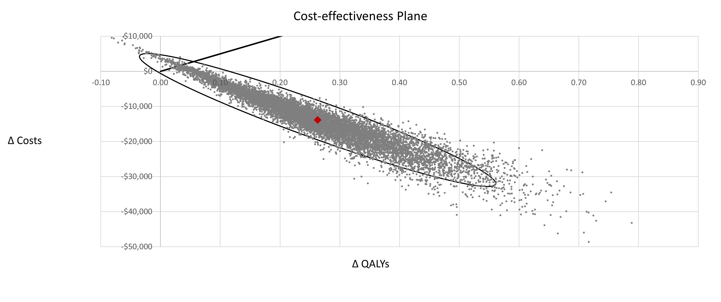
Figure A1: Scatter diagram from the probabilistic sensitivity analysis (PSA) for the combined N0 population. The PSA was conducted using Monte Carlo simulation with 10,000 random draws from pre-defined probability distributions for all uncertain parameters. The ellipse represents the area which contains 95% of the simulated points. The line from the origin corresponds to the $100,000 per QALY willingness-to-pay threshold for cost-effectiveness set by ICER.
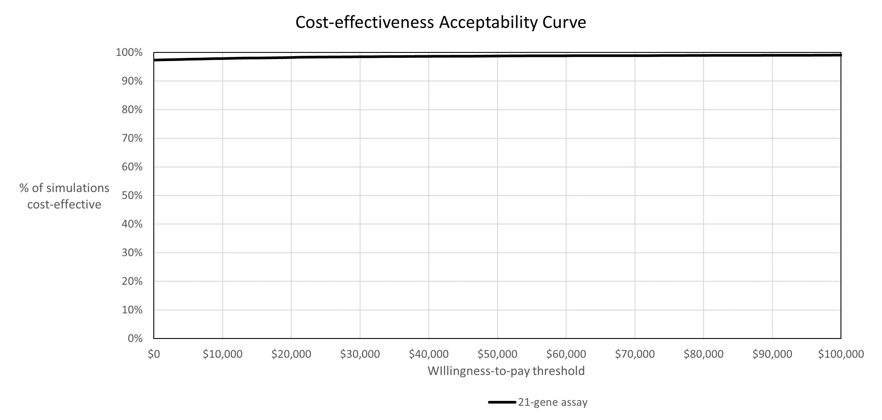
Figure A2: Cost-effectiveness acceptability curve for the combined N0 population. Acceptability curves plot the probability of cost-effectiveness of the Oncotype DX test based on a range of willingness-to-pay thresholds per QALY.
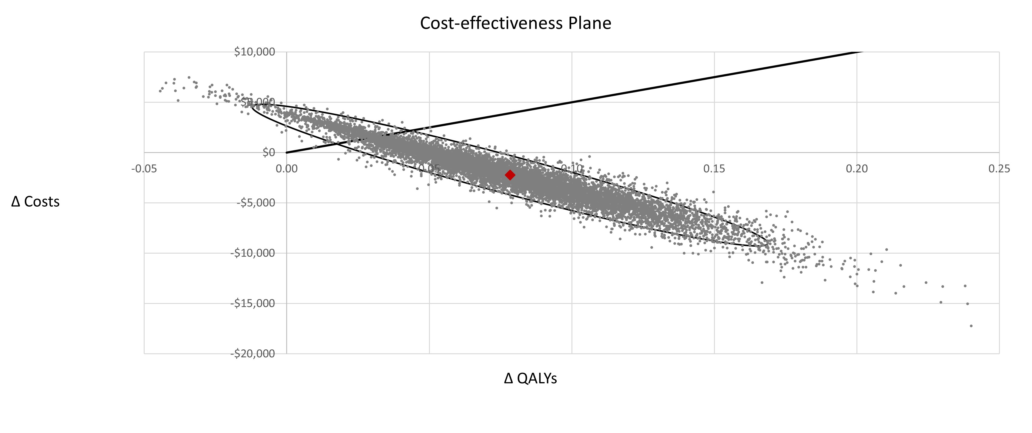
Figure A3: Scatter diagram from the probabilistic sensitivity analysis for the combined N1 population.
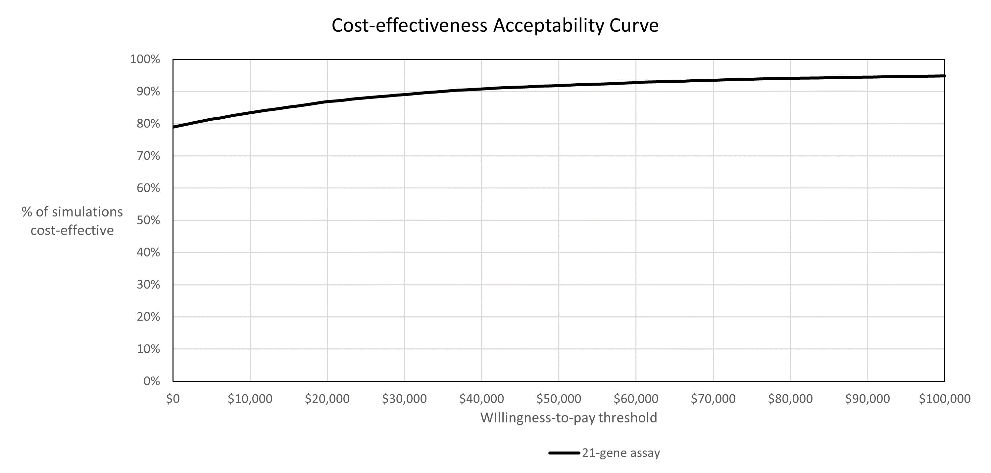
Figure A4: Cost-effectiveness acceptability curve for the combined N1 population.
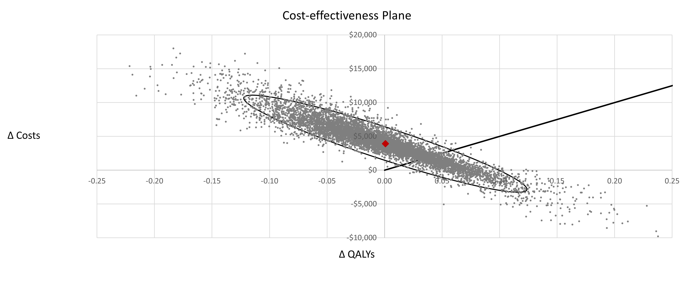
Figure A5: Scatter diagram from the probabilistic sensitivity analysis for the premenopausal N1 population
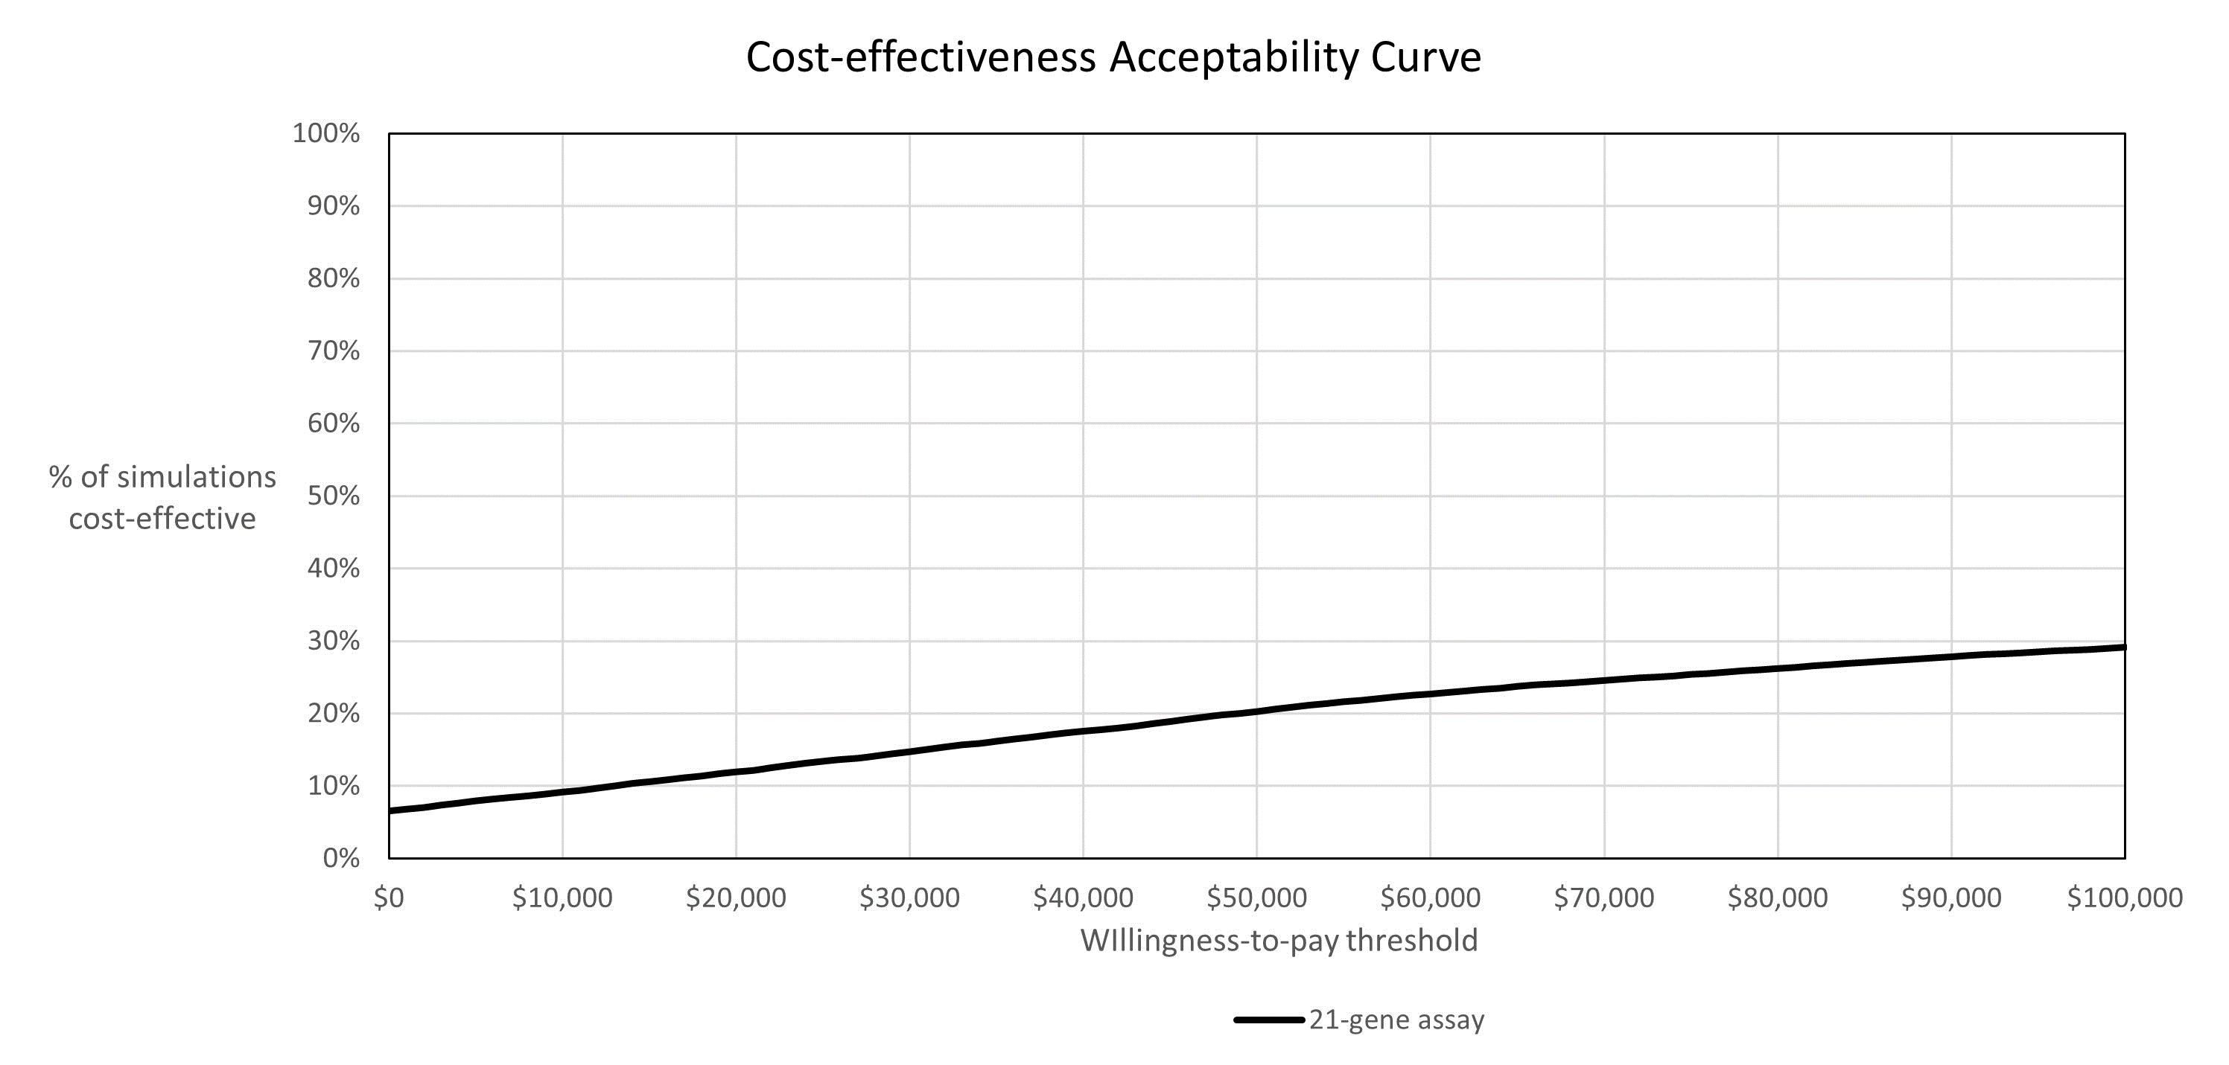
Figure A6: Cost-effectiveness acceptability curve for the premenopausal N1 population.
Table S30. CHEERS checklist
Section/item | Item no. | Recommendation | Reported on p. no./line no.
Title and abstract
Title | 1 | Identify the study as an economic evaluation and describe the interventions being compared | Title page
Abstract | 2 | Provide a structured summary that highlights context, key methods, results, and alternative analyses | Page 1-2
Introduction
Background and objectives | 3 | Give the context for the study, the study question, and its practical relevance for decision making in policy or practice | Page 3-4, lines 37-67
Methods
Health economic analysis plan | 4 | Indicate whether a health economic analysis plan was developed and where available | A health economic analysis plan was not developed
Study population | 5 | Describe characteristics of the study population (such as age range, demographics, socioeconomic, or clinical characteristics) | Page 4-5, lines 70-79  Subgroups: page 4-5, lines 79-83
Setting and location | 6 | Provide relevant contextual information that may influence findings | Page 5, lines 90-96
Comparators | 7 | Describe the interventions or strategies being compared and why chosen | Page 4, lines 64-67
Perspective | 8 | State the perspective(s) adopted by the study and why chosen | Page 5, lines 90-94
Time horizon | 9 | State the horizon for the study and why appropriate | Page 5, line 90
Discount rate | 10 | Report the discount rate(s) and reason chosen | Page 5, line 95
Selection of outcomes | 11 | Describe what outcomes were used as the measure(s) of benefit(s) and harm(s) | Page 7-8, lines 154-169
Measurement of effectiveness | 12 | Describe how outcomes used to capture benefit(s) and harm(s) were measured | Page 8, lines 172-174
Valuation of outcomes | 13 | Describe the population and methods used to measure and value outcomes | Utility values obtained from literature: page 7, lines 155-159, Supplementary file p.6, Supplementary table S9
Measurement and valuation of resources and costs | 14 | Describe how costs were valued | Page 8, lines 160-169  Supplementary file p.6, Supplementary tables S3-S8
Currency, price date, and conversion | 15 | Report the dates of the estimated resource quantities and unit costs, plus the currency and year of conversion. | Page 8, lines 168
Rationale and description of model | 16 | If modelling is used, describe in detail and why used. Report if the model is publicly available and where it can accessed | Page 5, lines 85-90  Figures 1 and 2
Analytics and assumptions | 17 | Describe any methods for analysing or statistically transforming data, any extrapolation methods, and approaches for validating any model used | Extrapolation: page 5, lines 87-90, pages 6-7, lines 127-147  Validation: page 8, lines 179-181 and supplementary file pp. 31-33, Tables S28 & S29
Characterising heterogeneity | 18 | Describe any methods used for estimating how the results of the study vary for subgroups | Page 4-5 lines 79-83
Characterising distributional effects | 19 | Describe how impacts are distributed across different individuals or adjustments made to reflect priority populations | Subgroups considered: page 4-5 lines 79-83
Characterising uncertainty | 20 | Describe methods to characterise any sources of uncertainty in the analysis | Page 8: lines 177-179  Page 10: lines 217-224  Supplementary file page 33, lines 185-190, page 34 lines 192-194
Approach to engagement with patients and others affected by the study | 21 | Describe any approaches to engage patients or service recipients, the general public, communities, or stakeholders (such as clinicians or payers) in the design of the study | No patients or service recipients were engaged in the design of this study. Clinical experts were engaged to inform model inputs as reported in pages 1-2 of the Online supplement and results in supplementary table S1
Results
Study parameters | 22 | Report all analytic inputs (such as values, ranges, references) including uncertainty or distributional assumptions | Supplementary table S9
Summary of main results | 23 | Report the mean values for the main categories of costs and outcomes of interest and summarise them in the most appropriate overall measure | Page 9: lines 186-200  Table 2, Table 3, Table 4, Table 5
Effect of uncertainty | 24 | Describe how uncertainty about analytic judgments, inputs, or projections affect findings. Report the effect of choice of discount rate and time horizon, if applicable | Page 10: lines 205-215  Pages 10-11: lines 228-240  Figure 3, Figure 4  Supplementary figures A1-A6  supplementary table S11, S12
Effect of engagement with patients and others affected by the study | 25 | Report on any difference patient/service recipient, general public, community, or stakeholder involvement made to the approach and findings of the study | Sensitivity and scenario analyses to test uncertainty from inputs derived from the clinical expert survey: Page 11: lines 236-240  Figure 3, Figure 4  supplementary table S11, S12
Discussion
Study findings, limitations, generalisability, and current knowledge | 26 | Report key findings, limitations, ethical or equity considerations not captured, and how these could affect patients, policy, or practice | Pages 11-17, lines 247-384
Other
Source of funding | 27 | Describe how the study was funded and any role of the funder in the identification, design, conduct, and reporting of the analysis | Page 18, lines 386-388
Conflicts of interest | 28 | Report authors conflicts of interest according to journal or International Committee of Medical Journal Editors requirements | Page 18, lines 389-396

References
1. Sparano JA, Gray RJ, Ravdin PM, et al. Clinical and Genomic Risk to Guide the Use of Adjuvant Therapy for Breast Cancer. N Engl J Med. 2019;380(25):2395-2405. doi:10.1056/NEJMOA1904819/SUPPL_FILE/NEJMOA1904819_DATA-SHARING.PDF
2. Sparano JA, Gray RJ, Ravdin PM, et al. Clinical and Genomic Risk to Guide the Use of Adjuvant Therapy for Breast Cancer. N Engl J Med. 2019;380(25):2395-2405. doi:10.1056/NEJMOA1904819
3. Kalinsky K, Barlow WE, Gralow JR, et al. 21-Gene Assay to Inform Chemotherapy Benefit in Node-Positive Breast Cancer. N Engl J Med. 2021;385(25):2336-2347. doi:10.1056/NEJMOA2108873/SUPPL_FILE/NEJMOA2108873_DATA-SHARING.PDF
4. Petkov VI, Miller DP, Howlader N, et al. Breast-cancer-specific mortality in patients treated based on the 21-gene assay: A SEER population-based study. npj Breast Cancer. 2016;2(1). doi:10.1038/npjbcancer.2016.17
5. Choi IS, Jung J, Kim BH, et al. The 21-Gene Recurrence Score Assay and Prediction of Chemotherapy Benefit: A Propensity Score-Matched Analysis of the SEER Database. Cancers (Basel). 2020;12(7):1829. doi:10.3390/cancers12071829
6. Roberts MC, Miller DP, Shak S, Petkov VI. Breast cancer-specific survival in patients with lymph node-positive hormone receptor-positive invasive breast cancer and Oncotype DX Recurrence Score results in the SEER database. Breast Cancer Res Treat. 2017;163(2):303-310. doi:10.1007/s10549-017-4162-3
7. Rashmi Kumar N, Burns J, Abraham J, et al. NCCN Guidelines Version 1.2022 Breast Cancer. Published online 2021. Accessed November 28, 2021. https://www.
8. Lidgren M, Wilking N, Jönsson B, Rehnberg C. Health related quality of life in different states of breast cancer. Qual Life Res. 2007;16(6):1073-1081. doi:10.1007/s11136-007-9202-8
9. Campbell HE, Epstein D, Bloomfield D, et al. The cost-effectiveness of adjuvant chemotherapy for early breast cancer: A comparison of no chemotherapy and first, second, and third generation regimens for patients with differing prognoses. Eur J Cancer. 2011;47(17):2517-2530. doi:10.1016/j.ejca.2011.06.019
10. National Institute for Health and Care Excellence. Azacitidine for the Treatment of Myelodysplastic Syndromes, Chronic Myelomonocytic Leukaemia and Acute Myeloid Leukaemia.; 2011.
11. Berdunov V, Carter GC, Laws E, et al. HSR22-129: The Cost of Treatment of HR+/HER2- Early Breast Cancer and Implications for the Cost-Effectiveness of Multigene Assays in the US. J Natl Compr Cancer Netw. 2022;20(3.5):HSR22-129. doi:10.6004/JNCCN.2021.7241
12. Wang SY, Chen T, Dang W, Mougalian SS, Evans SB, Gross CP. Incorporating Tumor Characteristics to Maximize 21-Gene Assay Utility: A Cost-Effectiveness Analysis. J Natl Compr Canc Netw. 2019;17(1):39-46. doi:10.6004/JNCCN.2018.7077
13. Giordano SH, Niu J, Chavez-MacGregor M, et al. Estimating regimen-specific costs of chemotherapy for breast cancer: Observational cohort study. Cancer. 2016;122(22):3447-3455. doi:10.1002/CNCR.30274
14. Bradley CJ, Oberst K, Schenk M. Absenteeism from work: the experience of employed breast and prostate cancer patients in the months following diagnosis. Psychooncology. 2006;15(8):739-747. doi:10.1002/PON.1016
15. U.S. Department of Labor. Bureau of Labour Statistics New Release, January 19, 2022. Median weekly earnings. Published 2021. https://www.bls.gov/news.release/pdf/wkyeng.pdf

