Supplement martials
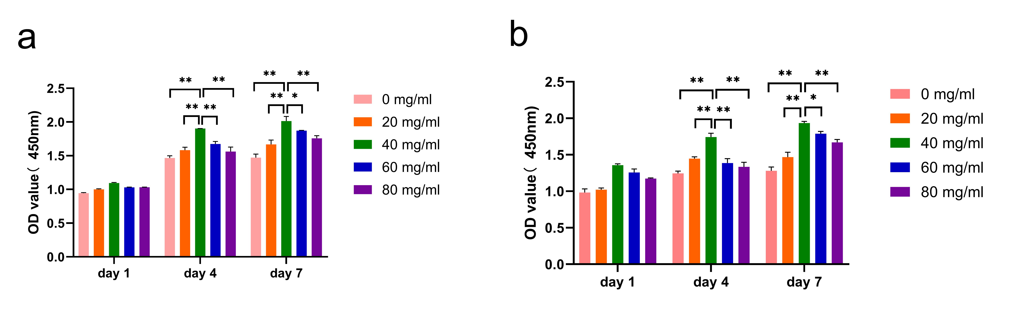
Figure s1. cytotoxicity of different concentration of MT@PLGA NPs contained in scaffolds towards (a) MC3T3-E1 cells and (b) bEnd.3 cells in vitro. n=3; *p < 0.05, **p < 0.01.
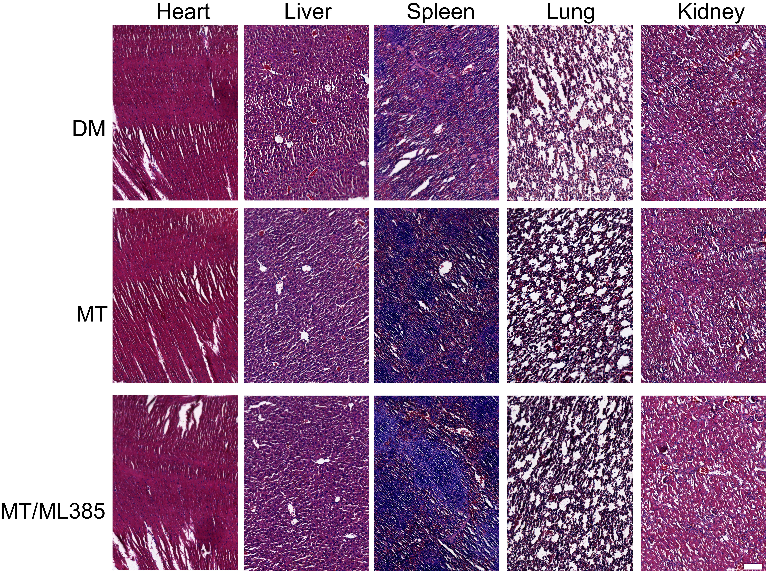

Figure s2. Evaluation of the safety profile in vivo. Hematoxylin and eosin (H&E) staining was used to determine the presence of injury in the heart, liver, spleen, lung and kidney after implantation of MT nanocomposite scaffold and injection of ML385. Scale bar: 100 µm.
Table s1. Primer sequences used in RT-qPCR
Gene | Forward primer sequence (5’-3’) | Reverse primer sequence (3’-5’)
Col1a1 | GCTCAGAGGCGAAGGCAACAG | GATGGGCAGGCGGGAGGTC
OPN | TGACGATGATGATGACGATGGAGAC | TGTAGGGACGATTGGAGTGAAAGTG
BMP-2 | GCCAAACACAAACAGCGGAAGC | GGTGCCACGATCCAGTCATTCC
OSX | TACGGCAAGGCTTCGCATCTG | AGCAGGCAGGTGAACTTCTTCTC
Runx2 | TCCCAGGCAGGCACAGTCTTC | AGCGGCGTGGTGGAGTGG
ALP | CACGGCGTCCATGAGCAGAAC | CAGGCACAGTGGTCAAGGTTGG
CD31 | TAGCAAGAAGCAGGAAGGACAGTAC | CCAATGACAACCACCGCAATGAG
Ang1 | TTCGTGCTGGGTCTGGTTGTG | TTGGCGTCATGGTGCTGAGTC
Ang2 | TCACTTCCAGGTCACCACTTGC | GGACAGGCCAGCCATTCTCAC
VEGF | CCACGACAGAAGGAGAGCAGAAG | GGTCTCAATCGGACGGCAGTAG
CAT | GGAGGCGGGAACCCAATAGGAG | TGTCAAAGTGTGCCATCTCGTCAG
SOD2 | TCCCAGACCTGCCTTACGACTATG | CTCCTCGGTGGCGTTGAGATTG
Nrf2 | CAACCCGAAGCACGCTGAAGG | GGACGCTCGGCTGGGACTC
FGFr3 | GGTGGTCATGGCAGAAGCTATTGG | CAGGTCCTTGTCAGTCGCATCATC
HO-1 | ACCGCCTTCCTGCTCAACATTG | CCTCTGACGAAGTGACGCCATC
SOD3 | TTCTTGTTCTACGGCTTGCTACTGG | CGTGTCGCCTATCTTCTCAACCAG
Wnt11 | AACTACCTGCTTGACCTGGAGAGAG | GGCGATGGTGTGACTGATGGTG
Col9a1 | GAGCCAGGAAGACAAGGACACA | CCAACTATGCCAGTGATGCCTCTC
Keap1 | TGGTCGCCCTGTGCCTCTATG | ATGCCACTCGTCCCGCTCTG
GADPH | GCGGG CGCTG GAGGA GAA | GGATC TTCAT GAGGT AGTCA GTC

