Table S1. Summary of province-specific study dates, databases, and algorithms used to identify cases of pediatric-onset inflammatory bowel disease and gastroenterologists.
 | Alberta | Manitoba | Nova Scotia | Ontario
Study Dates
IBD diagnosisª | April 1, 2005-March 31, 2015 | April 1, 1999-March 31, 2010 | April 1, 1999-March 31, 2011 | April 1, 1999-March 31, 2011
Follow-upª | April 1, 2005-March 31, 2017 | April 1, 1999-March 31, 2013 | April 1, 1999-March 31, 2011 | April 1, 1994-March 31, 2013
Datasets
Registry of all provincial residents eligible for universal healthcare coverage | Patient Registry | Manitoba Health Registry | Patient Registry | Registered Persons Database
Outpatient physician claims | Ambulatory Care Classification System | Manitoba Health Physicians Claims | MSI Physician Claims | OHIP Physician Claims
Hospitalizations | Discharge Abstract Database (CIHI) | Discharge Abstract Database (CIHI) | Discharge Abstract Database (CIHI) | Discharge Abstract Database (CIHI)
Date of switch from ICD-9/CCP to ICD-10/CCI coding in hospitalization data | April 1, 2002 | April 1, 2004 | April 1, 2001 | April 1, 2002
Emergency department visits | National Ambulatory Care Reporting System (CIHI) | n/a | n/a | ERCLAIMS (OHIP emergency department physician claims), National Ambulatory Care Reporting System (CIHI)
Outpatient endoscopy | Alberta Ambulatory Care Reporting System (AACRS), National Ambulatory Care Reporting System (NACRS) | Discharge Abstract Database (CIHI) | Discharge Abstract Database (CIHI) | Same Day Surgery (CIHI)
Maximum number of digits for diagnostic codes | Outpatient: 4  ED visits: 7  Hospitalization:  - ICD-10: 7 | Outpatient: 3  ED visits: n/a  Hospitalization:  - ICD-9: 5  - ICD-10: 7 | Outpatient: 5  ED visits: 7  Hospitalization:  - ICD-9: 5  ICD-10: 7 | Outpatient: 3  ED visits:  - ERCLAIMS: 3  - NACRS: 6  Hospitalization:  - ICD-9: 4  - ICD-10: 7
Identification of IBD Cases
Algorithm | 2 hospitalizations, 4 outpatient visits, or 2 ambulatory care contacts (eg emergency department visits, day surgeries and procedures) within 2 years | 5 outpatient visits or hospitalizations | Scoped: 4 outpatient visits or 2 hospitalizations  Not scoped: 7 outpatient visits or 3 hospitalizations | Scoped: 4 outpatient visits or 2 hospitalizations  Not scoped: 7 outpatient visits or 3 hospitalizations
Accuracy^{b} | Sensitivity 83.4%  Specificity 99.8%  PPV 97.4%  NPV 98.5% | Sensitivity 74.4-89.2%  Specificity 89.8-93.7% | Sensitivity 90.0%  Specificity 91.6%  PPV 65.3% | Sensitivity 89.6-91.1%  Specificity 99.5-100%  PPV 59.2-75.2%  NPV >99.9%
Reference for study validating algorithms | Rezaie 2012¹ | Bernstein 1999² | Development (Ontario): Benchimol 2009³  Validation (Nova Scotia): Otley 2018⁴ | Benchimol 2009³
Differentiation between CD and UC | Scoring system based on the number of CD and UC-specific codes:  UC: ‘greater than +2’  CD: ‘less than -2’  IBDU: ‘between -2 and +2’ | 5 of last 9 outpatient contacts | 5 of last 7 outpatient contacts | 5 of last 7 outpatient contacts
Identification of Gastroenterologists^{c}
Pediatric | n/a | Pediatricians with ≥5 colonoscopies in individuals <18 years of age | (1) Certified in pediatric gastroenterology or (2) certified as general pediatrician with >5 billing codes for endoscopy in a single year | (1) Certified in pediatric gastroenterology or (2) certified as general pediatrician with >5 billing codes for endoscopy in a single year
Adult | n/a | Billed as internal medicine with specialist in gastroenterology | (1) Certified in gastroenterology or (2) certified in internal medicine with ≥50 billing codes for endoscopy in a single year | (1) Certified in gastroenterology or (2) certified in internal medicine with ≥50 billing codes for endoscopy in a single year
Pediatric Tertiary-Care Centres
List of Centres | Alberta Children’s Hospital (Calgary); Stollery Children’s Hospital (Edmonton) | Health Sciences Centre (Winnipeg) | IWK Health Centre (Halifax) | Children’s Hospital at London Health Sciences Centre (London); Children’s Hospital of Eastern Ontario (Ottawa); McMaster Children’s Hospital (Hamilton); The Hospital for Sick Children (Toronto)
Definition of Sociodemographic Characteristics
Income quintile | Neighbourhood income quintile, adjusted per-person equivalent | Neighbourhood income quintile | Neighbourhood income quintile within a Census Metropolitan Area or Census Agglomeration | Neighbourhood income quintile before tax within a Census Metropolitan Area or Census Agglomeration
Rural/urban residence location | Urban residences include those in urban, metropolitan, or metropolitan-influenced regions; residences in all other regions are considered rural | Urban residences are those inside Census Metropolitan Areas for Census Agglomerations; residences in all other regions are rural | Rural residences include those in communities with a population <10,000 or in rural areas; residences in all other regions are considered urban⁵ | Rurality Index for Ontario (RIO) score
Abbreviations: CD, Crohn’s disease; CCI, Canadian Classification of Health Interventions; CCP, Canadian Classification of Diagnostic, Therapeutic, and Surgical Procedures; CIHI, Canadian Institute for Health Information; IBDU, inflammatory bowel disease type unclassified; ICD, International Classification of Diseases; MSI, Medical Services Insurance; NPV, negative predictive value; OHIP, Ontario health insurance plan; PPV, positive predictive value; UC, ulcerative colitis
ªThe end of the study (follow-up) extended beyond the last date for incident cases to be eligible for inclusion in the study to ensure cases were followed sufficiently long to meet the time requirements required by provincial algorithms
^{b}Range of values correspond to algorithm accuracy in development and validation cohorts
^{c}Physicians not meeting the minimum number of colonoscopies in a given year but did complete them in the year before or after were still considered gastroenterologists to allow for leaves of absence

Table S2. List of diagnostic codes used to identify IBD-specific and IBD-related health care encounters.
Description | ICD-9 Codeª | OHIP Code | ICD-10 Codeª
IBD-specific
Crohn's disease | 555.x | 555 | K50.x
Ulcerative colitis | 556.x | 556 | K51.x
IBD-related
Signs and Symptoms
Anorexia | 7830 | 787 | R63.0x
Abnormal Weight Gain | 783.1 |  | R63.5x
Abnormal Weight Loss | 783.2 |  | R63.4x
Lack of expected normal physiological development | 783.4 |  | R62.8x, R62.9x
Symptoms involving digestive system, including: (787.0) Nausea and vomiting; (787.1) Heartburn; (787.2) Dysphagia; (787.3) Gas/bloating; (787.6) Encopresis, fecal incontinence; (787.9) Other symptoms involving digestive system | 787..0, 787.1, 787.2, 787.3, 787.6, 787.9 | 787 | R11.x, R12.x, R13.x, R14.x, R15.x, R19.x
Abdominal pain | 789.0, 789.6, 789.9 | 787, 789 | R10.x
Dyspepsia | 536.8 | 536 | K30
Cachexia | 799.4 |  | R64
Esophagitis | 530.1 | 530 | K20, K21.x
Ulcer of esophagus | 5302 |  | K22.1x
Gastric ulcer | 531.x | 531 | K25.x
Duodenal ulcer | 532.x | 532 | K26.x
Peptic ulcer | 533.x |  | K27.x
GJ ulcer | 534.x | 534 | K28.x
Gastritis/duodenitis | 535.x | 535 | K29.x
Intestinal obstruction | 560.8  560.9 | 560 | K31.5x  K56.6x
Rectal/anal hemorrhage | 569.3 | 569 | K62.5x
Other disorder of rectum/anus, including: ulcer; pain, sphincter tear (healed); dysplasia; other specified, including proctitis, inflamm. | 569.4 | 569 | K62.6x, K62.8x
Abscess of the intestine | 569.5 | 569 | K63.0
Other disorders of intestine, including: fistula (excl rectum); ulcer of intestine; perforation; angiodysplasia, no hemorrhage; angiodysplasia, with hemorrhage; dieulafoy; and other (including enteroptosis, granuloma of intestine, prolapse of intestine, pericolitis, perisigmoiditis, visceroptosis) | 569.8 | 569 | K63.2, K63.3, K63.1, K552.x, K638.x
Malabsorption | 262, 263.0, 263.1, 263.2, 263.9, 579.8, 579.9 | 579 | E43, E44.0x, E44.1x, E45, E46, K90.8x, K90.9x
Anal Fistula | 565.1 | 565 | K60.3x
Anal Abscess | 566 | 566 | K610x, K611x, K612x, K613x, K614x
Ureteral Fistula | 593.8 |  | N288.1x, N288.8x
Urethral Fistula | 599.1 |  | N36.0x
Fistula of stomach & duodenum | 537.4 |  | K31.6x
Vesical fistula | 596.2 |  | N32.2x
Fistula involving female GU | 619.x |  | N82.x
Hemorrhoids, including: (455.9) Anal skin tags | 455.x | 455 | I84.x
Non-infective gastroenteritis and colitis | 558.9 |  | K529.x
Extra-Intestinal Manifestations
Rheumatoid arthritis | 713.1, 714.x, 716.4, 716.5, 716.6, 716.7, 716.8, 716.9 | 714 | M050x, M052x, M053x, M058x, M059x, M060x, M061x, M062x, M064x, M068x  M069x, M070x, M074x, M075x, M076x, M080x, M081x, M082x, M083x, M084x, M088x, M089x, M090x, M091x, M092x, M098x, M130x, M131x, M139x
Arthropathy associated GI cause | 713.3 |  | M074x, M076x, M075x
Inflammatory spondylopathies, including: (720.0) Ankylosing spondylitis; (720.1) Spinal enthesopathy; (720.2) Sacroiliitis; (720.8) Other inflammatory; (720.9) Other unspecified inflammatory | 720.x | 720 | M45.x, M46.x
Scleritis & episcleritis | 379.0 | 379 | H15.x
Unspecified iridocyclitis (uveitis NOS) | 364.3 | 364 | H20.9x
Chorioretinitis, unspecified (uveitis, posterior NOS) | 363.2 | 363 | H30.9x
Acute and subacute iridocyclitis | 364 | 364 | H20.0x
Erythema nodosum | 695.2 | 695 | L52
Pyoderma | 6860 | 686 | L08.0x
Pyogenic granuloma of the skin and soft tissue | 686.1 | 686 | L98.0x
Oral aphthae | 528.2 | 528 | K12.0x
Short stature | 783.4 |  | E34.3x
Osteoporosis | 7330.x, 7331 | 733 | M80.x, M81.x, M82.x, M83.x
Osteomyelitis | 730, 730.0, 730.1, 730.2 | 730 | M86.x
Acute glomerulonephritis | 580.x | 580 | N00.x
Nephrolithiasis | 592.x | 592 | N20.x
Primary Sclerosing Cholangitis | 576.1 | 576 | K83.0x
Venous embolism/thrombosis | 453.x |  | I82.x
ªCodes ending in ‘.x’ are inclusive of all sub-codes of the 3-digit code. For example, K50.x includes K50.0 (Crohn’s disease of the small intestine), K50.1 (Crohn’s disease of the large intestine), K50.8 (Crohn’s disease of both the small and large intestine), and K50.9 (Crohn’s disease, unspecified). Codes without a ‘.x’ are only included if the diagnostic code matches the specified 3-digit code.
Abbreviations: ICD, International Classification of Diseases; NOS, not otherwise specified; OHIP, Ontario Health Insurance Plan

Table S3. Procedural codes for endoscopy, intestinal resection, and colectomy.
Procedure | CCI Codes | CCP Codes
Endoscopy | 2NK70BABJ, 2NK70BNBJ, 2NK71BABJ, 2NK71BRBJ, 2NM70BA, 2NM70BABG, 2NM70BABH, 2NM70BABJ, 2NM70BN, 2NM70BNBG, 2NM70BNBH, 2NM70BNBJ, 2NM71BA, 2NM71BABG, 2NM71BABH, 2NM71BABJ, 2NM71BR, 2NM71BRBG, 2NM71BRBH, 2NM71BRBJ | 011.6, 012.0, 012.2, 012.4, 579.1, 579.3
Intestinal resection (small and/or large bowel)⁶ | 1NK87, 1NM87, 1NM89, 1NQ87, 1NQ89, 1NQ90ª, INM91^{b} | 574.1, 574.2, 574.3, 575, 575.1, 575.2, 575.3, 575.4, 575.5, 575.6, 575.9, 576
Colectomy⁷ | 1NM89, 1NM89, 1NQ89, INQ90, 1NM91 | 575, 575.1, 575.2, 575.3, 575.4, 575.5, 575.6, 575.9, 576
Abbreviations: CCI, Canadian Classification of Health Interventions; CCP, Canadian Classification of Diagnostic, Therapeutic, and Surgical Procedures
ªWas not included in validation algorithm but was used prior to 2006 and was replaced by 1NQ89
^{b}Was not included in the Crohn’s disease validation algorithm but was included in the ulcerative colitis validation algorithm

Table S4. List of diagnostic codes suggestive of a future inflammatory bowel disease diagnosis. Used to calculate diagnostic delay. Codes were identified from a survey of IBD specialists as being indicative of a future diagnosis of pediatric-onset IBD: codes with a mean rating ≥4 on a 5-point Likert scale were included.
More likely Crohn’s disease codes
Outpatient codes
ICD-9/OHIP Code |  | Description | Mean Rating on Survey
Codes with look back period as long as possible given data availability
560, 560.8xª, 560.9ª |  | Intestinal obstruction | 4.18
565, 565.1ª |  | Anal fistula | 4.91
566.x |  | Anal abscess | 4.91
569.4xª |  | Other specified disorders of rectum and anus | 4.36
569.5ª |  | Abscess of intestine | 4.36
569.8xª |  | Other specified disorders of intestine | 4.36
576^{b}, 576.1ª |  | Primary sclerosing cholangitis | 4.55
579.8ª |  | Other specified intestinal malabsorption | 4.09
579.9ª |  | Unspecified intestinal malabsorption | 4.09
686, 686.0xª |  | Pyoderma, pyoderma granuloma of the skin and soft tissue | 4.27
695, 695.2ª |  | Erythema nodosum | 4.55
Codes with look back of 1 year prior to diagnosis
280.x |  | Anemia, iron deficiency | Write-in
569, 569.3ª |  | Rectal/anal hemorrhage, Other disorder of rectum/anus (including: ulcer, pain, sphincter tear (healed), dysplasia, other specified including proctitis, inflammation), abscess of the intestine, Other disorders of intestine (including: fistula (excluding rectum), ulcer of intestine, perforation, angiodysplasia (no haemorrhage), angiodysplasia (with haemorrhage), Dieulafoy, enteroptosis, granuloma of intestine, prolapse of intestine, pericolitis, perisigmoiditis, visceroptosis) | 4.36
579 |  | Malabsorption | 4.09
787^{b}, 787.9xª, 789^{b}, 789.0xª |  | Anorexia, abdominal pain, Symptoms involving digestive system (including: nausea and vomiting, Nausea alone, vomiting alone, heartburn, dysphagia, gas/bloating, encopresis, fecal incontinence diarrhea NOS (not infectious)) | 4.27
Emergency Department and Hospitalization Codes
ICD-9 Code | ICD-10 Code | Description | Average Rating
Codes with look back period as long as possible given data availability
262.x, 263.0, 263.1, 263.2, 263.8, 263.9, 579.8, 579.9, | E43, E44.x, E45, E46, K90.8, K90.9 | Malabsorption and malnutrition | 4.36
535.x | K29.x | Gastritis/duodenitis | 4
537.4 | K31.6 | Fistula of the stomach and duodenum | 4.64
560.8x, 560.9 | K31.5, K56.6 | Intestinal obstruction | 4.73
565.1 | K60.3 | Anal fistula | 5
569.4x | K62.6 | Ulcer of the rectum/anus | 4.7
569.4x | K62.8 | Other unspecified disorder of rectum/anus (including: proctitis, inflammation) | 4.27
569.5 | K63.0 | Abscess of the intestine | 5
569.8x | K63.2 | Fistula of intestine (excluding rectum) | 4.91
569.8x | K63.3 | Ulcer of intestine | 4.73
569.8x | K63.1 | Perforation of intestine (non-traumatic) | 4.45
686.0x | L08.0 | Pyoderma | 4.27
695.2 | L52 | Erythema nodosum | 4.36
Codes with look back of 3 years prior to diagnosis
783.4x, 783.7 | R62.8, R62.9 | Failure to thrive^{c} | 4
787.4x | E34.3 | Short stature - 3 years prior to diagnosis^{d} | 4
Codes with look back of 1 year prior to diagnosis
582.2x | K12.0 | Oral apthae | 4.09
569.3 | K62.5 | Rectal/anal hemorrhage | 4.18
783.0 | R63.0 | Anorexia | 4.09
783.2 | R63.4 | Abnormal weight loss | 4.4
783.22 | R62.8 | Underweight; failure to thrive | 4.45
789.0x | R10.x | Abdominal pain | 4.27
799.4 | R64.x | Cachexia | 4.3
More likely ulcerative colitis codes
Outpatient Codes
ICD-9/OHIP Code |  | Description | Average Rating
Codes with look back period as long as possible given data availability
576^{b}, 576.1ª |  | Primary sclerosing cholangitis | 4.55
695, 695.2ª |  | Erythema nodosum | 4.27
Codes with look back of 1 year prior to diagnosis
280.x |  | Anemia, iron deficiency | Write-in
Emergency Department and Hospitalization Codes
ICD-9 Code | ICD-10 code | Description | Average Rating
Codes with look back period as long as possible given data availability
569.4x | K62.8 | Other unspecified disorder of rectum/anus (including: proctitis, inflammation) | 4
576.1 | K83.0 | Primary sclerosing cholangitis | 4.36
695.2 | L52 | Erythema nodosum | 4
Codes with look back of 6 months prior to diagnosis
569.3 | K62.5 | Rectal/anal hemorrhage | 4.5
783.2x | R63.4 | Abnormal weight loss | 4.09
787.9x | R19.4, R19.5 | Diarrhea NOS or change in bowel habit | 4.27
789.0x | R10.x | Abdominal pain | 4.09
Abbreviations: ICD, International Classification of Diseases; NOS, not otherwise specified; OHIP, Ontario Health Insurance Plan
ªUsed in provinces with 4- or 5-digit diagnostic codes
^{b}Used in provinces with 3-digit diagnostic codes
^{c}Failure to thrive in the year prior to diagnosis was identified as being associated with ‘more likely IBD’ with a rating of 4.45. However, failure to thrive in the three years prior to diagnosis was included instead because it also met criteria for inclusion and had a longer look back window.
^{d}Short stature in the year prior to diagnosis was identified as being associated with ‘more likely IBD’ with a rating of 4.45. However, short stature in the three years prior to diagnosis was included instead because it also met criteria for inclusion and had a longer look back window.
Figure S1. Pooled percentage of children with (A) IBD-specific and (B) IBD-related hospitalizations between six and 60 months following IBD diagnosis.
- IBD-specific
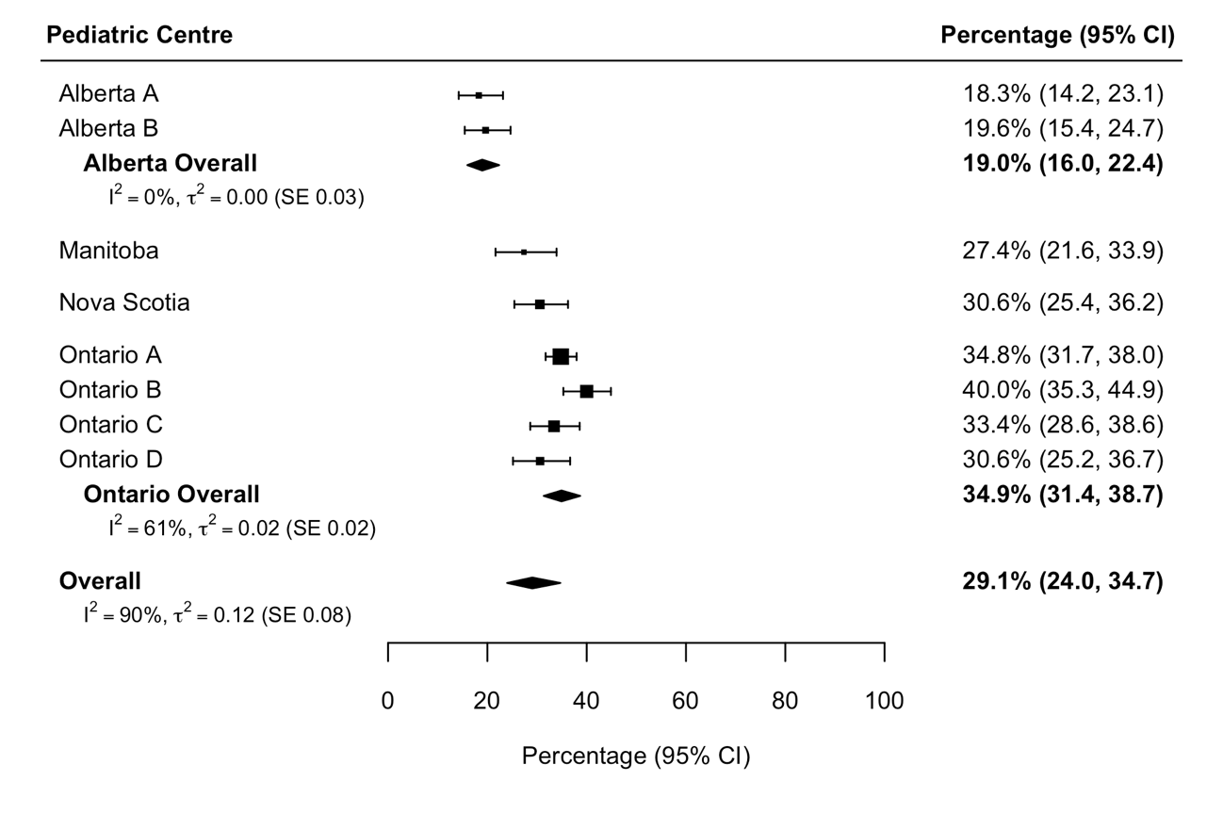
- IBD-related
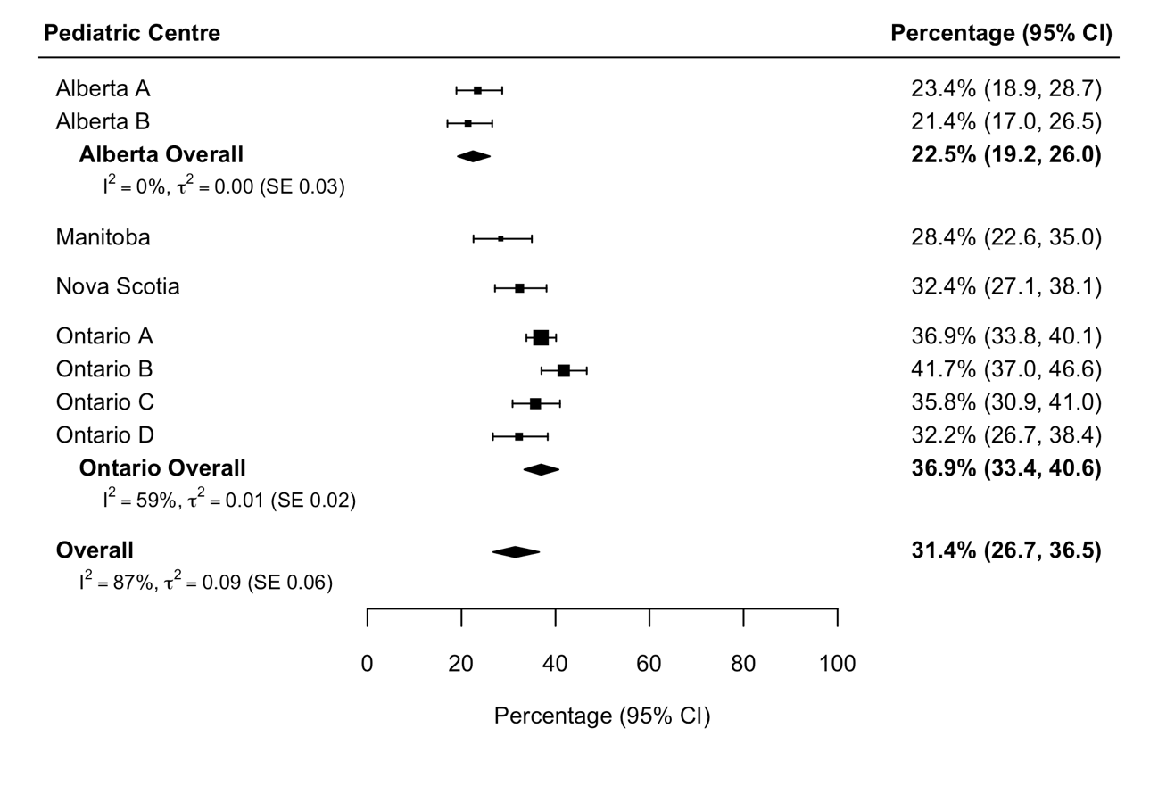
Figure S2. Scatterplots describing the associations between the likelihood of having ≥1 IBD-specific or IBD-related hospitalization in the time period spanning from six to 60 months after diagnosis and centre-level health services utilization at diagnosis.
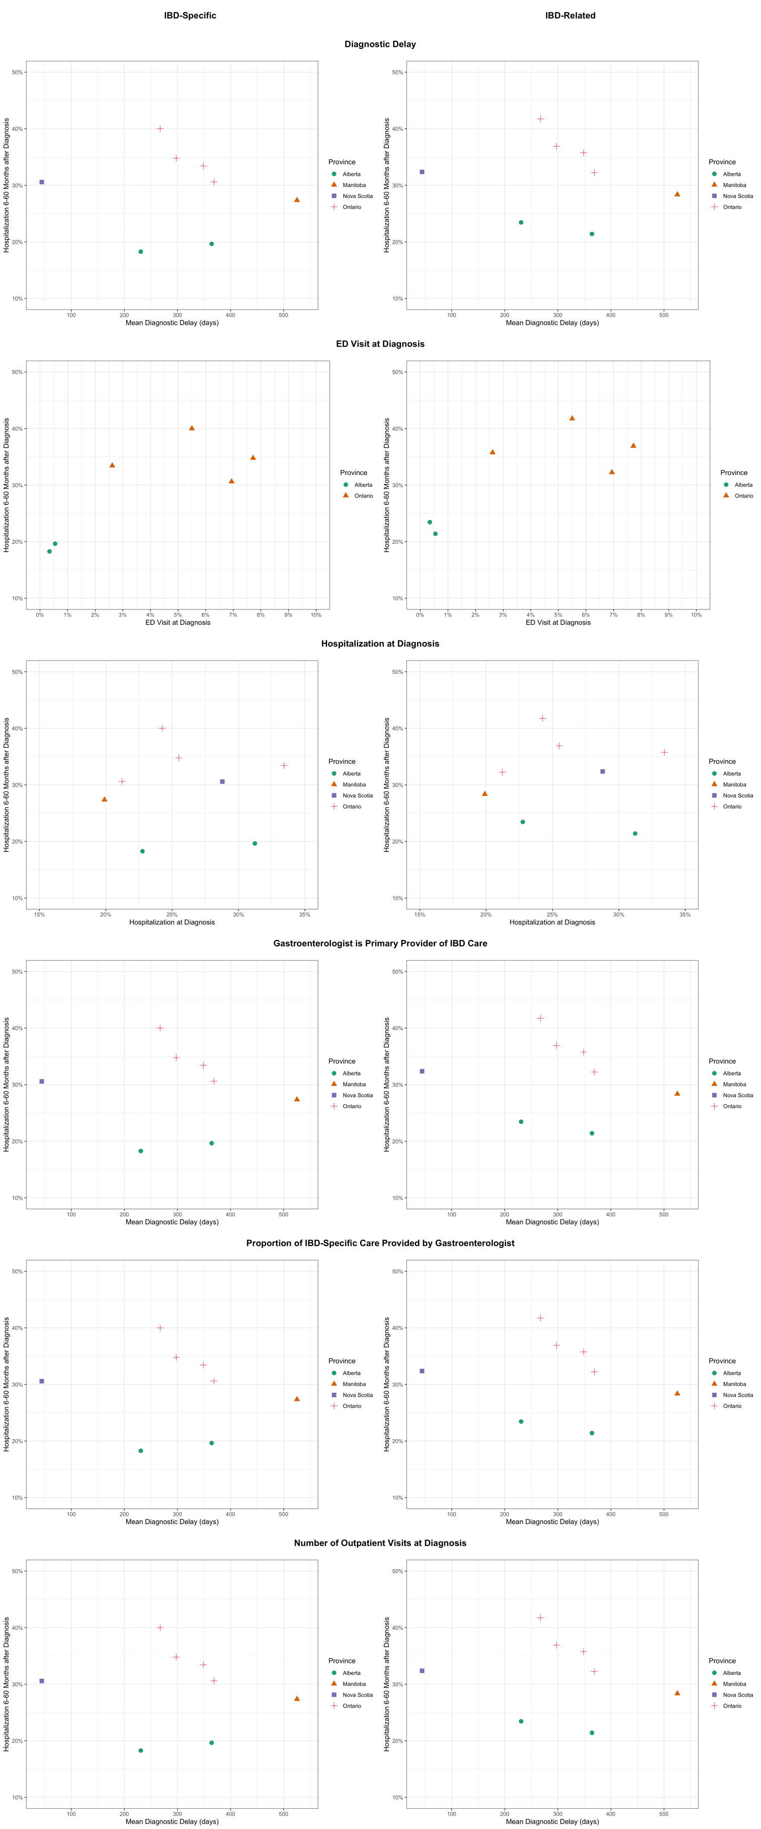
Figure S3. Pooled mean number of (A) IBD-specific and (B) IBD-related hospitalizations between six and 60 months following IBD diagnosis.
- IBD-specific
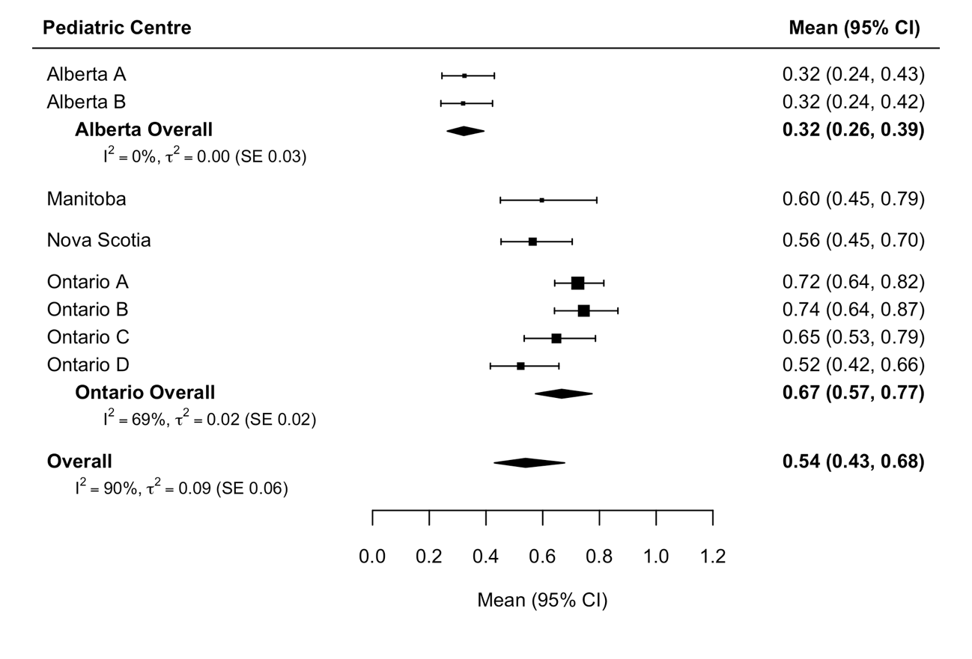
- IBD-related
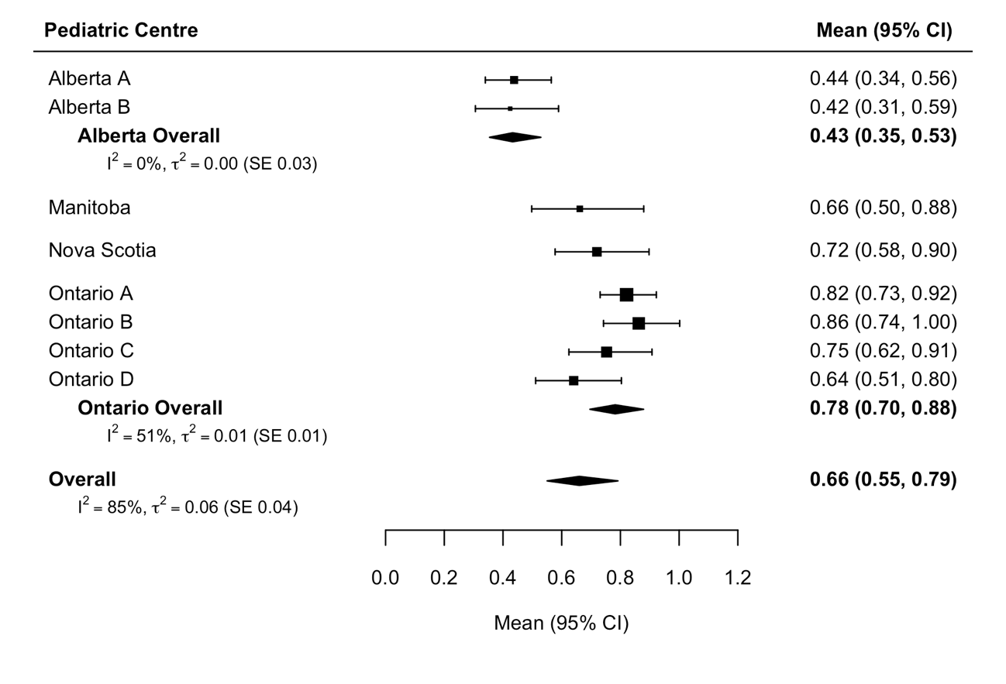
Figure S4. Scatterplots describing the associations between the frequency of IBD-specific or IBD-related hospitalizations in the time period spanning from six to 60 months after diagnosis and centre-level health services utilization at diagnosis.
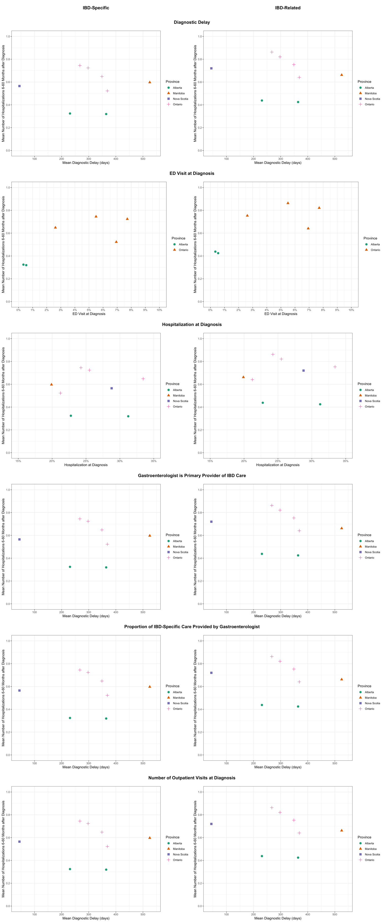
Figure S5. Pooled percentage of children with (A) IBD-specific and (B) IBD-related emergency department visits between six and 60 months following IBD diagnosis.
- IBD-specific
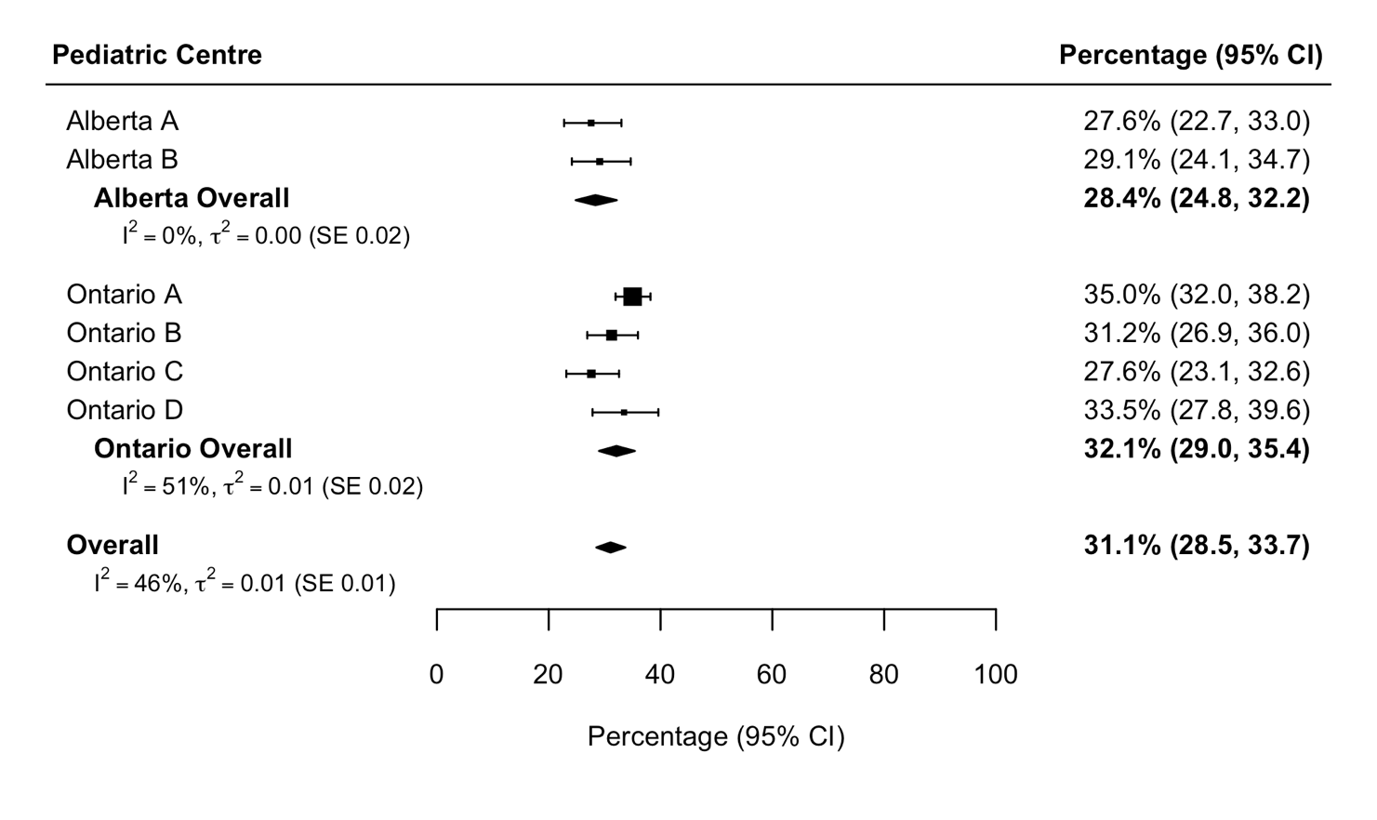
- IBD-related
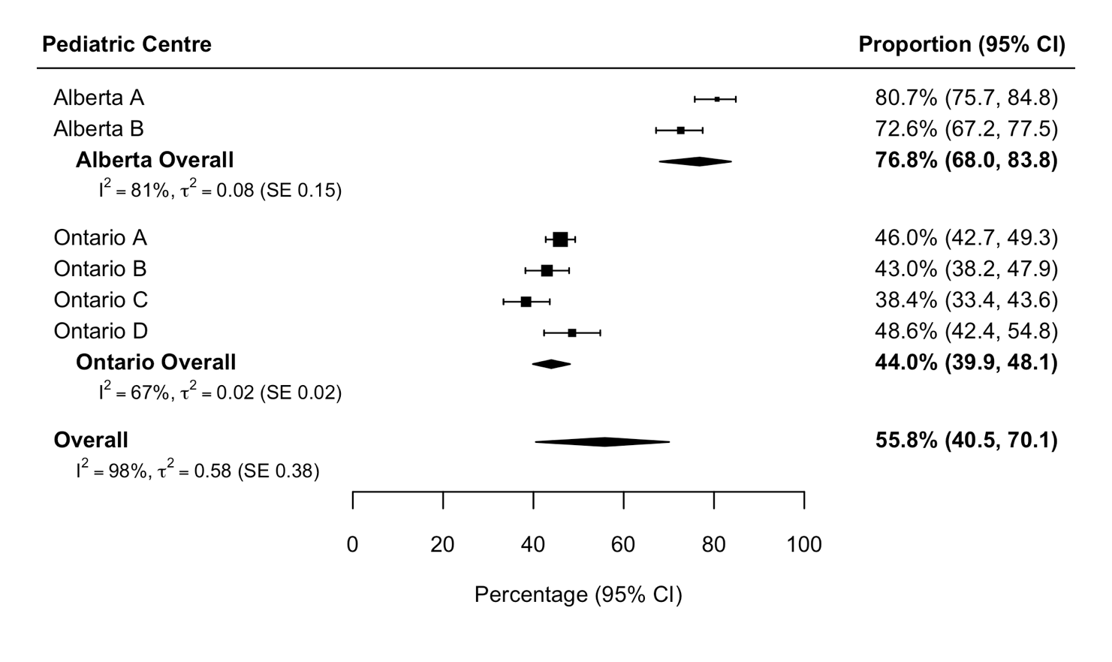
Figure S6. Scatterplots describing the associations between the likelihood of having ≥1 IBD-specific or IBD-related emergency department visit in the time period spanning from six to 60 months after diagnosis and centre-level health services utilization at diagnosis.
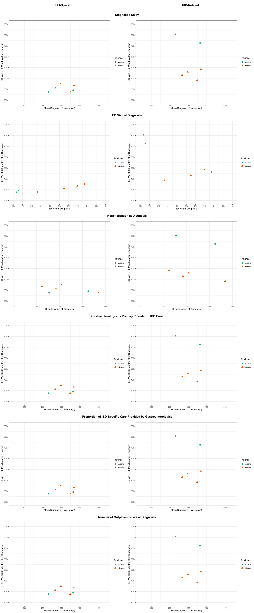
Figure S7. Pooled mean number of (A) IBD-specific and (B) IBD-related emergency department visits between six and 60 months following IBD diagnosis.
- IBD-specific
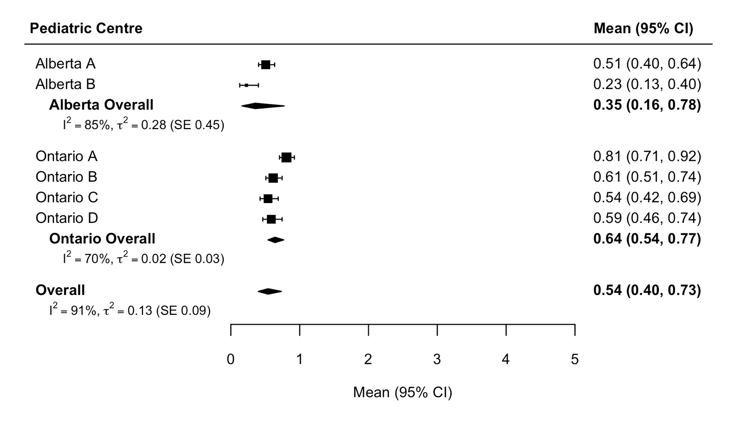
- IBD-related
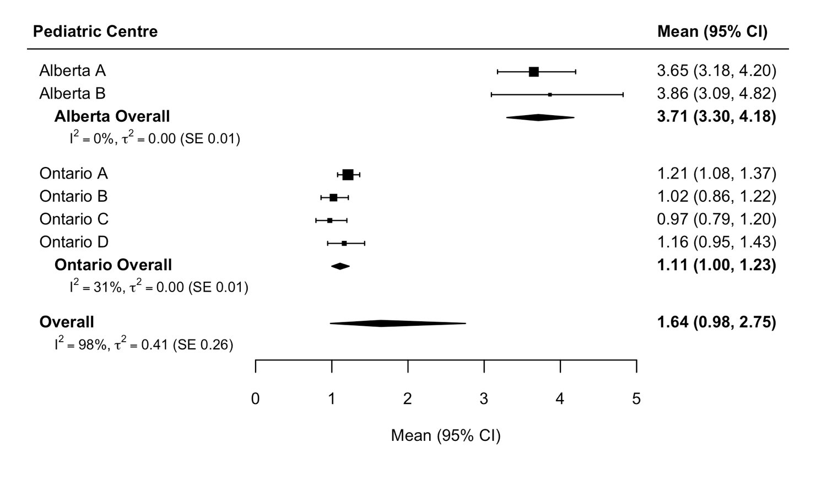
Figure S8. Scatterplots describing the associations between the frequency of IBD-specific or IBD-related emergency department visits in the time period spanning from six to 60 months after diagnosis and centre-level health services utilization at diagnosis.
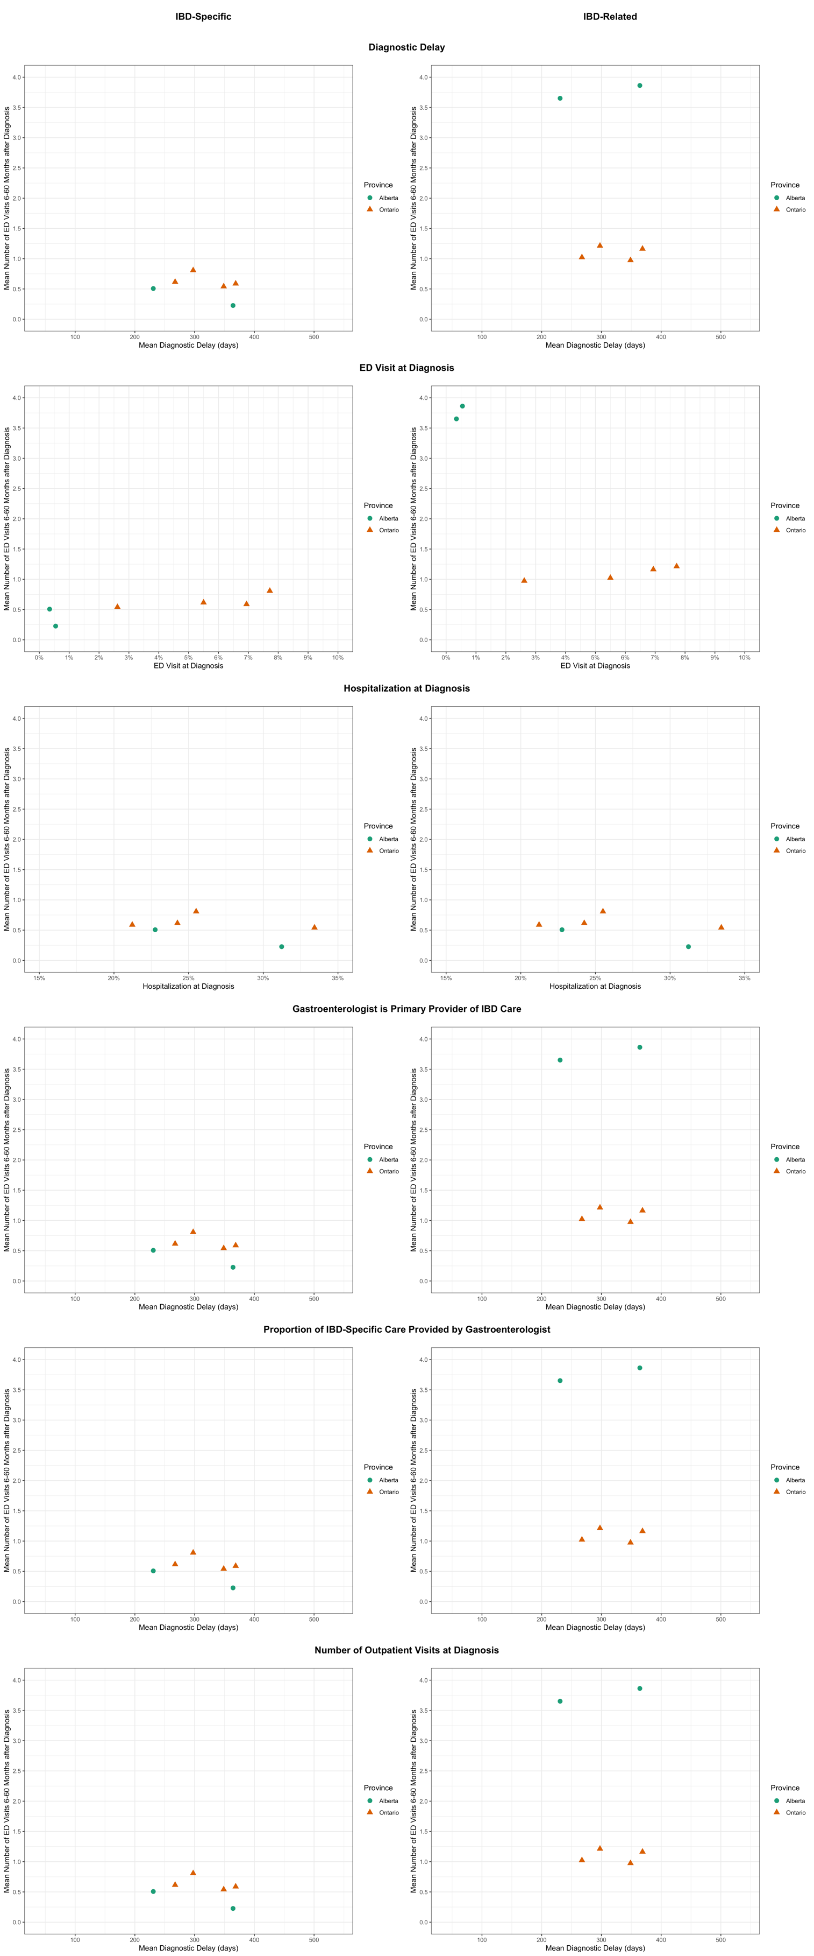
Figure S9. Pooled percentage of children with Crohn’s disease and ulcerative colitis requiring abdominal surgery between six and 60 months following IBD diagnosis.
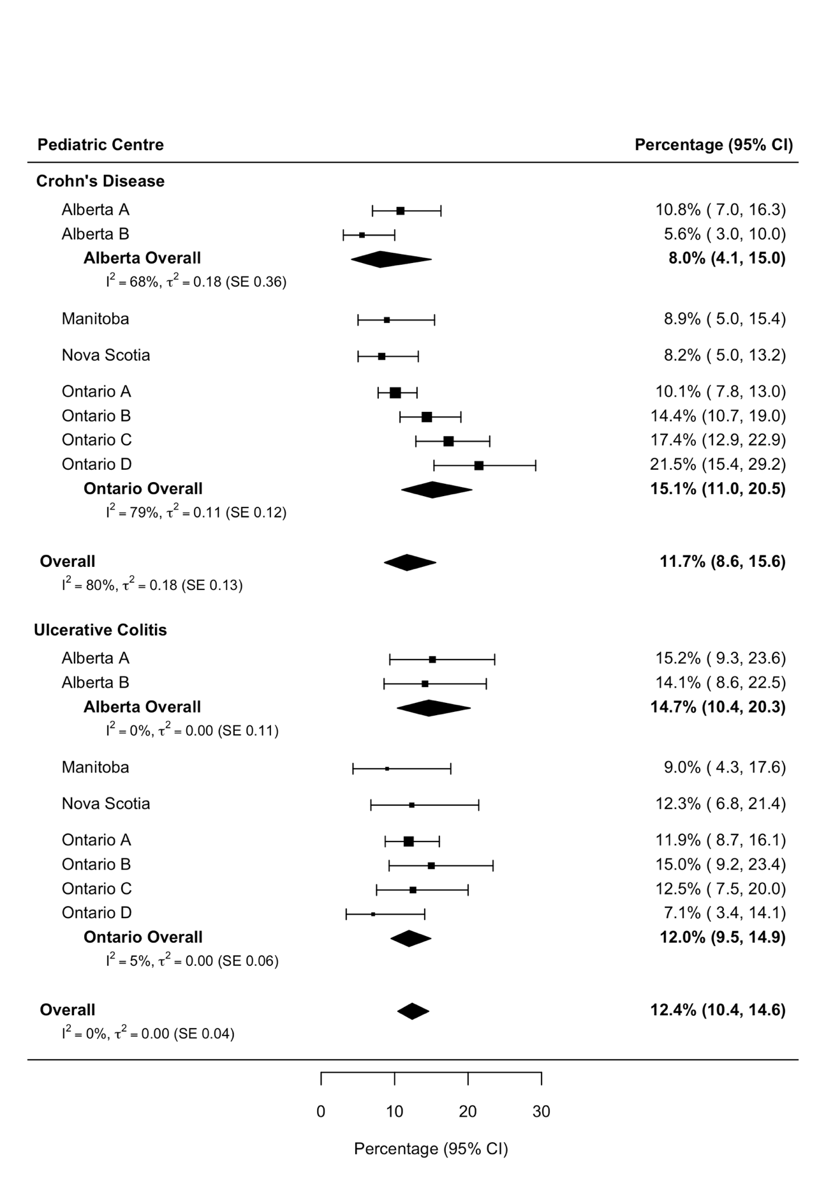
Figure S10. Scatterplots describing the associations between the likelihood of undergoing abdominal surgery in the time period spanning from six to 60 months after diagnosis and centre-level health services utilization at diagnosis. 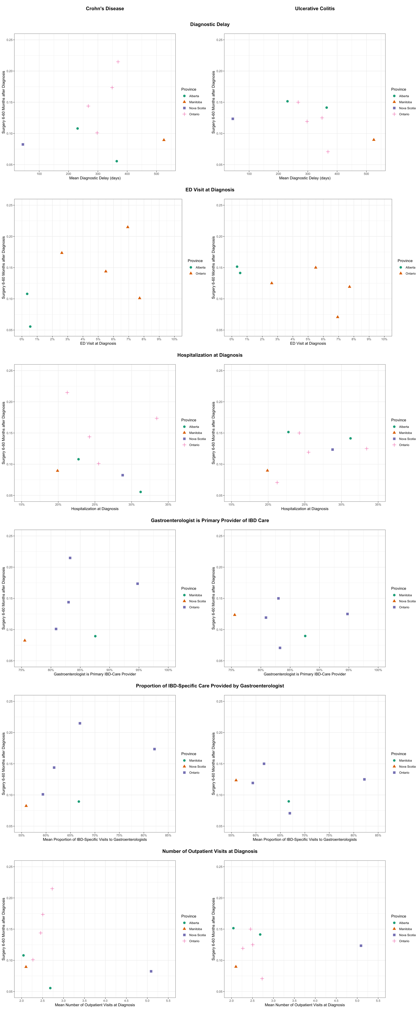

References for Supplemental File
1. Rezaie A, Quan H, Fedorak RN, et al. Development and Validation of an Administrative Case Definition for Inflammatory Bowel Diseases. Canadian Journal of Gastroenterology 2012;26:711-717.
2. Bernstein CN, Blanchard JF, Rawsthorne P, et al. Epidemiology of Crohn's disease and ulcerative colitis in a central Canadian province: a population-based study. Am J Epidemiol 1999;149:916 - 924.
3. Benchimol EI, Guttmann A, Griffiths AM, et al. Increasing incidence of paediatric inflammatory bowel disease in Ontario, Canada: evidence from health administrative data. Gut 2009;58:1490-1497.
4. Otley A, Cui Y, Dummer TJB. Validation of administrative case ascertainment algorithms for pediatric IBD in Nova Scotia, Canada. J Pediatr Gastroenterol Nutr 2018;67:S54.
5. Plessis VD, Beshiri R, Bollman RD, et al. Definition of "Rural". Agriculture and Rural Working Paper Series: Statistics Canada, Agriculture Division, 2002.
6. Ma C, Moran GW, Benchimol EI, et al. Surgical rates for Crohn's disease are decreasing: a population-based time trend analysis and validation study. Am J Gastroenterol 2017;148:344.
7. Ma C, Crespin M, Proulx M-C, et al. Postoperative complications following colectomy for ulcerative colitis: a validation study. BMC Gastroenterology 2012;12:39.

