Supplementary Information
Synthesis of GO
Graphite oxide was prepared using modified Hummer’s method.¹ Briefly, a mixture of 2 g of graphite and 2 g of sodium nitrate (NaNO₃) were dissolved in a 96 mL of sulfuric acid (H₂SO₄). After stirring completely, 12 g of potassium permanganate (KMnO₄) was slowly added to the solution and the mixture was stirred in an ice bath for 2 h followed by keeping at 45℃ for 2 h. After that, 500 mL of ice-cold water and a few drops of (10 mL) 30% hydrogen peroxide (H₂O₂) were added before the reaction mixture was cooled down to room temperature. The mixture was stirred about 30 min and then held for 12 h. Washing with 30 wt% hydrochloric acid aqueous solution (HCl, 10 wt%) three times and repeated washing with DI water until the pH of the filtrate was near 7. After that, an ultrasonication (120 W, 1 h) was used to exfoliate the graphite oxide to yield a GO suspension.
Construction of a rat sciatic nerve defect model
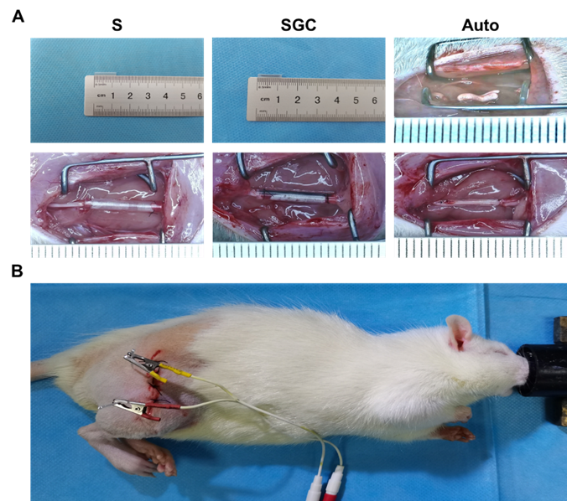

Figure S1: Photographs of in vivo implantation of S, SGC, and Autograft. (A) S, SGC, and Autograft were implanted in a 10 mm gap of sciatic nerve, respectively. (B) Experimental setup, showing the electrode position during ES treatment.

Characterization of GO

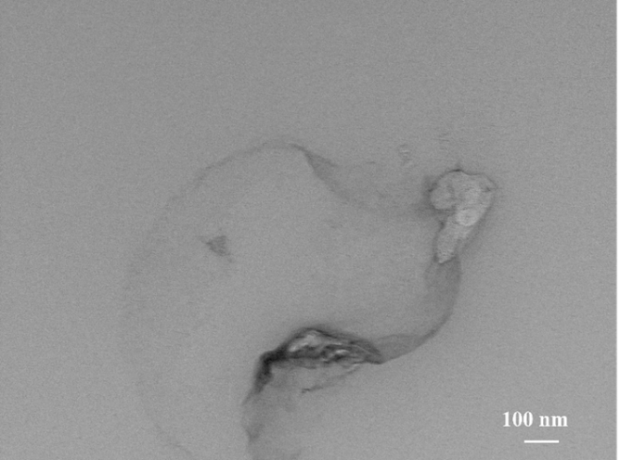

Figure S2: TEM image of GO sheet obtained from the 0.1 mg mL⁻¹ suspension. The sheet exhibits its nature of transparent to electrons, and some wrinkles and folded regions can be seen.
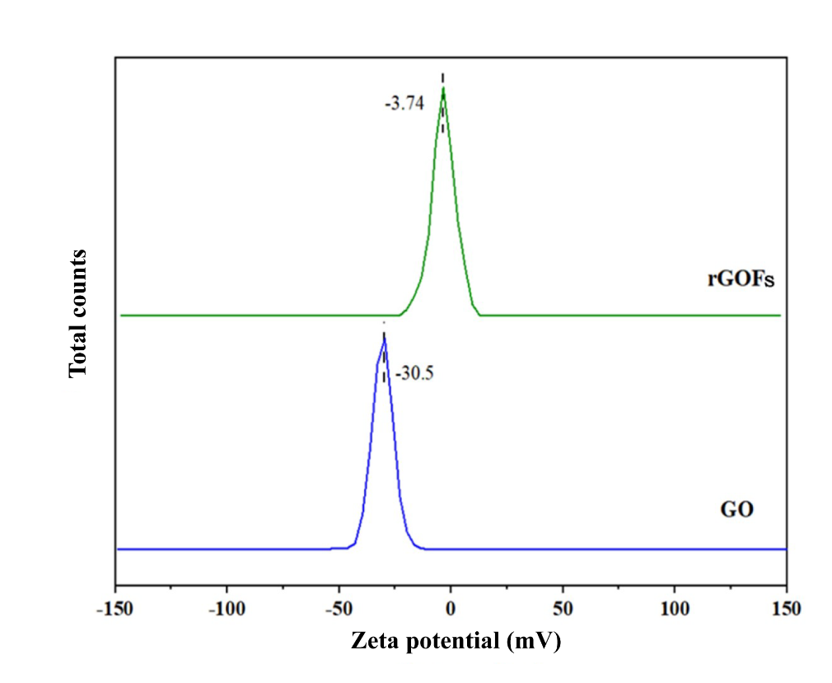
Figure S3: The surface charges of GO and rGOFs were analyzed and the results demonstrated that at pH 7 the GO and rGOFs had ζ potential values of -31.7 and -3.74 mV, respectively. The negative charges observed on the GO and rGOFs indicated the presence of hydroxyl (O⁻) and carboxylic acid (COO⁻) groups on the surface.² The surface negative charges in GO sheets ensured their forming stable dispersions to assembly into rGOFs with few-layer or single-layer rGO sheets, while the negative charges on the surface of rGOFs was supposed to be favorable for interaction of rGOFs with proteins and other positively charged groups on the cell membrane in the biological systems.

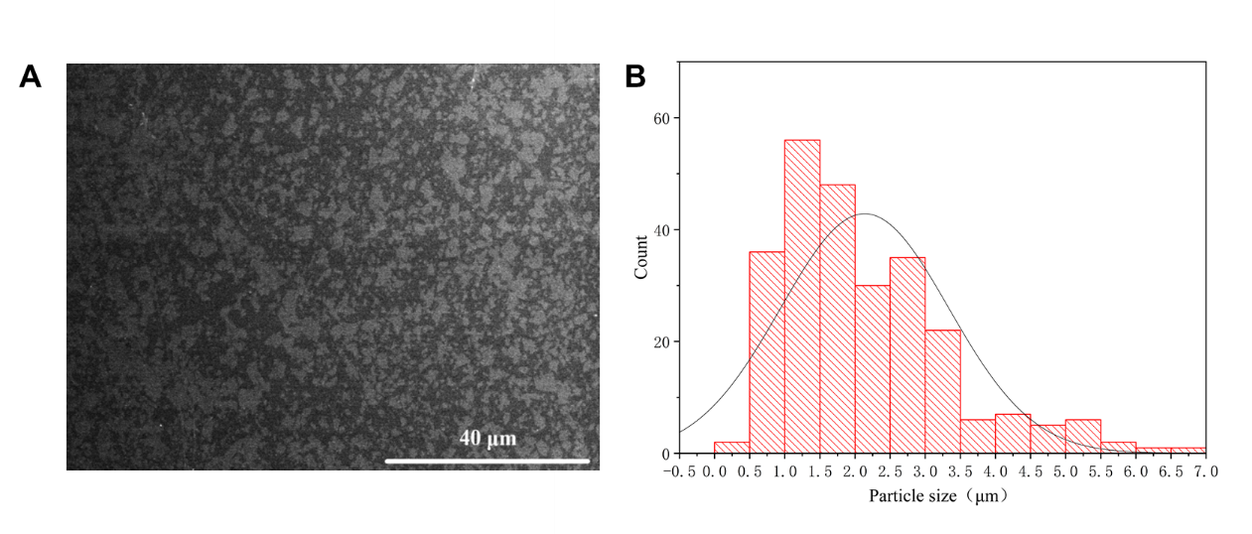
Figure S4: (A) SEM image. (B) The histogram of lateral sizes (~ 2.14 μm) of GO sheets, which was determined by Image J analysis.

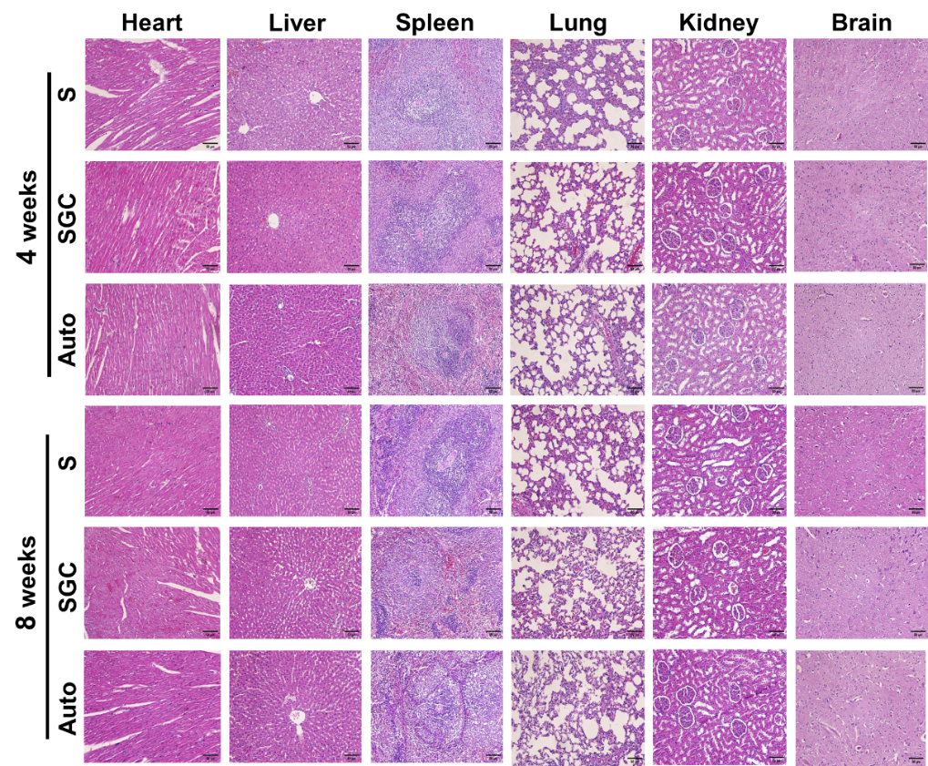

Figure S5: Histopathological images of key organs of rats at 4 and 8 weeks of implantation at injured sciatic nerve. Scale bar: 100 μm. No significant toxic effects were observed on various organs of the rats with different types of defective neural connections.

Effect on cells
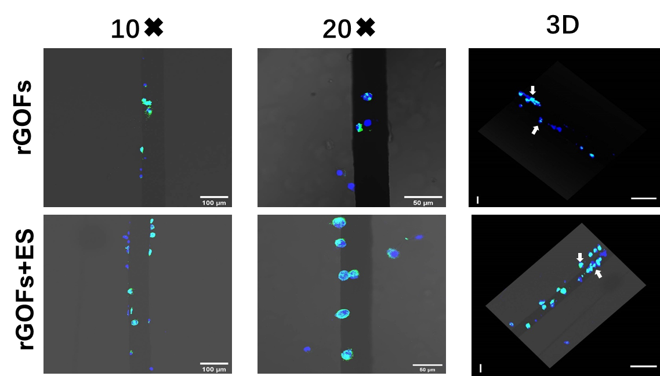

Figure S6: The morphology of PC-12 cells (two different magnifications and a 3D image) cultured on rGOFs and rGOFs+ES samples for 24 h. Our study confirmed the reports that bare rGO microfibers without coating any neural adhesive molecules provided few bioactive sites for neural cell colonization due to the curvature structure of the fibers. ³ However, in combination of ES, the rGOFs exhibited enhanced capacity of cell adhesion, both to the lateral sides of the cylindrical microfibers and the top areas, shown by white arrows. ES: 0.5 V cm⁻¹; 10 min. Nuclei: blue, stained by DAPI; F-actin: green, stained by β-actin. Scale bar: 3D: 200 μm (left) and 30 μm (right).

- Hummers WC, Offeman RE. Preparation of graphite oxide. J Am Chem Soc. 1958; 80:1339.
- Jastrzębska AM, Karcz J, Letmanowski R, Zabost D, Ciecierska E, Zdunek J, Karwowska E, Siekierski M, Olszyna A, Kunicki A. Synthesis of the RGO/Al2O3 Core–Shell Nanocomposite Flakes and Characterization of Their Unique Electrostatic Properties Using Zeta Potential Measurements. Appl Surf Sci. 2016; 362:577–594.
- González-Mayorga A, López-Dolado E, Gutiérrez MC, Collazos-Castro JE, Ferrer ML. Del Monte F, Serrano MC. Favorable Biological Responses of Neural Cells and Tissue Interacting with Graphene Oxide Microfibers. ACS Omega. 2017; 2(11):8253–8263.

