Table S1: Sequences of primers for genes detected by Real-time-PCR
Primer | Forword | Reverse
JUN | 5′-CAGTGAGTGACCGCGACTT-3′ | 5′-TGCAGTCATAGAACAGTCCGTC-3′
MELK | 5′-TGATCACCTCACGGCTACCT-3′, | 5′-GAATGGGGTAGCACTGGCTT-3′
AURKA | 5′-GTTGGCGAAGCCTGGTAAAG-3′, | 5′-AAACCCAATCAGGCCTACCG-3′
GAPDH | 5′- CAACGTGTCAGTGGTGGACCTG-3′, | 5′-GTGTCGCTGTTGAAGTCAGAGGAG-3′
Table S1 Cycling conditions were as follows: denaturation at 95 °C for 1 min, followed by 40 cycles of denaturation at 95 °C for 10 s, annealing at 60 °C for 10 s and extension at 72 °C for 10 s.

Table S2: Determination of blood biochemical indexes in mice administered with the drug for 21 days
 | 0mg/kg |  |  | 30mg/kg |  |  | 15mg/kg
 | #1 | #40 | #42 | #47 | #79 | #49 | #41 | #46 | #45 | reference range（Max/Min）
Alanine transaminase（ALT） | 62.8 | 26.11 | 16.23 | 48.9 | 69.34 | 47.65 | 32.03 | 33.41 | 19.08 | 38 | 14
Aspartate amino  transferase（AST） | 196.98 | 39.34 | 35.66 | 223.26 | 192.55 | 165.34 | 61.16 | 59.3 | 37.17 | 78 | 28
AST/ALT | 3.14 | 1.51 | 2.2 | 4.57 | 2.78 | 3.47 | 1.91 | 1.77 | 1.95
Total serum bile acids（TBA） | 142.36 | 5.57 | 6.12 | 18.68 | 11.43 | 3.27 | 2.23 | 2.82 | 3.37
Cholyglycine（CG） | 56.9 | 1.78 | 1.26 | 10.28 | 5.61 | 1.8 | 1.08 | 1.41 | 0.93
blood urea nitrogen（BUN ） | 7.9 | 12.22 | 11.16 | 10.05 | 10.88 | ######## | 12.48 | 14.64 | 10.84
Creatinine（CR） | 11.8 | 15.7 | 13.1 | 14.4 | 14.9 | ######## | 11.5 | 12.6 | 10.2 | 28 | 11
BUN/CR | 0.67 | 0.78 | 0.85 | 0.7 | 0.73 | ######## | 1.09 | 1.16 | 1.06
Cystatin C | 0.2 | 0.2 | 0.2 | 0.2 | 0.2 | ######## | 0.2 | 0.2 | 0.2 | 0.07 | 0.05
β2—MG | -0.03 |  | -0.05 | 0.01 | -0.01 | -0.03 | 0.01 | -0.04 | -0.04
Osm | 412 |  |  | 417 | 411
Osm Osm-2 | 304 |  |  | 321 | 319
TotalProtein (TP) | 49.2 |  |  | 61.97 | 56.56 | 58.34
Albumin (ALB) | 28.27 |  |  | 31.8 | 29.98 | 25.75
Globulin (GLB) | 20.93 |  |  | 30.17 | 26.58 | 32.59
A/G | 1.35 |  |  | 1.05 | 1.13 | 0.79
Prealbumin (PA) | 6.39 |  |  | 6.2 | 2.78 | -13.73

########:The hash symbols here are the abnormal instrument data readings due to various objective factors when we are performing on-line testing of blood samples.

Figure S1 CCK-8 experiments showed the cell viability of A549 cells and BEAS-2Bcells under different concentrations of HCTMPPK stimulation.

Figure S2 HCTMPPK average IC50 profiles against A549 and BEAS-2B cell lines.

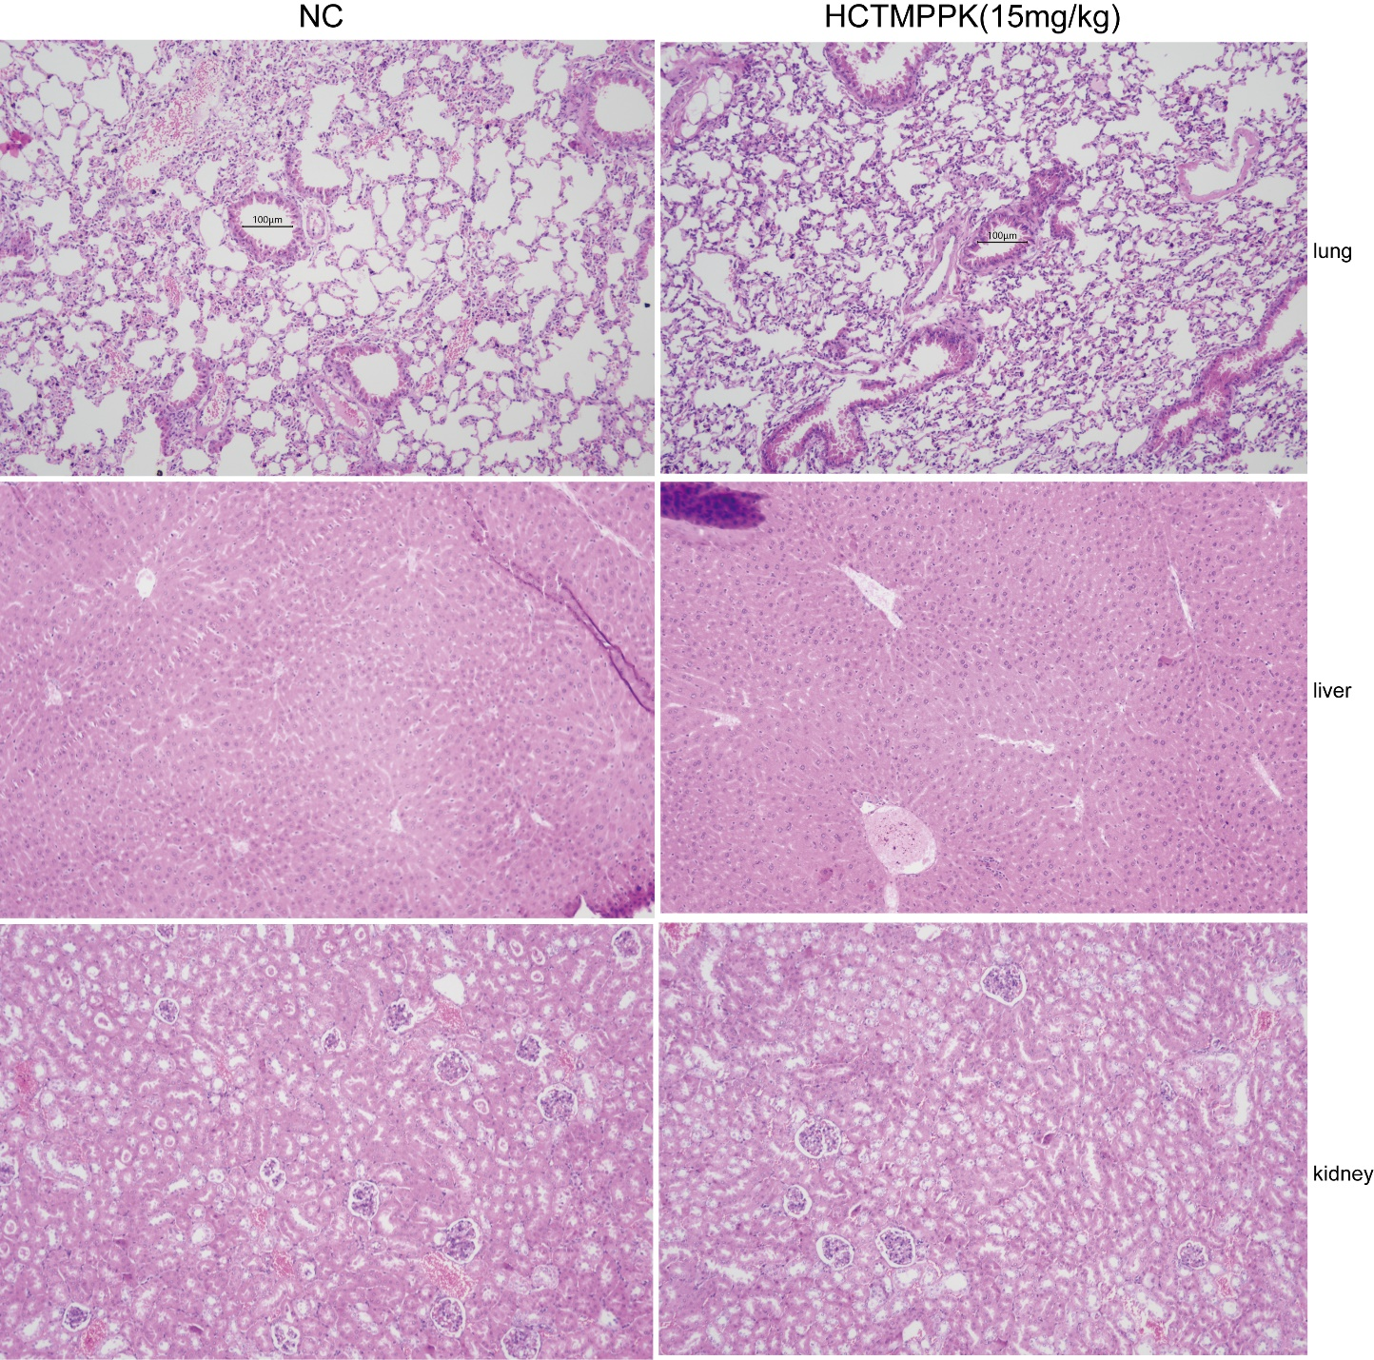
Figure S3 Hematoxylin-eosin staining HCTMPPK (15 mg/kg) did not show hepatic and renal toxicity in C57BL/c mice The scale bar in HE staining of lung tissue was 100 μm.

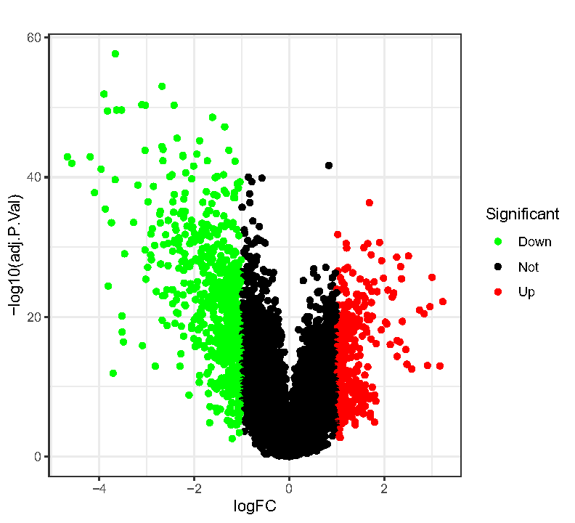
Figure S4 Volcano plots of up- and down-regulated genes in lung adenocarcinoma patients compared to normal subjects in GEO.

