Supplementary Information
Figure. S1. Synthesis scheme of TPP-TPGS polymer.

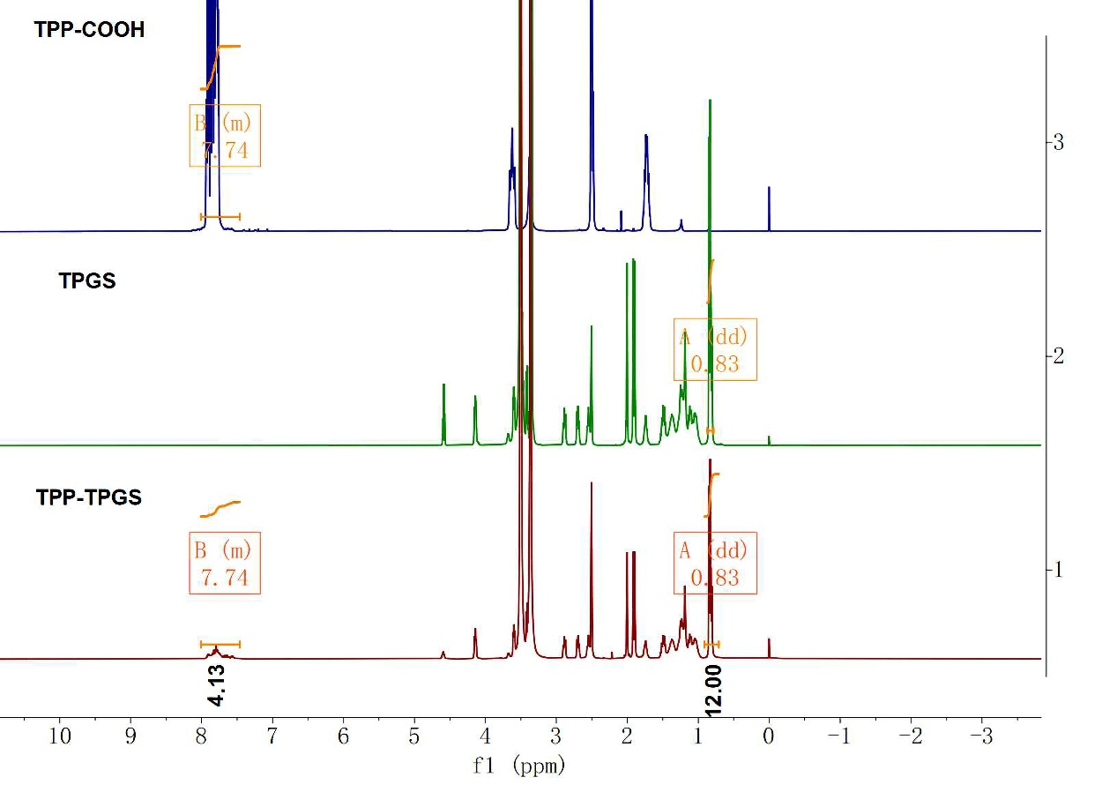
Figure. S2. ¹H NMR spectra of TPP-TPGS polymer. The peak at 0.83ppm was denoted A and the peak at 7.74ppm was denoted B.
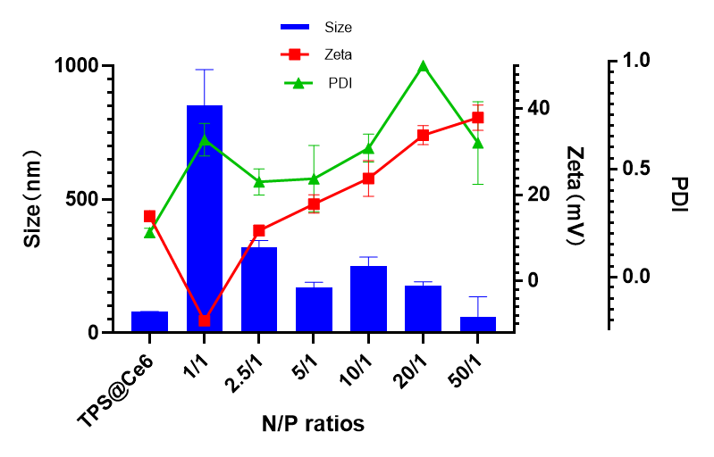
168.93nm
17.91mV
0.47
Figure. S3. Sizes, zeta potentials (ZP), and PDI of TPS@Ce6/miRNA complexes at various N/P ratios. (mean ± SD, n = 3).

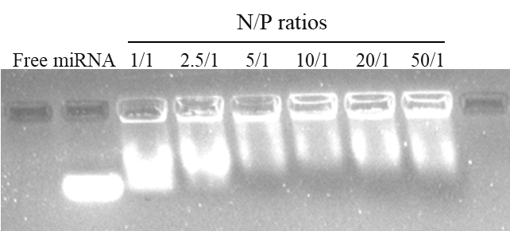
Figure. S4. Gel-retardation assay of TPS@Ce6/miRNA complexes at various N/P ratios.

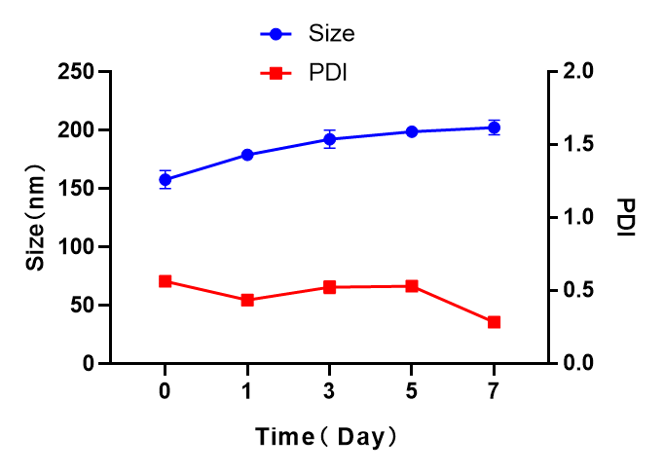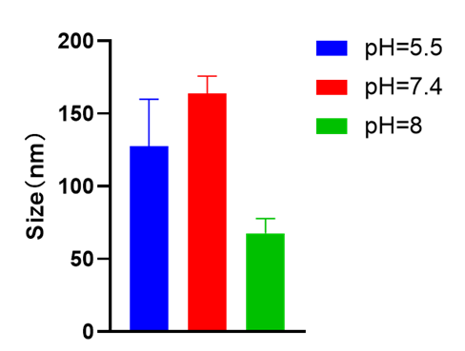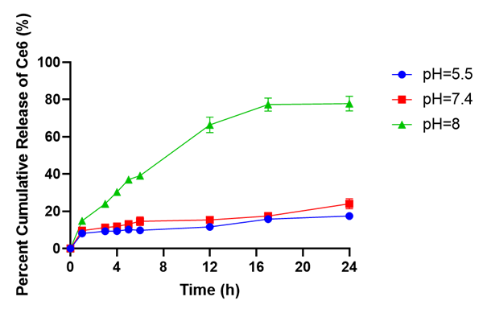
a
b
c
Figure. S5. (a) Particle size and PDI variations of TPS@Ce6/miRNA NPs in 7 days. (mean ± SD, n = 3). (b) Particle size of TPS@Ce6/miRNA NPs at different pH values. (mean ± SD, n = 3). (c) In vitro release profiles of Ce6 from TPS@Ce6/miRNA NPs at different pH values. (mean ± SD, n = 3).
Figure. S6. Cell viability of MDA-MB-231 and MCF-10A cells incubated with gradient concentrations of Ce6 and TPS@Ce6/miRNA NPs with or without NIR irradiation. (mean ± SD, n = 3).

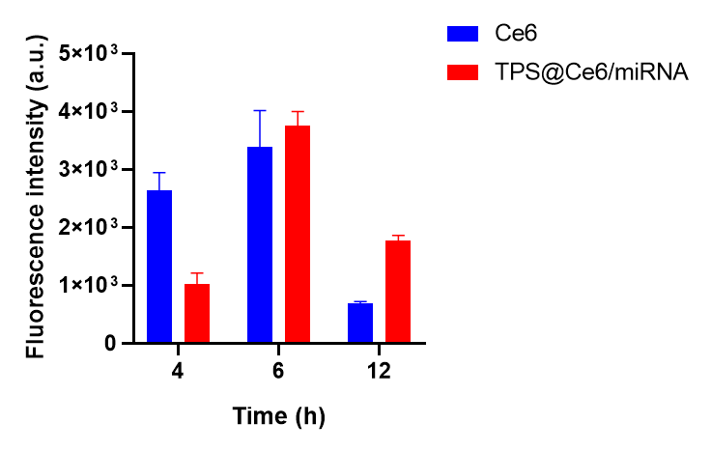
Figure. S7. The fluorescence intensity of MDA-MB-231 was quantified after 4 h, 6h, and 12h of incubation with Ce6 and TPS@Ce6/miRNA. (mean ± SD, n = 3).
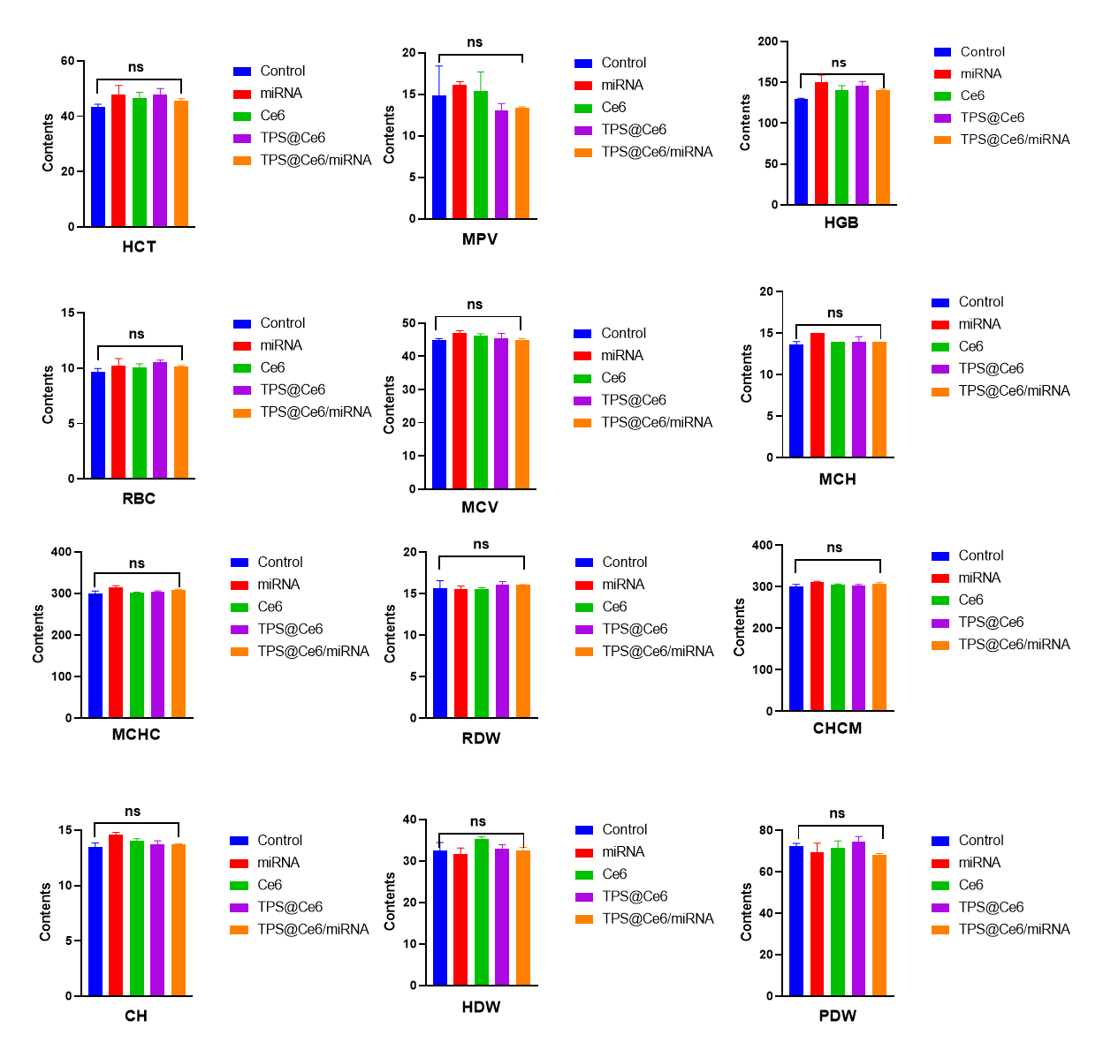
Figure. S8. The blood routine analysis of MDA-MB-231 tumor-bearing mice after treatment with injection of different drugs in the presence of light on the 21st day. (mean ± SD, n = 3), ns indicates no significant difference.

Table. S1. Biophysical characterization of TPS@Ce6 mixed micelles at various carrier/drug ratios (w/w). (mean ± SD, n = 3).
Micelles | Water-oil ratio ^{a)} | Size  (nm) | Zeta potential  (mV) | PDI^{b)} | DL ^{c)}  (%) | EE ^{d)}  (%)
Ce6 | - | 1802.00±150.60 | -29.06±1.33 | 0.6012±0.130 | - | -
TPS | - | 408.30±114.80 | 22.97±2.39 | 0.5076±0.159 | - | -
TPS@Ce6 | 5:1 | 9.53±3.27 | 9.12±0.95 | 0.6894±0.059 | 4.98 | 64.63
TPS@Ce6 | 10:1 | 76.43±2.44 | 7.10±1.19 | 0.4291±0.036 | 3.73 | 86.23
TPS@Ce6 | 20:1 | 79.83±0.52 | 15.06±1.08 | 0.2261±0.016 | 5.77 | 89.26
^{a)} Ce6 concentration in micelles was kept at 4 mg/ml, TPS concentration in micelles was kept at 3.2 mg/ml. Units: ml: ml; ^{b)} PDI, polydispersity index; ^{c)} DL, drug loading capacity; ^{d)} EE, drug encapsulation efficiency.

