Supplementary material
Table S1. Descriptive Statistics for Statements of Physician’s Choice based on Symptoms (N=808)
Specialty | Who would you see if you develop joints pain/swelling | Who would you see if you develop photosensitive rash | Who would you see if you develop painful discoloration of finger after cold | Who would you see if you develop oral and genital ulcers | Who would you see if you develop back pain
Rheumatologist | 358 (44.3) | 77 (9.5) | 240 (29.7) | 80 (9.9) | 83 (10.3)
Orthopedic | 297 (36.8) | 27 (3.3) | 117 (14.5) | 25 (3.1) | 511 (63.2)
General Physician | 39 (4.8) | 49 (6.1) | 131 (16.2) | 102 (12.6) | 63 (7.8)
Family Physician | 55 (6.8) | 58 (7.2) | 80 (9.9) | 108 (13.4) | 71 (8.8)
Internist | 32 (4.0) | 28 (3.5) | 83 (10.3) | 186 (23.0) | 52 (6.4)
Emergency Physician | 13 (1.6) | 12 (1.5) | 87 (10.8) | 38 (4.7) | 17 (2.1)
Dermatologist | 7 (0.9) | 557 (68.9) | 62 (7.7) | 228 (28.2) | 3 (0.4)
Urologist | 1 (0.1) | 0 (0.0) | 0 (0.0) | 17 (2.1) | 0 (0.0)
Hematologist | 0 (0.0) | 0 (0.0) | 1 (0.1) | 0 (0.0) | 0 (0.0)
Gynecologist | 0 (0.0) | 0 (0.0) | 0 (0.0) | 15 (1.9) | 1 (0.1)
General Surgeon | 0 (0.0) | 0 (0.0) | 0 (0.0) | 1 (0.1) | 0 (0.0)
Ear, Nose, Throat | 0 (0.0) | 0 (0.0) | 0 (0.0) | 4 (0.5) | 0 (0.0)
Physiotherapist | 1 (0.1) | 0 (0.0) | 0 (0.0) | 0 (0.0) | 3 (0.4)
Neurologist | 1 (0.1) | 0 (0.0) | 2 (0.2) | 0 (0.0) | 4 (0.5)
General practitioner | 0 (0.0) | 0 (0.0) | 0 (0.0) | 1 (0.1) | 0 (0.0)
Infectious Disease | 0 (0.0) | 0 (0.0) | 0 (0.0) | 3 (0.4) | 0 (0.0)
Immunologist | 1 (0.1) | 0 (0.0) | 0 (0.0) | 0 (0.0) | 0 (0.0)
Dentist | 0 (0.0) | 0 (0.0) | 0 (0.0) | 1 (0.1) | 0 (0.0)
Vascular Surgeon | 0 (0.0) | 0 (0.0) | 1 (0.1) | 0 (0.0) | 0 (0.0)
Neurosurgeon | 0 (0.0) | 0 (0.0) | 0 (0.0) | 0 (0.0) | 1 (0.1)
Cardiologist/Pulmonologist | 0 (0.0) | 0 (0.0) | 1 (0.1) | 0 (0.0) | 0 (0.0)
I don’t know | 3 (0.4) | 1 (0.1) | 3 (0.4) | 7 (0.9) | 1 (0.1)

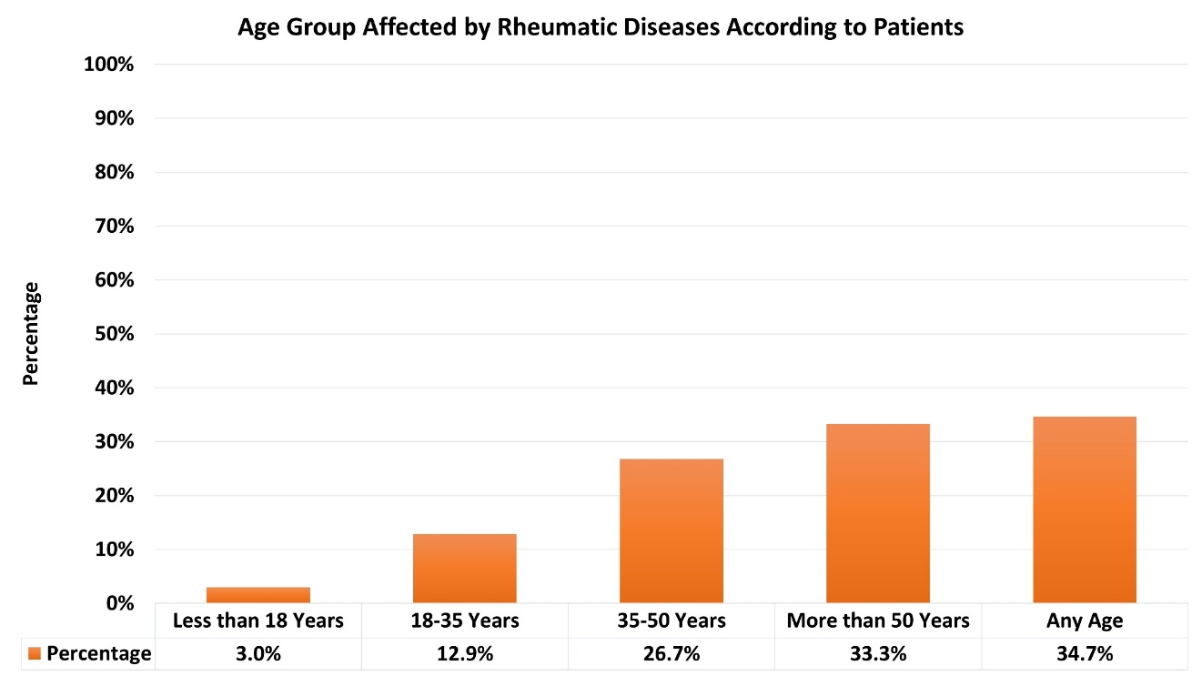
Figure S1: Age Group Affected by Rheumatic Diseases According to Patients (N=808)

