Injectable hydrogel loaded with CDs and FTY720 combined with neural stem cells for the treatment of spinal cord injury

Zhiping Qi¹, Su Pan¹, Xiaoyu Yang¹, Renfeng Zhang¹, Cheng Qin¹, Hongye Yan¹, Longchuan Zhu¹*, Weijian Kong²*

1.Department of Orthopedic Surgery, The Second Hospital of Jilin University, Changchun, 130041, People’s Republic of China
2.Department of Nuclear Medicine, The Second Hospital of Jilin University, Changchun, 130041, People’s Republic of China

Correspondence
Weijian Kong, Email: kongweijian0613@sina.com
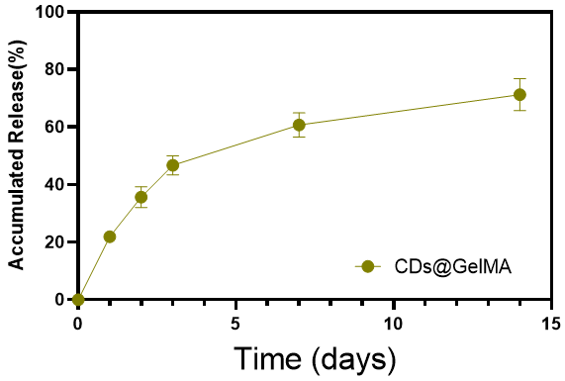
Figure S1: In vitro cumulative release of Se-CDs from hydrogels (n=3).

