Supplemental materials

Figure S1: Bootstrapped 95% confidence intervals (CIs) for the estimated edge weights in
the networks.
A
B
(A) SA group; (B) SI group.
Notes. The red line indicates the sample values and the gray area the bootstrapped CIs. Smaller CIs present higher accuracy weight values. The y-axis labels have been omitted to avoid cluttering.
Figure S2: Case-dropping bootstrap for the networks.
A
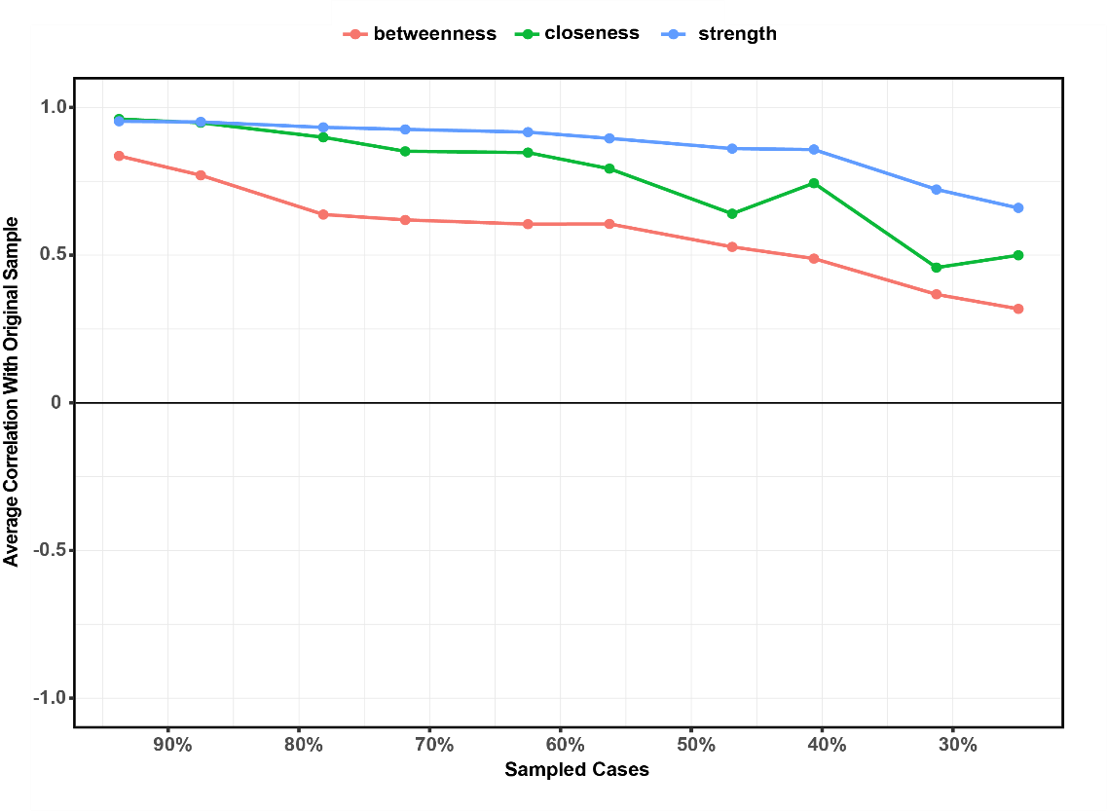
B
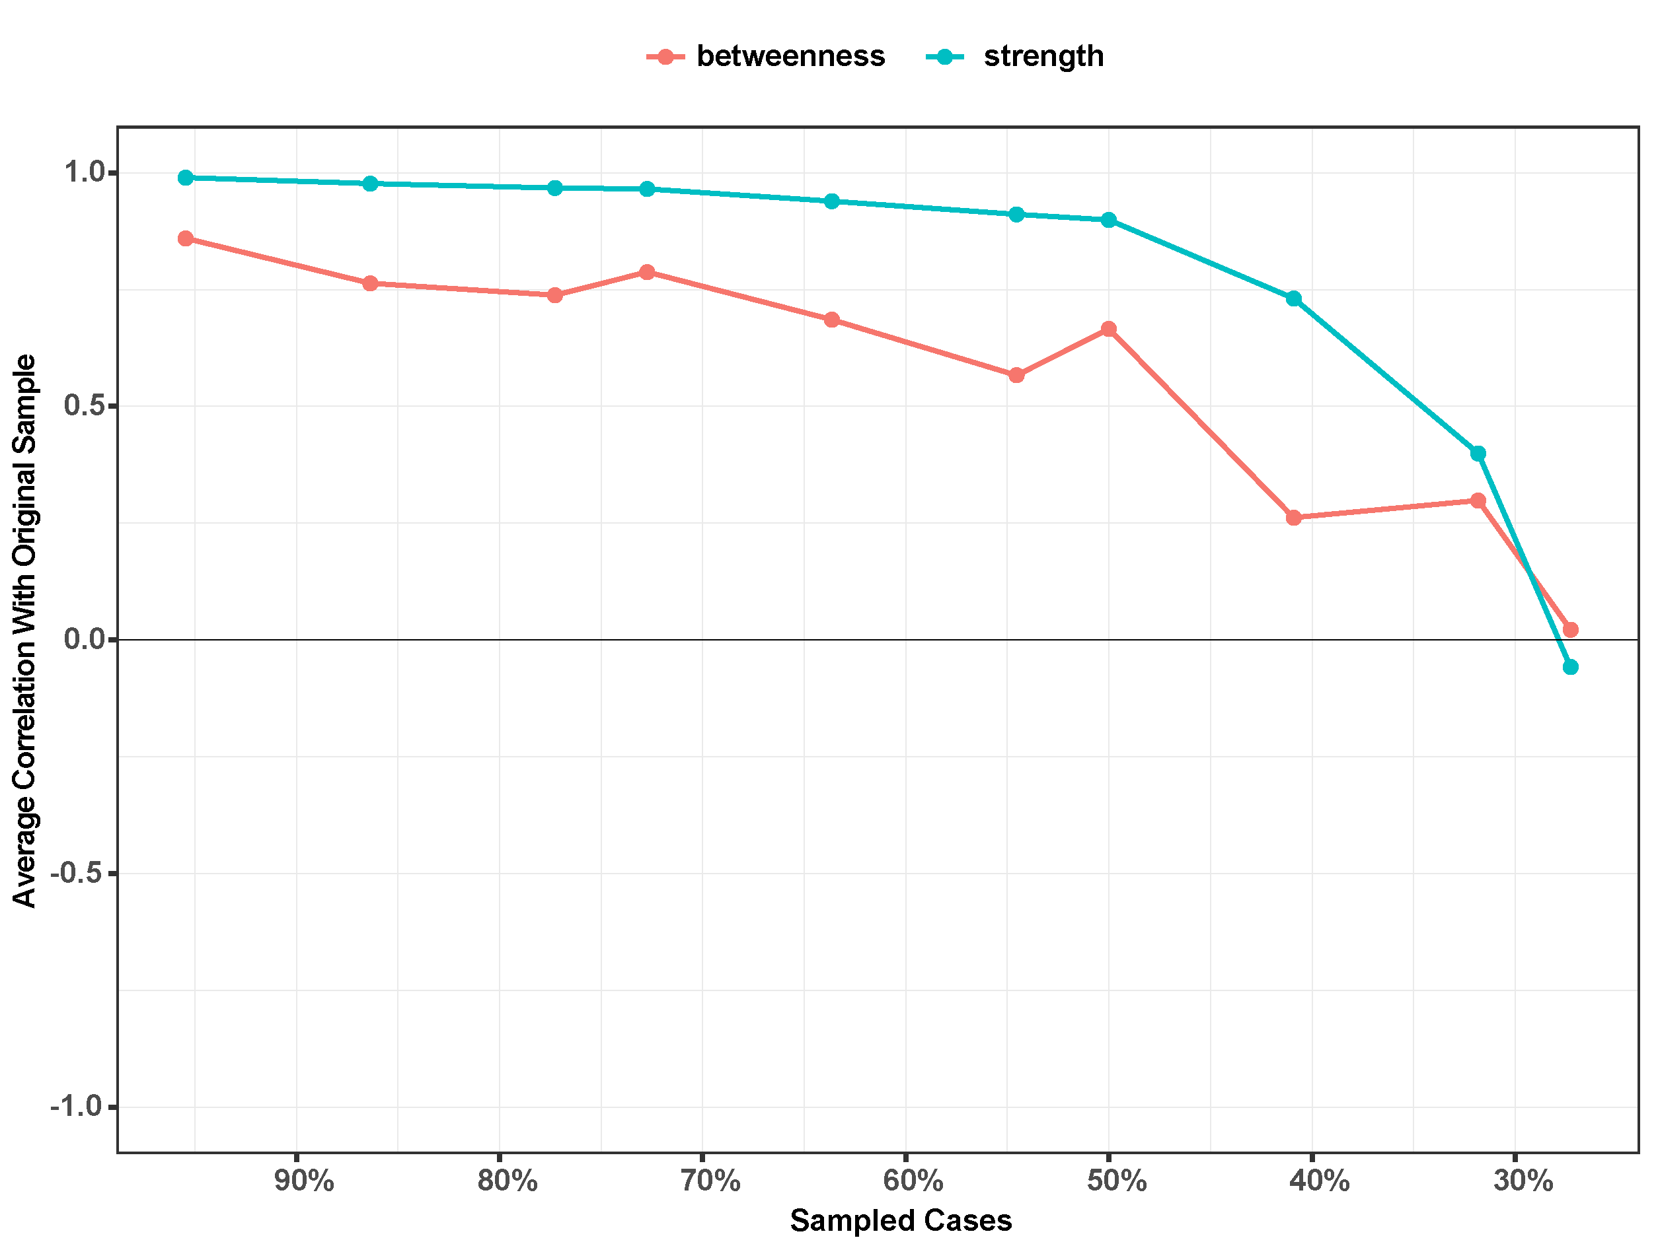
(A) SA group; (B) SI group.
Notes. Average correlations between the centrality measures between the original sample and the case-dropping samples. Color lines demonstrate average value and area demonstrate the 95%CI.

Figure S3. Bootstrapped difference tests of node weights in the networks.
A
B
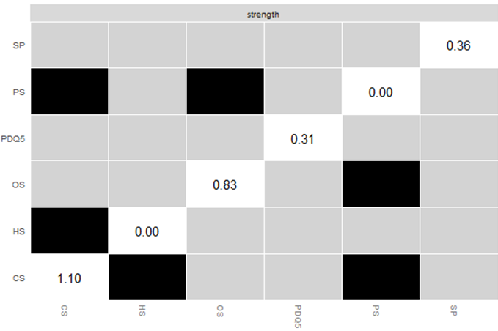
(A) SA group; (B) SI group.
Notes. Black and gray boxes demonstrate the corresponding color of the node within the network. The y-axis and x-axis represent each node. Black boxes show a significant difference between two nodes (alpha = .05). Additionally, it suggests that the stability of the node is inadequate. Grey boxes show no significant difference between two nodes. Meanwhile, it indicates that nodes are relatively stable. SP, spotter; PS, PANSI score; PDQ5, five-item Perceived Deficits Questionnaire for Depression; OS, Composite score of THINC-it objective test; HS, HAMD-17 total score; CS, Composite score of THINC-it.
Figure S4. Bootstrapped difference tests of edge weights in the networks.
A
B
(A) SA group; (B) SI group.
Notes. Black and gray boxes demonstrate the corresponding color of the edge within the network. The y-axis and x-axis represent each edge. Black boxes show a significant difference between two edges (alpha = .05). Additionally, it suggests that the stability of the edge is inadequate. Grey boxes show no significant difference between two edges. Meanwhile, it indicates that edges are relatively stable. The diagonal color box represents the weight value color of the edges in the variable network. Here, blue indicates a positive correlation, while red signifies a negative correlation. SP, spotter; PS, PANSI score; PDQ5, five-item Perceived Deficits Questionnaire for Depression; OS, Composite score of THINC-it objective test; HS, HAMD-17 total score; CS, Composite score of THINC-it.

