Figure S1. Animal experiment operation process. Preparation of bone defect and implantation of bacteria.

Figure S2. Degradation process of the hydrogels in vivo. External image of the hydrogel degradation process in 56 days.

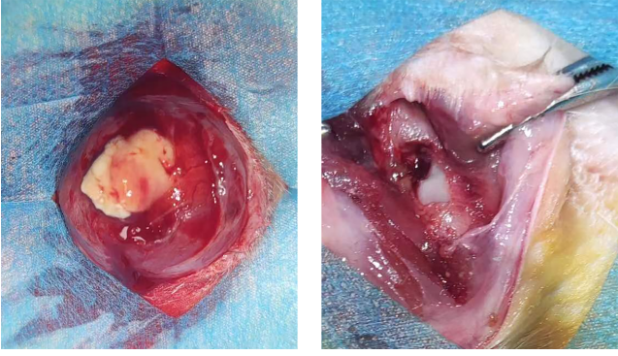
Figure S3. External image of bone defect after 4 weeks of bacterial implantation and external image after debridement.

Figure S4. Verification of infected bone defect in rats. (A) Coating test of bacteria removed from rat femur after 4 weeks of bacterial implantation; (B) Gram staining of the obtained bacteria.

