Supplementary figure

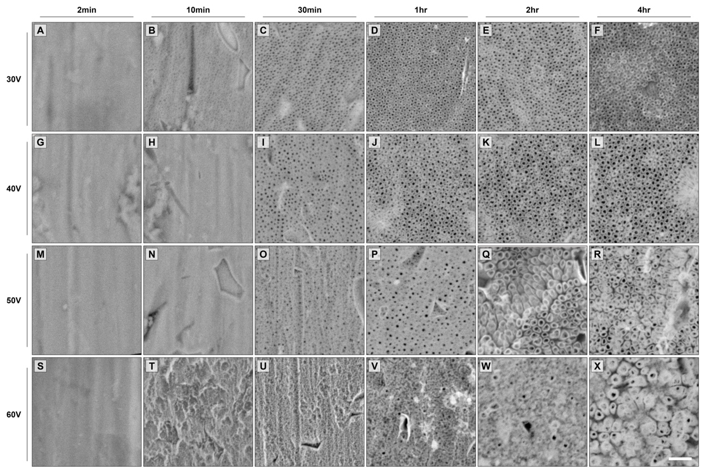

Supplementary figure. Surface characteristics of titanium disk under different anodization parameter. Under 30 and 40 V, nanopores were initially formed on the surface at 30min (A-C and G-H). With procession time increased, nanopores grew and formed nanotubes (D-F, and J-L). Under 50 V, pores did not form until the 1st hour of processing (M-O). Nanotubes formed from the 2nd hour on the surface (Q, R). However, under 60 V, nanopores failed to form on the surface (S-V) until the 2nd hour when pores microstructures were not mature enough (W). Disorderly-distributed tube-like structures finally appeared on the surface at the 4th hour processing (X). (Scale bar = 1μm of all panels)

