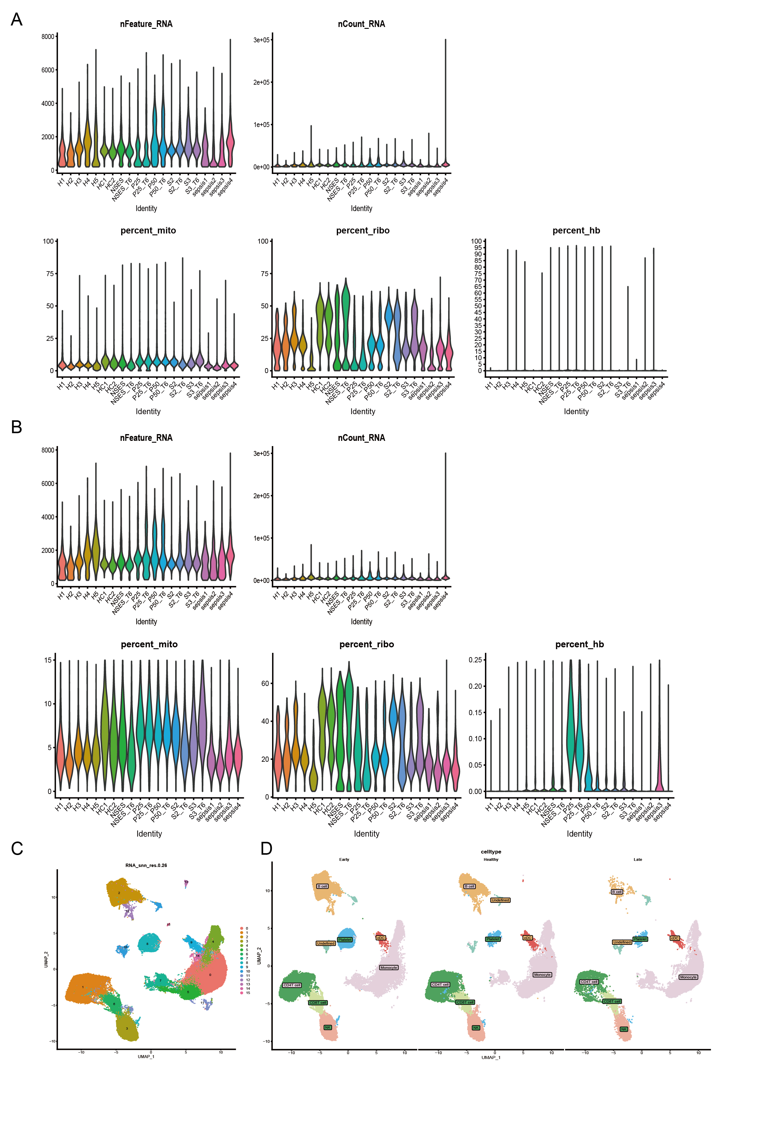
Supplementary Figure 1: Single-cell data QC. A: Single-cell data QC before censoring. B: Single-cell data QC after censoring. C: Clustering with a resolution of 0.26. D: Single-cell UMAP plots between the three clusters.
Supplementary Figure 2: Cell scale box plots of all CD4 T cell subpopulations with p-values calculated using a one-sided unpaired Wilcoxon test. The center line indicates the median value, and the upper and lower hinge lines indicate the 75th and 25th percentiles, respectively.
Supplementary Figure 3: Cell scale box plots of all CD8 T cell subsets with p-values calculated using a one-sided unpaired Wilcoxon test. The center line indicates the median value, and the upper and lower hinge lines indicate the 75th and 25th percentiles, respectively.

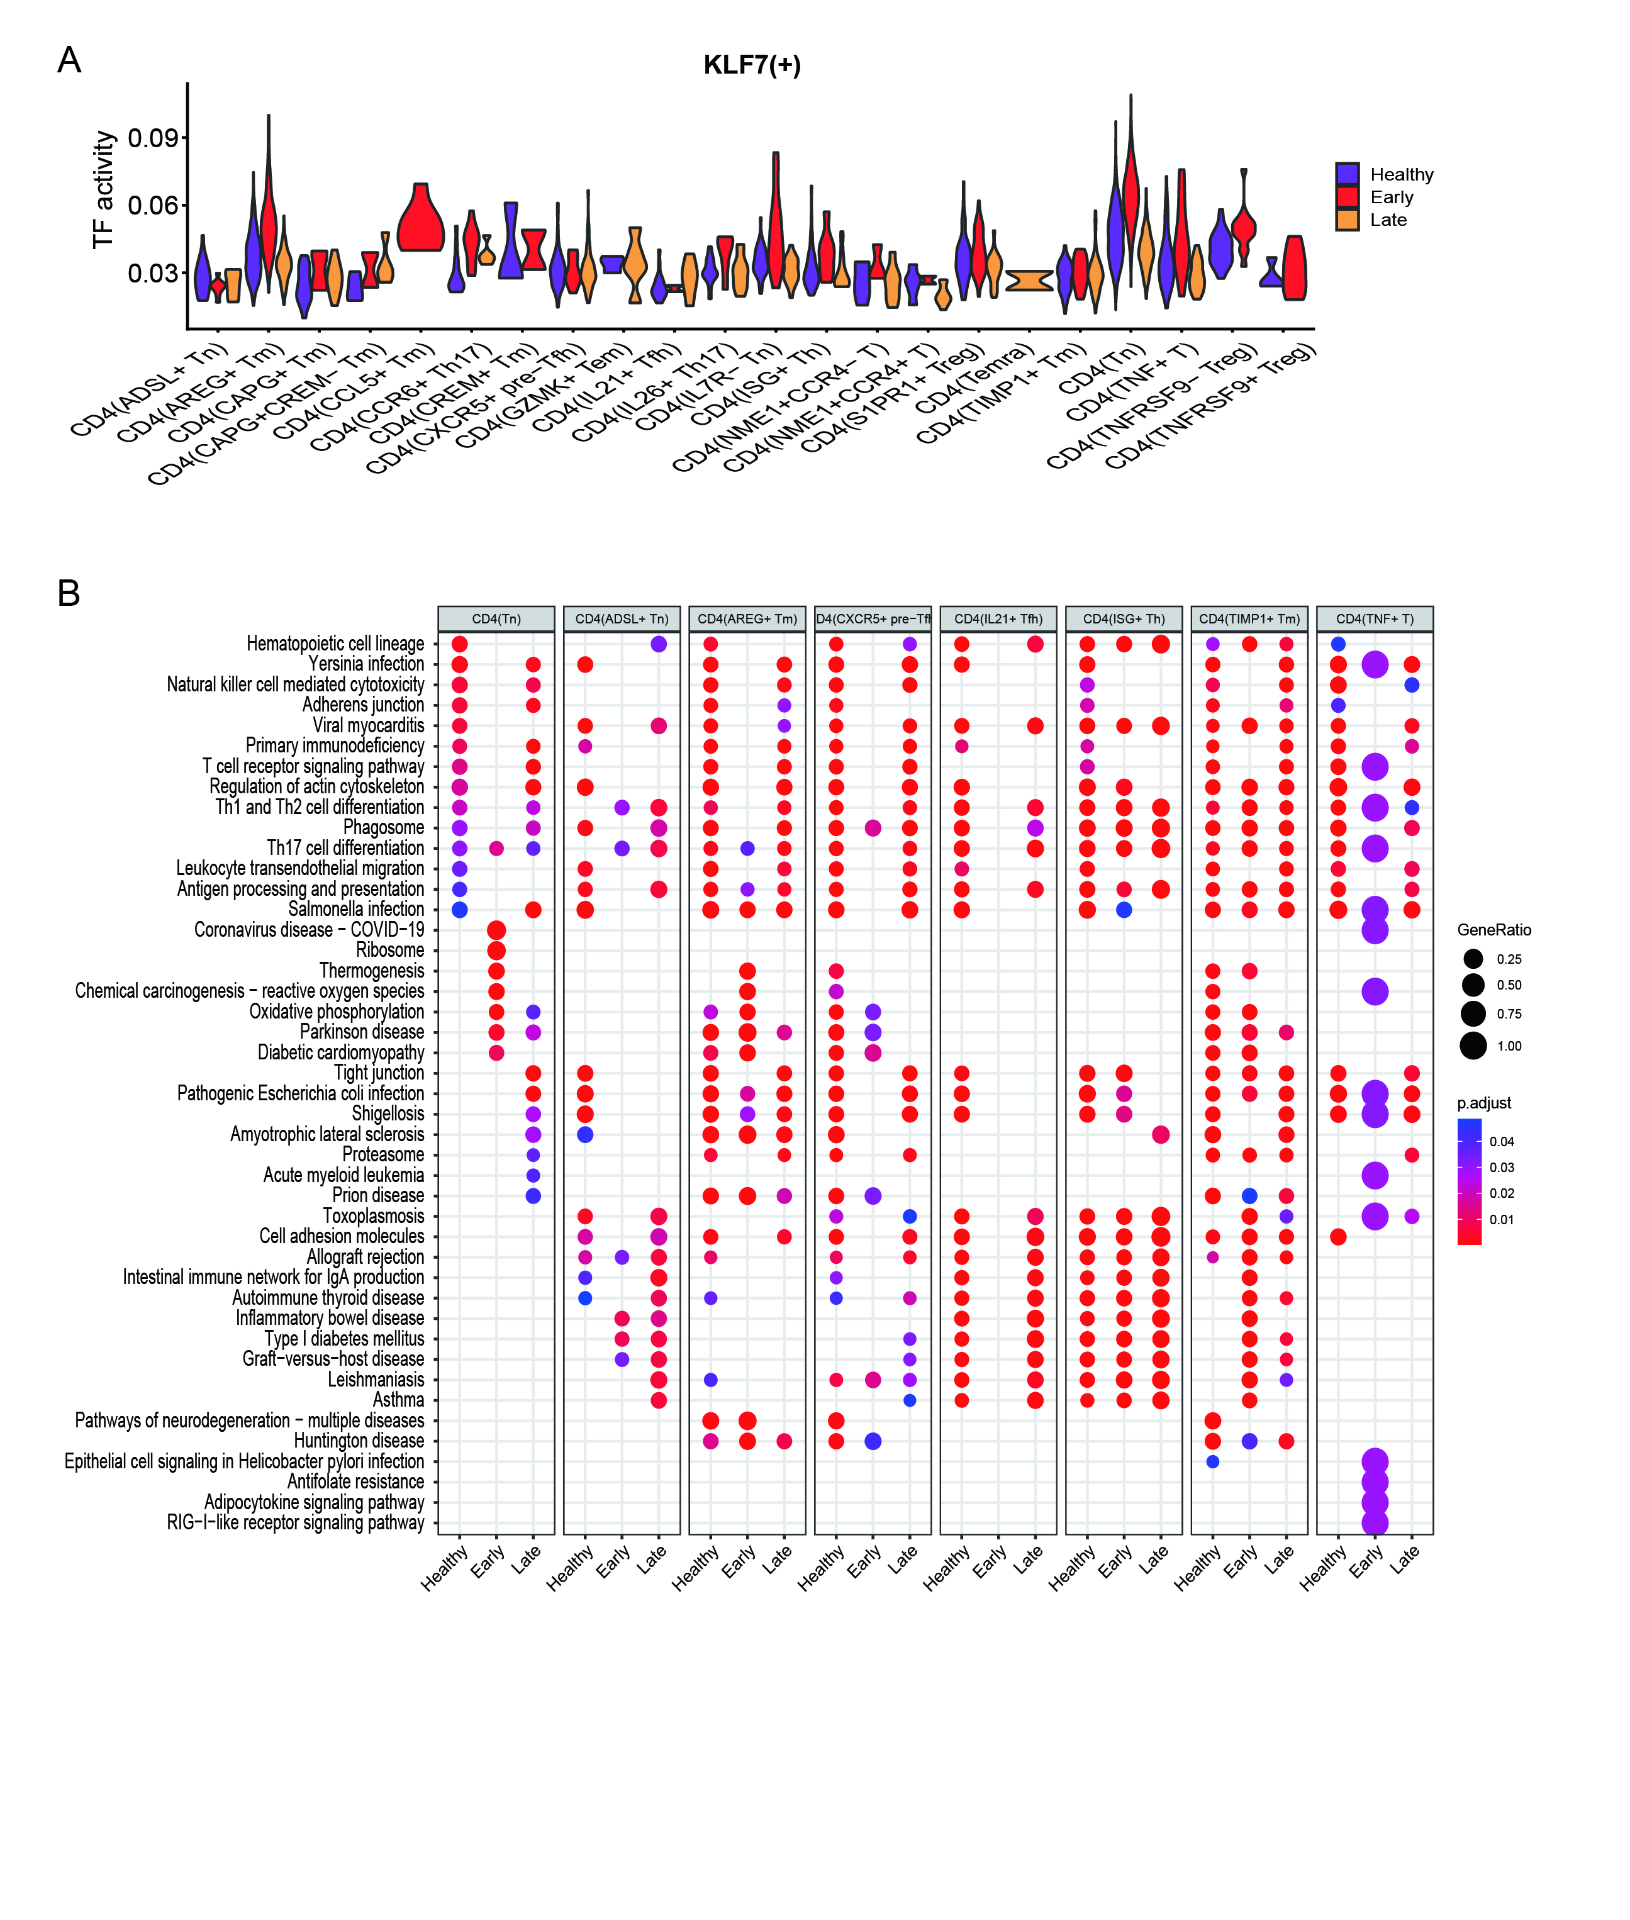
Supplementary Figure 4: Other specific transcription factors in CD4 Tn and GO analysis. A. CD4 Tn specific transcription factor: KLF7. B: GO analysis of statistically significant CD4 T cell subpopulations.
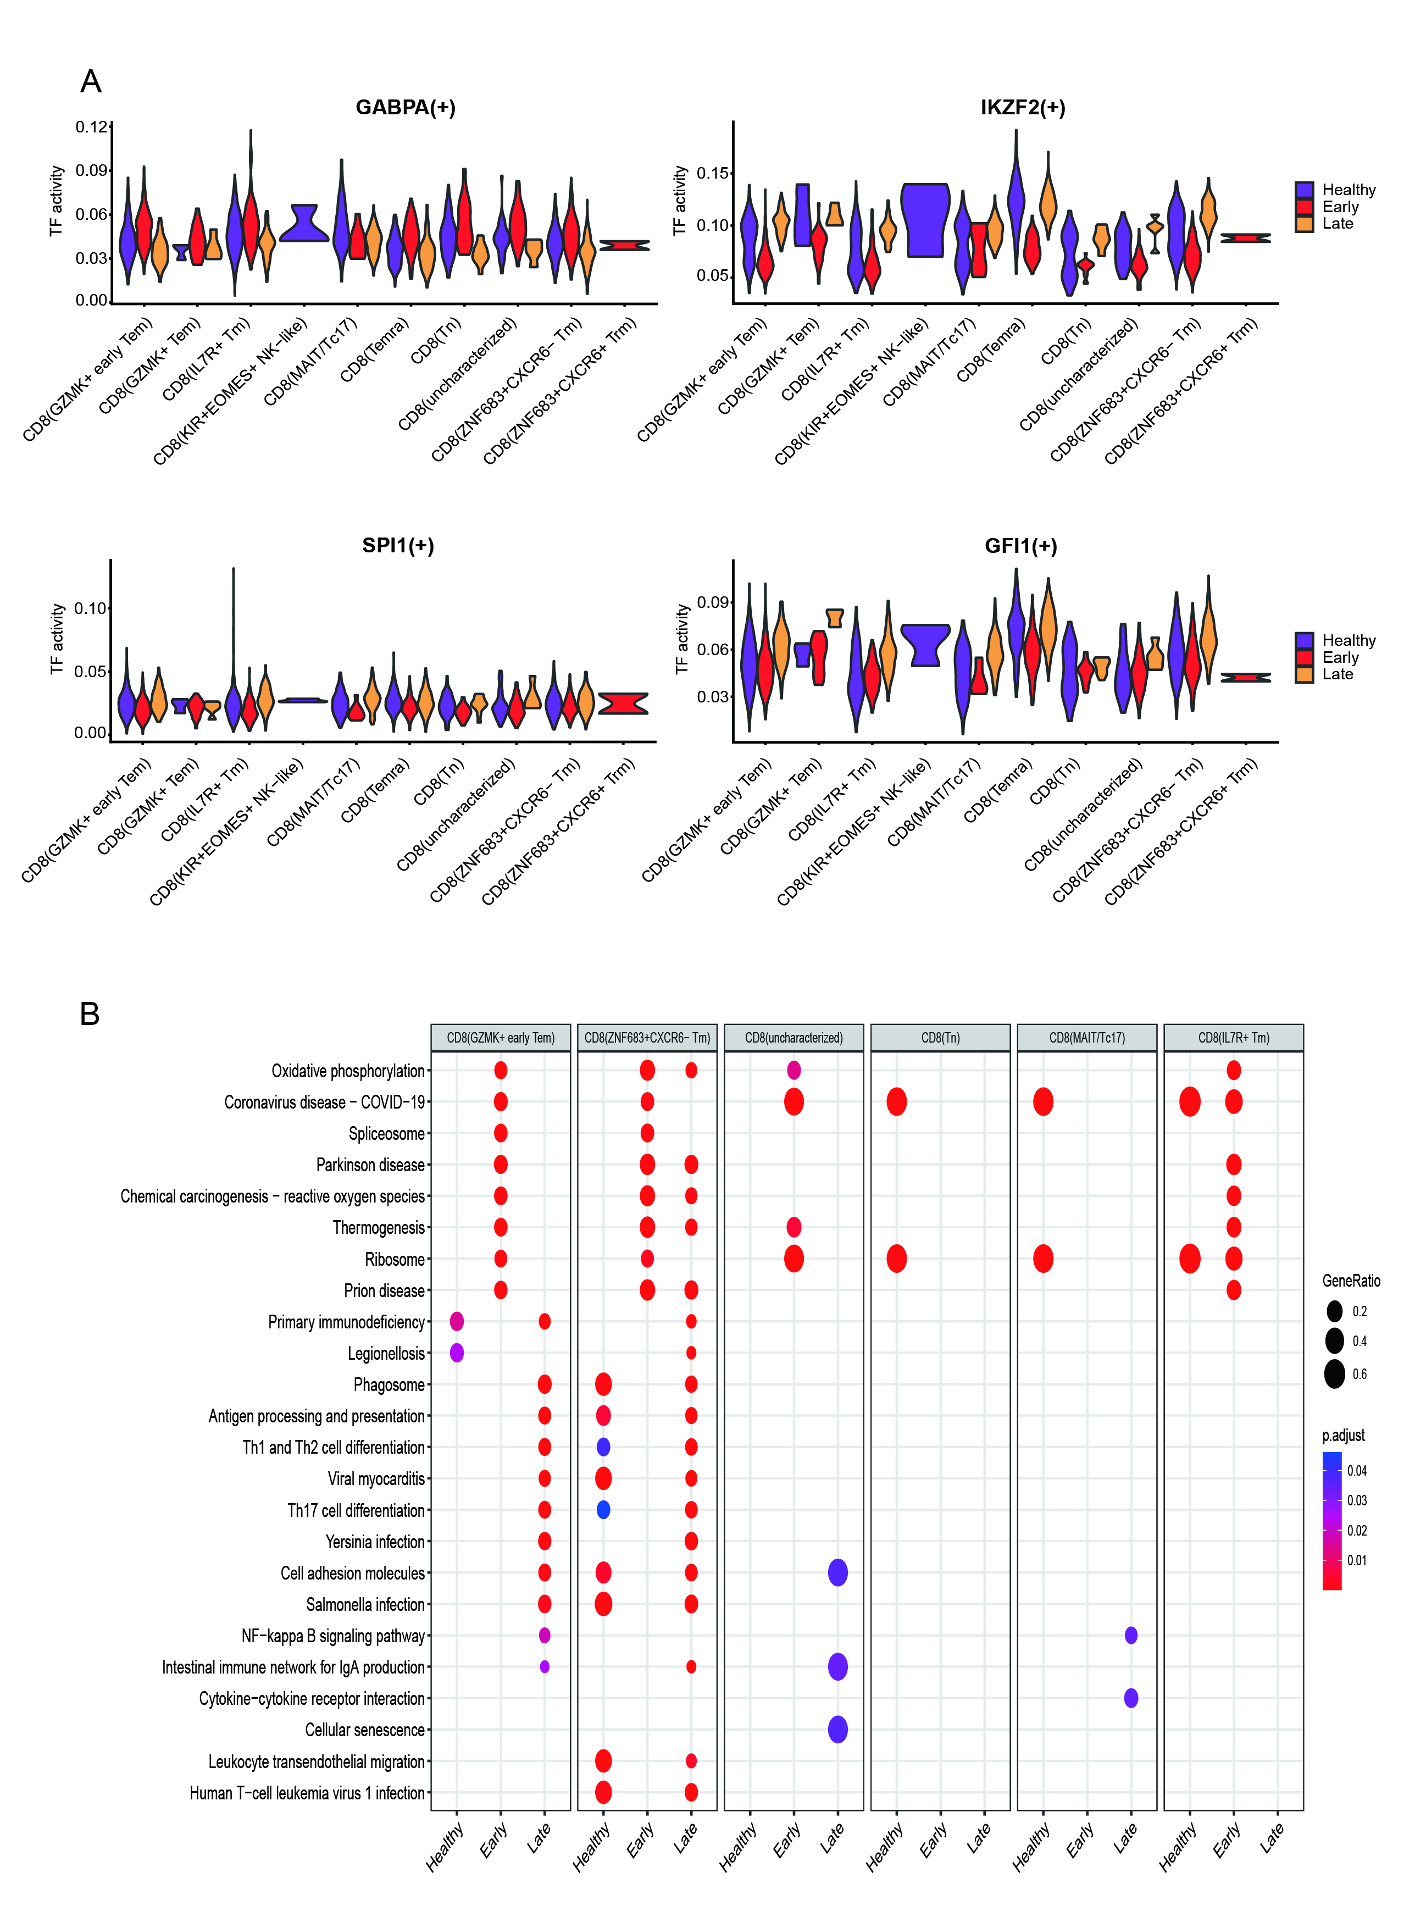
Supplementary Figure 5: Other specific transcription factors and GO analysis in CD8(GZMK+ early Tem), and CD8(ZNF683+CXCR6- Tm) cells. A. CD8(GZMK+ early Tem) cells specific transcription factor: KLF7; CD8(ZNF683+CXCR6- Tm) cells-specific transcription factors: IKZF2, SPI1, GFI1. B: GO analysis of statistically significant CD8 T cell subpopulations.

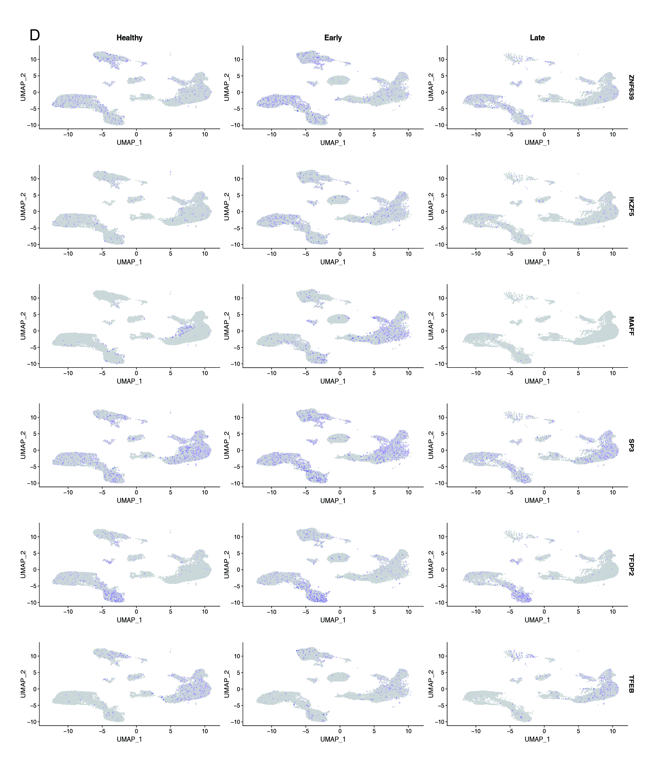
Supplementary Figure 6: At the gene level, UMAP of the other transcription factors(ZNF639, IKZF5, MAFF, SP3, TFDP2, TFEB).

