Supplementary Material

Figure S1. Distribution of (a) hospitals in the nine regions of England; and (b) income deprivation quintiles. 2
Table S1. Percentage of patients within 10km threshold 3
Figure S2. Distance between patient and hospital addresses (‘patient-to-hospital’). Red vertical line represents 10km threshold. 3
Table S2. STROBE checklist. 4
Table S3. Descriptive statistics of daily average NO₂, temperature and relative humidity across patients. 8
Figure S3. Yearly time-series plot of daily mean NO₂ concentrations averaged across all patients exposures. 9
Table S4. Sensitivity analysis: association of emergency hospital admission for asthma with daily lag exposure to NO₂, using only patients within the 10-kilometres patient-to-hospital distance. Odds ratios are per 10 µg/m³ change in NO₂. 9
Table S5. Association of asthma-related emergency hospital admission with different lag exposure to NO₂; overall and by age group (years) and sex. Odds ratios are per 10 µg/m³ change in NO₂. 11
Table S6. Association of asthma-related emergency hospital admission with different lag exposure to NO₂ by season and income deprivation quintile (IMD). Odds ratios are 10 µg/m³ change in NO₂. Warm season: April to September; cold season: October to March. IMD = indices of multiple deprivation (income), with IMD1 (quintile 1) being the least deprived and IMD5 (quintile 5) being the most deprived. 12
Table S7. Association of asthma-related emergency hospital admission with different lag exposure to NO₂ by region. Odds ratios are per 10 µg/m³ change in NO₂. 14

Figure S1. Distribution of (a) hospitals in the nine regions of England; and (b) income deprivation quintiles.
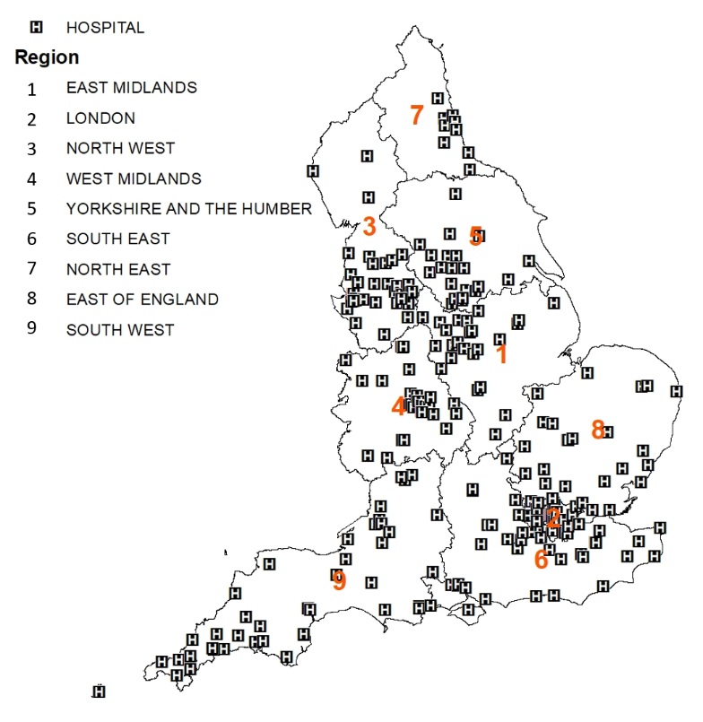
- Hospitals and regions of England.
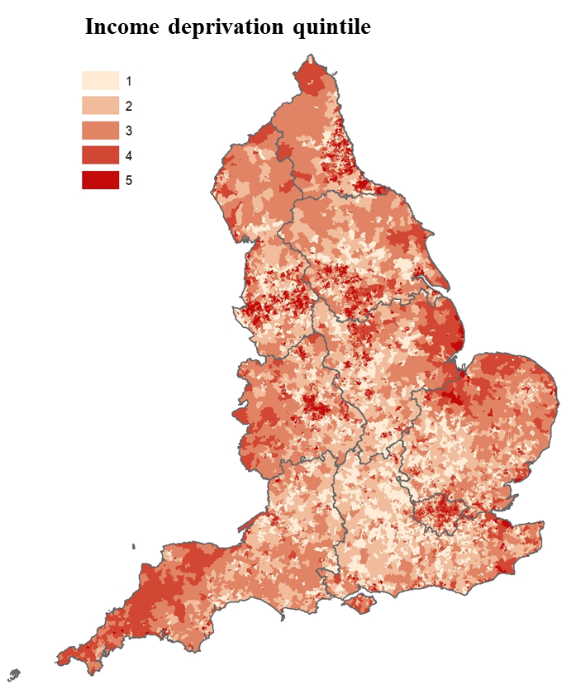
- Colour-coded income deprivation quintile by Lower Layer Super Output Area (LSOA). With quintile 1 being the least deprived, and quintile 5 being the most deprived.

Table S1. Percentage of patients within 10km threshold
 | %Patients within 10km ‘patient-to-hospital’ threshold
Overall | 73
Season
Warm season | 72
Cold season | 74
Month
Jan | 75
Feb | 74
Mar | 74
Apr | 72
May | 73
Jun | 74
Jul | 72
Aug | 68
Sep | 74
Oct | 74
Nov | 73
Dec | 72

Figure S2. Distance between patient and hospital addresses (‘patient-to-hospital’). Red vertical line represents 10km threshold.

Table S2. STROBE checklist.
 | Item No. | Recommendation | Page  No. | Relevant text from manuscript
Title and abstract | 1 | (a) Indicate the study’s design with a commonly used term in the title or the abstract | 1 | Title, Abstract (“case-crossover”)
Title and abstract | 1 | (b) Provide in the abstract an informative and balanced summary of what was done and what was found | 1 | Abstract
Introduction
Background/rationale | 2 | Explain the scientific background and rationale for the investigation being reported | 5 | Introduction
Objectives | 3 | State specific objectives, including any prespecified hypotheses | 5 | Introduction
Methods
Study design | 4 | Present key elements of study design early in the paper | 6 | Materials and methods
Setting | 5 | Describe the setting, locations, and relevant dates, including periods of recruitment, exposure, follow-up, and data collection | 6 | Materials and methods
Participants | 6 | (a) Cohort study—Give the eligibility criteria, and the sources and methods of selection of participants. Describe methods of follow-up  Case-control study—Give the eligibility criteria, and the sources and methods of case ascertainment and control selection. Give the rationale for the choice of cases and controls  Cross-sectional study—Give the eligibility criteria, and the sources and methods of selection of participants | 6,8 | Materials and methods – Study population and comes/Statistical analysis
Participants | 6 | (b) Cohort study—For matched studies, give matching criteria and number of exposed and unexposed  Case-control study—For matched studies, give matching criteria and the number of controls per case | 8 | Materials and methods – Statistical analysis
Variables | 7 | Clearly define all outcomes, exposures, predictors, potential confounders, and effect modifiers. Give diagnostic criteria, if applicable | 6 | Materials and methods
Data sources/ measurement | 8* | For each variable of interest, give sources of data and details of methods of assessment (measurement). Describe comparability of assessment methods if there is more than one group | 6 | Materials and methods
Bias | 9 | Describe any efforts to address potential sources of bias | 8 | Materials and methods – Statistical analysis
Study size | 10 | Explain how the study size was arrived at | 6,10, Supplementary | Materials and methods – Study population and outcome, Results, Figure S3

Quantitative variables | 11 | Explain how quantitative variables were handled in the analyses. If applicable, describe which groupings were chosen and why | 6 | Materials and methods
Statistical methods | 12 | (a) Describe all statistical methods, including those used to control for confounding | 6 | Materials and methods
Statistical methods | 12 | (b) Describe any methods used to examine subgroups and interactions | 8 | Materials and methods – Statistical analysis
Statistical methods | 12 | (c) Explain how missing data were addressed | 10 | Results (cases with missing sex or postcode were removed)
Statistical methods | 12 | (d) Cohort study—If applicable, explain how loss to follow-up was addressed  Case-control study—If applicable, explain how matching of cases and controls was addressed  Cross-sectional study—If applicable, describe analytical methods taking account of sampling strategy | 8 | Materials and methods – Statistical analysis
Statistical methods | 12 | (e) Describe any sensitivity analyses | 8 | Materials and methods – Statistical analysis
Results
Participants | 13* | (a) Report numbers of individuals at each stage of study—eg numbers potentially eligible, examined for eligibility, confirmed eligible, included in the study, completing follow-up, and analysed | 6,10, Supplementary | Materials and methods – Study population and outcome, Results, Figure S3
Participants | 13* | (b) Give reasons for non-participation at each stage | 6,10, Supplementary | Materials and methods – Study population and outcome, Results, Figure S3
Participants | 13* | (c) Consider use of a flow diagram | Supplementary | Figure S3
Descriptive data | 14* | (a) Give characteristics of study participants (eg demographic, clinical, social) and information on exposures and potential confounders | 10,  Supplementary | Results, Table 1, Table S2
Descriptive data | 14* | (b) Indicate number of participants with missing data for each variable of interest | N/A | Exposure and confounder data do not have missing data
Descriptive data | 14* | (c) Cohort study—Summarise follow-up time (eg, average and total amount) | N/A | Case-crossover study
Outcome data | 15* | Cohort study—Report numbers of outcome events or summary measures over time | N/A | Case-crossover study
Outcome data | 15* | Case-control study—Report numbers in each exposure category, or summary measures of exposure | N/A | Case-crossover study
Outcome data | 15* | Cross-sectional study—Report numbers of outcome events or summary measures | N/A | Case-crossover study
Main results | 16 | (a) Give unadjusted estimates and, if applicable, confounder-adjusted estimates and their precision (eg, 95% confidence interval). Make clear which confounders were adjusted for and why they were included | 10 | Results, Figure 2
Main results | 16 | (b) Report category boundaries when continuous variables were categorized | 10 | Results
Main results | 16 | (c) If relevant, consider translating estimates of relative risk into absolute risk for a meaningful time period | N/A | N/A

Other analyses | 17 | Report other analyses done—eg analyses of subgroups and interactions, and sensitivity analyses | 10, Supplementary | Results, Table S3, Figure S5-S8
Discussion
Key results | 18 | Summarise key results with reference to study objectives | 17 | Discussion
Limitations | 19 | Discuss limitations of the study, taking into account sources of potential bias or imprecision. Discuss both direction and magnitude of any potential bias | 21 | Discussion – Strengths and limitations
Interpretation | 20 | Give a cautious overall interpretation of results considering objectives, limitations, multiplicity of analyses, results from similar studies, and other relevant evidence | 17 | Discussion
Generalisability | 21 | Discuss the generalisability (external validity) of the study results | N/A | N/A
Other information
Funding | 22 | Give the source of funding and the role of the funders for the present study and, if applicable, for the original study on which the present article is based | 24 | Funding

*Give information separately for cases and controls in case-control studies and, if applicable, for exposed and unexposed groups in cohort and cross-sectional studies.

Note: An Explanation and Elaboration article discusses each checklist item and gives methodological background and published examples of transparent reporting. The STROBE checklist is best used in conjunction with this article (freely available on the Web sites of PLoS Medicine at http://www.plosmedicine.org/, Annals of Internal Medicine at http://www.annals.org/, and Epidemiology at http://www.epidem.com/). Information on the STROBE Initiative is available at www.strobe-statement.org.

Table S3. Descriptive statistics of daily average NO₂, temperature and relative humidity across patients.
Variable | Median | Mean | IQR
NO₂ (µg/m³)*
All | 17.1 | 19.0 | 12.6-26.5
Season
Warm season | 15.5 | 17.4 | 11.0-22.8
Cold season | 17.6 | 19.6 | 14.4-29.7
Region
South West | 11.7 | 13.0 | 8.2-16.2
Yorkshire and the Humber | 15.6 | 16.6 | 11.9-20.4
East Midlands | 14.5 | 15.9 | 11.1-19.5
London | 28.7 | 29.5 | 23.4-35.0
North West | 18.6 | 19.7 | 14.5-23.9
West Midlands | 17.0 | 17.8 | 12.9-21.8
East of England | 13.9 | 14.9 | 10.6-18.0
South East | 13.6 | 14.6 | 10.4-18.0
North East | 13.8 | 15.0 | 10.2-18.5
Income deprivation quintile
1 (least deprived) | 13.6 | 15.3 | 9.5-19.3
2 | 14.3 | 16.5 | 9.6-20.9
3 | 15.3 | 17.5 | 9.9-22.6
4 | 18.2 | 20.6 | 11.9-26.6
5 (most deprived) | 18.9 | 21.2 | 13.1-27.1
Daily mean temperature (°C)†
All | 10.1 | 9.8 | 6.7-12.8
Warm season | 12.4 | 12.3 | 10.2-14.5
Cold season | 7.2 | 7.2 | 4.6-10.1
Daily mean relative humidity (%)†
All | 82.3 | 81.8 | 75.9-88.2
Warm season | 79.0 | 78.8 | 72.7-85.0
Cold season | 85.2 | 84.8 | 79.8-90.4
*Descriptive statistics of NO₂ is based on daily data for patient cases with less than or equal to 10-km ‘patient-to-hospital’ distance
†Descriptive statistics of daily weather (temperature and relative humidity) data at patient residential postcode

Figure S3. Yearly time-series plot of daily mean NO₂ concentrations averaged across all patients exposures.

Table S4. Sensitivity analysis: association of emergency hospital admission for asthma with daily lag exposure to NO₂, using only patients within the 10-kilometres patient-to-hospital distance. Odds ratios are per 10 µg/m³ change in NO₂.
Category |  | OR (95%CI) | P-value
All |  | 1.083 (1.063, 1.105) | 0.000
Age group (years) | 0–4 | 1.078 (1.046, 1.110) | 0.000
Age group (years) | 5–9 | 1.095 (1.061, 1.130) | 0.000
Age group (years) | 10–14 | 1.072 (1.026, 1.120) | 0.001
Sex | Male | 1.101 (1.074, 1.128) | 0.000
Sex | Female | 1.055 (1.021, 1.089) | 0.001
Season | Warm | 1.070 (0.994, 1.153) | 0.070
Season | Cold | 1.082 (1.018, 1.151) | 0.011
Income deprivation quintile | 1 (least deprived) | 1.106 (1.048, 1.167) | 0.000
Income deprivation quintile | 2 | 1.084 (1.043, 1.127) | 0.000
Income deprivation quintile | 3 | 1.080 (1.049, 1.112) | 0.000
Income deprivation quintile | 4 | 1.127 (1.013, 1.254) | 0.027
Income deprivation quintile | 5 (most deprived) | 1.105 (1.060, 1.152) | 0.000
Region | South West | 1.099 (1.074, 1.125) | 0.000
Region | Yorkshire and the Humber | 1.002 (0.915, 1.098) | 0.953
Region | East Midlands | 1.075 (1.035, 1.116) | 0.000
Region | London | 1.059 (1.008, 1.112) | 0.020
Region | North West | 1.131 (1.057, 1.209) | 0.000
Region | West Midlands | 1.058 (0.988, 1.132) | 0.105
Region | East of England | 0.937 (0.901, 0.975) | 0.000
Region | South East | 1.062 (0.974, 1.158) | 0.171
Region | North East | 1.168 (1.074, 1.271) | 0.000
Values in bold indicate statistical significance with p-value < 0.05

Table S5. Association of asthma-related emergency hospital admission with different lag exposure to NO₂; overall and by age group (years) and sex. Odds ratios are per 10 µg/m³ change in NO₂.
Category |  | Lag | OR (95% CI) | P-value
All |  | 0 | 1.030 (1.008, 1.018) | 0.000
 |  | 1 | 1.042 (1.013, 1.023) | 0.000
 |  | 2 | 1.040 (1.012, 1.022) | 0.000
 |  | 3 | 1.038 (1.011, 1.021) | 0.000
 |  | 4 | 1.047 (1.015, 1.025) | 0.000
 |  | 0-4 | 1.082 (1.027, 1.043) | 0.000
Age groups (years) | 0–4 | 0 | 1.035 (1.007, 1.023) | 0.000
 |  | 1 | 1.054 (1.015, 1.031) | 0.000
 |  | 2 | 1.033 (1.007, 1.022) | 0.000
 |  | 3 | 1.043 (1.010, 1.026) | 0.000
 |  | 4 | 1.047 (1.013, 1.028) | 0.000
 |  | 0-4 | 1.089 (1.026, 1.050) | 0.000
 | 5–9 | 0 | 1.029 (1.004, 1.021) | 0.003
 |  | 1 | 1.034 (1.006, 1.023) | 0.001
 |  | 2 | 1.047 (1.012, 1.029) | 0.000
 |  | 3 | 1.027 (1.004, 1.020) | 0.005
 |  | 4 | 1.048 (1.012, 1.029) | 0.000
 |  | 0-4 | 1.077 (1.020, 1.045) | 0.000
 | 10–14 | 0 | 1.022 (0.998, 1.021) | 0.103
 |  | 1 | 1.031 (1.002, 1.025) | 0.021
 |  | 2 | 1.038 (1.005, 1.028) | 0.005
 |  | 3 | 1.045 (1.008, 1.031) | 0.001
 |  | 4 | 1.045 (1.008, 1.031) | 0.001
 |  | 0-4 | 1.075 (1.015, 1.049) | 0.000
Sex | Male | 0 | 1.032 (1.007, 1.020) | 0.000
 |  | 1 | 1.050 (1.015, 1.028) | 0.000
 |  | 2 | 1.047 (1.014, 1.027) | 0.000
 |  | 3 | 1.041 (1.011, 1.024) | 0.000
 |  | 4 | 1.056 (1.018, 1.031) | 0.000
 |  | 0-4 | 1.096 (1.031, 1.050) | 0.000
 | Female | 0 | 1.027 (1.003, 1.020) | 0.006
 |  | 1 | 1.029 (1.004, 1.021) | 0.004
 |  | 2 | 1.028 (1.004, 1.020) | 0.005
 |  | 3 | 1.032 (1.006, 1.022) | 0.001
 |  | 4 | 1.032 (1.005, 1.022) | 0.001
 |  | 0-4 | 1.060 (1.013, 1.038) | 0.000
Values in bold indicate statistical significance with p-value < 0.05

Table S6. Association of asthma-related emergency hospital admission with different lag exposure to NO₂ by season and income deprivation quintile (IMD). Odds ratios are 10 µg/m³ change in NO₂. Warm season: April to September; cold season: October to March. IMD = indices of multiple deprivation (income), with IMD1 (quintile 1) being the least deprived and IMD5 (quintile 5) being the most deprived.
Category |  | Lag | OR (95% CI) | P-value
Season | Warm | 0 | 0.953 (0.970, 0.989) | 0.000
 |  | 1 | 0.979 (0.981, 1.000) | 0.059
 |  | 2 | 0.966 (0.976, 0.994) | 0.002
 |  | 3 | 0.956 (0.971, 0.990) | 0.000
 |  | 4 | 0.992 (0.988, 1.006) | 0.483
 |  | 0-4 | 0.933 (0.956, 0.985) | 0.000
 | Cold | 0 | 1.049 (1.015, 1.027) | 0.000
 |  | 1 | 1.051 (1.016, 1.028) | 0.000
 |  | 2 | 1.052 (1.016, 1.029) | 0.000
 |  | 3 | 1.053 (1.017, 1.029) | 0.000
 |  | 4 | 1.052 (1.016, 1.029) | 0.000
 |  | 0-4 | 1.101 (1.034, 1.052) | 0.000
Income deprivation quintile | 1 (least deprived) | 0 | 1.005 (0.986, 1.019) | 0.788
 |  | 1 | 0.998 (0.982, 1.016) | 0.902
 |  | 2 | 1.017 (0.991, 1.024) | 0.394
 |  | 3 | 1.025 (0.994, 1.027) | 0.203
 |  | 4 | 1.051 (1.005, 1.039) | 0.010
 |  | 0-4 | 1.038 (0.992, 1.041) | 0.185
 | 2 | 0 | 1.047 (1.005, 1.035) | 0.008
 |  | 1 | 1.035 (1.000, 1.030) | 0.045
 |  | 2 | 1.053 (1.008, 1.037) | 0.002
 |  | 3 | 1.024 (0.996, 1.025) | 0.166
 |  | 4 | 1.037 (1.002, 1.031) | 0.030
 |  | 0-4 | 1.081 (1.013, 1.056) | 0.001
 | 3 | 0 | 1.046 (1.007, 1.033) | 0.003
 |  | 1 | 1.055 (1.010, 1.037) | 0.001
 |  | 2 | 1.064 (1.014, 1.041) | 0.000
 |  | 3 | 1.047 (1.007, 1.034) | 0.002
 |  | 4 | 1.059 (1.012, 1.039) | 0.000
 |  | 0-4 | 1.113 (1.028, 1.068) | 0.000
 | 4 | 0 | 1.028 (1.002, 1.023) | 0.022
 |  | 1 | 1.052 (1.012, 1.033) | 0.000
 |  | 2 | 1.026 (1.001, 1.022) | 0.033
 |  | 3 | 1.030 (1.002, 1.023) | 0.015
 |  | 4 | 1.037 (1.006, 1.026) | 0.002
 |  | 0-4 | 1.072 (1.015, 1.046) | 0.000
 | 5 (most deprived) | 0 | 1.027 (1.003, 1.020) | 0.006
 |  | 1 | 1.044 (1.010, 1.027) | 0.000
 |  | 2 | 1.041 (1.009, 1.026) | 0.000
 |  | 3 | 1.047 (1.012, 1.028) | 0.000
 |  | 4 | 1.051 (1.014, 1.030) | 0.000
 |  | 0-4 | 1.089 (1.025, 1.050) | 0.000
Values in bold indicate statistical significance with p-value < 0.05

Table S7. Association of asthma-related emergency hospital admission with different lag exposure to NO₂ by region. Odds ratios are per 10 µg/m³ change in NO₂.
Category |  | Lag | OR (95% CI) | P-value
Region | East Midlands | 0 | 1.040 (0.992, 1.042) | 0.179
 |  | 1 | 1.098 (1.017, 1.067) | 0.001
 |  | 2 | 1.042 (0.994, 1.043) | 0.149
 |  | 3 | 1.053 (0.999, 1.048) | 0.066
 |  | 4 | 1.047 (0.996, 1.045) | 0.101
 |  | 0-4 | 1.114 (1.011, 1.086) | 0.010
 | London | 0 | 1.040 (1.006, 1.029) | 0.003
 |  | 1 | 1.039 (1.005, 1.028) | 0.004
 |  | 2 | 1.038 (1.005, 1.028) | 0.005
 |  | 3 | 1.034 (1.003, 1.026) | 0.010
 |  | 4 | 1.047 (1.009, 1.031) | 0.000
 |  | 0-4 | 1.095 (1.023, 1.058) | 0.000
 | North West | 0 | 1.030 (1.002, 1.024) | 0.016
 |  | 1 | 1.055 (1.013, 1.034) | 0.000
 |  | 2 | 1.033 (1.004, 1.025) | 0.008
 |  | 3 | 1.037 (1.005, 1.026) | 0.003
 |  | 4 | 1.051 (1.012, 1.033) | 0.000
 |  | 0-4 | 1.086 (1.021, 1.052) | 0.000
 | West Midlands | 0 | 1.007 (0.989, 1.017) | 0.668
 |  | 1 | 1.025 (0.997, 1.025) | 0.136
 |  | 2 | 1.064 (1.013, 1.041) | 0.000
 |  | 3 | 1.053 (1.009, 1.036) | 0.001
 |  | 4 | 1.049 (1.008, 1.035) | 0.002
 |  | 0-4 | 1.077 (1.013, 1.053) | 0.001
 | Yorkshire and the Humber | 0 | 1.034 (0.996, 1.033) | 0.117
 |  | 1 | 1.035 (0.997, 1.034) | 0.098
 |  | 2 | 1.072 (1.012, 1.049) | 0.001
 |  | 3 | 1.076 (1.014, 1.051) | 0.000
 |  | 4 | 1.054 (1.005, 1.041) | 0.011
 |  | 0-4 | 1.118 (1.022, 1.078) | 0.000
 | South East | 0 | 1.031 (0.997, 1.030) | 0.112
 |  | 1 | 1.023 (0.994, 1.027) | 0.231
 |  | 2 | 1.025 (0.995, 1.027) | 0.187
 |  | 3 | 1.006 (0.986, 1.019) | 0.770
 |  | 4 | 1.034 (0.999, 1.031) | 0.073
 |  | 0-4 | 1.051 (0.999, 1.045) | 0.066
 | North East | 0 | 1.001 (0.978, 1.023) | 0.973
 |  | 1 | 1.013 (0.983, 1.029) | 0.643
 |  | 2 | 1.010 (0.982, 1.027) | 0.718
 |  | 3 | 0.983 (0.970, 1.015) | 0.506
 |  | 4 | 1.030 (0.990, 1.036) | 0.266
 |  | 0-4 | 1.010 (0.972, 1.038) | 0.786
 | East of England | 0 | 1.043 (0.998, 1.039) | 0.071
 |  | 1 | 1.035 (0.996, 1.035) | 0.131
 |  | 2 | 1.020 (0.989, 1.029) | 0.378
 |  | 3 | 1.021 (0.989, 1.029) | 0.372
 |  | 4 | 1.029 (0.993, 1.032) | 0.213
 |  | 0-4 | 1.061 (0.997, 1.056) | 0.083
 | South West | 0 | 1.054 (1.004, 1.043) | 0.016
 |  | 1 | 1.072 (1.011, 1.050) | 0.002
 |  | 2 | 1.051 (1.003, 1.041) | 0.021
 |  | 3 | 1.068 (1.011, 1.048) | 0.002
 |  | 4 | 1.069 (1.011, 1.048) | 0.002
 |  | 0-4 | 1.120 (1.023, 1.078) | 0.000
Values in bold indicate statistical significance with p-value < 0.05

