SUPPLEMENTARY TABLES
Supplementary Table 1. Characteristics of convincing allergy, probable allergy and self-report allergy between
N = 285 | Among respondents  (N=1038) | Among reported SFA  (N=285)
Any | 285 (27.46%) | 285 (100%)
Convincing allergy | 209 (20.13%) | 209 (73.33%)
Probable allergy | 23 (2.22%) | 23 (8.07%)
Self-reported allergy | 53 (5.11%) | 53 (18.6%)
Shellfish allergy | 265 (25.53%) | 265 (92.98%)
Convincing allergy | 197 (18.98%) | 197 (69.12%)
Probable allergy | 22 (2.12%) | 22 (7.72%)
Self-reported allergy | 46 (4.43%) | 46 (16.14%)
Fish allergy | 51 (4.91%) | 51 (17.89%)
Convincing allergy | 37 (3.56%) | 37 (12.98%)
Probable allergy | 3 (0.29%) | 3 (1.05%)
Self-reported allergy | 11 (1.06%) | 11 (3.86%)
Shellfish & fish | 31 (2.99%) | 31 (10.88%)
Convincing allergy | 25 (2.41%) | 25 (8.77%)
Probable allergy | 2 (0.19%) | 2 (0.7%)
Self-reported allergy | 4 (0.39%) | 4 (1.4%)
Supplementary Table 2. Profile of shellfish and fish among the convincing allergy group
- Shellfish allergy
Shellfish |  | N = 197
Crustaceans | Tiger prawn | 115 (58.38%)
Crustaceans | Seawater crab | 113 (57.36%)
Crustaceans | Sentinnel crab | 82 (41.62%)
Crustaceans | Freshwater crab | 69 (35.03%)
Crustaceans | Tiny shrimp | 60 (30.46%)
Crustaceans | Lobster | 3 (1.52%)
Mollusk | Squid | 32 (16.24%)
  9 (4.57%)
  12 (6.09%)
 | Clam | 18 (9.14%)
 | Oyster | 18 (9.14%)
 | Snail | 15 (7.61%)
Others |  | 6 (3.47%)
Unknown |  | 5.74%)

- Fish allergy
Fish | N = 37
Tuna | 21 (56.76%)
Mackerel | 10 (27.03%)
Pompano | 7 (18.92%)
Red tilapia | 2 (5.41%)
Salmon | 1 (2.70%)
Snakehead | 1 (2.70%)
Capelin | 0
Ray | 0
Others | 2 (5.41%)
Unknown | 1 (2.70%)

SUPPLEMENTARY FIGURE
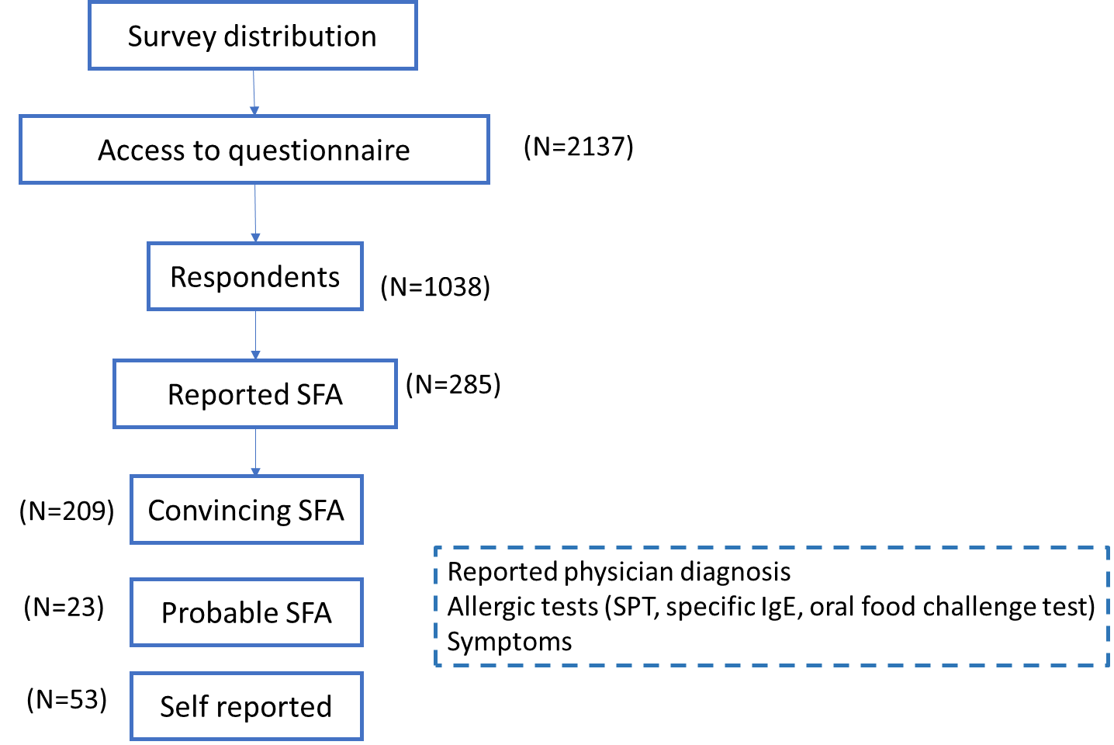
Supplementary Figure 1. Flowchart showing the data collection and selection of participants with SFA. SFA, seafood allergy

