SUPPLEMENTARY FIGURES
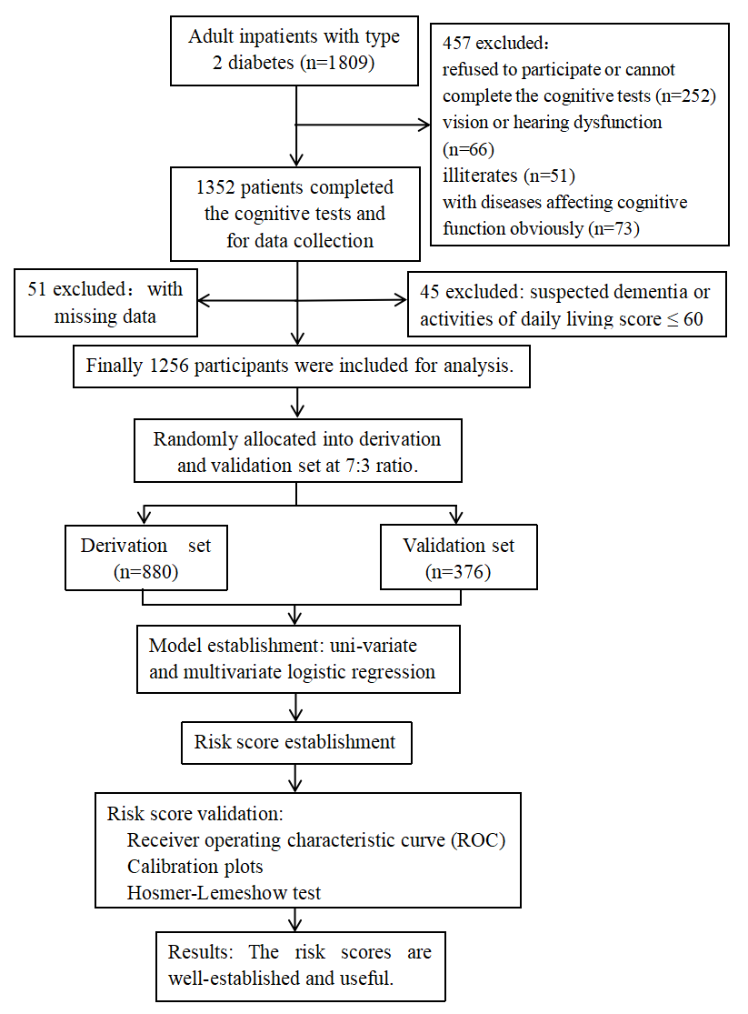
Supplementary Figure 1 Flowchart of the study.

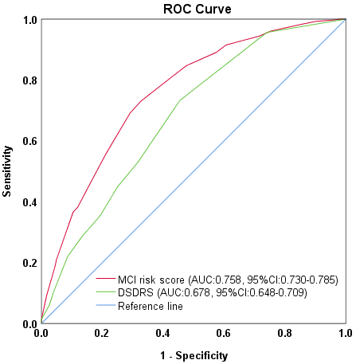
Supplementary Figure 2 Area under the receiver-operating characteristic curve (AUC) of the MCI risk score and the diabetes specific dementia risk score (DSDRS) in 1256 patients with diabetes.

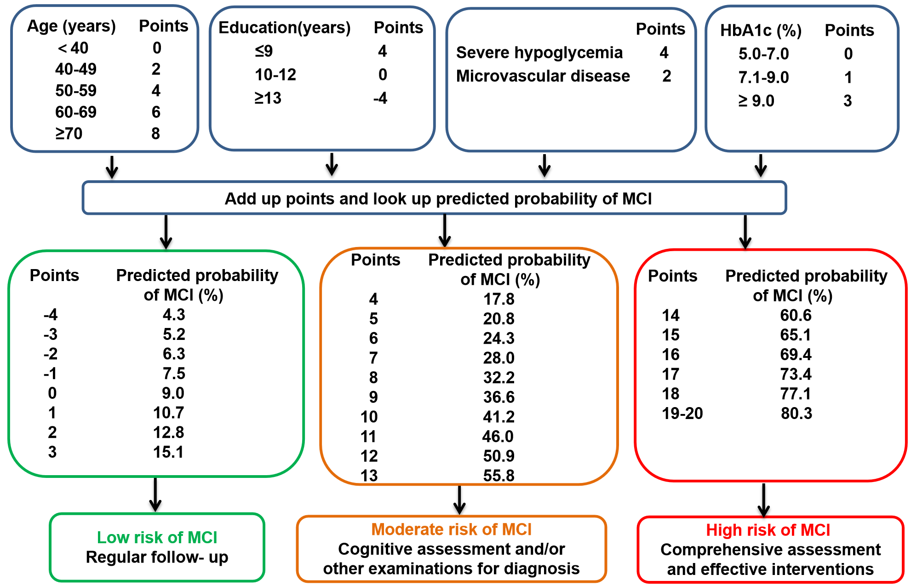
Supplementary Figure 3 Flowchart of summary of the diabetes specific MCI risk score.
Abbreviations: HbA_{1c}, hemoglobin A1c; MCI, mild cognitive impairment.

Supplementary Table 1 The steps for risk score construction.

Risk factor | Categories | Reference value (W_{ij}) | β_{i} | β_{i}(W_{ij}-W_{iREF}) | Points_{ij}=  β_{i}(W_{ij}-W_{iREF})/B | Integer Points
Age (years) |  |  | 0.048
 | ＜40* | 33.5=W_{1REF} |  | 0 | 0 | 0
 | 40-49 | 44.5 |  | 0.528 | 2.2 | 2
 | 50-59 | 54.5 |  | 1.008 | 4.2 | 4
 | 60-69 | 64.5 |  | 1.488 | 6.2 | 6
 | ≥70* | 75.0 |  | 1.992 | 8.3 | 8
Education  (years) |  |  | -0.178
 | ≤9* | 6 |  | 0.890 | 3.7 | 4
 | 10-12 | 11=W_{2REF} |  | 0 | 0 | 0
 | ＞12* | 16 |  | -0.890 | -3.7 | -4
HbA1c (%) |  |  | 0.126
 | 5.0-7.0 | 6.00=W_{3REF} |  | 0 | 0 | 0
 | 7.1-9.0 | 8.05 |  | 0.258 | 1.1 | 1
 | ＞9.0* | 12.05 |  | 0.762 | 3.2 | 3
Microvascular disease |  |  | 0.533
 | No | 0=W_{4REF} |  | 0 | 0 | 0
 | Yes | 1 |  | 0.533 | 4.0 | 4
Self-reported  history of severe hypoglycemia |  |  | 0.963
 | No | 0=W_{5REF} |  | 0 | 0 | 0
 | Yes | 1 |  | 0.963 | 2.2 | 2
Note：
W_{ij=}the middle value in the group.
*To determine the reference values (W_{ij}) for the first and last categories of age, education and HbA1c, we use the 1st percentile and the 99th percentile to minimize the influence of extreme values.
B=5β_{age}=5×0.048=0.24.

SUPPLEMENTARY TABLES

Supplementary Table 2 The sensitivity and specificity of the MCI risk score at the two cut-off points in the derivation and validation set
Cut-off | Predicted probability of MCI (%) | Derivation set |  |  |  | Validation set
Cut-off | Predicted probability of MCI (%) | Sensitivity(%) | Specificity(%) | PPV  (%) | NPV  (%) | Sensitivity  (%) | Specificity (%) | PPV  (%) | NPV  (%)
4 | 17.8 | 92.3 | 38.0 | 41.6 | 91.1 | 89.8 | 42.6 | 44.4 | 89.1
14 | 60.6 | 21.4 | 94.5 | 64.9 | 71.5 | 20.5 | 96.4 | 74.3 | 70.4

Abbreviations: MCI, mild cognitive impairment; PPV, positive predictive value; NPV, negative predictive value.

Supplementary Table 3 Binary logistic regression analysis of MCI in T2DM patients in different risk score groups in the derivation set

Variable | Groups | T2DM-CN  n (%) | T2DM-MCI  n (%) | β | OR (95%CI) | P-value
MCI risk score | low-score (≤3) | 226 (91.1) | 22 (8.9) | - | 1.00 | ＜0.001
 | medium-score (4-13) | 336 (62.5) | 202 (37.5) | 1.821 | 6.18 (3.86, 9.89) | ＜0.001
 | high-score (≥14) | 33 (35.1) | 61 (64.9) | 2.944 | 18.99 (10.33, 34.92) | ＜0.001

Abbreviations: T2DM, type 2 diabetes mellitus; CN, cognitively normal; MCI, mild cognitive impairment; OR, odds ratio, CI, confidence interval.

