Supplementary Table 1. Pathological classification of 57 LR-M observations of HCC
Subtype | Value
Trabecular type | 35 (61.4)
Trabecular mixed with pseudo-glandular type | 17 (29.8)
Solid type | 4 (7.0)
Trabecular mixed with solid type | 1 (1.8)

Note: Data are described as number of lesions with percentage in parenthesis.

Supplementary Table 2. The inter-reader agreement between the current readers for all features within LR-M and LI-RADS categories.
Feature | ĸ value | Agreement level
Major features
Non-rim APHE | 0.614 | Substantial
Non-peripheral washout | 0.667 | Substantial
Enhancing capsule | 0.806 | Excellent
Targetoid appearance
Rim APHE | 0.614 | Substantial
Thick rim | 0.688 | Substantial
Thin rim | 0.778 | Substantial
Peripheral washout | 0.692 | Substantial
Delayed central enhancement | 0.667 | Substantial
Targetoid DWI | 0.820 | Excellent
Targetoid TP/HBP | 0.824 | Excellent
Ancillary features
Surface retraction | 0.727 | Substantial
Bile duct dilatation | 0.840 | Excellent
Lobulated margin | 0.610 | Substantial
Modified LI-RADS category | 0.718 | Substantial
The kappa (κ) test was used to determine inter-observer agreement. A κ value of 0.01–0.20 was interpreted as slight, 0.21–0.40 as fair, 0.41–0.60 as moderate, 0.61–0.80 as substantial, and 0.81–1.00 as excellent agreement.

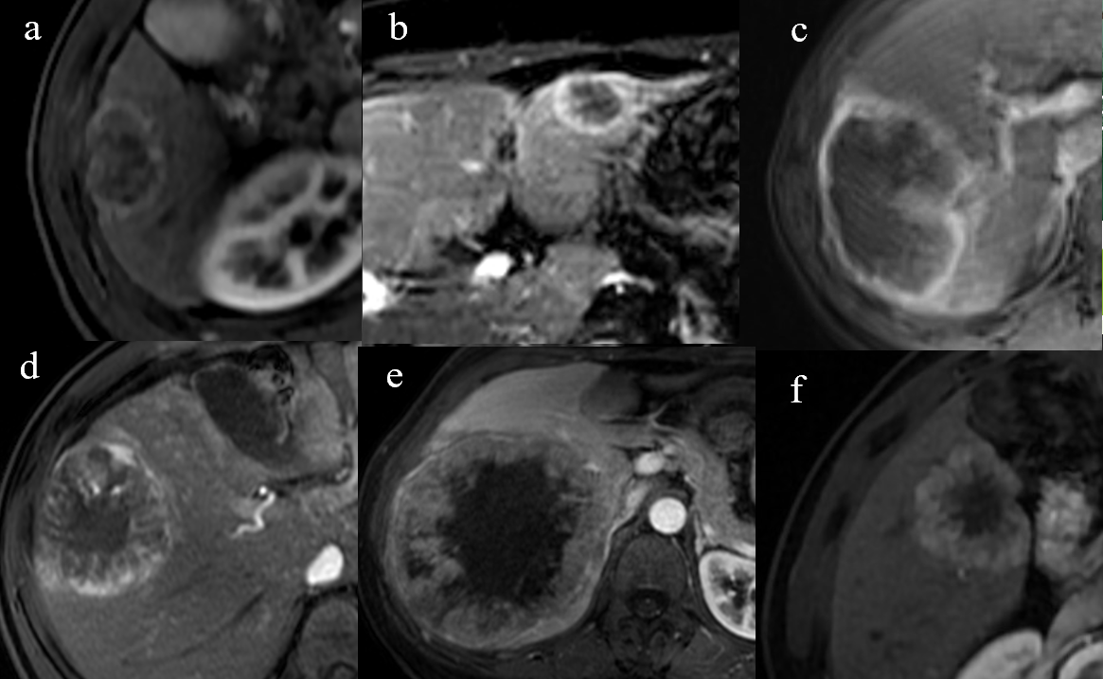
Supplementary Fig. 1 Typical thin rim and thick rim APHE in different cases.
a-c. The axial arterial phase images from three non-HCC malignancy cases showed thin-rim APHE;
d-f. The axial arterial phase images from three HCC cases presented thick-rim APHE.

Supplement for the LI-RADS
LI-RADS (Liver Imaging Reporting and Data System) is a system that provides interpretation and reporting guidelines for CT and MRI scans of patients at high risk for HCC. Among these, LI-RADS 5 indicates 100% certainty of HCC. LI-RADS M indicates high certainty of malignancy but the features are not specific for HCC. These levels of classification indicate that further treatment and management measures may be necessary. It is important to note that the LI-RADS classification is based on imaging findings, and a pathological examination (such as a biopsy) is still required for a definitive diagnosis of liver cancer.
The differences between LI-RADS 3-5 were showed with below Figure which was cited from the LI-RADS v2018.
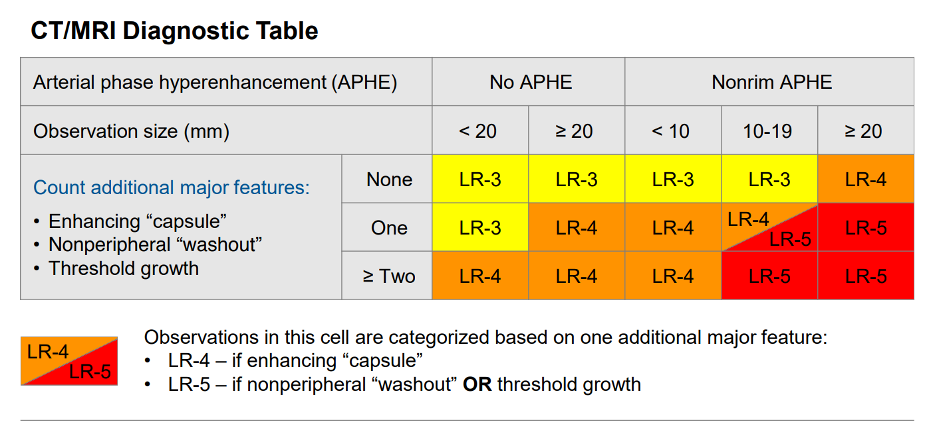

The conventional criteria of the LI-RADS M as shown in the following table
Targetoid features | Imaging appearance
Rim APHE | Spatially defined subtype of APHE in which arterial phase enhancement is most pronounced in observation periphery
Peripheral washout | Spatially defined subtype of “washout” in which apparent washout is most pronounced in observation periphery
Delayed central enhancement | Central area of progressive postarterial phase enhancement
Targetoid restriction | Concentric pattern on DWI characterized by restricted diffusion in observation periphery with less restricted diffusion in observation center
Targetoid TP or HBP appearance | Concentric pattern in TP or HBP characterized by moderate-to-marked hypointensity in observation periphery with milder hypointensity in center

