Figure S1 | The status of extrapulmonary lesions before and after treatment. (A) CT and MRI images before treatment. (a) Adrenal gland, CT images. (b) Neck lymph nodes, T2 weighted lipid suppression images. (c) The first and fifth lumbar vertebrae, T2 weighted lipid suppression images. (B) CT and MRI images after targeted therapy. (d-f) After targeted therapy, the patient's adrenal mass exhibited a reduction in size, the right cervical lymph node demonstrated significant regression, and there was observed improvement in bone integrity of the lumbar spine following radiotherapy and targeted therapy.

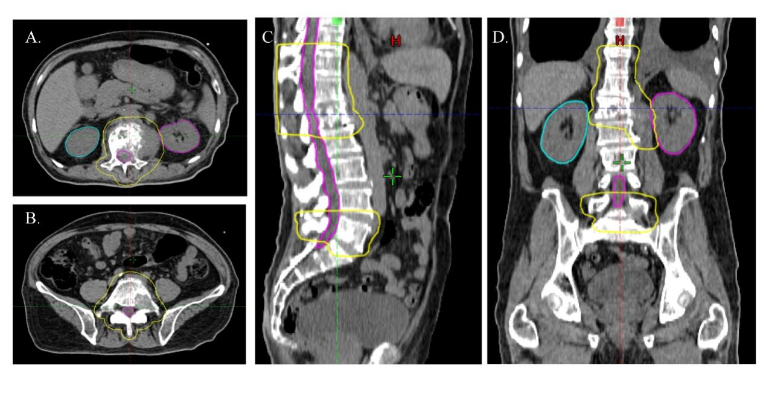
Figure S2 | Radiotherapy aimed at the patient's bone metastases. (A-D) Radiotherapy target volume. Because bone destruction caused by the patient's spinal metastases has caused severe pain and affected the patient's daily life, we performed radiotherapy on the first and fifth lumbar vertebrae. Dt = 30Gy/10F.

Figure S3 | Next-generation sequencing (NGS) analysis of pericardial effusion samples revealed BRAF mutation in exon 11, c.1397G>T, p.G466V, with variant allele frequency (VAF) of 62.85%. No other mutations were found in the NGS panel used in this patient.

S4 Technical details of pathology
4.1 Next-generation sequencing (NGS)
NGS platform: Life DA8600, proton

Table S1 | Gene panel
Project | Gene
DNA sequenced genes | AKT1 | ALK | AR | BRAF
 | CCND1 | CDK4 | CDK6 | CTNNB1
 | DDR2 | EGFR | ERBB2 | ERBB3
 | ERBB4 | ESR1 | FBXW7 | FGFR1
 | FGFR2 | FGFR3 | FGFR4 | GNA11
 | GNAQ | HRAS | IDH1 | IDH2
 | JAK1 | JAK2 | JAK3 | KIT
 | KRAS | MAP2K1 | MAP2K2 | MET
 | MTOR | MYC | MYCN | NOTCH1
 | NRAS | PDGFRA | PIK3CA | PTEN
 | RAF1 | RB1 | RET | ROS1
 | SMAD4 | SMO | STK11 | TP53
 | UGT1A1
RNA sequenced genes | ABL1 | AKT3 | ALK | AXL
 | BRAF | EGFR | ERBB2 | ERG
 | ETV1 | ETV4 | ETV5 | FGFR1
 | FGFR2 | FGFR3 | MET | NTRK1
 | NTRK2 | NTRK3 | PDGFRA | PPARG
 | RAF1 | RET | ROS1
* Detection forms include single nucleotide variants (SNV), insertion and deletion (InDel), copy number variations (CNV), and fusions.

4.2 Immunohistochemistry
The automated platform: Leica BOND MAX

Table S2 | Antibody sources and information
Antibody | Corporation | Item No. | Clone No.
PD-L1 | AmoyDx, China | - | E1L3N
CK7 | ZSGB-BIO, China | ZM-0071 | UMAB161
Napsin A | ZSGB-BIO, China | ZM-0473 | OTI8A5
TTF-1 | ZSGB-BIO, China | ZM-0270 | SPT24
P40 | ZSGB-BIO, China | ZM-0472 | BC28
MOC31 | ZSGB-BIO, China | ZM-0359 | UMAB131
Muc4 | ZSGB-BIO, China | ZM-0376 | 8G7
Ki-67 | ZSGB-BIO, China | ZM-0167 | MIB-1

