Supplementary Table S1: Details of volunteers.
Number | Gender | Age (years) | Comorbidity | Infection | leukocyte (10⁹/L) | Neutrophil percentage (%)
1 | Male | 24 | None | None | 6.3 | 55.6
2 | Female | 27 | None | None | 3.7 | 47.7
3 | Female | 26 | None | None | 6.1 | 52.0
4 | Male | 23 | None | None | 9.5 | 59.2
5 | Male | 35 | None | None | 4.5 | 66.1
6 | Male | 30 | None | None | 5.3 | 54.3
7 | Female | 33 | None | None | 8.0 | 48.4
8 | Female | 24 | None | None | 5.3 | 51.6
9 | Male | 28 | None | None | 4.9 | 60.1
10 | Male | 24 | None | None | 7.9 | 58.7
11 | Female | 27 | None | None | 7.7 | 55.7
12 | Male | 23 | None | None | 6.3 | 61.8
13 | Female | 28 | None | None | 4.4 | 64.8
14 | Female | 24 | None | None | 3.8 | 48.1
15 | Female | 35 | None | None | 7.5 | 69.5
16 | Female | 27 | None | None | 6.4 | 66.3
17 | Male | 31 | None | None | 3.6 | 52.2

Supplementary Table S2: Primer sequences for RT-qPCR.
Genes | Forward (5’-3’) | Reverse (5’-3’)
BAP31 | GCGGAGGTCTTTGTTGTGTT | CCTGCTGCGAAATGAGAGTC
IL-1β | TGACGGACCCCAAAAGATGA | TCTCCACAGCCACAATGAGT
TNF-α | CCCTCACACTCAGATCATCTTCT | GCTACGACGTGGGCTACAG
IL-10 | GATGCCTTCAGCAGAGTGAA | GCAACCCAGGTAACCCTTAAA
TGF-β | CAATTCCTGGCGATACCTCAG | GCACAACTCCGGTGACATCAA
β-actin | CCTTCCTGGGCATGGAGTCCTG | GGAGCAATGATCTTGATCTTC

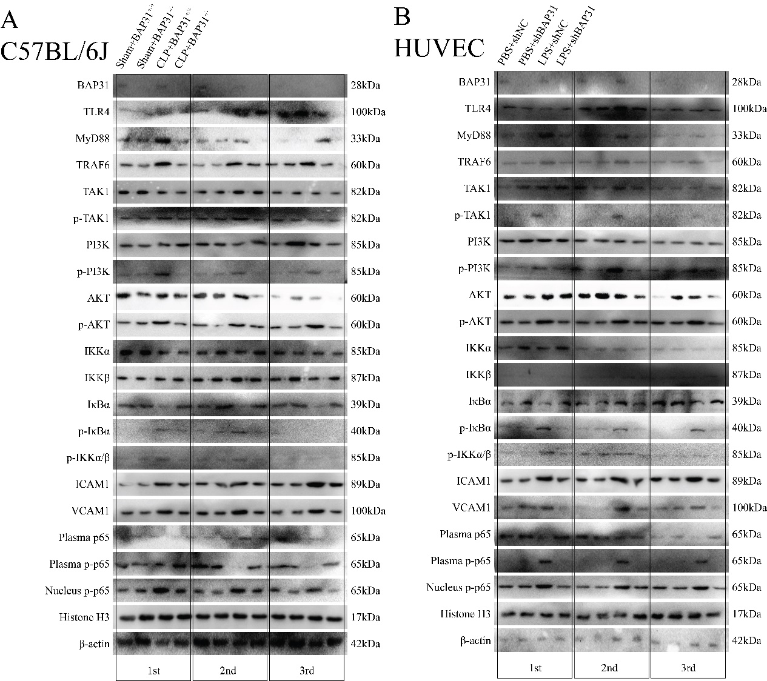
Supplementary Figure S1: Repetition of WB images (A: C57BL/6J, B: HUVEC).

