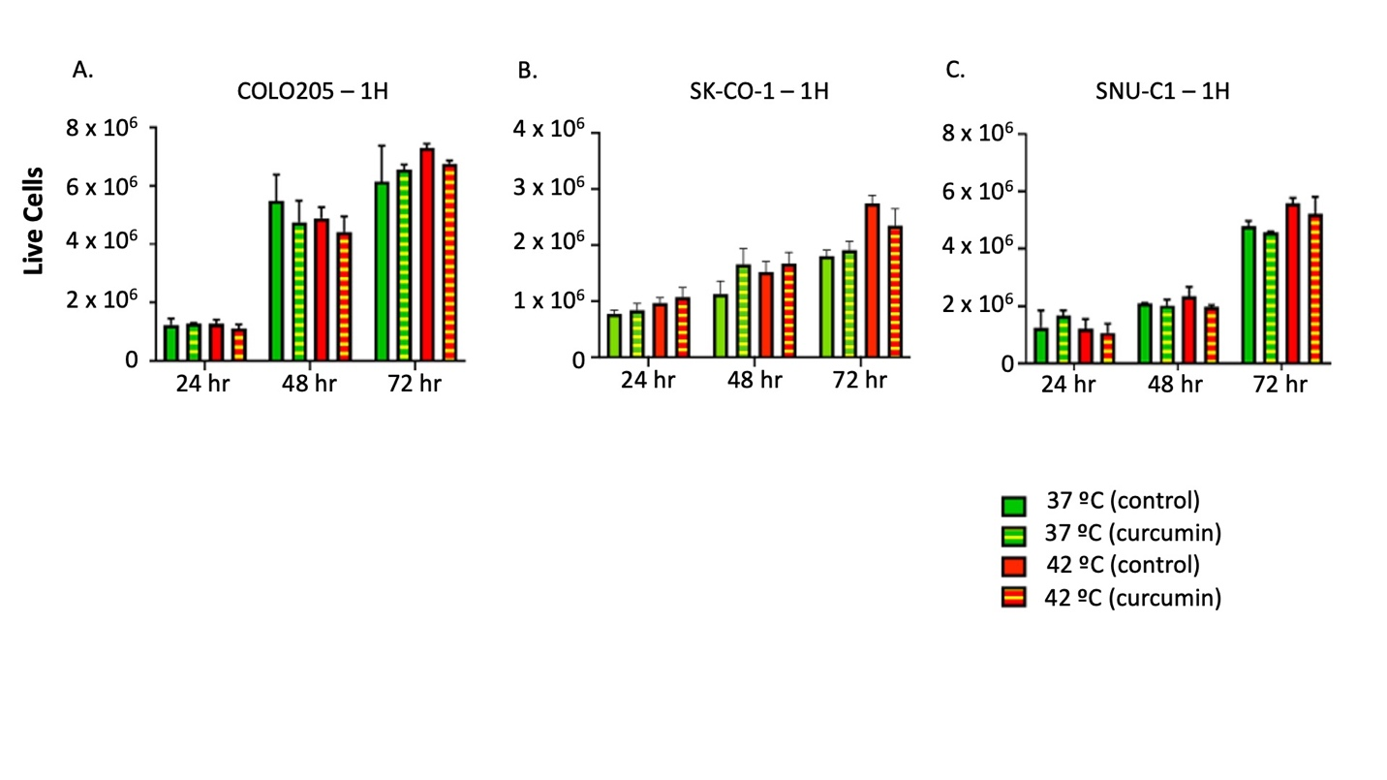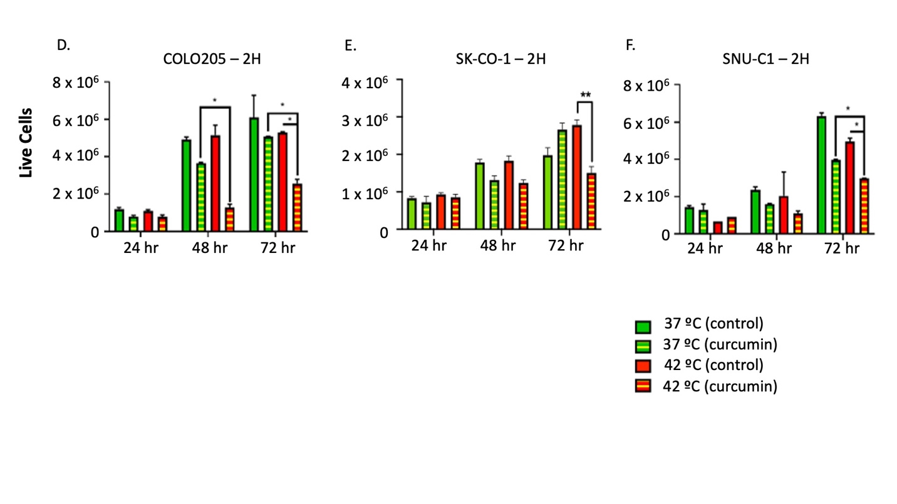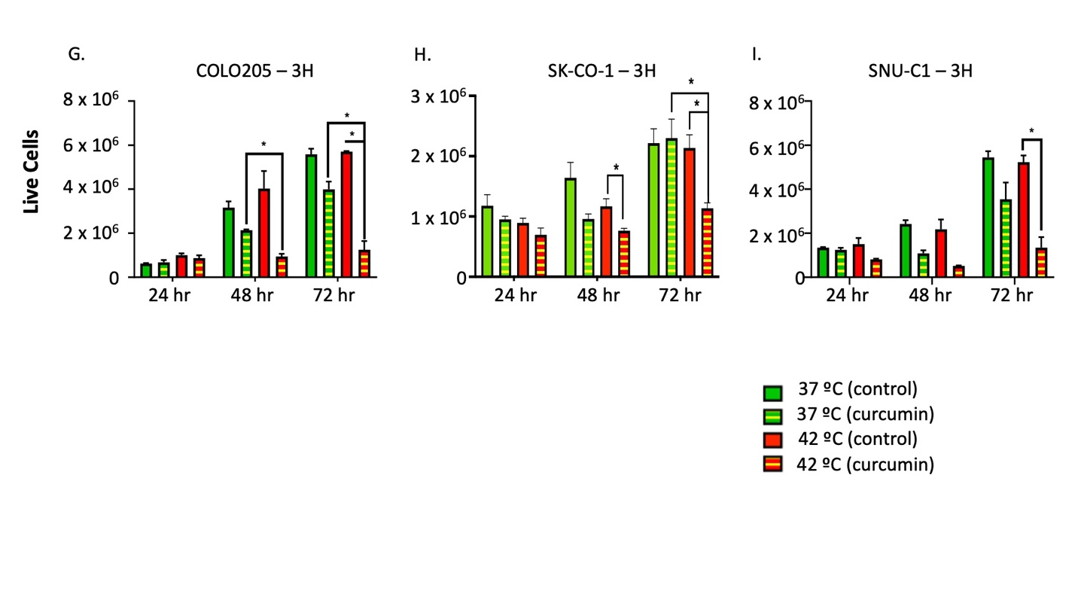
Supplemental Figure 1.
Human colon cancer cells (COLO205, SNU-C1 and SK-CO-1) were incubated with 25uM curcumin in either a 37ºC (normothermia) or 42ºC (hyperthermia) incubator for 1(A, B, C) , 2 (D, E, F) and 3 (G, H, I) hours respectively. Cell cultures were moved to 37ºC (time 0) after which cell viability was determined using trypan blue exclusion cell counting after 24, 48 and 72 hours. For statistical analysis, a student t-test was used, *P<0.05, **P<0.01.

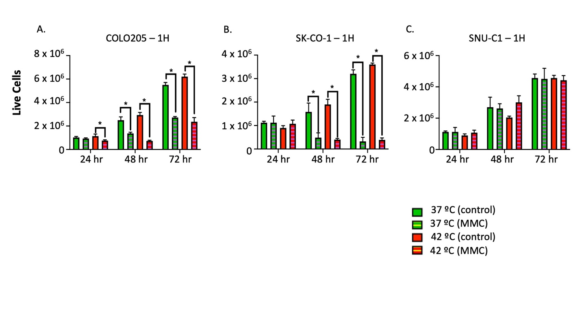
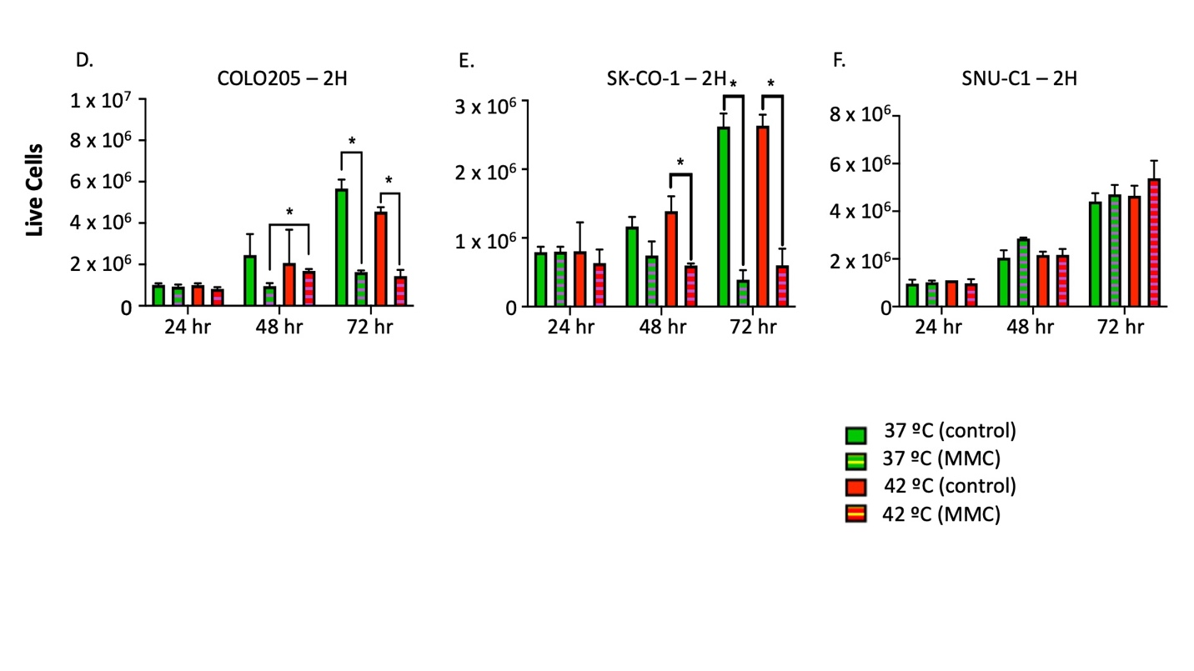
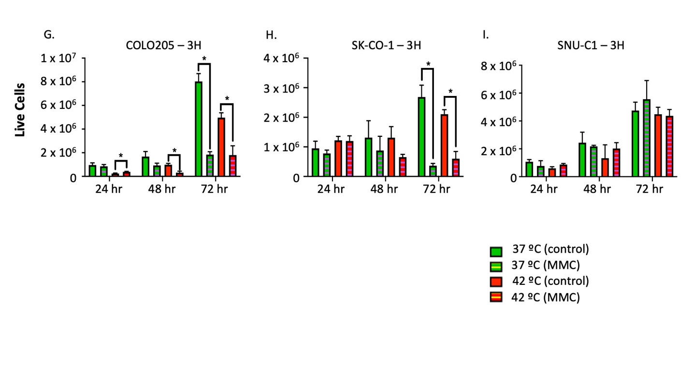
Supplemental Figure 2.
Human colon cancer cells (COLO205, SNU-C1 and SK-CO-1) were incubated with 1uM MMC in either a 37ºC (normothermia) or 42ºC (hyperthermia) incubator for 1(A, B, C) , 2 (D, E, F) and 3 (G, H, I) hours respectively. Cell cultures were moved to 37ºC (time 0) after which cell viability was determined using trypan blue exclusion cell counting after 24, 48 and 72 hours. For statistical analysis, a student t-test was used, *P<0.05.

