Table S1. Information of 38 Chinese S. Kentucky ST198 strains involved in phylogenomic analysis.
Strains | Source | Location | Year | Accession no. | Reference
sc-h43 | Human | Sichuan | 2013 | PRJNA543407 | (1)
sc-h42 | Human | Sichuan | 2013 | PRJNA543407 | (1)
hn-h4 | Human | Hunan | 2016 | PRJNA543407 | (1)
zj-h17 | Human | Zhejiang | 2017 | PRJNA543407 | (1)
gx-f4 | Mutton | Guangxi | 2017 | PRJNA543407 | (1)
hn-h2 | Human | Hunan | 2017 | PRJNA543407 | (1)
gx-f5 | Pork | Guangxi | 2017 | PRJNA543407 | (1)
gx-f9 | Duck | Guangxi | 2017 | PRJNA543407 | (1)
gx-f7 | Pork | Guangxi | 2017 | PRJNA543407 | (1)
hn-f5 | Chicken | Hunan | 2016 | PRJNA543407 | (1)
zj-h16 | Human | Zhejiang | 2016 | PRJNA543407 | (1)
zj-f82 | Chicken | Zhejiang | 2017 | PRJNA543407 | (1)
zj-f100 | Chicken | Zhejiang | 2017 | PRJNA543407 | (1)
zj-f94 | Chicken | Zhejiang | 2017 | PRJNA543407 | (1)
zj-f78 | Chicken | Zhejiang | 2017 | PRJNA543407 | (1)
zj-f95 | Chicken | Zhejiang | 2017 | PRJNA543407 | (1)
zj-f72 | Chicken | Zhejiang | 2017 | PRJNA543407 | (1)
zj-f79 | Chicken | Zhejiang | 2017 | PRJNA543407 | (1)
zj-f75 | Chicken | Zhejiang | 2017 | PRJNA543407 | (1)
zj-f87 | Chicken | Zhejiang | 2017 | PRJNA543407 | (1)
zj-f77 | Chicken | Zhejiang | 2017 | PRJNA543407 | (1)
zj-f50 | Chicken | Zhejiang | 2017 | PRJNA543407 | (1)
gx-f8 | Pig liver | Guangxi | 2017 | PRJNA543407 | (1)
gx-h1 | Human | Guangxi | 2015 | PRJNA543407 | (1)
fj-h1 | Human | Fujian | 2017 | PRJNA543407 | (1)
zj-f60 | Chicken | Zhejiang | 2017 | PRJNA543407 | (1)
zj-f54 | Chicken | Zhejiang | 2017 | PRJNA543407 | (1)
NT-h3189 | Human | Jiangsu | 2021 | PRJNA820366 | (2)
AH19MCS1 | drumstick | Anhui | 2019 | PRJNA868865 | (3)
AH19MCS13 | chicken | Anhui | 2019 | PRJNA868865 | (3)
AH19MCS6 | chicken gizzard | Anhui | 2019 | PRJNA868865 | (3)
AH19MCS11 | chicken feet | Anhui | 2019 | PRJNA868865 | (3)
AH19MCS9 | drumstick | Anhui | 2019 | PRJNA868865 | (3)
AH19MCS8 | chicken | Anhui | 2019 | PRJNA868865 | (3)
AH19MCS7 | chicken gizzard | Anhui | 2019 | PRJNA868865 | (3)
AH19MCS10 | drumstick | Anhui | 2019 | PRJNA868865 | (3)
AH19MCS3 | chicken liver | Anhui | 2019 | PRJNA868865 | (3)
AH19MCS12 | chicken feet | Anhui | 2019 | PRJNA868865 | (3)

Table S2. Results of antimicrobial susceptibility test of three S. Kentucky in this study.
MIC (mg/L) | SZ22HS1 | SZ22HS2 | SZ22HS3 | Interpretation
Ceftazidime | 32 | 32 | 32 | R
Cefepime | 32 | ≥32 | 32 | R
Aztreonam | ≥64 | ≥64 | ≥64 | R
Ticarcillin/clavulanic acid | 64/2 | 64/2 | 64/2 | I
Piperacillin/tazobactam | 8/4 | 8/4 | 8/4 | S
Imipenem | ≤0.25 | ≤0.25 | ≤0.25 | S
Meropenem | ≤0.25 | ≤0.25 | ≤0.25 | S
Ciprofloxacin | ≥4 | ≥4 | ≥4 | R
Levofloxacin | ≥8 | ≥8 | ≥8 | R
Doxycycline | ≥16 | ≥16 | ≥16 | R
Minocycline | ≥16 | ≥16 | ≥16 | R
Tigecycline | ≥8 | ≥8 | ≥8 | R
Colistin | ≤0.5 | ≤0.5 | ≤0.5 | R
Sulfamethoxazole/trimethoprim | ≥4/76 | ≥4/76 | ≥4/76 | R
R, resistant; I, intermediate; S, susceptible.

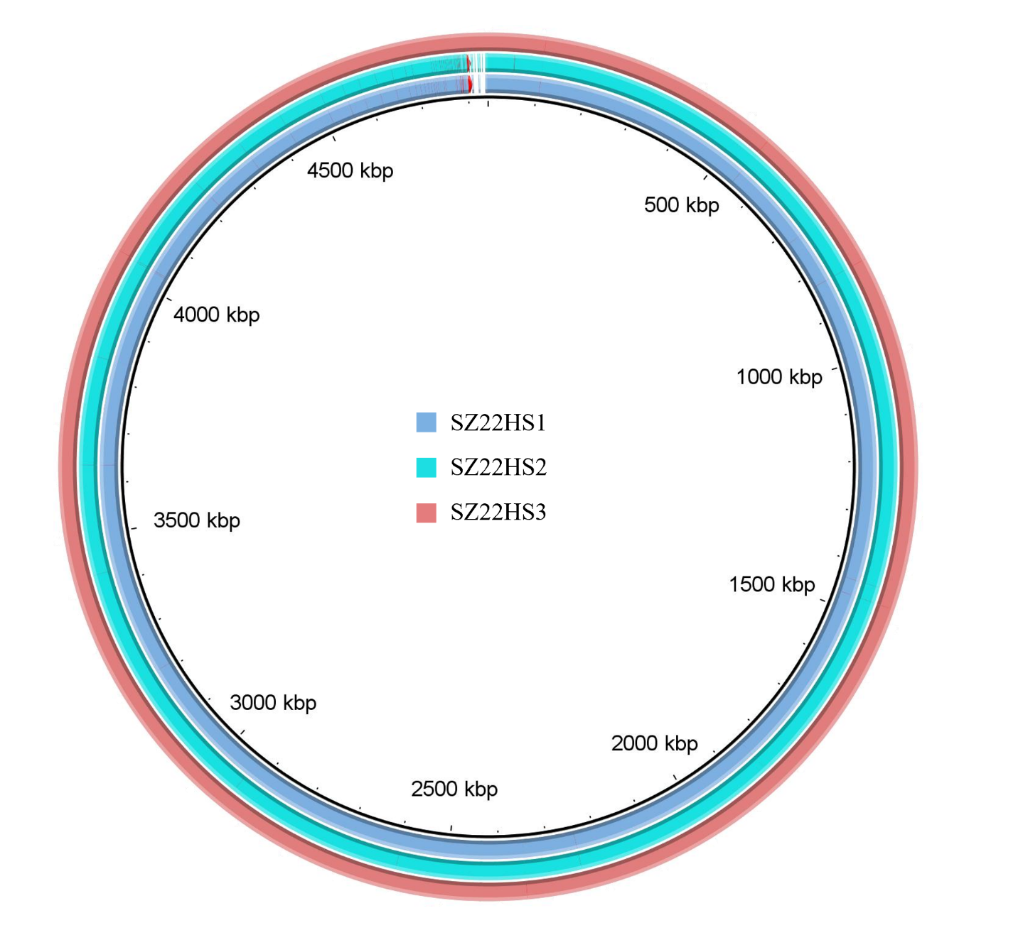
Figure S1. Genome map of Salmonella enterica serovar Kentucky strains in this study.

[1] Chen H, Song J, Zeng X, Chen D, Chen R, Qiu C, et al. National prevalence of Salmonella enterica serotype Kentucky ST198 with high-level resistance to ciprofloxacin and extended-spectrum cephalosporins in China, 2013 to 2017. mSystems 2021;6:e00935-20. doi:10.1128/mSystems.00935-20.
[2] Xu H, Cao X, Zhang W, Li Q. Co-existence of two ciprofloxacin-resistant Salmonella enterica serovar Kentucky strains in the urine of a bladder cancer patient. J Glob Antimicrob Resist. 2022;30:354-6. doi:10.1016/j.jgar.2022.07.011.
[3] Jiang Y, Wang ZY, Li QC, Lu MJ, Wu H, Mei CY, et al. Characterization of extensively drug-resistant Salmonella enterica Serovar Kentucky sequence type 198 isolates from chicken meat products in Xuancheng, China. Microbiol Spectr. 2023;11:e0321922. doi:10.1128/spectrum.03219-22.

