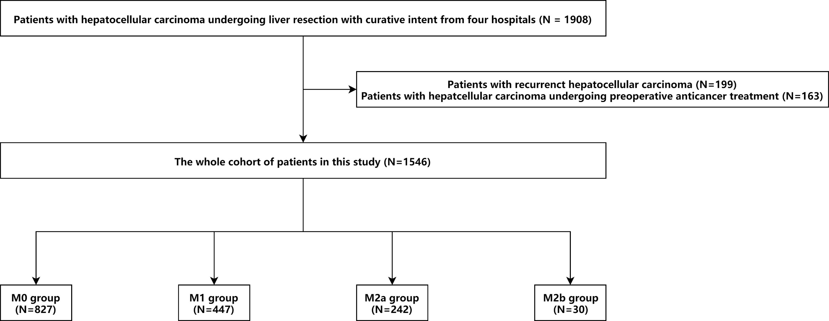
Supplementary Figure 1: Selection of the study population.

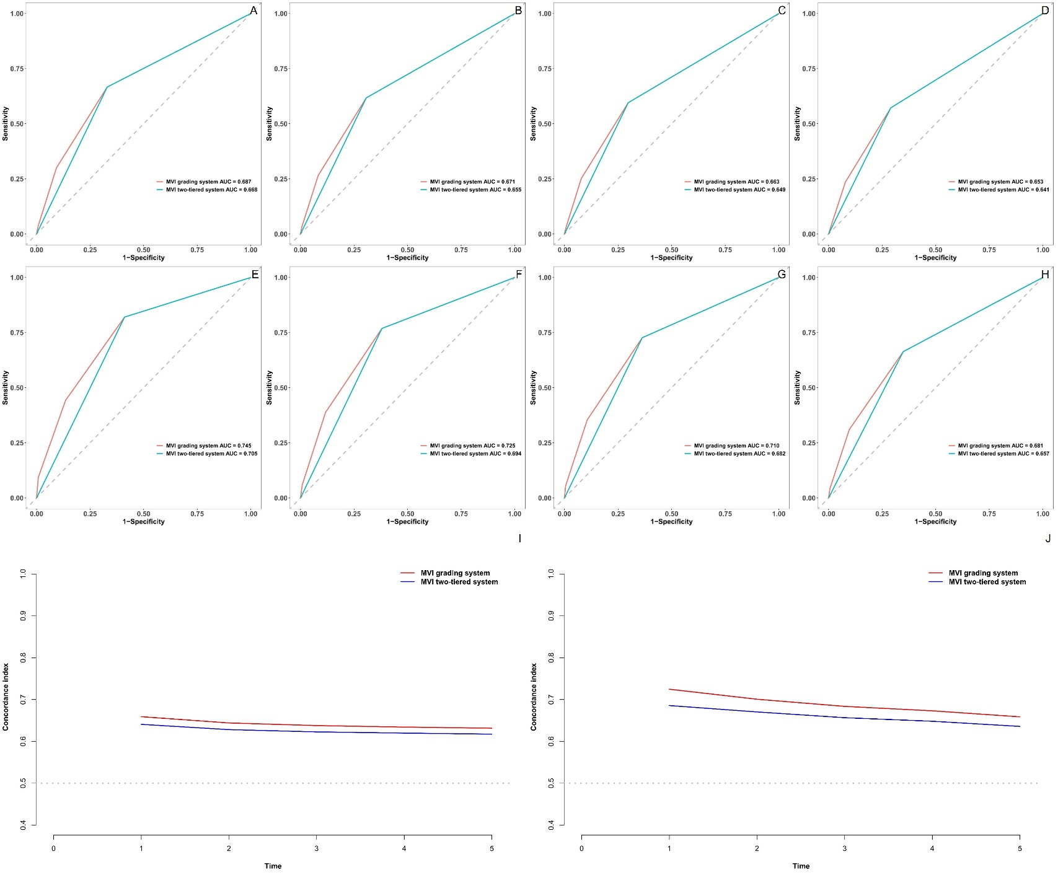
Supplementary Figure 2: Time-ROC curve and time-AUC of the MVI grading system and the MVI two-tiered system in predicting prognosis. A. 1-year RFS; B. 2-year RFS; C. 3-year RFS; D. 5-year RFS; E. 1-year OS; F. 2-year OS; G. 3-year OS; H. 5-year OS; I. RFS; J. OS.

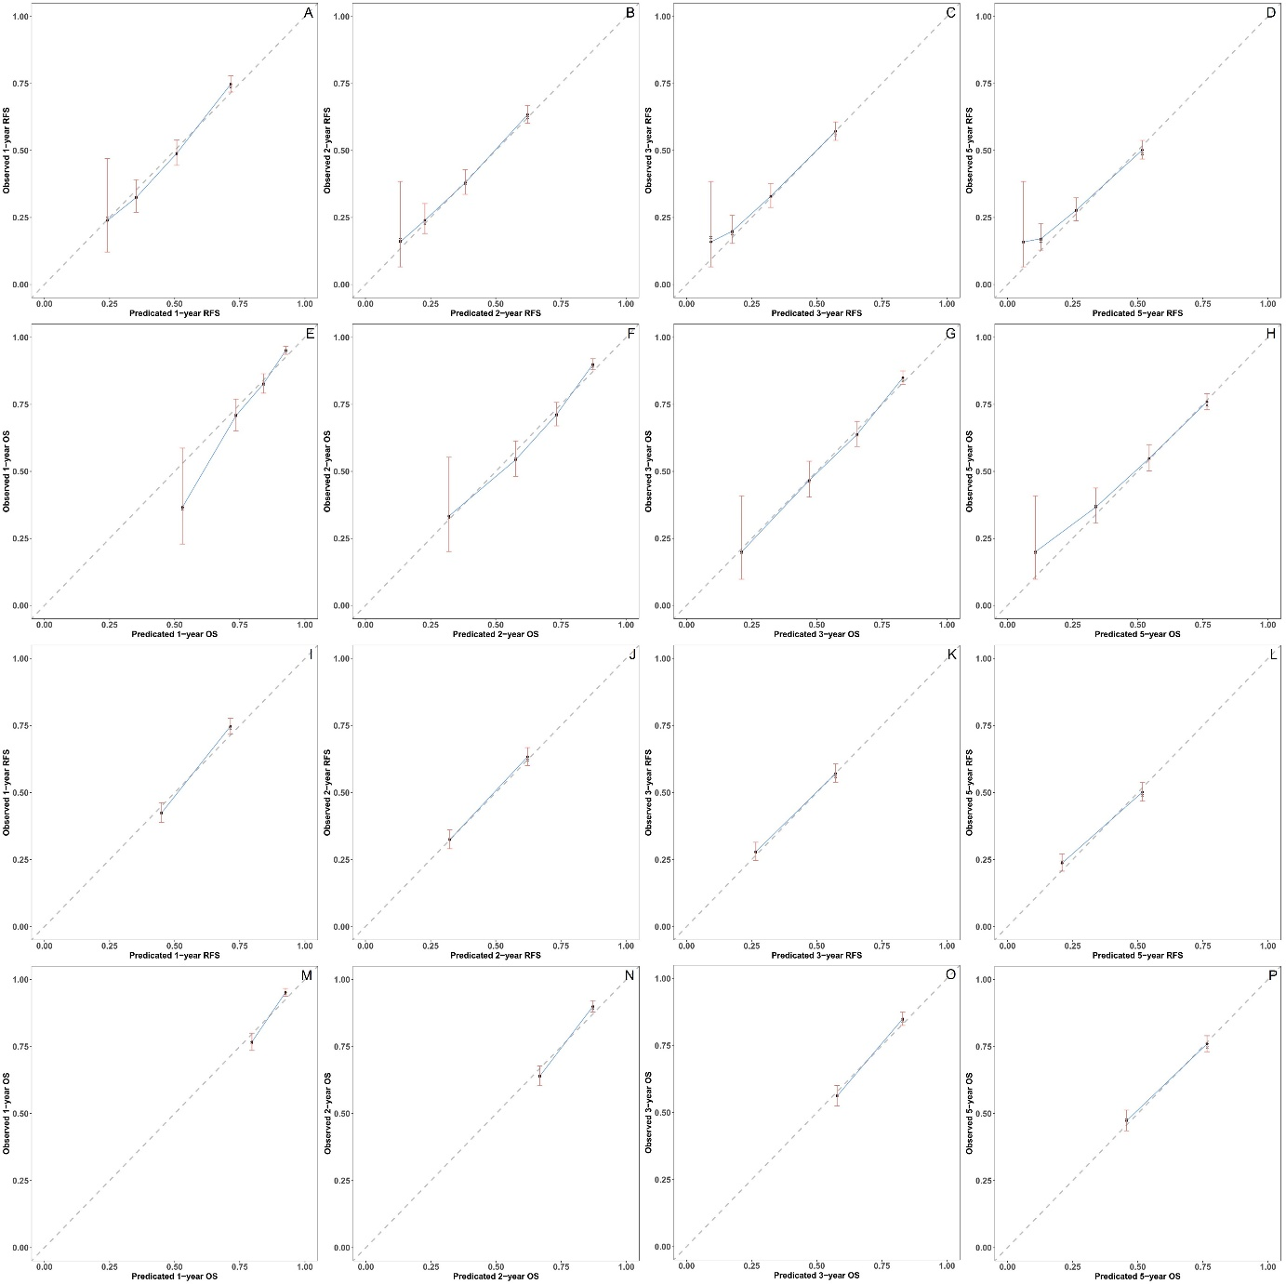
Supplementary Figure 3: Calibration curve of the MVI grading system (A-H) and the MVI two-tiered system (I-P) in predicting prognosis. A. 1-year RFS; B. 2-year RFS; C. 3-year RFS; D. 5-year RFS; E. 1-year OS; F. 2-year OS; G. 3-year OS; H. 5-year OS; I. 1-year RFS; J. 2-year RFS; K. 3-year RFS; L. 5-year RFS; M. 1-year OS; N. 2-year OS; O. 3-year OS; P. 5-year OS.

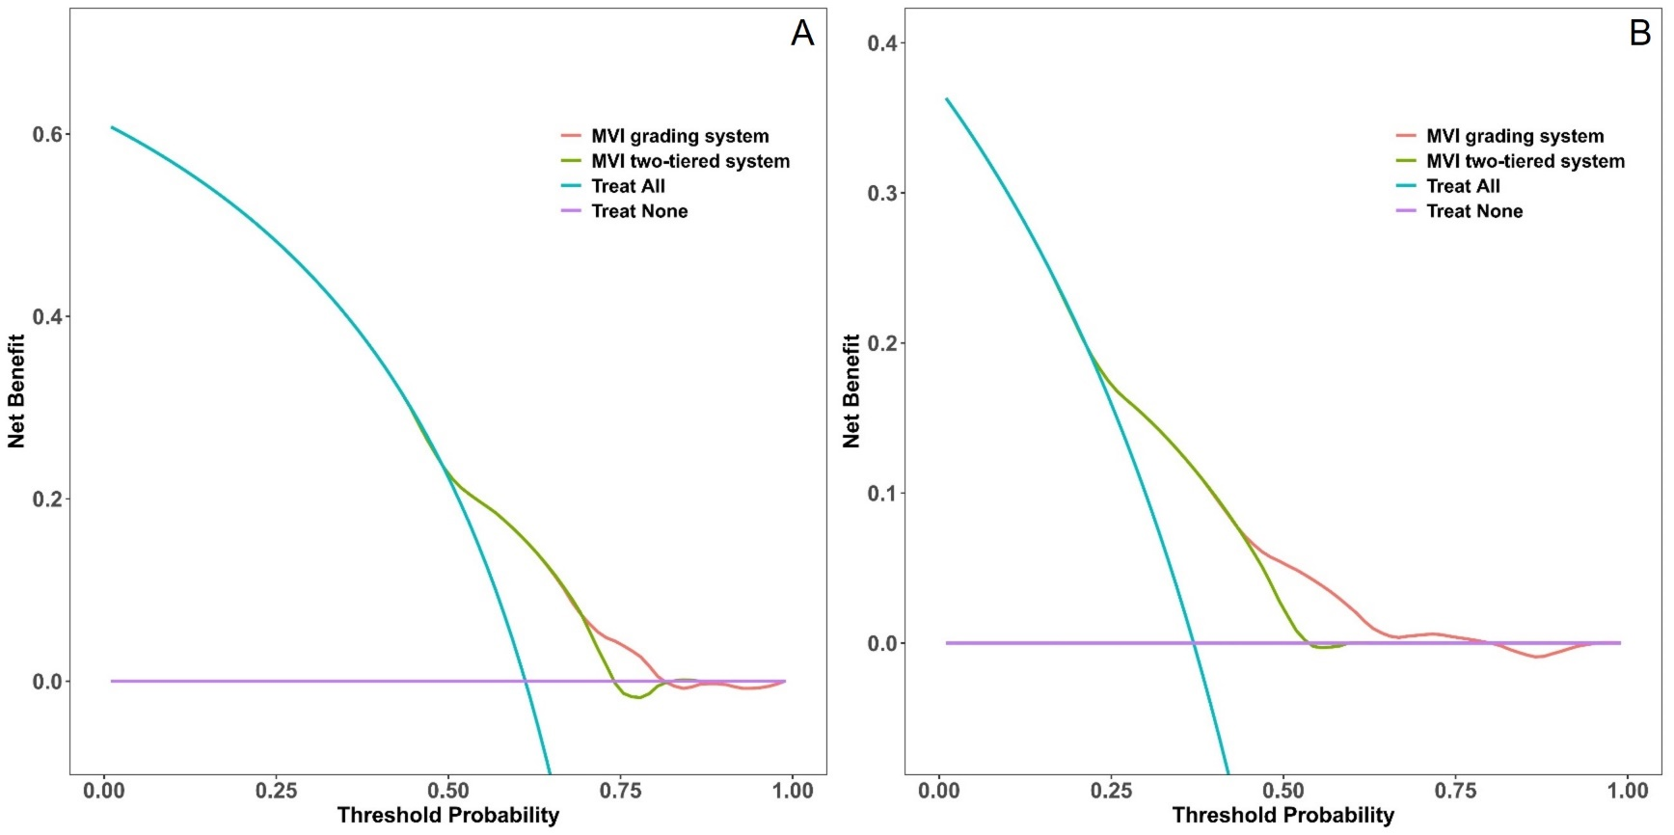
Supplementary Figure 4: Decision curve of the MVI grading system and the MVI two-tiered system in predicting prognosis. A. RFS; B. OS.

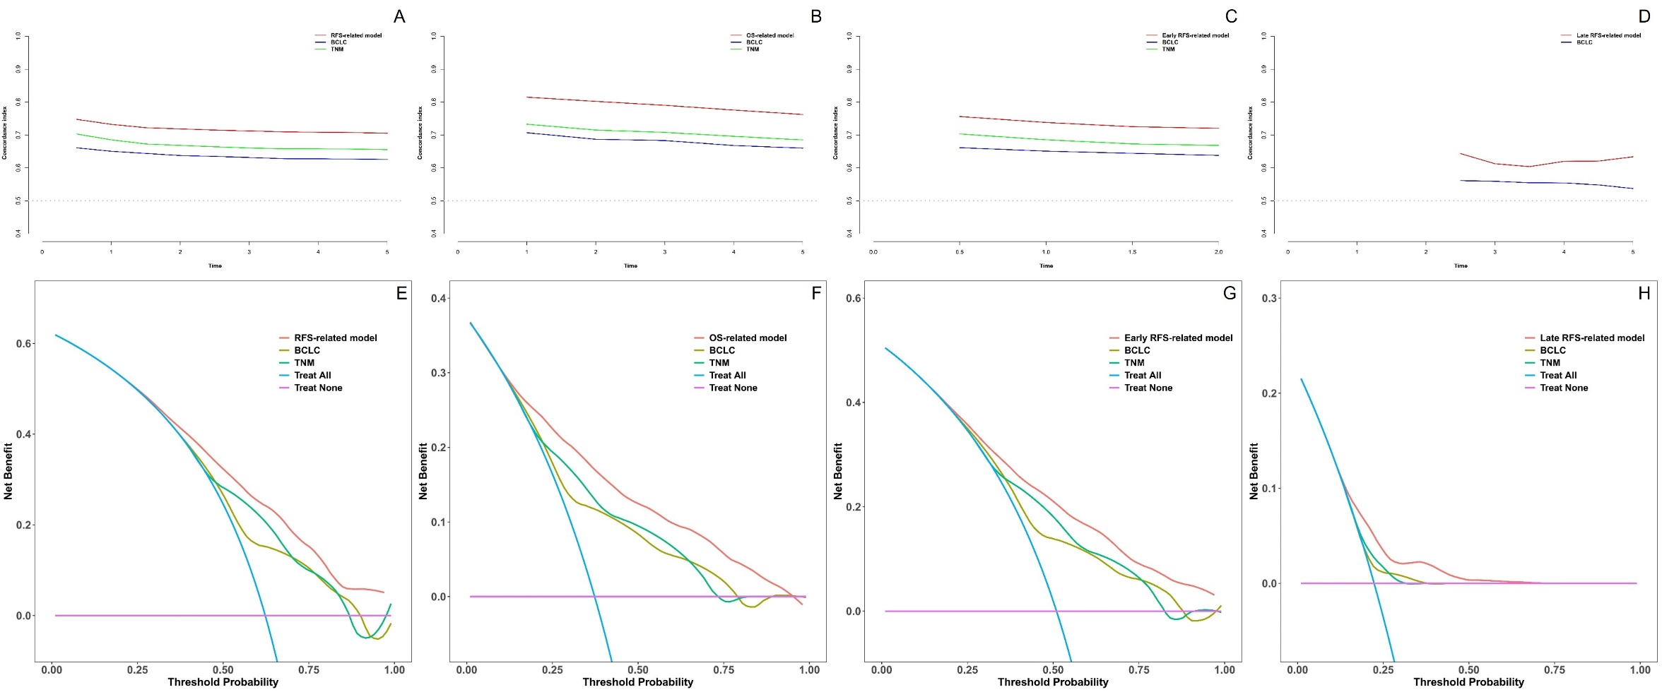
Supplementary Figure 5: Time-AUC and decision curve of the prognostic model, BCLC staging and TNM classification in predicting clinical outcomes. A. RFS; B. OS; C. early RFS; D. late RFS; E. RFS; F. OS; G. early RFS; H. late RFS. Notes: Only one patient is TNM stage Ⅳ patient among late RFS cohort so that the time-AUC curve could not be generated.

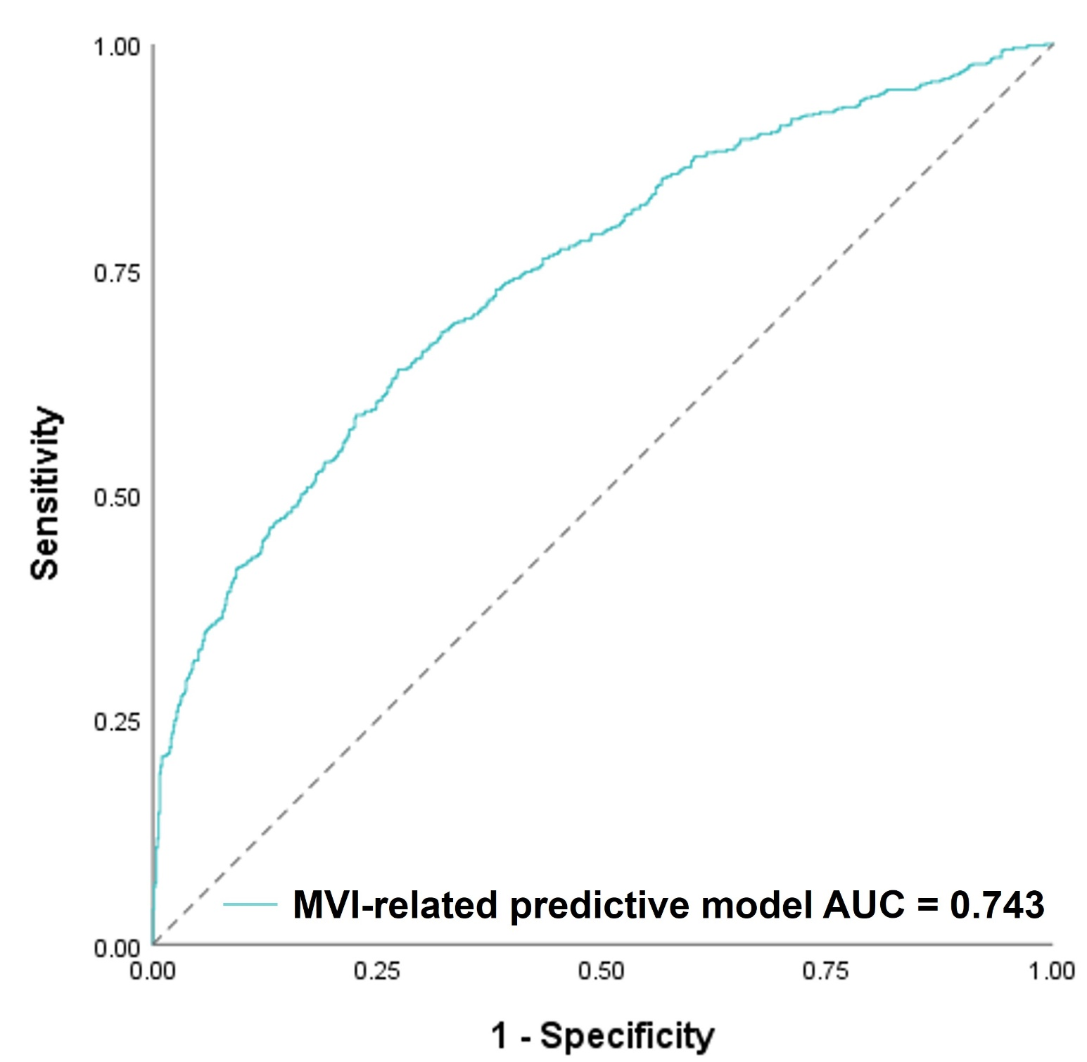
Supplementary Figure 6: ROC curve of the prediction model of MVI.

Supplementary Table 1: univariate Cox regression analysis of RFS.
Characteristics | B | SE | P value | HR | 95%CI
Age, year | -0.008 | 0.003 | 0.010 | 0.992 | 0.986-0.998
Sex, male | 0.213 | 0.099 | 0.032 | 1.237 | 1.019-1.502
TBIL, μmol/L | 0.004 | 0.003 | 0.173 | 1.004 | 0.998-1.010
DBIL, μmol/L | 0.008 | 0.003 | 0.021 | 1.008 | 1.001-1.014
IBIL, μmol/L | -0.002 | 0.008 | 0.770 | 0.998 | 0.983-1.013
TBA, μmol/L | 0.001 | 0.002 | 0.573 | 1.001 | 0.997-1.005
TP, g/L | -0.003 | 0.006 | 0.590 | 0.997 | 0.984-1.009
ALB, g/L | -0.046 | 0.009 | <0.001 | 0.955 | 0.938-0.973
GLB, g/L | 0.027 | 0.008 | <0.001 | 1.028 | 1.012-1.043
PA, mg/L | -0.003 | 0.000 | <0.001 | 0.997 | 0.996-0.998
ALT, U/L | 0.003 | 0.001 | <0.001 | 1.003 | 1.001-1.005
AST, U/L | 0.008 | 0.001 | <0.001 | 1.008 | 1.006-1.009
GGT, U/L | 0.002 | 0.000 | <0.001 | 1.002 | 1.001-1.002
ALP, U/L | 0.006 | 0.001 | <0.001 | 1.006 | 1.005-1.007
LDH, U/L | 0.001 | 0.000 | <0.001 | 1.001 | 1.001-1.002
BUN, mmol/L | -0.036 | 0.024 | 0.136 | 0.965 | 0.921-1.011
SCR, μmol/L | -0.005 | 0.002 | 0.027 | 0.995 | 0.990-0.999
PT, s | 0.102 | 0.033 | 0.002 | 1.107 | 1.039-1.180
INR | 1.304 | 0.390 | 0.001 | 3.684 | 1.715-7.910
TT, s | -0.064 | 0.022 | 0.003 | 0.938 | 0.899-0.979
Fbg, g/L | 0.264 | 0.030 | <0.001 | 1.302 | 1.227-1.382
WBC, ×10⁹/L | 0.034 | 0.018 | 0.059 | 1.035 | 0.999-1.072
Lym, ×10⁹/L | -0.260 | 0.059 | <0.001 | 0.771 | 0.687-0.866
Mono, ×10⁹/L | 0.607 | 0.227 | 0.008 | 1.834 | 1.175-2.863
Neut, ×10⁹/L | 0.058 | 0.018 | 0.001 | 1.060 | 1.023-1.097
EOS, ×10⁹/L | -0.137 | 0.223 | 0.537 | 0.872 | 0.563-1.349
BASO, ×10⁹/L | 0.249 | 2.597 | 0.924 | 1.282 | 0.008-208.172
RBC, ×10¹²/L | 0.112 | 0.067 | 0.094 | 1.119 | 0.981-1.275
PCV, % | 0.010 | 0.008 | 0.215 | 1.010 | 0.994-1.027
MCV, fL | -0.006 | 0.006 | 0.358 | 0.994 | 0.982-1.007
MCH, pg | -0.031 | 0.015 | 0.038 | 0.969 | 0.941-0.998
MCHC, g/L | -0.006 | 0.002 | 0.002 | 0.994 | 0.990-0.998
RDW, % | 0.028 | 0.028 | 0.314 | 1.029 | 0.974-1.086
PLT, ×10⁹/L | 0.001 | 0.000 | 0.002 | 1.001 | 1.001-1.002
MPV, fL | -0.026 | 0.029 | 0.357 | 0.974 | 0.921-1.030
PCT, % | 1.116 | 0.444 | 0.012 | 3.053 | 1.278-7.293
PDW, fL | -0.009 | 0.013 | 0.504 | 0.991 | 0.967-1.017
AFP, μg/L | 0.001 | 0.000 | <0.001 | 1.001 | 1.000-1.001
CEA, μg/L | -0.002 | 0.016 | 0.892 | 0.998 | 0.967-1.030
CA199, U/mL | 0.005 | 0.001 | <0.001 | 1.005 | 1.003-1.007
HBsAg, positive | 0.228 | 0.099 | 0.021 | 1.255 | 1.035-1.523
HBsAb, positive | -0.139 | 0.114 | 0.224 | 0.871 | 0.697-1.088
HBeAg, positive | 0.175 | 0.075 | 0.019 | 1.191 | 1.029-1.379
HBeAb, positive | -0.036 | 0.069 | 0.604 | 0.965 | 0.842-1.105
HBcAb, positive | 0.124 | 0.245 | 0.613 | 1.132 | 0.700-1.829
HBV DNA load, ≥50 IU/mL | 0.352 | 0.069 | <0.001 | 1.422 | 1.242-1.628
HCV, positive | -0.039 | 0.252 | 0.876 | 0.961 | 0.586-1.576
Ultrasonic tumor echo, high | 0.264 | 0.073 | <0.001 | 1.303 | 1.130-1.502
Ultrasonic tumor echo, uneven strength | 0.558 | 0.107 | <0.001 | 1.747 | 1.416-2.154
Ultrasonic tumor boundary, unclear | 0.210 | 0.068 | 0.002 | 1.234 | 1.079-1.411
Ultrasonic intratumor echo, unevenness | 0.449 | 0.119 | <0.001 | 1.567 | 1.241-1.978
Splenomegaly, yes | 0.132 | 0.099 | 0.185 | 1.141 | 0.939-1.385
Surgery, nonanatomic | -0.326 | 0.082 | <0.001 | 0.722 | 0.615-0.847
Surgical margin, ≤0.1cm | 0.576 | 0.072 | <0.001 | 1.779 | 1.545-2.048
Cholecystectomy, yes | 0.171 | 0.066 | 0.010 | 1.187 | 1.042-1.351
Tumor size, cm | 0.110 | 0.007 | <0.001 | 1.116 | 1.101-1.131
Tumor number, multiple | 0.819 | 0.076 | <0.001 | 2.269 | 1.956-2.631
Portal invasion, yes | 1.250 | 0.098 | <0.001 | 3.489 | 2.878-4.229
Extrahepatic metastasis, yes | 1.341 | 0.177 | <0.001 | 3.825 | 2.706-5.406
Tumor grading, III-IV | 0.561 | 0.106 | <0.001 | 1.752 | 1.424-2.157
Tumor capsule, incomplete | 0.456 | 0.098 | <0.001 | 1.578 | 1.301-1.913
MVI=M1 | 0.704 | 0.076 | <0.001 | 2.022 | 1.741-2.347
MVI=M2a | 1.135 | 0.089 | <0.001 | 3.110 | 2.613-3.702
MVI=M2b | 1.433 | 0.215 | <0.001 | 4.192 | 2.750-6.391
Liver cirrhosis, yes | -0.005 | 0.079 | 0.945 | 0.995 | 0.851-1.162
BCLC, A | 0.605 | 0.146 | <0.001 | 1.831 | 1.374-2.439
BCLC, B | 1.359 | 0.161 | <0.001 | 3.891 | 2.835-5.339
BCLC, C | 1.949 | 0.164 | <0.001 | 7.023 | 5.090-9.690
TNM, II | 0.735 | 0.078 | <0.001 | 2.086 | 1.790-2.431
TNM, III | 1.478 | 0.086 | <0.001 | 4.385 | 3.707-5.187
TNM, IV | 1.604 | 0.295 | <0.001 | 4.975 | 2.789-8.875
RFS: recurrence-free survival; TBIL: total bilirubin; DBIL: direct bilirubin; IBIL: indirect bilirubin; TBA: total biliary acid; TP: total protein; ALB: albumin; GLB: globulin; PA: prealbumin; ALT: alanine amino transferase; AST: aspartate amino transferase; GGT: γ-glutamyl transpeptidase; ALP: alkaline phosphatase; LDH: lactate dehydrogenase; BUN: blood urea nitrogen; SCR: serum creatinine; PT: prothrombin time; INR: international normalized ratio; TT: thrombin time; Fbg: fibrinogen; WBC: white blood cell; Lym: lymphocyte; Mono: monocyte; Neut: neutrophil; EOS: eosinophil; BASO: basophil; RBC: red blood cell; PCV: packed cell volume; MCV: mean corpuscular volume; MCH: mean corpuscular hemoglobin; MCHC: mean corpuscular hemoglobin concentration; RDW: red blood cell volume distribution width; PLT: platelet; MPV: mean platelet volume; PCT: thrombocytocrit; PDW: platelet distribution width; AFP: alpha fetoprotein; CEA: carcinoembryonic antigen; CA199: carbohydrate antigen 199; HBsAg: hepatitis B surface antigen; HBsAb: hepatitis B surface antibody; HBeAg: hepatitis B e antigen; HBeAb: hepatitis B e antibody; HBcAb: hepatitis B core antibody; HBV DNA: hepatitis B virus deoxyribonucleic acid; HCV: hepatitis C virus; MVI: microvascular invasion; BCLC: Barcelona Clinic Liver Cancer; TNM: Tumor-Node-Metastasis.

Supplementary Table 2: univariate Cox regression analysis of OS.
Characteristics | B | SE | P value | HR | 95%CI
Age, year | -0.003 | 0.004 | 0.440 | 0.997 | 0.989-1.005
Sex, male | 0.046 | 0.123 | 0.711 | 1.047 | 0.822-1.333
TBIL, μmol/L | 0.008 | 0.003 | 0.005 | 1.008 | 1.003-1.014
DBIL, μmol/L | 0.013 | 0.003 | <0.001 | 1.013 | 1.007-1.019
IBIL, μmol/L | -0.002 | 0.010 | 0.828 | 0.998 | 0.978-1.018
TBA, μmol/L | 0.002 | 0.002 | 0.396 | 1.002 | 0.997-1.007
TP, g/L | -0.001 | 0.008 | 0.919 | 0.999 | 0.983-1.016
ALB, g/L | -0.073 | 0.012 | <0.001 | 0.930 | 0.908-0.952
GLB, g/L | 0.049 | 0.010 | <0.001 | 1.051 | 1.030-1.071
PA, mg/L | -0.005 | 0.001 | <0.001 | 0.995 | 0.993-0.996
ALT, U/L | 0.004 | 0.001 | 0.001 | 1.004 | 1.001-1.006
AST, U/L | 0.010 | 0.001 | <0.001 | 1.010 | 1.008-1.011
GGT, U/L | 0.003 | 0.000 | <0.001 | 1.003 | 1.002-1.003
ALP, U/L | 0.008 | 0.001 | <0.001 | 1.008 | 1.006-1.009
LDH, U/L | 0.001 | 0.000 | <0.001 | 1.001 | 1.001-1.002
BUN, mmol/L | -0.053 | 0.032 | 0.099 | 0.948 | 0.891-1.010
SCR, μmol/L | -0.010 | 0.003 | 0.002 | 0.990 | 0.984-0.996
PT, s | 0.182 | 0.041 | <0.001 | 1.200 | 1.107-1.301
INR | 2.233 | 0.497 | <0.001 | 9.327 | 3.524-24.687
TT, s | -0.111 | 0.029 | <0.001 | 0.895 | 0.847-0.947
Fbg, g/L | 0.341 | 0.035 | <0.001 | 1.406 | 1.312-1.507
WBC, ×10⁹/L | 0.050 | 0.024 | 0.036 | 1.051 | 1.003-1.101
Lym, ×10⁹/L | -0.419 | 0.082 | <0.001 | 0.658 | 0.561-0.772
Mono, ×10⁹/L | 0.881 | 0.298 | 0.003 | 2.413 | 1.347-4.323
Neut, ×10⁹/L | 0.085 | 0.022 | <0.001 | 1.089 | 1.043-1.137
EOS, ×10⁹/L | 0.135 | 0.268 | 0.614 | 1.144 | 0.677-1.933
BASO, ×10⁹/L | -3.539 | 3.546 | 0.318 | 0.029 | 0.000-30.283
RBC, ×10¹²/L | -0.099 | 0.089 | 0.267 | 0.906 | 0.761-1.078
PCV, % | -0.022 | 0.011 | 0.042 | 0.978 | 0.957-0.999
MCV, fL | -0.005 | 0.008 | 0.494 | 0.995 | 0.979-1.010
MCH, pg | -0.043 | 0.019 | 0.025 | 0.958 | 0.923-0.995
MCHC, g/L | -0.007 | 0.002 | 0.002 | 0.993 | 0.988-0.997
RDW, % | 0.076 | 0.034 | 0.024 | 1.079 | 1.010-1.154
PLT, ×10⁹/L | 0.001 | 0.001 | 0.015 | 1.001 | 1.000-1.003
MPV, fL | -0.032 | 0.038 | 0.397 | 0.968 | 0.899-1.043
PCT, % | 1.343 | 0.578 | 0.02 | 3.832 | 1.234-11.898
PDW, fL | -0.006 | 0.017 | 0.724 | 0.994 | 0.961-1.028
AFP, μg/L | 0.001 | 0.000 | <0.001 | 1.001 | 1.001-1.001
CEA, μg/L | -0.002 | 0.021 | 0.918 | 0.998 | 0.957-1.040
CA199, U/mL | 0.005 | 0.001 | <0.001 | 1.005 | 1.004-1.007
HBsAg, positive | 0.096 | 0.125 | 0.445 | 1.101 | 0.861-1.407
HbsAb, positive | -0.162 | 0.151 | 0.285 | 0.851 | 0.632-1.144
HbeAg, positive | 0.200 | 0.097 | 0.04 | 1.221 | 1.009-1.478
HbeAb, positive | -0.048 | 0.091 | 0.603 | 0.954 | 0.797-1.140
HbcAb, positive | -0.410 | 0.262 | 0.118 | 0.664 | 0.397-1.109
HBV DNA load, ≥50 IU/mL | 0.336 | 0.091 | <0.001 | 1.399 | 1.170-1.673
HCV, positive | -0.510 | 0.411 | 0.214 | 0.601 | 0.269-1.343
Ultrasonic tumor echo, high | 0.462 | 0.097 | <0.001 | 1.588 | 1.313-1.920
Ultrasonic tumor echo, uneven strength | 0.691 | 0.138 | <0.001 | 1.996 | 1.524-2.615
Ultrasonic tumor boundary, unclear | 0.329 | 0.090 | <0.001 | 1.390 | 1.166-1.658
Ultrasonic intratumor echo, unevenness | 0.846 | 0.188 | <0.001 | 2.331 | 1.611-3.372
Splenomegaly, yes | 0.399 | 0.121 | 0.001 | 1.490 | 1.175-1.889
Surgery, nonanatomic | -0.402 | 0.104 | <0.001 | 0.669 | 0.546-0.820
Surgical margin, ≤0.1cm | 0.774 | 0.101 | <0.001 | 2.168 | 1.780-2.640
Cholecystectomy, yes | 0.306 | 0.087 | <0.001 | 1.358 | 1.145-1.611
Tumor size, cm | 0.139 | 0.009 | <0.001 | 1.150 | 1.130-1.169
Tumor number, multiple | 0.901 | 0.094 | <0.001 | 2.462 | 2.048-2.960
Portal invasion, yes | 1.613 | 0.110 | <0.001 | 5.016 | 4.039-6.228
Extrahepatic metastasis, yes | 1.294 | 0.214 | <0.001 | 3.646 | 2.397-5.547
Tumor grading, III-IV | 0.583 | 0.145 | <0.001 | 1.792 | 1.349-2.380
Tumor capsule, incomplete | 0.612 | 0.140 | <0.001 | 1.843 | 1.400-2.427
MVI=M1 | 0.825 | 0.104 | <0.001 | 2.282 | 1.860-2.801
MVI=M2a | 1.400 | 0.113 | <0.001 | 4.056 | 3.251-5.062
MVI=M2b | 2.124 | 0.218 | <0.001 | 8.368 | 5.461-12.822
Liver cirrhosis, yes | 0.088 | 0.102 | 0.389 | 1.092 | 0.894-1.333
BCLC, A | 1.094 | 0.265 | <0.001 | 2.986 | 1.777-5.018
BCLC, B | 1.933 | 0.276 | <0.001 | 6.910 | 4.021-11.873
BCLC, C | 2.737 | 0.275 | <0.001 | 15.439 | 9.007-26.463
TNM, II | 0.817 | 0.111 | <0.001 | 2.263 | 1.821-2.812
TNM, III | 1.804 | 0.110 | <0.001 | 6.074 | 4.893-7.539
TNM, IV | 1.866 | 0.388 | <0.001 | 6.463 | 3.022-13.823
OS: overall survival; TBIL: total bilirubin; DBIL: direct bilirubin; IBIL: indirect bilirubin; TBA: total biliary acid; TP: total protein; ALB: albumin; GLB: globulin; PA: prealbumin; ALT: alanine amino transferase; AST: aspartate amino transferase; GGT: γ-glutamyl transpeptidase; ALP: alkaline phosphatase; LDH: lactate dehydrogenase; BUN: blood urea nitrogen; SCR: serum creatinine; PT: prothrombin time; INR: international normalized ratio; TT: thrombin time; Fbg: fibrinogen; WBC: white blood cell; Lym: lymphocyte; Mono: monocyte; Neut: neutrophil; EOS: eosinophil; BASO: basophil; RBC: red blood cell; PCV: packed cell volume; MCV: mean corpuscular volume; MCH: mean corpuscular hemoglobin; MCHC: mean corpuscular hemoglobin concentration; RDW: red blood cell volume distribution width; PLT: platelet; MPV: mean platelet volume; PCT: thrombocytocrit; PDW: platelet distribution width; AFP: alpha fetoprotein; CEA: carcinoembryonic antigen; CA199: carbohydrate antigen 199; HbsAg: hepatitis B surface antigen; HbsAb: hepatitis B surface antibody; HbeAg: hepatitis B e antigen; HbeAb: hepatitis B e antibody; HbcAb: hepatitis B core antibody; HBV DNA: hepatitis B virus deoxyribonucleic acid; HCV: hepatitis C virus; MVI: microvascular invasion; BCLC: Barcelona Clinic Liver Cancer; TNM: Tumor-Node-Metastasis.

Supplementary Table 3: univariate Cox regression analysis of early RFS.
Characteristics | B | SE | P value | HR | 95%CI
Age, year | -0.014 | 0.003 | <0.001 | 0.986 | 0.980-0.993
Sex, male | 0.151 | 0.107 | 0.160 | 1.163 | 0.942-1.435
TBIL, μmol/L | 0.003 | 0.003 | 0.274 | 1.003 | 0.997-1.010
DBIL, μmol/L | 0.007 | 0.003 | 0.034 | 1.007 | 1.001-1.014
IBIL, μmol/L | -0.006 | 0.009 | 0.490 | 0.994 | 0.978-1.011
TBA, μmol/L | 0.001 | 0.002 | 0.752 | 1.001 | 0.996-1.005
TP, g/L | -0.002 | 0.007 | 0.742 | 0.998 | 0.984-1.011
ALB, g/L | -0.045 | 0.010 | <0.001 | 0.956 | 0.937-0.975
GLB, g/L | 0.029 | 0.008 | 0.001 | 1.029 | 1.012-1.046
PA, mg/L | -0.003 | 0.001 | <0.001 | 0.997 | 0.996-0.998
ALT, U/L | 0.003 | 0.001 | 0.002 | 1.003 | 1.001-1.005
AST, U/L | 0.008 | 0.001 | <0.001 | 1.008 | 1.006-1.009
GGT, U/L | 0.002 | 0.000 | <0.001 | 1.002 | 1.001-1.002
ALP, U/L | 0.006 | 0.001 | <0.001 | 1.006 | 1.005-1.007
LDH, U/L | 0.001 | 0.000 | <0.001 | 1.001 | 1.001-1.002
BUN, mmol/L | -0.076 | 0.027 | 0.005 | 0.927 | 0.879-0.977
SCR, μmol/L | -0.008 | 0.003 | 0.002 | 0.992 | 0.987-0.997
PT, s | 0.095 | 0.036 | 0.008 | 1.100 | 1.025-1.179
INR | 1.289 | 0.427 | 0.003 | 3.627 | 1.570-8.380
TT, s | -0.057 | 0.024 | 0.016 | 0.945 | 0.902-0.990
Fbg, g/L | 0.282 | 0.031 | <0.001 | 1.326 | 1.247-1.411
WBC, ×10⁹/L | 0.041 | 0.019 | 0.035 | 1.042 | 1.003-1.082
Lym, ×10⁹/L | -0.276 | 0.065 | <0.001 | 0.759 | 0.668-0.863
Mono, ×10⁹/L | 0.663 | 0.248 | 0.007 | 1.940 | 1.194-3.151
Neut, ×10⁹/L | 0.067 | 0.019 | <0.001 | 1.070 | 1.030-1.110
EOS, ×10⁹/L | -0.167 | 0.250 | 0.505 | 0.846 | 0.519-1.381
BASO, ×10⁹/L | -0.399 | 2.860 | 0.889 | 0.671 | 0.002-182.601
RBC, ×10¹²/L | 0.150 | 0.073 | 0.040 | 1.162 | 1.007-1.341
PCV, % | 0.012 | 0.009 | 0.176 | 1.012 | 0.994-1.031
MCV, fL | -0.009 | 0.007 | 0.191 | 0.991 | 0.978-1.004
MCH, pg | -0.038 | 0.016 | 0.021 | 0.963 | 0.933-0.994
MCHC, g/L | -0.006 | 0.002 | 0.004 | 0.994 | 0.990-0.998
RDW, % | 0.012 | 0.032 | 0.702 | 1.012 | 0.950-1.079
PLT, ×10⁹/L | 0.002 | 0.000 | <0.001 | 1.002 | 1.001-1.003
MPV, fL | -0.052 | 0.032 | 0.105 | 0.949 | 0.891-1.011
PCT, % | 1.766 | 0.475 | <0.001 | 5.846 | 2.305-14.822
PDW, fL | -0.013 | 0.014 | 0.346 | 0.987 | 0.959-1.015
AFP, μg/L | 0.001 | 0.000 | <0.001 | 1.001 | 1.001-1.001
CEA, μg/L | -0.013 | 0.019 | 0.502 | 0.987 | 0.952-1.025
CA199, U/mL | 0.005 | 0.001 | <0.001 | 1.005 | 1.003-1.007
HBsAg, positive | 0.180 | 0.107 | 0.094 | 1.197 | 0.970-1.477
HBsAb, positive | -0.167 | 0.127 | 0.189 | 0.846 | 0.660-1.086
HBeAg, positive | 0.199 | 0.081 | 0.014 | 1.221 | 1.041-1.431
HBeAb, positive | -0.045 | 0.076 | 0.550 | 0.956 | 0.823-1.109
HBcAb, positive | 0.131 | 0.270 | 0.628 | 1.140 | 0.672-1.934
HBV DNA load, ≥50 IU/mL | 0.317 | 0.076 | <0.001 | 1.372 | 1.183-1.592
HCV, positive | -0.049 | 0.280 | 0.861 | 0.952 | 0.550-1.648
Ultrasonic tumor echo, high | 0.274 | 0.080 | 0.001 | 1.316 | 1.125-1.539
Ultrasonic tumor echo, uneven strength | 0.562 | 0.117 | <0.001 | 1.753 | 1.393-2.206
Ultrasonic tumor boundary, unclear | 0.244 | 0.075 | 0.001 | 1.277 | 1.102-1.479
Ultrasonic intratumor echo, unevenness | -0.074 | 0.223 | 0.740 | 0.929 | 0.600-1.437
Splenomegaly, yes | 0.162 | 0.108 | 0.132 | 1.176 | 0.952-1.452
Surgery, nonanatomic | -0.376 | 0.088 | <0.001 | 0.687 | 0.578-0.816
Surgical margin, ≤0.1cm | 0.677 | 0.082 | <0.001 | 1.967 | 1.677-2.309
Cholecystectomy, yes | 0.219 | 0.073 | 0.003 | 1.245 | 1.079-1.435
Tumor size, cm | 0.121 | 0.007 | <0.001 | 1.128 | 1.112-1.145
Tumor number, multiple | 0.839 | 0.081 | <0.001 | 2.313 | 1.974-2.711
Portal invasion, yes | 1.364 | 0.101 | <0.001 | 3.913 | 3.213-4.765
Extrahepatic metastasis, yes | 1.343 | 0.179 | <0.001 | 3.829 | 2.694-5.442
Tumor grading, III-IV | 0.714 | 0.126 | <0.001 | 2.043 | 1.597-2.613
Tumor capsule, incomplete | 0.598 | 0.115 | <0.001 | 1.819 | 1.451-2.279
MVI=M1 | 0.805 | 0.085 | <0.001 | 2.236 | 1.893-2.640
MVI=M2a | 1.266 | 0.096 | <0.001 | 3.547 | 2.938-4.281
MVI=M2b | 1.651 | 0.217 | <0.001 | 5.214 | 3.405-7.983
Liver cirrhosis, yes | -0.052 | 0.088 | 0.558 | 0.950 | 0.798-1.129
BCLC, A | 0.865 | 0.189 | <0.001 | 2.375 | 1.641-3.437
BCLC, B | 1.617 | 0.202 | <0.001 | 5.038 | 3.392-7.483
BCLC, C | 2.305 | 0.202 | <0.001 | 10.028 | 6.748-14.903
TNM, II | 0.807 | 0.089 | <0.001 | 2.242 | 1.884-2.666
TNM, III | 1.628 | 0.093 | <0.001 | 5.094 | 4.242-6.116
TNM, IV | 1.730 | 0.297 | <0.001 | 5.638 | 3.15-10.091
RFS: recurrence-free survival; TBIL: total bilirubin; DBIL: direct bilirubin; IBIL: indirect bilirubin; TBA: total biliary acid; TP: total protein; ALB: albumin; GLB: globulin; PA: prealbumin; ALT: alanine amino transferase; AST: aspartate amino transferase; GGT: γ-glutamyl transpeptidase; ALP: alkaline phosphatase; LDH: lactate dehydrogenase; BUN: blood urea nitrogen; SCR: serum creatinine; PT: prothrombin time; INR: international normalized ratio; TT: thrombin time; Fbg: fibrinogen; WBC: white blood cell; Lym: lymphocyte; Mono: monocyte; Neut: neutrophil; EOS: eosinophil; BASO: basophil; RBC: red blood cell; PCV: packed cell volume; MCV: mean corpuscular volume; MCH: mean corpuscular hemoglobin; MCHC: mean corpuscular hemoglobin concentration; RDW: red blood cell volume distribution width; PLT: platelet; MPV: mean platelet volume; PCT: thrombocytocrit; PDW: platelet distribution width; AFP: alpha fetoprotein; CEA: carcinoembryonic antigen; CA199: carbohydrate antigen 199; HBsAg: hepatitis B surface antigen; HBsAb: hepatitis B surface antibody; HBeAg: hepatitis B e antigen; HBeAb: hepatitis B e antibody; HBcAb: hepatitis B core antibody; HBV DNA: hepatitis B virus deoxyribonucleic acid; HCV: hepatitis C virus; MVI: microvascular invasion; BCLC: Barcelona Clinic Liver Cancer; TNM: Tumor-Node-Metastasis.

Supplementary Table 4: univariate Cox regression analysis of late RFS.
Characteristics | B | SE | P value | HR | 95%CI
Age, year | 0.020 | 0.007 | 0.006 | 1.021 | 1.006-1.036
Sex, male | 0.519 | 0.257 | 0.043 | 1.680 | 1.016-2.779
TBIL, μmol/L | 0.011 | 0.011 | 0.317 | 1.011 | 0.990-1.032
DBIL, μmol/L | 0.026 | 0.023 | 0.253 | 1.027 | 0.981-1.074
IBIL, μmol/L | 0.012 | 0.016 | 0.438 | 1.013 | 0.981-1.045
TBA, μmol/L | 0.003 | 0.004 | 0.509 | 1.003 | 0.994-1.012
TP, g/L | -0.009 | 0.015 | 0.567 | 0.991 | 0.962-1.021
ALB, g/L | -0.050 | 0.023 | 0.030 | 0.952 | 0.910-0.995
GLB, g/L | 0.020 | 0.019 | 0.289 | 1.020 | 0.983-1.058
PA, mg/L | -0.003 | 0.001 | 0.015 | 0.997 | 0.995-0.999
ALT, U/L | 0.004 | 0.002 | 0.043 | 1.004 | 1.000-1.007
AST, U/L | 0.008 | 0.002 | <0.001 | 1.008 | 1.003-1.012
GGT, U/L | 0.001 | 0.001 | 0.471 | 1.001 | 0.999-1.002
ALP, U/L | 0.006 | 0.003 | 0.021 | 1.006 | 1.001-1.011
LDH, U/L | 0.001 | 0.001 | 0.362 | 1.001 | 0.999-1.002
BUN, mmol/L | 0.139 | 0.053 | 0.009 | 1.149 | 1.036-1.275
SCR, μmol/L | 0.007 | 0.005 | 0.213 | 1.007 | 0.996-1.017
PT, s | 0.134 | 0.078 | 0.086 | 1.144 | 0.981-1.333
INR | 1.381 | 0.956 | 0.148 | 3.980 | 0.611-25.903
TT, s | -0.099 | 0.053 | 0.059 | 0.906 | 0.817-1.004
Fbg, g/L | 0.096 | 0.103 | 0.349 | 1.101 | 0.900-1.347
WBC, ×10⁹/L | -0.003 | 0.046 | 0.951 | 0.997 | 0.911-1.091
Lym, ×10⁹/L | -0.187 | 0.139 | 0.179 | 0.830 | 0.632-1.089
Mono, ×10⁹/L | 0.319 | 0.568 | 0.574 | 1.376 | 0.452-4.190
Neut, ×10⁹/L | 0.008 | 0.050 | 0.867 | 1.008 | 0.914-1.112
EOS, ×10⁹/L | -0.019 | 0.482 | 0.969 | 0.981 | 0.382-2.524
BASO, ×10⁹/L | 3.458 | 6.244 | 0.580 | 31.751 | 0.000-6554372.985
RBC, ×10¹²/L | -0.078 | 0.165 | 0.636 | 0.925 | 0.669-1.278
PCV, % | 0.000 | 0.020 | 0.991 | 1.000 | 0.961-1.041
MCV, fL | 0.010 | 0.015 | 0.519 | 1.010 | 0.980-1.041
MCH, pg | 0.002 | 0.038 | 0.948 | 1.002 | 0.930-1.080
MCHC, g/L | -0.008 | 0.007 | 0.250 | 0.993 | 0.980-1.005
RDW, % | 0.080 | 0.053 | 0.132 | 1.083 | 0.976-1.203
PLT, ×10⁹/L | -0.002 | 0.001 | 0.068 | 0.998 | 0.995-1.000
MPV, fL | 0.084 | 0.059 | 0.154 | 1.087 | 0.969-1.220
PCT, % | -2.678 | 1.183 | 0.024 | 0.069 | 0.007-0.699
PDW, fL | 0.013 | 0.030 | 0.657 | 1.013 | 0.955-1.075
AFP, μg/L | 0.000 | 0.000 | 0.176 | 1.000 | 0.999-1.000
CEA, μg/L | 0.032 | 0.029 | 0.266 | 1.033 | 0.976-1.092
CA199, U/mL | 0.005 | 0.003 | 0.108 | 1.005 | 0.999-1.012
HBsAg, positive | 0.460 | 0.250 | 0.066 | 1.584 | 0.970-2.587
HbsAb, positive | -0.015 | 0.257 | 0.952 | 0.985 | 0.595-1.629
HbeAg, positive | 0.047 | 0.190 | 0.803 | 1.048 | 0.723-1.520
HbeAb, positive | 0.011 | 0.170 | 0.949 | 1.011 | 0.725-1.410
HbcAb, positive | 0.090 | 0.583 | 0.877 | 1.094 | 0.349-3.430
HBV DNA load, ≥50 IU/mL | 0.519 | 0.167 | 0.002 | 1.681 | 1.212-2.330
HCV, positive | 0.004 | 0.583 | 0.995 | 1.004 | 0.320-3.147
Ultrasonic tumor echo, high | 0.217 | 0.175 | 0.216 | 1.242 | 0.881-1.750
Ultrasonic tumor echo, uneven strength | 0.542 | 0.263 | 0.039 | 1.719 | 1.027-2.880
Ultrasonic tumor boundary, unclear | 0.045 | 0.167 | 0.789 | 1.046 | 0.754-1.450
Ultrasonic intratumor echo, unevenness | -0.079 | 0.223 | 0.723 | 0.924 | 0.597-1.430
Splenomegaly, yes | -0.029 | 0.257 | 0.910 | 0.971 | 0.587-1.607
Surgery, nonanatomic | -0.031 | 0.225 | 0.890 | 0.969 | 0.623-1.508
Surgical margin, ≤0.1cm | 0.171 | 0.159 | 0.284 | 1.186 | 0.868-1.621
Cholecystectomy, yes | -0.061 | 0.163 | 0.708 | 0.941 | 0.684-1.294
Tumor size, cm | 0.021 | 0.024 | 0.391 | 1.021 | 0.974-1.070
Tumor number, multiple | 0.688 | 0.215 | 0.001 | 1.991 | 1.307-3.031
Portal invasion, yes | -0.690 | 0.712 | 0.333 | 0.502 | 0.124-2.024
Extrahepatic metastasis, yes | 1.307 | 1.005 | 0.193 | 3.694 | 0.515-26.474
Tumor grading, III-IV | 0.060 | 0.203 | 0.767 | 1.062 | 0.714-1.580
Tumor capsule, incomplete | -0.035 | 0.193 | 0.855 | 0.965 | 0.661-1.410
MVI=M1 | 0.300 | 0.183 | 0.101 | 1.350 | 0.943-1.934
MVI=M2a | 0.387 | 0.277 | 0.162 | 1.472 | 0.856-2.531
MVI=M2b | -14.920 | 1799.743 | 0.993 | 0.000 | 0.000-Inf
Liver cirrhosis, yes | 0.203 | 0.181 | 0.263 | 1.225 | 0.859-1.747
BCLC, A | 0.058 | 0.238 | 0.807 | 1.060 | 0.665-1.689
BCLC, B | 0.845 | 0.305 | 0.006 | 2.328 | 1.280-4.233
BCLC, C | -0.217 | 0.617 | 0.725 | 0.805 | 0.240-2.698
TNM, II | 0.517 | 0.170 | 0.002 | 1.678 | 1.202-2.342
TNM, III | 0.430 | 0.297 | 0.147 | 1.538 | 0.860-2.751
TNM, IV | -12.846 | 1652.162 | 0.994 | 0.000 | 0.000-Inf
RFS: recurrence-free survival; TBIL: total bilirubin; DBIL: direct bilirubin; IBIL: indirect bilirubin; TBA: total biliary acid; TP: total protein; ALB: albumin; GLB: globulin; PA: prealbumin; ALT: alanine amino transferase; AST: aspartate amino transferase; GGT: γ-glutamyl transpeptidase; ALP: alkaline phosphatase; LDH: lactate dehydrogenase; BUN: blood urea nitrogen; SCR: serum creatinine; PT: prothrombin time; INR: international normalized ratio; TT: thrombin time; Fbg: fibrinogen; WBC: white blood cell; Lym: lymphocyte; Mono: monocyte; Neut: neutrophil; EOS: eosinophil; BASO: basophil; RBC: red blood cell; PCV: packed cell volume; MCV: mean corpuscular volume; MCH: mean corpuscular hemoglobin; MCHC: mean corpuscular hemoglobin concentration; RDW: red blood cell volume distribution width; PLT: platelet; MPV: mean platelet volume; PCT: thrombocytocrit; PDW: platelet distribution width; AFP: alpha fetoprotein; CEA: carcinoembryonic antigen; CA199: carbohydrate antigen 199; HbsAg: hepatitis B surface antigen; HbsAb: hepatitis B surface antibody; HbeAg: hepatitis B e antigen; HbeAb: hepatitis B e antibody; HbcAb: hepatitis B core antibody; HBV DNA: hepatitis B virus deoxyribonucleic acid; HCV: hepatitis C virus; MVI: microvascular invasion; BCLC: Barcelona Clinic Liver Cancer; TNM: Tumor-Node-Metastasis.

Supplementary Table 5: univariate logistic analysis for the related factors of MVI.
Characteristics | B | SE | P value | OR | 95%CI
Age, years | -0.023 | 0.005 | <0.001 | 0.977 | 0.968-0.986
Sex, male | 0.149 | 0.145 | 0.305 | 1.160 | 0.873-1.542
TBIL, μmol/L | 0.005 | 0.005 | 0.271 | 1.005 | 0.996-1.015
DBIL, μmol/L | 0.018 | 0.011 | 0.103 | 1.018 | 0.996-1.041
IBIL, μmol/L | -0.009 | 0.012 | 0.431 | 0.991 | 0.969-1.014
TBA, μmol/L | -0.004 | 0.003 | 0.178 | 0.996 | 0.989-1.002
TP, g/L | 0.011 | 0.010 | 0.267 | 1.011 | 0.992-1.031
ALB, g/L | -0.020 | 0.014 | 0.169 | 0.981 | 0.953-1.008
GLB, g/L | 0.031 | 0.012 | 0.011 | 1.032 | 1.007-1.057
PA, mg/L | -0.003 | 0.001 | <0.001 | 0.997 | 0.996-0.998
ALT, U/L | 0.004 | 0.002 | 0.018 | 1.004 | 1.001-1.008
AST, U/L | 0.010 | 0.002 | <0.001 | 1.010 | 1.006-1.015
GGT, U/L | 0.002 | 0.001 | <0.001 | 1.002 | 1.001-1.003
ALP, U/L | 0.006 | 0.001 | <0.001 | 1.006 | 1.003-1.009
LDH, U/L | 0.002 | 0.001 | 0.008 | 1.002 | 1.000-1.003
BUN, mmol/L | -0.087 | 0.036 | 0.015 | 0.916 | 0.854-0.983
SCR, μmol/L | -0.007 | 0.004 | 0.045 | 0.993 | 0.986-1.000
PT, s | 0.064 | 0.054 | 0.231 | 1.066 | 0.960-1.185
INR | 0.914 | 0.645 | 0.157 | 2.495 | 0.704-8.839
TT, s | -0.021 | 0.033 | 0.529 | 0.980 | 0.919-1.044
Fbg, g/L | 0.306 | 0.061 | <0.001 | 1.358 | 1.204-1.531
WBC, ×10⁹/L | 0.029 | 0.029 | 0.312 | 1.030 | 0.973-1.090
Lym, ×10⁹/L | -0.239 | 0.090 | 0.008 | 0.787 | 0.661-0.938
Mono, ×10⁹/L | 0.262 | 0.360 | 0.466 | 1.300 | 0.642-2.632
Neut, ×10⁹/L | 0.066 | 0.035 | 0.060 | 1.068 | 0.997-1.144
EOS, ×10⁹/L | 0.033 | 0.346 | 0.925 | 1.033 | 0.524-2.035
BASO, ×10⁹/L | 5.122 | 3.975 | 0.198 | 167.655 | 0.069-405768.516
RBC, ×10¹²/L | 0.244 | 0.097 | 0.012 | 1.276 | 1.055-1.542
PCV, % | 0.016 | 0.012 | 0.176 | 1.016 | 0.993-1.040
MCV, fL | -0.022 | 0.010 | 0.021 | 0.978 | 0.960-0.997
MCH, pg | -0.079 | 0.024 | 0.001 | 0.924 | 0.881-0.969
MCHC, g/L | -0.006 | 0.004 | 0.117 | 0.994 | 0.986-1.002
RDW, % | -0.047 | 0.048 | 0.331 | 0.955 | 0.869-1.048
PLT, ×10⁹/L | 0.003 | 0.001 | <0.001 | 1.003 | 1.001-1.004
MPV, fL | -0.003 | 0.044 | 0.952 | 0.997 | 0.916-1.086
PCT, % | 2.218 | 0.681 | 0.001 | 9.186 | 2.420-34.866
PDW, fL | -0.009 | 0.020 | 0.663 | 0.991 | 0.954-1.031
AFP, μg/L | 0.001 | 0.000 | <0.001 | 1.001 | 1.001-1.001
CEA, μg/L | -0.054 | 0.028 | 0.049 | 0.947 | 0.897-1.000
CA199, U/mL | 0.004 | 0.002 | 0.018 | 1.004 | 1.001-1.008
HBsAg, positive | 0.139 | 0.145 | 0.337 | 1.150 | 0.865-1.528
HBsAb, positive | -0.177 | 0.171 | 0.302 | 0.838 | 0.599-1.172
HBeAg, positive | 0.379 | 0.117 | 0.001 | 1.461 | 1.162-1.838
HBeAb, positive | -0.169 | 0.107 | 0.115 | 0.845 | 0.685-1.042
HBcAb, positive | -0.475 | 0.368 | 0.196 | 0.622 | 0.303-1.278
HBV DNA, ≥50 IU/mL | 0.294 | 0.104 | 0.005 | 1.342 | 1.093-1.646
HCV, positive | -0.504 | 0.415 | 0.225 | 0.604 | 0.268-1.363
Ultrasonic tumor echo, high | 0.430 | 0.112 | <0.001 | 1.538 | 1.234-1.915
Ultrasonic tumor echo, uneven strength | 0.658 | 0.177 | <0.001 | 1.931 | 1.366-2.730
Ultrasonic tumor boundary, unclear | 0.621 | 0.107 | <0.001 | 1.860 | 1.508-2.294
Ultrasonic intratumoral echo, uneveness | 0.272 | 0.170 | 0.109 | 1.312 | 0.941-1.830
Splenomegaly, yes | 0.148 | 0.156 | 0.341 | 1.160 | 0.855-1.574
Tumor size, cm | 0.124 | 0.013 | <0.001 | 1.132 | 1.103-1.162
Tumor number, multiple | 0.945 | 0.132 | <0.001 | 2.574 | 1.986-3.334
Portal invasion, yes | 3.227 | 0.367 | <0.001 | 25.195 | 12.262-51.767
Extrahepatic metastasis, yes | 1.664 | 0.422 | <0.001 | 5.278 | 2.310-12.061
BCLC, A | 0.585 | 0.204 | 0.004 | 1.796 | 1.203-2.680
BCLC, B | 1.361 | 0.240 | <0.001 | 3.902 | 2.439-6.241
BCLC, C | 3.480 | 0.340 | <0.001 | 32.464 | 16.688-63.156
MVI: microvascular invasion; TBIL: total bilirubin; DBIL: direct bilirubin; IBIL: indirect bilirubin; TBA: total biliary acid; TP: total protein; ALB: albumin; GLB: globulin; PA: prealbumin; ALT: alanine amino transferase; AST: aspartate amino transferase; GGT: γ-glutamyl transpeptidase; ALP: alkaline phosphatase; LDH: lactate dehydrogenase; BUN: blood urea nitrogen; SCR: serum creatinine; PT: prothrombin time; INR: international normalized ratio; TT: thrombin time; Fbg: fibrinogen; WBC: white blood cell; Lym: lymphocyte; Mono: monocyte; Neut: neutrophil; EOS: eosinophil; BASO: basophil; RBC: red blood cell; PCV: packed cell volume; MCV: mean corpuscular volume; MCH: mean corpuscular hemoglobin; MCHC: mean corpuscular hemoglobin concentration; RDW: red blood cell volume distribution width; PLT: platelet; MPV: mean platelet volume; PCT: thrombocytocrit; PDW: platelet distribution width; AFP: alpha fetoprotein; CEA: carcinoembryonic antigen; CA199: carbohydrate antigen 199; HBsAg: hepatitis B surface antigen; HBsAb: hepatitis B surface antibody; HBeAg: hepatitis B e antigen; HBeAb: hepatitis B e antibody; HBcAb: hepatitis B core antibody; HBV DNA: hepatitis B virus deoxyribonucleic acid; HCV: hepatitis C virus; BCLC: Barcelona Clinic Liver Cancer.

