Online Supplementary Data

Respiratory Infection Triggering Severe Acute Exacerbations of Chronic Obstructive Pulmonary Disease

Georges Abi-Abdallah, MD¹; Sylvain Diop, MD²; Matthieu Jamme, PhD^{3,4}; Stéphane Legriel, PhD^{1,5}; and Alexis Ferré, MD¹

Definitions
A severe acute exacerbation was defined by the presence of acute respiratory failure (clinical signs of excessive muscle activity, polypnea ≥30 breaths/min, or the use of accessory respiratory muscles) and/or hypercapnic acidosis (pH ≤7.35 and arterial partial pressure of carbon dioxide [PaCO₂] >45 mmHg), and the need for ICU admission.
Acute bronchitis was defined as the presence of dyspnea or cough with purulent expectorations or tracheal suction without a new radiological infiltrate. Pneumonia was defined as the presence of at least two of the following criteria: auscultatory crackles, purulent sputum or tracheal suction (for intubated patients), fever >38 °C, and biological inflammatory syndrome; associated with a new radiological infiltrate.
A search for bacteria with standard methods and for viruses with sensitive methods (i.e. polymerase chain reaction [PCR]), as reported elsewhere (E1–E3), was performed in all patients admitted for a severe acute exacerbation of COPD in case of suspected respiratory infection according to the standards of care in our intensive care unit (ICU) at admission. Microbiological samples in our ICU included blood culture, pulmonary sample, virus and Mycoplasma pneumonia PCR, and antigen in urines sample for Streptococcus pneumoniae and Legionella pneumophila. The type of respiratory sample depends on the patient intubation status in the early management after ICU admission: sputum sample versus tracheobronchial aspirations or bronchoalveolar lavage or protected distal lung sampling; nasopharyngeal swab versus tracheobronchial aspirations. Briefly, respiratory samples were bacteriologically processed if less than 1% of the observed field contained squamous epithelial cells and more than 25 neutrophils were observed (E4). Infection was considered bacteriologically confirmed when at least one of the following criteria was present: pathogen concentration greater than 10⁷ cfu/ml in sputum samples, or 10⁵ cfu/ml in tracheobronchial aspirations or 10⁴ cfu/ml in bronchoalveolar lavage or 10³ cfu/ml in protected distal lung sampling; blood culture positive for a bacterial pathogen in the absence of an extrapulmonary focus (E4–E7). In addition, a positive detection of Legionella pneumophila serogroup 1 antigen in urine samples was considered as a confirmed diagnosis of pulmonary legionellosis; a positive PCR for M. pneumoniae in a nasopharyngeal swab or bronchoalveolar lavage was considered as a confirmed diagnosis of Mycoplasma pneumonia.

ICU management and ventilatory support

According to international guidelines for patients with severe acute exacerbation of COPD, non-invasive ventilation (NIV) was used as first-line therapy for signs of respiratory failure with respiratory acidosis, e.g., pH ≤7.35 and hypercapnia with arterial partial pressure of carbon dioxide [PaCO₂] ≥45 mmHg (8).
NIV failures that require invasive mechanical ventilation was defined as previously reported in studies using NIV(E8–E12) and correspond to current clinical daily practice in the ICU. The formal indications for invasive mechanical ventilation (MV) were standardized defined such as: i) NIV failure (neurological worsening with persistent hypercapnic acidosis; respiratory and hypercapnic acidosis worsening; refractory hypoxemia under NIV); ii) cardiac arrhythmias leading to circulatory failure; iii) shock requiring a vasopressor; iv) cardiopulmonary arrest; or v) respiratory failure and hypercapnic acidosis with contraindication to NIV (surgery, deformity or facial trauma, or digestive intolerance with uncontrollable vomiting making NIV impossible). For invasive mechanical ventilation, the procedure and ventilatory settings were standardized according to international recommendations. In case of acute respiratory distress syndrome (ARDS) (Berlin definition (E13)), settings of ventilatory parameters were left to the discretion of the clinician in charge but in accordance with international ARDS guidelines.
In case of successful NIV (without the need for invasive mechanical ventilation during ICU stay), the weaning process was progressive. In the absence of universal established criteria, the NIV withdrawal procedure was standardized but with flexibility left to the clinician in charge of the patient. The weaning took clinical and gasometrical criteria into account. If the strategy of reducing the number of NIV sessions was successful after a 24-hour period, the weaning period was started. In case of poor tolerance of the weaning process (clinical and/or gasometrical), NIV sessions were increased until stabilization (no sign of acute respiratory failure, breath rate <30/minute with stable pH >7.35 and normocapnia or mild stable hypercapnia [<50 mmHg]).
During the weaning process of invasive MV, patients fulfilling the recommended prespecified criteria were given a spontaneous breathing trial (E12, E14). The modalities of this test were standardized in our ICU with minimum ventilatory assistance test (zero-end-expiratory pressure and 7 cmH₂O of inspiratory pressure). After the spontaneous breathing trial and its tolerance, the extubation decision was left to the clinician's decision according to international guidelines.
After weaning from invasive MV, prophylactic NIV was used for all extubated patients because underlying COPD puts patients at high risk of extubation failure (E8, E15). NIV was stopped after 24 hours according to clinical respiratory status associated with stable arterial blood gas. For patients with persistent moderate to severe respiratory symptoms, hypoxaemia (defined as a need for FiO₂ ≥50% to maintain SpO₂ ≥92% or PaO₂/FiO₂ ≤150 mmHg) and/or hypercapnic acidosis (pH ≤7.35 with PaCO₂ ≥45 mmHg), NIV was continued until clinical and/or gasometrical improvement for 24-hour periods until complete resolution. The rhythm and duration of NIV during each 24-hour period was left to the clinician’s discretion.

Supplementary Figure 1. Summary of all microbiological samples performed in the entire cohort and in the group of COPD patients with respiratory tract infection.

TBA: Tracheobronchial aspiration; BAL: Bronchoalveolar lavage; PDS: Protected distal lung sampling; AgU pneumo: antigen in urines sample for Streptococcus pneumoniae; AgU Legion: antigen in urines sample for Legionella pneumophila.

* Completion of at least one sample among sputum sample/tracheobronchial aspiration/bronchoalveolar lavage/protected distal lung sampling.

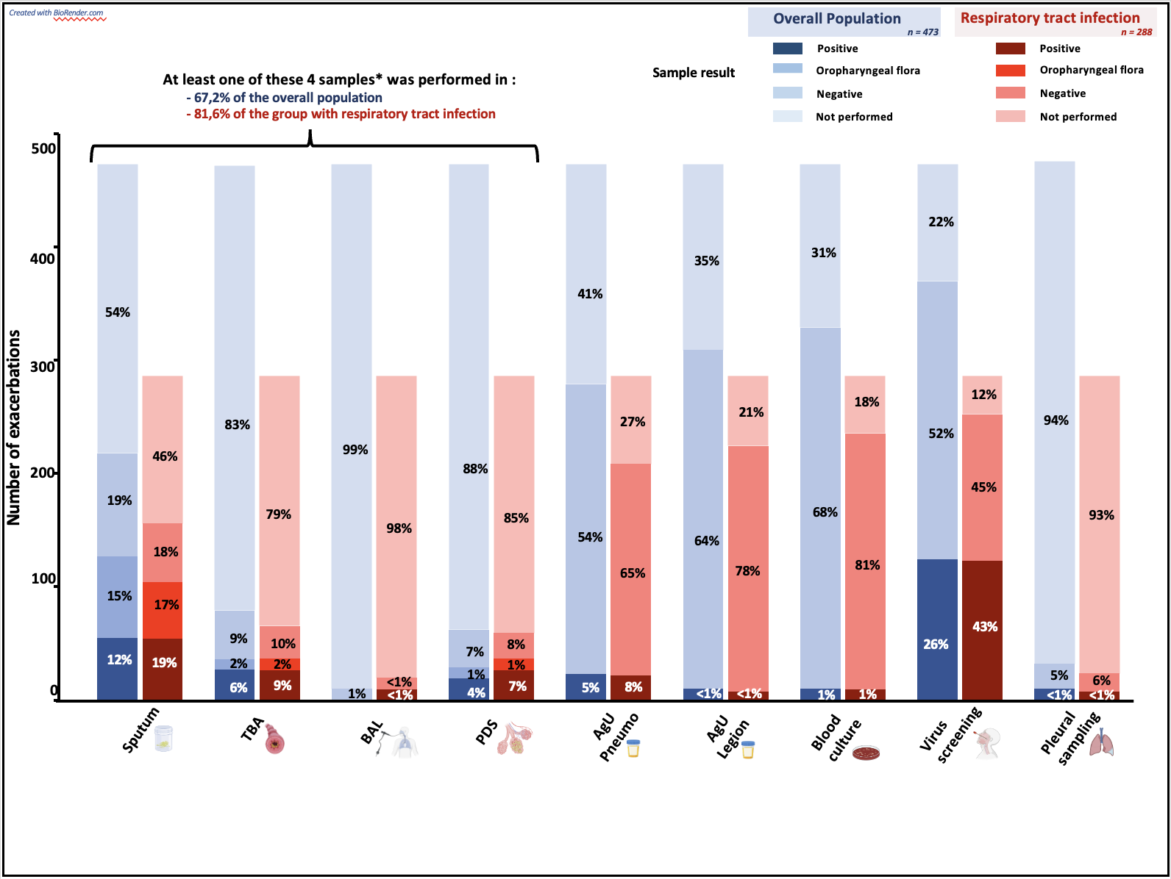

Supplementary Figure 2. Kaplan–Meier survival curves at 90 days according to the type of respiratory infection.
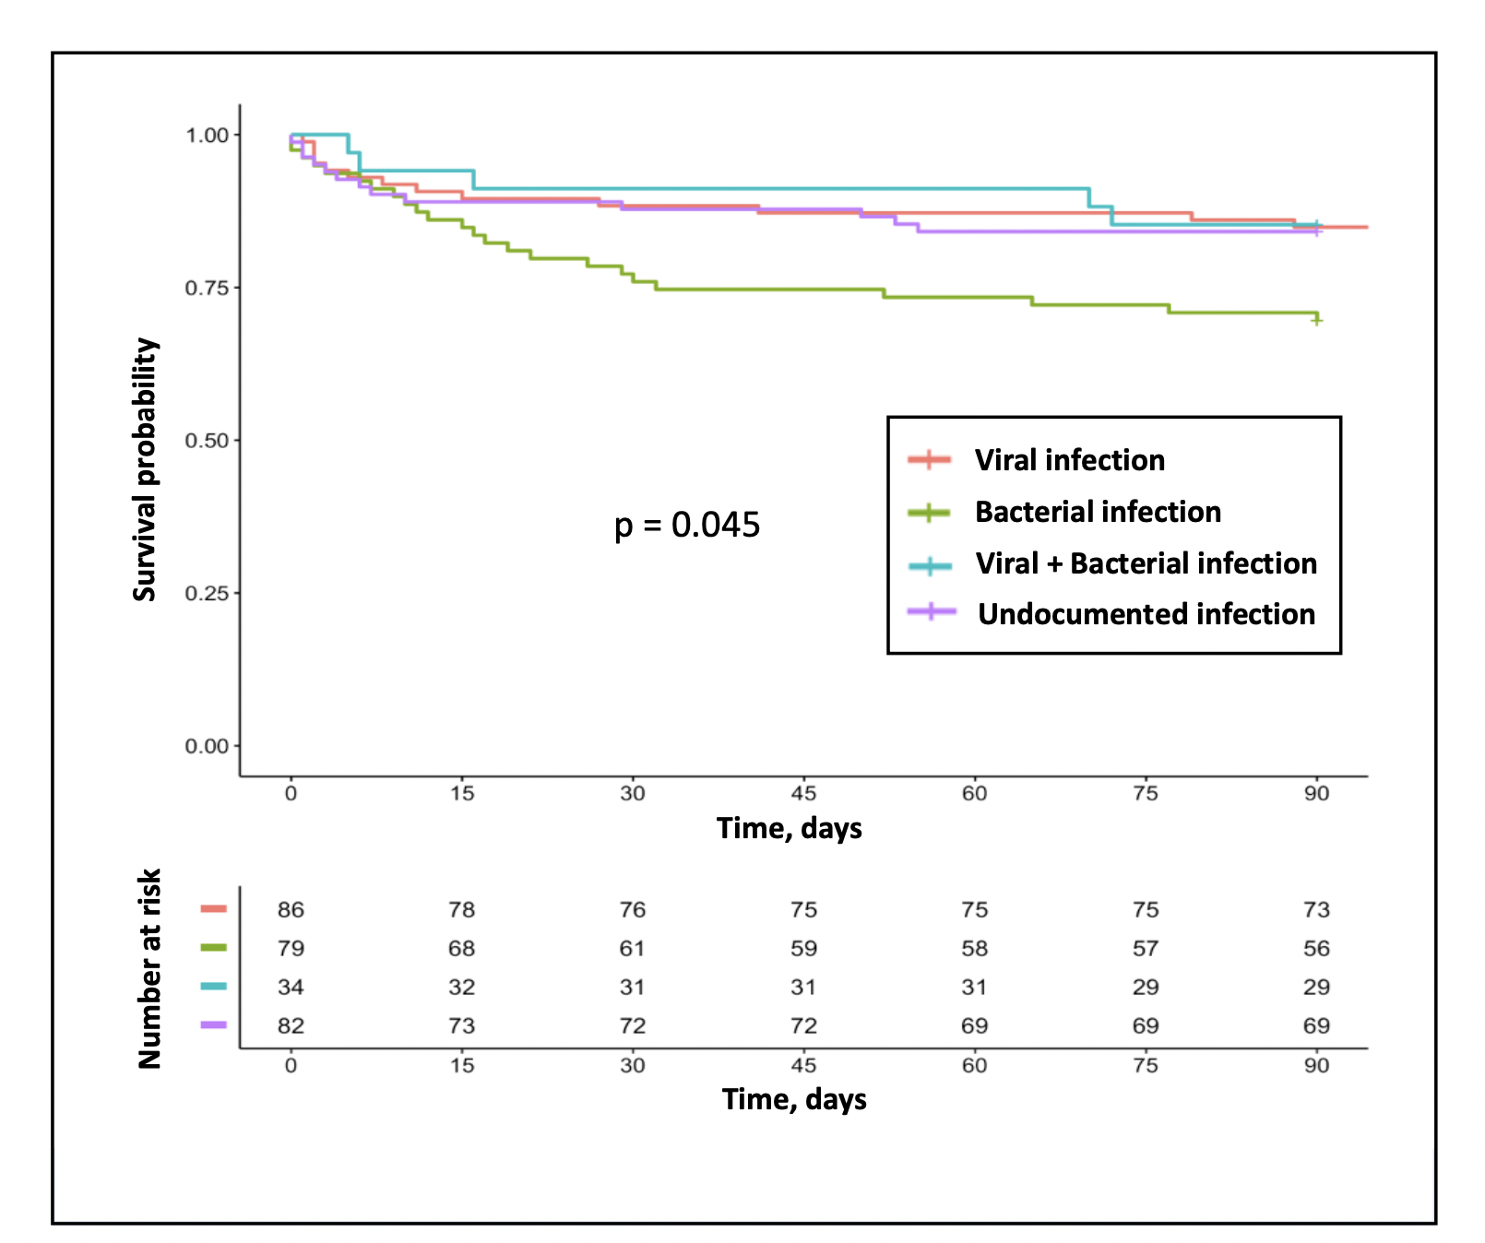

Table-S1. Baseline and intensive care unit (ICU) characteristics in patients admitted for a severe acute exacerbation of chronic obstructive pulmonary disease (COPD).
Variables | All cases  n=473 | Respiratory tract infectionª n=288 (60.9) |  |  |  | No respiratory tract infection  n=185 (39.1) | N missing†
 |  | Respiratory tract infectionª  All cases  n=288 (60.9) | Viral  infection  n=89 | Bacterial  infection  n=81 | Viral + Bacterial infection  n=34 | No respiratory tract infection  n=185 (39.1) | N missing†
Demography
Age (years) | 69 [62-77] | 71 [62-77] | 72 [65-78] | 70 (63-76] | 67 [59-77] | 67 [61-76]
Male sex | 304 (64.3) | 189 (65.6) | 57 (64.0) | 59 (72.8) | 24 (70.6) | 115 (62.2)
COPD stage 1 and 2 | 115 (30.0) | 74 (32) | 26 (34.7)** | 14 (23) | 15 (55.5) | 41 (27) | 92
COPD stage 3 and 4 | 266 (70) | 154 (68) | 49 (65.3)** | 47 (77) | 12 (44.5) | 112 (73)
Long-term oral corticosteroids therapy | 61 (12.9) | 37 (12.8) | 12 (13.5) | 11 (13.6) | 4 (11.8) | 24 (13.0) | 1
Long-term oxygen therapy | 154 (32.6) | 84 (29.2) | 21 (23.6) | 29 (35.8) | 6 (17.6) | 70 (37.8)
Long-term homecare NIV | 75 (15.9) | 34 (11.8)* | 8 (9.0) | 16 (19.8) | 1 (2.9) | 41 (22.2)
Diabetes mellitus | 104 (22.0) | 65 (22.6) | 17 (19.1) | 28 (22.2) | 10 (29.4) | 39 (21.1)
Immunodeficiency | 107 (22.6) | 69 (24.0) | 23 (25.8) | 24 (29.6) | 8 (23.5) | 38 (20.5)
Body mass index (kg/m²) | 25.3 [31.0-30.7] | 24.8 [20.7-29.4] | 26 [22-30] | 24 [21-29] | 23 [21-27] | 26.1 [22.3-32.1]
Chronic kidney failure | 39 (8.2) | 27 (9.4) | 7 (7.9) | 10 (12.3) | 3 (8.8) | 12 (6.5)
Coronary artery disease | 102 (21.6) | 64 (22.2) | 21 (23.6) | 16 (19.8) | 10 (29.4) | 38 (20.5)
Treated arterial hypertension | 270 (57.1) | 162 (56.2) | 53 (59.6) | 46 (56.8) | 23 (67.6) | 108 (58.4)
Rhythmic cardiopathy | 103 (21.8) | 57 (19.8) | 22 (24.7) | 19 (23.5) | 5 (14.7) | 46 (24.9)
Chronic heart failure | 73 (15.5) | 43 (15.1) | 11 (12.5) | 13 (16.0) | 5 (14.7) | 30 (16.2) | 3
Variables at ICU admission
Glasgow Coma Scale | 15 [14-15] | 15 [13-15] | 15 [14-15]** | 14 [10-15] | 15 [13-15] | 15 [14-15]
Temperature (°C) | 37.1 [36.5-37.6] | 37.2 [36.6-37.8]* | 37.4 [36.9-38.0] | 37.2 [36.5-37.7] | 37.1 [36.5-37.9] | 36.8 [36.3-37.3] | 2
Mean arterial pressure (mmHg) | 84 [72-95] | 83 [71-94] | 86 [71-96] | 82 [70-94] | 80 [70-93] | 87 [76-98] | 1
Heart rate (/min) | 100 [87-115] | 100 [88-116] | 105 [89-123] | 100 [88-118] | 103 [94-114] | 100 [85-112] | 2
Respiratory rate (cycle/min) | 25 [21-29] | 25 [21-30] | 25 [21-30] | 25 [20-28] | 24 [21-31] | 24 [20-28] | 4
pH | 7.31 [7.24-7.36] | 7.31 [7.24-7.36] | 7.31 [7.27-7.36] | 7.31 [7.21-7.37] | 7.31 [7.22-7.36] | 7.31 [7.25-7.36] | 1
PaO₂ (mmHg) /FiO₂ | 254 [193-312] | 249 [183-299] | 259 [211-300] | 241 [174-292] | 226 [168-258] | 270 [209-333] | 4
PaCO₂ (mmHg) | 60 [49-74] | 59 [48-74] | 57 [49-68] | 63 [50-74] | 56 [43-75] | 61 [50-75] | 1
Total CO₂ (mmol/L) | 30 [26-35] | 30 [26-34] | 29 [26-33] | 30 [27-36] | 29 [24-32] | 31 [27-35] | 4
SaO₂ (%) | 95 [91-97] | 94 [91-97] | 95 [91-97] | 94 [92-96] | 95 [94-98] | 95 [91-98] | 7
Lactate (mmol/L) | 1.4 [1.0-1.9] | 1.4 [1.0-2.0] | 1.4 [1.0-1.9] | 1.4 [1.1-2.0] | 1.6 [1.3-2.1] | 1.3 [0.9-1.8] | 25
SAPS II | 39 [31-49] | 41 [34-54]* | 40 [33-49] | 44 [36-58] | 46 [38-62] | 35 [29-43] | 3
Total white blood cells (G/L) | 11.5 [8.5-15.4] | 12.1 [8.8-16.1]* | 11.0 [8.0-15.2]** | 13.0 [9.5-17.6] | 11.4 [9.6-15.7] | 10.7 [8-13.4] | 1
Neutrophilic polynuclear cells (G/L) | 9.3 [6.2-12.9] | 10.0 [7.0-14.0]* | 8.8 [5.9-12.9]** | 10.5 [7.7-15.3] | 9.4 [7.7-12.8] | 8.0 [5.5-11.6] | 1
Eosinophilic polynuclear cells (G/L) | 0.05 [0.01-0.20] | 0.03 [0.01-0.10]* | 0.04 [0.01-0.09] | 0.03 [0.01-0.13] | 0.01 [0.00-0.06] | 0.10 [0.03-0.25] | 1
Lymphocytes (G/L) | 0.96 [0.66-1.44] | 0.87 [0.60-1.28]* | 0.89 [0.68-1.32] | 0.95 [0.54-1.49] | 0.86 [0.59-1.18] | 1.06 [0.79-1.60] | 2
C-reactive protein (mg/L) | 35 [9-104] | 60 [14-152]* | 49 [16-140] | 77 [25-213] | 91 [40-203] | 12 [5-46] | 116
Procalcitonin (ng/mL) | 0.12 [0.06-0.38] | 0.19 [0.09-0.62]* | 0.17 [0.07-0.39]** | 0.27 [0.11-1.29] | 0.27 [0.13-1.59] | 0.07 [0.05-0.11] | 82
Creatinine (µmol/L) | 74 [55-98] | 76 [60-103]* | 76 [57-99] | 81 [61-109] | 79 [62-104] | 65 [51-89] | 1
NT-proBNP (pg/mL) | 703 [209-2854] | 778 [247-3937]* | 744 [210-4234] | 760 [324-2910] | 2287 [571-7221] | 584 [141-1693] | 97
Serum albumin (g/L) | 31 [27-35] | 31 [25-34]* | 32 [27-35]** | 30 [25-34] | 27 [24-32] | 33 [30-37] | 121
Pneumonia | 182 (38.5) | 182 (63.2) | 54 (61) | 57 (70) | 26 (76) | -
Bronchitis | 106 (22.4) | 106 (36.8) | 35 (39) | 24 (30) | 8 (24) | -

Data are presented as N (%) or Median [interquartile range]
† Number of missing observations, unless Ø
*p<0.05 between respiratory tract infection and no respiratory tract infection
** p<0.05 between viral, bacterial and [viral + bacterial] respiratory tract infection
ª 24/288 patients had a suspected respiratory tract infection without microbial identification or oropharyngeal flora
ICU: intensive care unit; COPD: chronic obstructive pulmonary disease; GOLD: Global initiative for obstructive lung disease; NIV: non-invasive ventilation; NT-proBNP: NT-pro B-type natriuretic peptide; SAPS II: Simplified Acute Physiology Score II

Table-S2. Logistic regression analysis of predictive factors associated with respiratory tract infection as triggering factor of chronic obstructive pulmonary disease (COPD) exacerbation.
Variables |  | Univariable  OR (95%CI) | P value | Multivariable  OR (95%CI) | P value
Clinical characteristics
Age, years (+ 1 year) |  | 1.01 (0.99-1.03) | 0.16 | 1.01 (0.99-1.04) | 0.09
Male sex |  | 1.16 (0.79-1.70) | 0.44
Immunodeficiency |  | 1.22 (0.78-1.92) | 0.39
Performans status (-1 point) |  | 0.80 (0.64-0.98) | 0.04 | 0.73 (0.58-0.93) | 0.01
COPD stage 3-4 (GOLD classification) |  | 0.77 (0.51-1.14) | 0.19 | 0.52 (0.34-0.78) | 0.002
Chronic right heart failure |  | 0.52 (0.35-0.76) | < 0.001
Long-term oral corticosteroids therapy |  | 0.98 (0.57-1.72) | 0.95
Long-term oxygen therapy |  | 0.68 (0.46-1.01) | 0.05
Vitals parameters at ICU admission
Temperature (+ 1 °C) |  | 1.44 (1.19-1.77) | < 0.001 | 1.43 (1.16-1.78) | 0.008
Mean arterial pressure (+ 10 mmHg) |  | 0.94 (0.85-1.05) | 0.27
Heart rate (+ 10 /min) |  | 1.05 (0.97-1.15) | 0.22
Respiratory rate (+ 5 cycles/min) |  | 1.14 (0.98-1.32) | 0.09
Arterial blood gas parameters
pH (+ 0.1 unit) |  | 0.98 (0.81-1.19) | 0.85
PaO₂ (+ 10 mmHg) |  | 1.01 (0.97-1.05) | 0.59
PaCO₂ (+ 10 mmHg) |  | 0.95 (0.86-1.05) | 0.33
Lactate (+ 1 mmol/L) |  | 1.11 (0.96-1.31) | 0.19
Laboratory tests at ICU admission
Total white blood cells count (+ 1 G/L) |  | 1.06 (1.03-1.10) | < 0.001
 | Neutrophilic polynuclear cells (+ 1 G/L) | 1.08 (1.04-1.13) | < 0.001 | 1.07 (1.02-1.11) | 0.002
 | Eosinophilic polynuclear cells (+ 0.1 G/L) | 0.84 (0.77-0.91) | < 0.001 | 0.87 (0.79-0.94) | 0.002
 | Lymphocytes (+ 0.1 G/L) | 0.82 (0.66-0.99) | 0.04
 | C-reactive protein (+ 10 mg/L) | 1.08 (1.05-1.10) | < 0.001
 | Procalcitonin (+ 1 ng/mL) | 1.03 (1.00-1.08) | 0.05
Data are presented as N (%) or Median [interquartile range]
Imputation by chains equation had been used to handle missing data.
Hosmer Lemeshow test: p = 0.62
OR: Odds ratio; 95%CI: 95% Confidence intervals
COPD: chronic obstructive pulmonary disease; ICU: intensive care unit; GOLD: Global initiative for obstructive lung disease

Table-S3. Logistic regression analysis of predictive factors associated with bacterial infection (mixed or bacteria alone) versus viral infection.
Variables  Viral infection, n=89  Bacterial + mixed [bact + virus] infection, n=115 | Univariable  OR (95%CI) | P value | Multivariable  OR (95%CI) | P value
Clinical characteristics
Age, years (+ 1 year) | 0.99 [0.96-1.01] | 0.41
Male sex | 1.46 [0.81-2.64] | 0.22 | 2.21 [1.14-4.41] | 0.02
Immunodeficiency | 1.11 [0.59-2.08] | 0.75
Performans status (+1 point) | 0.92 [0.66-1.26] | 0.92
GOLD classification (+ 1 point) | 1.08 [0.56-2.07] | 0.82
Chronic heart failure | 1.31 [0.59-3.02] | 0.50
Chronic right heart failure | 0.48 [0.25-0.91] | 0.02
Body mass index (kg/m2) | 0.97 [0.94-1.02] | 0.21
Denutrition | 1.95 [1.11-3.46] | 0.02
Long-term oral corticosteroids therapy | 0.96 [0.43-2.21] | 0.92
Long-term oxygen therapy | 1.42 [0.76-2.69] | 0.28
Pneumonia | 1.68 [0.93-3.04] | 0.08
Bronchitis | 0.60 [0.33-1.07] | 0.08
Vitals parameters at ICU admission
SAPS II (+ 10 points) | 1.25 [1.06-1.49] | 0.01
Glasgow coma scale (-1 point) | 0.88 [0.81-0.96] | 0.003 | 0.90 [0.82-0.97] | 0.01
Temperature (+ 1 °C) | 0.76 [0.58-1.00] | 0.05
Mean arterial pressure (+ 10 mmHg) | 0.90 [0.78-1.05] | 0.19
Heart rate (+ 10 /min) | 0.95 [0.83-1.08] | 0.45
Respiratory rate (+ 5 cycles/min) | 0.94 [0.76-1.16] | 0.57
Arterial blood gas parameters
pH (+ 0.1 unit) | 0.86 [0.64-1.13] | 0.28
PaO2 (+ 10 mmHg) | 0.99 [0.94-1.04] | 0.62
PaCO2 (+ 10 mmHg) | 1.15 [0.98-1.36] | 0.09
Lactate (+ 1 mmol/L) | 1.09 [0.85-1.44] | 0.49
Laboratory tests at ICU admission
Total white blood cells count (+ 1 G/L) | 1.07 [1.02-1.13] | 0.006
Neutrophilic polynuclear cells (+ 1 G/L) | 1.08 [1.02-1.14] | 0.005 | 1.06 [1.01-1.13] | 0.04
Eosinophilic polynuclear cells (+ 0.1 G/L) | 0.98 [0.83-1.15] | 0.79
Lymphocytes (+ 0.1 G/L) | 1.14 [0.89-1.60] | 0.35
Serum albumin (+ 1 g/L) | 0.95 [0.90-0.98] | 0.03 | 0.94 [0.89-0.98] | 0.01
Serum creatinine (+ 50 µmol/L) | 1.25 [0.97-1.66] | 0.09
C-reactive protein (+ 10 mg/L) | 1.04 [1.01-1.07] | 0.006
Procalcitonin (+ 1 ng/mL) | 1.03 [1.01-1.06] | 0.01

Data are presented as N (%) or Median [interquartile range]
Imputation by chains equation had been used to handle missing data.
Hosmer Lemeshow test: p=0.29
OR: Odds ratio; 95%CI: 95% Confidence intervals

References

1. Daubin C, Parienti J-J, Vincent S, et al.: Epidemiology and clinical outcome of virus-positive respiratory samples in ventilated patients: a prospective cohort study. Crit Care 2006; 10:R142
2. Daubin C, Parienti J-J, Vabret A, et al.: Procalcitonin levels in acute exacerbation of COPD admitted in ICU: a prospective cohort study. BMC Infect Dis 2008; 8:145
3. Daubin C, Vincent S, Vabret A, et al.: Nosocomial viral ventilator-associated pneumonia in the intensive care unit: a prospective cohort study. Intensive Care Med 2005; 31:1116–1122
4. Murray PR, Washington JA: Microscopic and baceriologic analysis of expectorated sputum. Mayo Clin Proc 1975; 50:339–344
5. Soler N, Torres A, Ewig S, et al.: Bronchial microbial patterns in severe exacerbations of chronic obstructive pulmonary disease (COPD) requiring mechanical ventilation. Am J Respir Crit Care Med 1998; 157:1498–1505
6. Cantral DE, Tape TG, Reed EC, et al.: Quantitative culture of bronchoalveolar lavage fluid for the diagnosis of bacterial pneumonia. Am J Med 1993; 95:601–607
7. Kalil AC, Metersky ML, Klompas M, et al.: Management of Adults With Hospital-acquired and Ventilator-associated Pneumonia: 2016 Clinical Practice Guidelines by the Infectious Diseases Society of America and the American Thoracic Society. Clin Infect Dis 2016; 63:e61–e111
8. Rochwerg B, Brochard L, Elliott MW, et al.: Official ERS/ATS clinical practice guidelines: noninvasive ventilation for acute respiratory failure. Eur Respir J 2017; 50:1602426
9. Davidson AC, Banham S, Elliott M, et al.: BTS/ICS guideline for the ventilatory management of acute hypercapnic respiratory failure in adults. Thorax 2016; 71 Suppl 2:ii1-35
10. Ram FSF, Picot J, Lightowler J, et al.: Non-invasive positive pressure ventilation for treatment of respiratory failure due to exacerbations of chronic obstructive pulmonary disease. Cochrane Database Syst Rev 2004; CD004104
11. Devlin JW, Skrobik Y, Gélinas C, et al.: Clinical Practice Guidelines for the Prevention and Management of Pain, Agitation/Sedation, Delirium, Immobility, and Sleep Disruption in Adult Patients in the ICU. Crit Care Med 2018; 46:e825–e873
12. Boles J-M, Bion J, Connors A, et al.: Weaning from mechanical ventilation. Eur Respir J 2007; 29:1033–1056
13. ARDS Definition Task Force, Ranieri VM, Rubenfeld GD, et al.: Acute respiratory distress syndrome: the Berlin Definition. JAMA 2012; 307:2526–2533
14. Quintard H, l’Her E, Pottecher J, et al.: Experts’ guidelines of intubation and extubation of the ICU patient of French Society of Anaesthesia and Intensive Care Medicine (SFAR) and French-speaking Intensive Care Society (SRLF) : In collaboration with the pediatric Association of French-speaking Anaesthetists and Intensivists (ADARPEF), French-speaking Group of Intensive Care and Paediatric emergencies (GFRUP) and Intensive Care physiotherapy society (SKR). Ann Intensive Care 2019; 9:13
15. Thille AW, Harrois A, Schortgen F, et al.: Outcomes of extubation failure in medical intensive care unit patients. Crit Care Med 2011; 39:2612–2618

