Supplementary Material

Supplementary Figures legends
Fig. S1. Cellular communication of different cells.
Fig. S2. Analysis of epithelial cell signaling pathways.
Fig. S3. Enrichment analysis of intersecting genes.
Fig. S4. Pseudo-timing analysis.
Fig. S5. Correlation of risk factors and clinical information.
Fig. S6. DCA analysis for predicting survival in ESCC patients.
Fig. S7. Immune checkpoint analysis.

Supplementary tables Legends

Table. S1: Clinical information.

Supplementary Figures
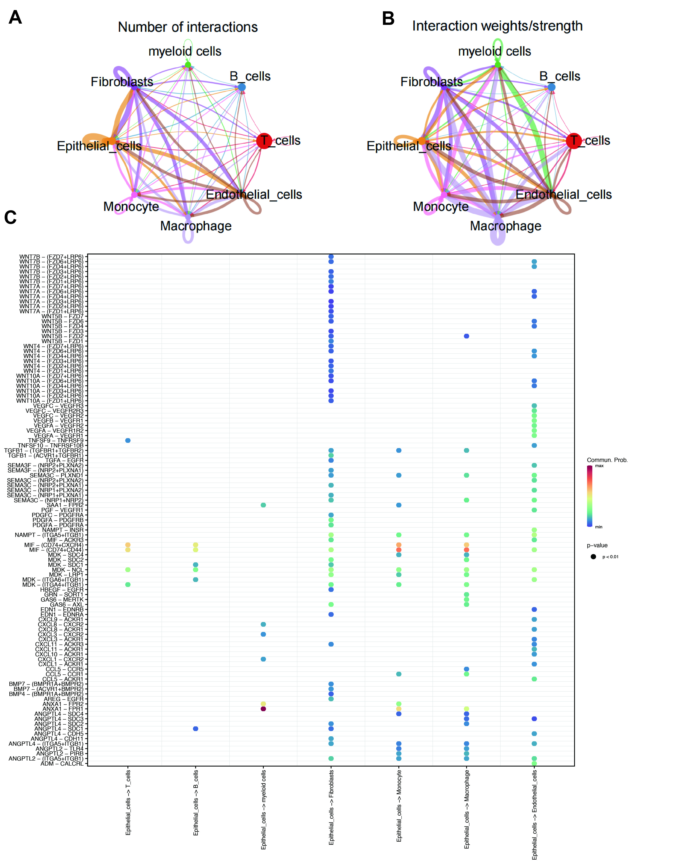
Fig. S1. Cellular communication of different cells. (A) The number of cellular communications. (B) Strength of cellular communication. (C) Receptor–ligand interactions between epithelial and other cells.

Fig. S2. Analysis of epithelial cell signaling pathways. (A-C) Receptor and ligand diagrams for epithelial and other cell types.

Fig. S3. Enrichment analysis of intersecting genes. (A) Gene Ontology enrichment analysis circle graph. (B) Kyoto Encyclopedia of Genes and Genomes enrichment analysis histogram.

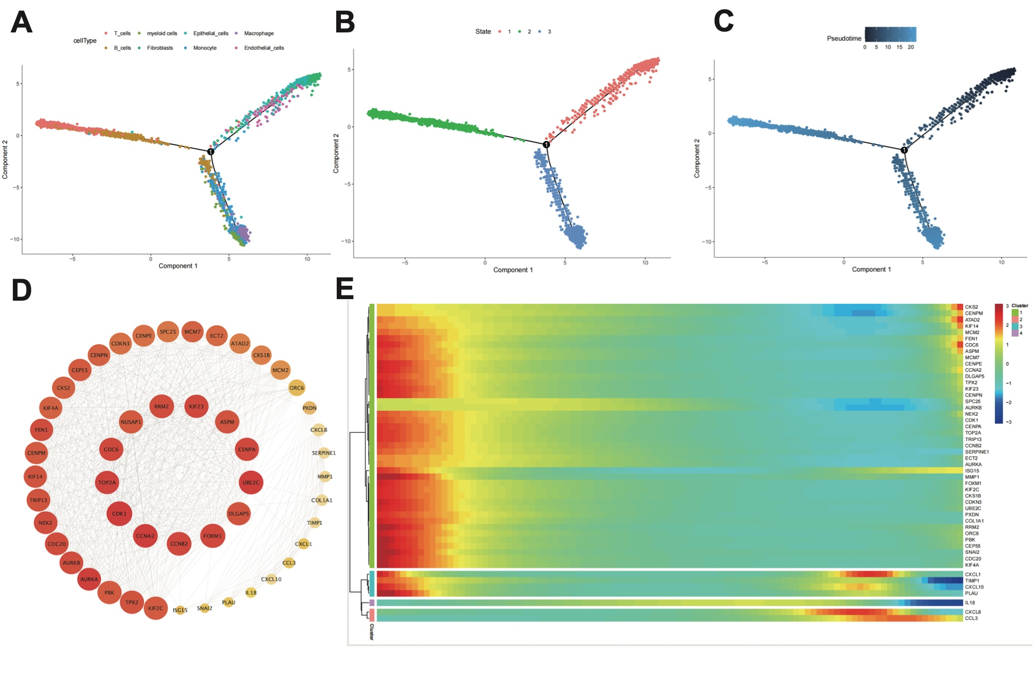
Fig. S4. Pseudo-timing analysis. (A) Pseudo-temporal maps of different cell subpopulations. (B) Pseudo-temporal plot of different differentiation states. (C) A graph of the pseudo-time trajectory, with darker to lighter colors denoting differentiation states from early to late, respectively. (D) Selection of the top 50 core genes using the Degree parameter. (E) Heatmap of the core gene dynamics.

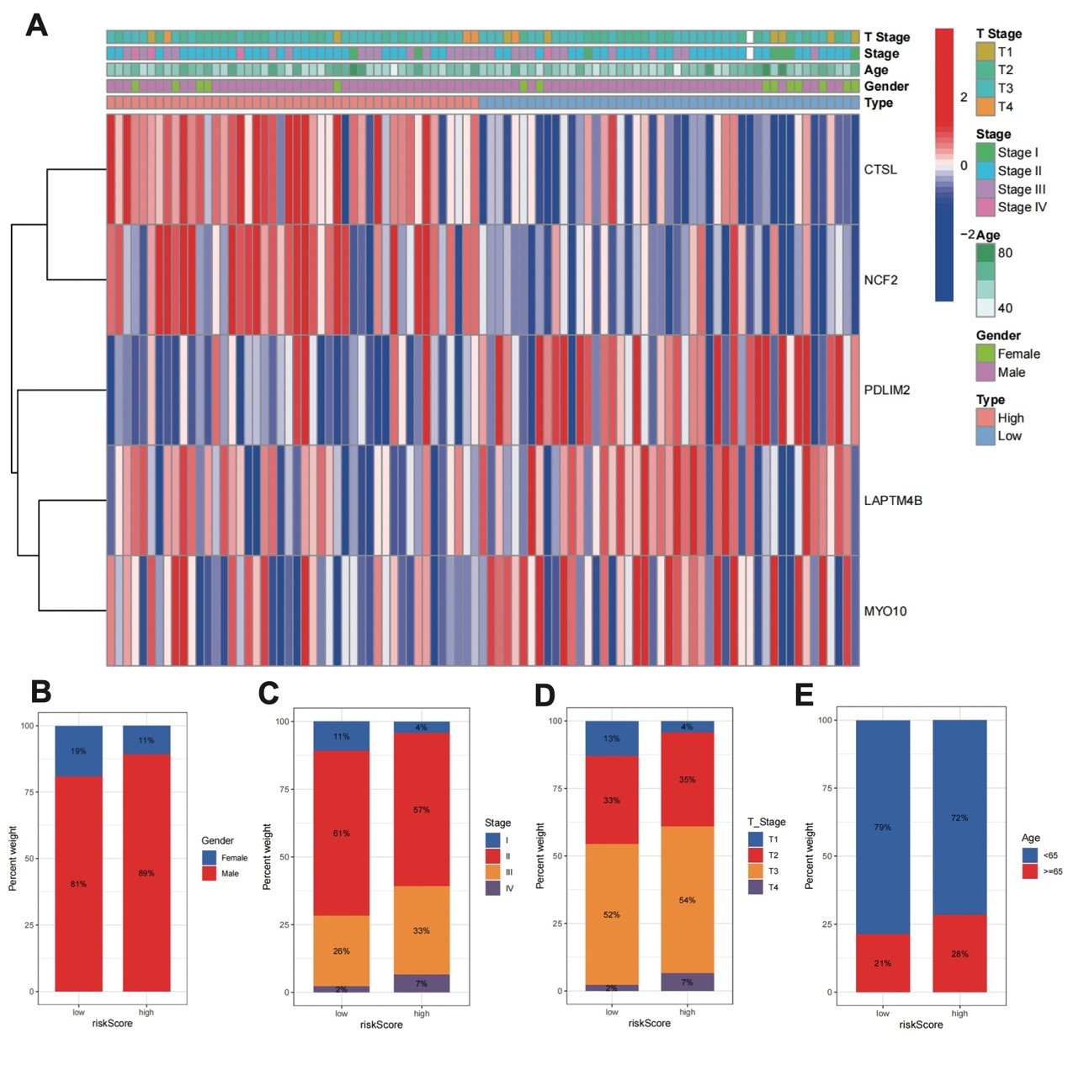
Fig. S5. Correlation of risk factors and clinical information. (A) Heatmaps related to clinical information. (B) Proportion of each sex in the high- and low-risk groups. (C) Proportion of various tumor stages in the high- and low-risk groups. (D) Proportion of T stages in the high- and low-risk groups. (E) Proportion of age classes in the high- and low-risk groups.

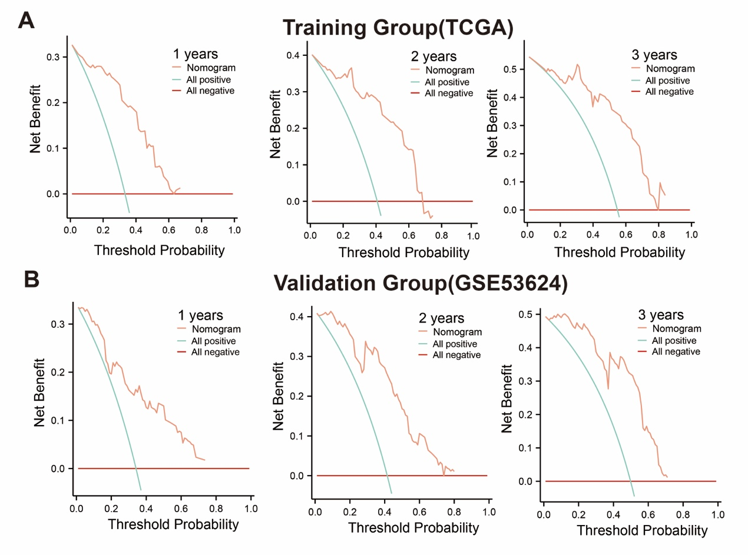
Fig. S6. DCA analysis for predicting survival in ESCC patients. (A) Decision analysis curves for 1, 2, and 3 years in the training group. (B) Decision analysis curves for the validation group at 1, 2, and 3 years.
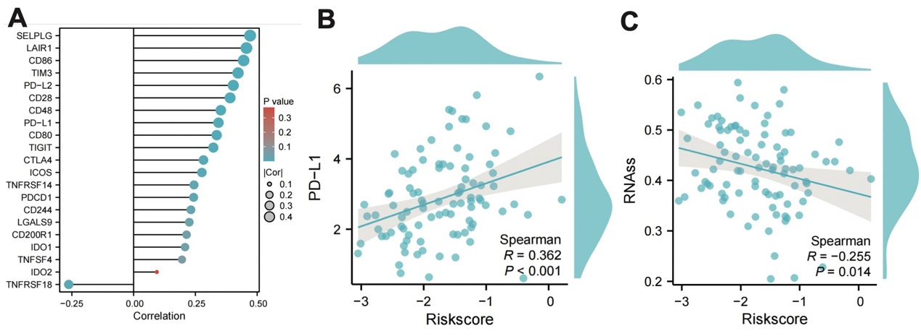
Fig. S7. Immune checkpoint analysis. (A) Correlation plot of Risk score with immune checkpoints; (B) Correlation of PD-L1 with Risk score; (C) Correlation analysis of MSI with Risk score.

Table S1: Clinical information.

Characteristics | Dead | Alive | P value
n | 30 | 63
Gender, n (%) |  |  | 0.211
male | 28 (30.1%) | 51 (54.8%)
female | 2 (2.2%) | 12 (12.9%)
Age, n (%) |  |  | 0.765
<65 | 22 (23.7%) | 48 (51.6%)
>=65 | 8 (8.6%) | 15 (16.1%)
Stage, n (%) |  |  | 0.051
Stage II | 12 (13%) | 42 (45.7%)
Stage IV | 3 (3.3%) | 1 (1.1%)
Stage III | 12 (13%) | 15 (16.3%)
Stage I | 2 (2.2%) | 5 (5.4%)
T_stage, n (%) |  |  | 0.270
T3 | 14 (15.2%) | 35 (38%)
T1 | 3 (3.3%) | 5 (5.4%)
T2 | 9 (9.8%) | 22 (23.9%)
T4 | 3 (3.3%) | 1 (1.1%)
riskScore, n (%) |  |  | < 0.001
High | 23 (24.7%) | 23 (24.7%)
Low | 7 (7.5%) | 40 (43%)

