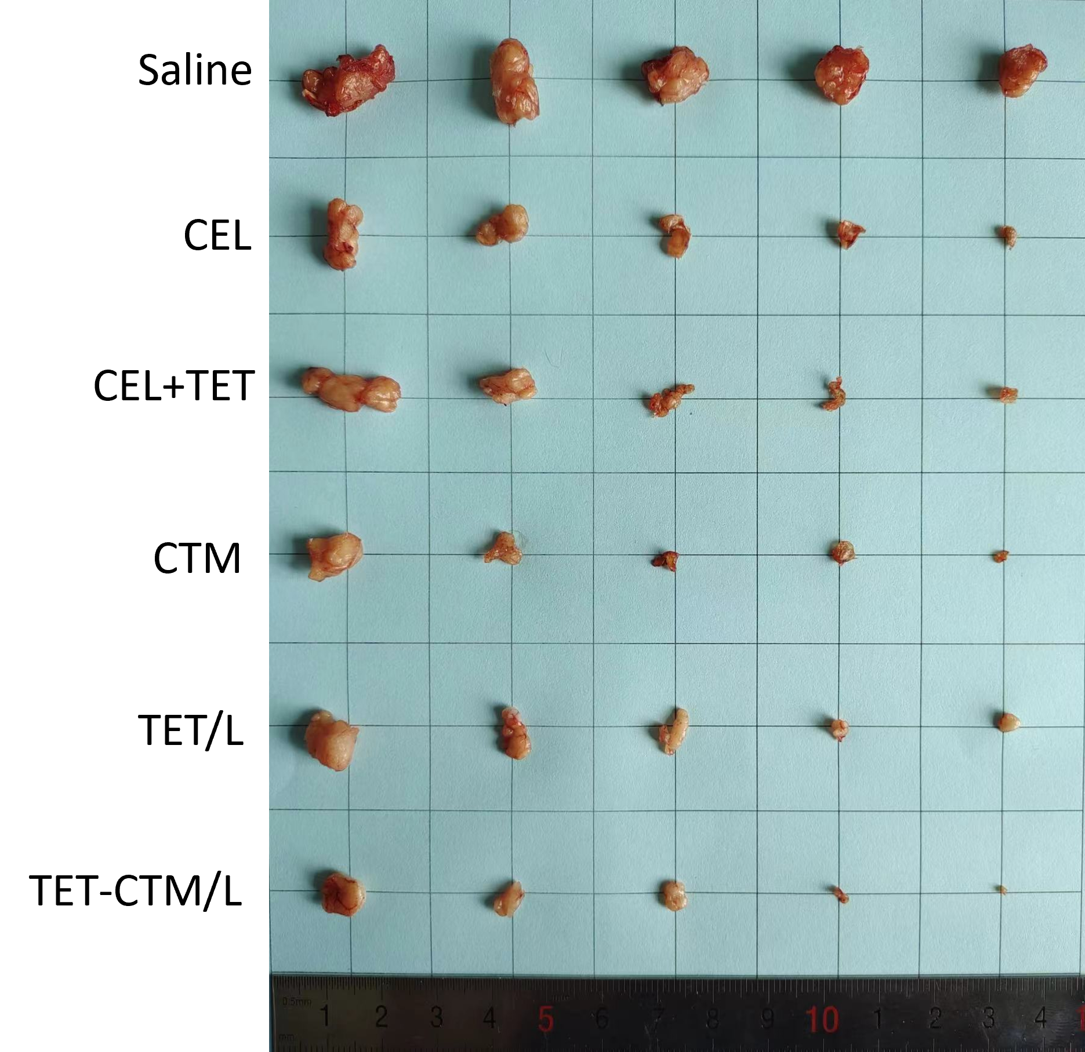
Figure S1. Photograph of tumors stripped from mice administrated intravenously with each formulation group（n = 5, ± s）

