Supplemental Table 1 Calculation methods of NPS
Factor | Threshold value | Score
Serum albumin (g/L) | ≥40 | 0
 | ＜40 | 1
Total cholesterol (mg/dl) | ＞180 | 0
 | ≤180 | 1
Neutrophil lymphocyte ratio | ≤2.96 | 0
 | ＞2.96 | 1
Lymphocyte monocyte ratio | ＞4.44 | 0
 | ≤4.44 | 1
Abbreviations: NPS, Nutritional Prognostic Score.

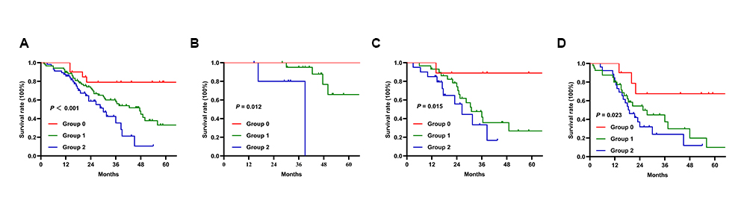
Supplemental Figure 1 The survival subgroup analysis of resected CCA patients by the Kaplan–Meier method. (A) The survival curves of Group based on NPS in all patients. (B) The survival curves of Group based on NPS in patients with stage I. (C) The survival curves of Group based on NPS in patients with stage II. (D) The survival curves of Group based on NPS in patients with stage III.
Abbreviations: CCA, cholangiocarcinoma; NPS, Nutritional Prognostic Score.

