Table S1 failure mode distribution, number (percentage) of teeth
Group | Before aging |  |  |  | After aging
Group | A | CE | CF | M | A | CE | CF | M
A | 1 | - | 6 | 3 | - | - | 9 | 1
B | 2 | 2 | 2 | 4 | 2 | 2 | 3 | 3
C | 4 | 3 | 1 | 2 | 3 | 1 | 3 | 3
D | 5 | 2 | - | 3 | 4 | 2 | - | 4
E | 4 | 1 | - | 5 | 3 | 1 | 1 | 5
F | 4 | 1 | 1 | 4 | 3 | 1 | 2 | 4
A: adhesive failure; CE: cohesive failure within enamel; CF: cohesive failure within FRC; M: mixed failure.
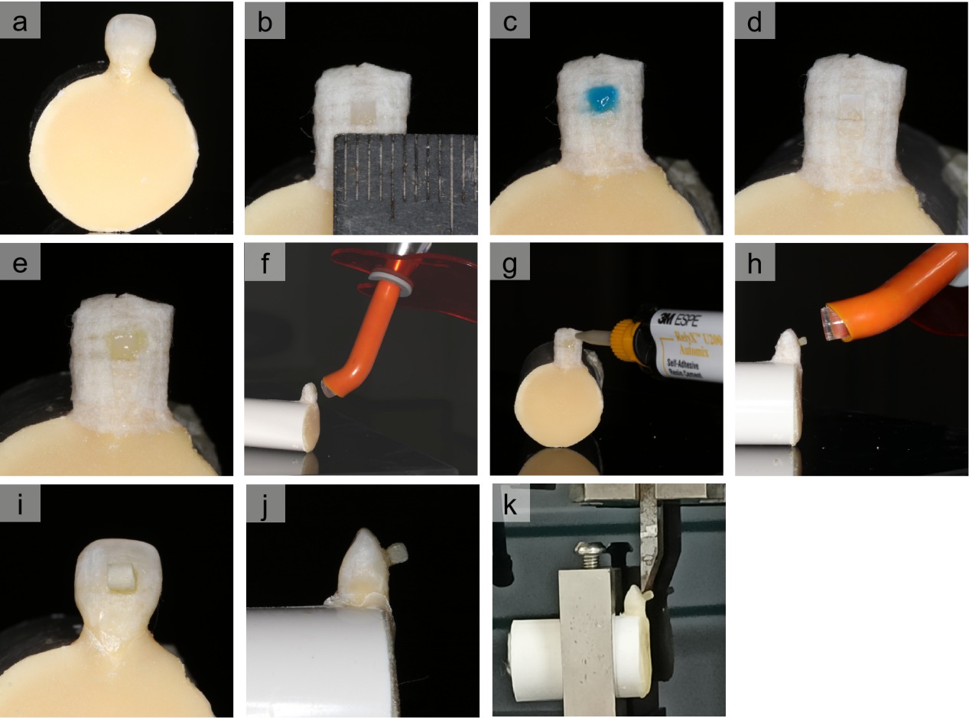
Figure S1 a) select extracted sound human anterior tooth; b) use medical tape to isolate the standard bonding area; c) 37.5% phosphoric acid etching; d) white spot after acid etching; e) apply dental adhesive to the etched area; f) light cure; g) place the composite resin on the standardized bonding area; h) light cure; i) and j) are photographs of the standard specimen; k) schematic diagrams of shear bond strength test.
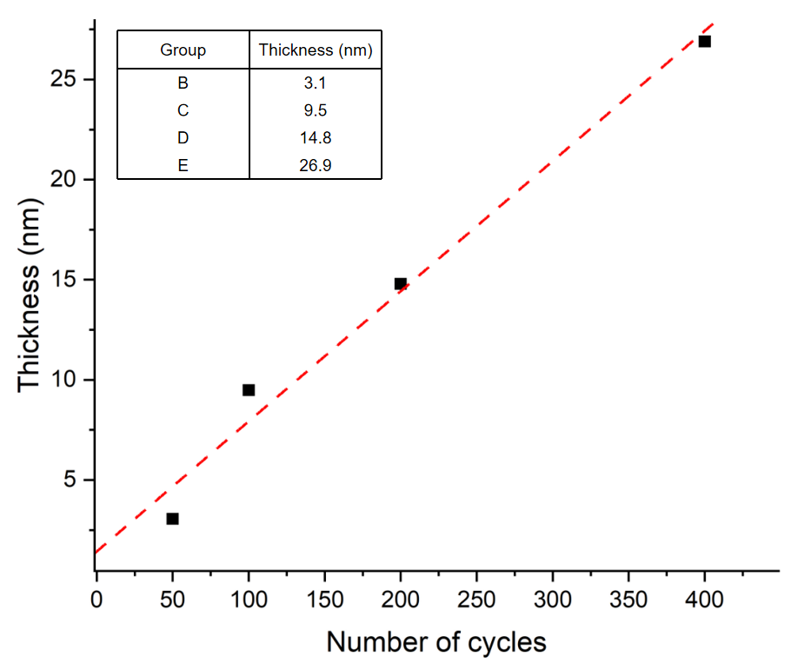
Figure S2 Linear correlation between the thickness of SiO₂ nanofilms and number of ALD cycles.

