Supporting information
Min Chen ^{1, #,} *, Tao Liu ^{2, #}, Wenqiang Li ³, Yingting Li ¹, Puxin Zhong ¹, Huanchen Yan ¹, Jingyin Kong ¹, Weixiang Liang ²

¹ Department of Obstetrics and Gynecology, Department of Fetal Medicine and Prenatal Diagnosis; Guangdong Provincial Key Laboratory of Major Obstetric Diseases; Guangdong Provincial Clinical Research Center for Obstetrics and Gynecology; Guangdong-Hong Kong-Macao Greater Bay Area Higher Education Joint Laboratory of Maternal-Fetal Medicine; The Third Affiliated Hospital of Guangzhou Medical University, Guangzhou 510000, China.
² Department of ultrasound; Guangdong Provincial Key Laboratory of Major Obstetric Diseases; Guangdong Provincial Clinical Research Center for Obstetrics and Gynecology; The Third Affiliated Hospital of Guangzhou Medical University, Guangzhou 510000, China.
³ Engineering Technology Research Center for Sports Assistive Devices of Guangdong, Guangzhou Sport University, Guangzhou 510076, China.

#Author Contributions: Min Chen and Tao Liu
These authors contributed equally to this work.
*Correspondence: Min Chen
E-mail: edchen99@gmail.com
Figure S1 N₂ adsorption-desorption isotherm of MOS or MMOS-Ica@HA.

Figure S2 Hydrodynamic particle size of MMOS-Ica@HA in H₂O, PBS (pH 7.4) buffer, or DMEM within 7.0 days.
Figure S3 Polydispersity index (PDI) value of MMOS-Ica@HA dispersed in deionized water, PBS buffer, or DMEM medium for 1 or 7 days, which is measured by DLS.

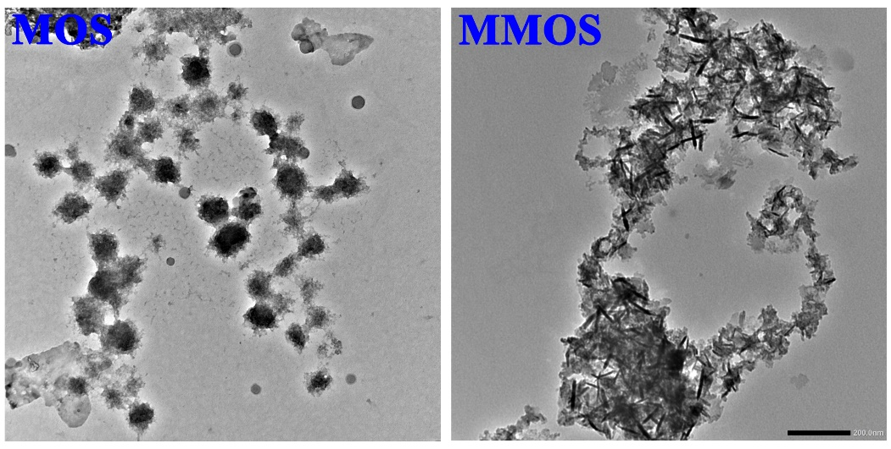
Figure S4 TEM images of biodegradable MOS or MMOS after incubation in SBF solution containing 1.0 mM of GSH for 7.0 days

Figure S5 Release profile of Ica (A) or Mg²⁺ (B) from MMOS-Ica and MMOS-Ica@HA nanoplatforms in PBS solution containing1.0 mM GSH

Figure S6 CLSM results of BMSCs after treatment with R6G-labelled MOS or MMOS.

Figure S7 Cell viability of BMSCs after incubation with different concentrations of MMOS-Ica or MMOS-Ica for 3.0 days. * P < 0.05, represents a significant difference.
Figure S8 Live/dead cell staining of BMSCs incubated with MMOS-Ica for 3.0 days.

Figure S9 Dose-response and time course of the percent survival for zebrafish.

Figure S10 Percent of malformed zebrafish treated with different concentrations of MMOS-Ica@HA nanoplatforms was analyzed at 1-7 dpf.

