Supplemental material 1. Two-dimensional renderings of the particles from Experiment 3.
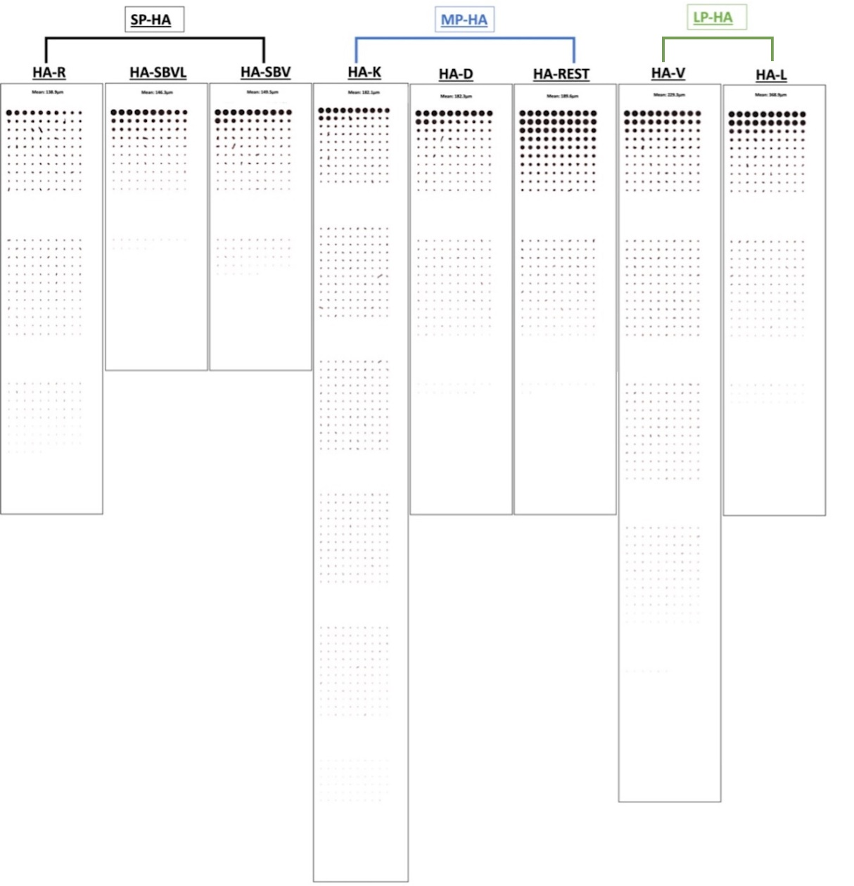

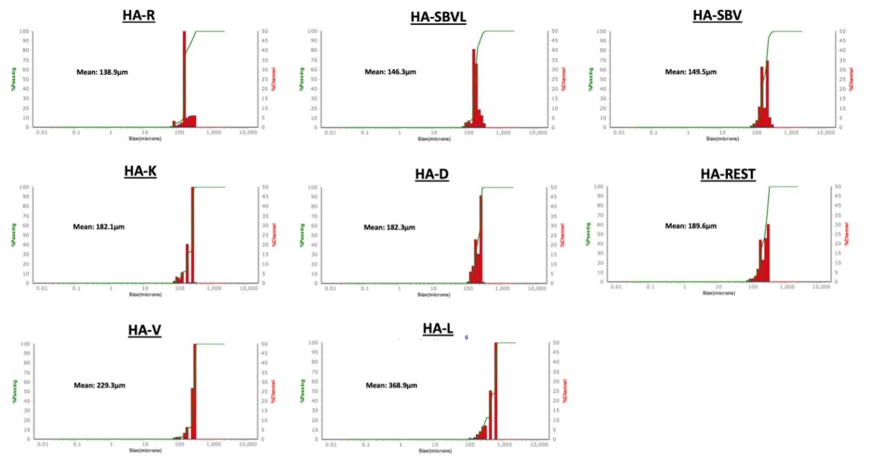
Supplemental material 2. Results of the particle size analyses (Experiment 3). The particle size distributions of each of the eight HA fillers evaluated are depicted by the histograms. Samples are displayed by increasing mean area [MA (μm); upper left (smallest), lower right (largest).

Supplemental material 3. Summary of findings. Swelling factor and cohesivity positively correlated.
Manufacturing technology | Swelling factor/capacity | Cohesivity | Width of the particle size distribution | Range of mean particle size  [MA (μm)]
NASHA | Low | Low | Narrow | 146.3 to 368.9
OBT | Moderate | Moderate | Wide | 138.9 to 229.3
Note: NASHA = Non-animal stabilized hyaluronic acid. OBT = Optimal Balance Technology. The swelling factor (ml/g) was calculated by V₇/V₁, where V₁ is the initial volume of the gel at Day 1 and V₇ is the volume of the fully swollen gel at Day 7. Cohesivity was defined as the force of attraction holding the molecules of the sample together.

Supplemental material 4. Swelling factor and degree of cohesion positively correlate among the eight samples of hyaluronic acid fillers evaluated.

