Supplementary Figures
Figure S1 Restricted cubic spline regression analysis of SII index with in all-cause mortality. (A, B and C) Restricted cubic spline for in-hospital mortality. (D, E and F) Restricted cubic spline for long-term follow-up death.
HR: hazard ratio, CI: confidence interval, SII: Systemic immune inflammatory index.
Heavy central lines represent the estimated adjusted hazard ratios, with shaded ribbons denoting 95% confidence intervals. logSII index 7.19 was selected as the reference level represented by the vertical dotted lines. The horizontal dotted lines represent the hazard ratio of 1.0.
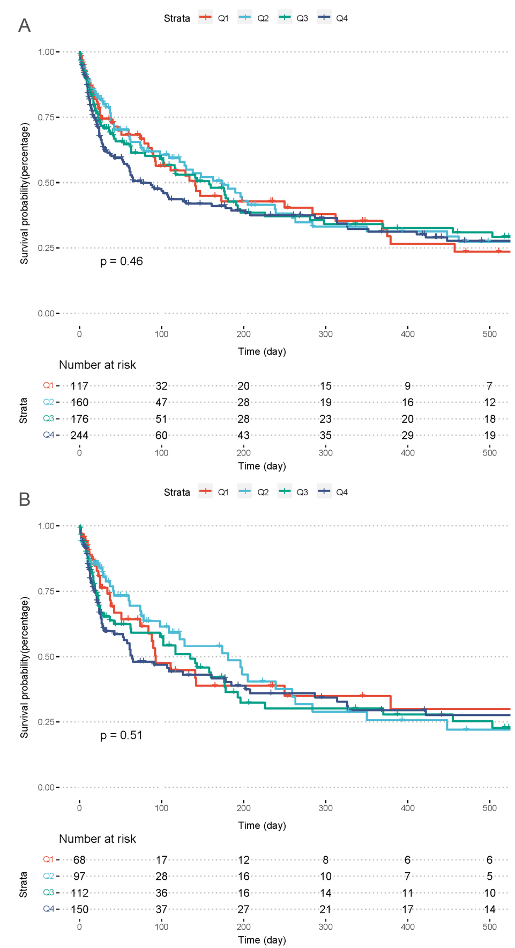
Figure S2 Kaplan-Meier survival analysis curves for all-cause mortality in patients with COPD combined with respiratory failure. SII index: Q1 (SII≥634.51), Q2 (634.51＜SII≤1302.17), Q3 (1302.17＜SII≤2821.88), Q4 (SII＞2821.88). Respiratory failure (A), hypercapnic respiratory failure (B).

