Electronic Supplementary Material
Fig S1. Distribution map of survey sites
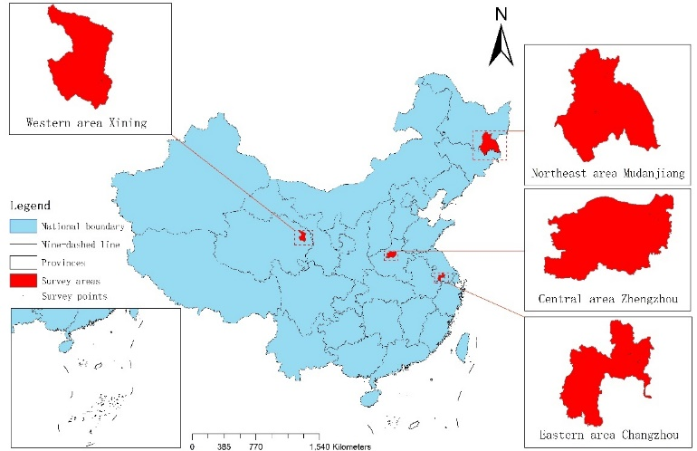

Table S1. Factors influencing the health status of long COVID and non-long COVID cases
 | Long COVID |  |  | Non long COVID
 | β(95%CI) | P value | αβ(95%CI) | P value | β(95%CI) | P value | αβ(95%CI) | P value
Sex
Male | Ref. | P | Ref. | P | Ref. | P | Ref. | P
Female | 1（-3.16~5.16） | 0.638 | 0.20（-5.29~5.70）) | 0.942 | 0.40（-0.72~1.51） | 0.485 | -0.26（-1.67~1.14) | 0.715
Age
18-29 | Ref. |  | Ref. |  | Ref. |  | Ref.
30-39 | -4.36（-13.35~4.62） | 0.340 | -8.70(-18.37~0.97) | 0.077 | -3.66（-5.57~-1.77） | ＜0.001 | -4.85（-7.22~-2.48) | ＜0.001
40-49 | 0.06（-9.08~9.20） | 0.990 | -3.36（-13.12~6.39） | 0.498 | -4.05（-6.08~-2.03） | ＜0.001 | -5.57（-8.05~-3.08) | ＜0.001
50-59 | -3.66（-12,98~5.66） | 0.440 | -4.00（-13.90~5.90） | 0.427 | -5.04（-7.03~-3.05） | ＜0.001 | -6.96（-9.53~-4.39) | ＜0.001
≥60 | -5.10（-14.68~4.47） | 0.295 | -2.91（-14.15~8.34） | 0.611 | -8.99（-11.00~-6.97） | ＜0.001 | -10.30（-12.91~-7.70) | ＜0.001
Ethnic
Minority | Ref. |  | Ref. |  | Ref. |  | Ref.
Han | -2.05（-18.18~14.08） | 0.803 | -5.31（-20.84~10.22） | 0.501 | 0.51（-3.19~4.21） | 0.787 | -1.70（-5.7~2.29) | 0.404
Marriage
Others | Ref. |  | Ref. |  | Ref. |  | Ref.
Married | -3.74（-10.94~3.45） | 0.307 | -6.19（-13.72~1.34） | 0.107 | 3.25（1.46~5.04） | ＜0.001 | -1.87（-4.2~0.47) | 0.117
Religion
Others | Ref. |  | Ref. |  | Ref. |  | Ref.
Atheist | 8.67（-2.79~20.13） | 0.138 | 11.69（0.25~23.13） | 0.045 | 4.72（1.93~7.51） | 0.001 | 4.12（1.09~7.14) | 0.008
BMI
＜18.5 | Ref. |  | Ref. |  | Ref. |  | Ref.
18.5-24.99 | 1.27(-8.23~10.77) | 0.793 | 2.8（-6.57~12.17） | 0.577 | 3.11（-0.93~6.32） | 0.057 | 4.03（0.9~7.15) | 0.012
25.00-29.99 | 0.35（-9.71~10.40） | 0.946 | 2.05（-7.86~11.96） | 0.684 | 2.01（-1.29~5.30） | 0.232 | 4.00（0.75~7.25) | 0.016
≥30 | -9.47（-21.24~2.30） | 0.114 | -3.19（-14.68~8.29） | 0.585 | 1.25（-2.75~5.25） | 0.540 | 3.22（-0.69~7.13) | 0.106
Annual household
income (CNY)
＜20000 | Ref. |  | Ref. |  | Ref. |  | Ref.
20000-49999 | -2.12（-12.32~8.08） | 0.682 | 1.42（-8.46~11.3） | 0.777 | 2.50（0.11~4.89） | 0.040 | 1.82（-0.49~4.13) | 0.122
50000-99999 | -8.26（-17.45~0.93） | 0.078 | -11.64（-20.59~-2.69） | 0.011 | 2.56（0.28~4.84） | 0.028 | 1.99（-0.23~4.2) | 0.079
199999-200000 | 0.29（-8.83~9.41） | 0.950 | -2.52（-11.59~6.56） | 0.585 | 3.75（1.51~5.98） | 0.001 | 2.61（0.41~4.8) | 0.02
≥200000 | 1.06（-8.00~10.12） | 0.818 | -5.07（-14~3.86） | 0.265 | 3.93（1.69~6.18） | 0.001 | 2.59（0.38~4.79) | 0.022
Education level
High school or below | Ref. |  | Ref. |  | Ref. |  | Ref.
Bachelor or above | 8.21（3.33~13.09） | 0.001 | 7.44（1.14~13.74） | 0.021 | 2.25（1.11~3.38） | ＜0.001 | -0.30（-1.64~1.03) | 0.654
Wearing masks
Always | Ref. |  | Ref. |  | Ref. |  | Ref.
often | -2.19（-6.47~2.08） |  | -3.05（-7.18~1.08） |  | -2.59（-3.80~-1.39） |  | -1.07（-2.36~0.22) | 0.103
seldom | -8.59（-15.68~-1.49） |  | -7.33（-14.29~-0.37） |  | -4.51（-6.23~-2.79） |  | -0.91（-2.74~0.93) | 0.332
Smoking
Yes | Ref. |  | Ref. |  | Ref. |  | Ref.
Quit | 5.71（-2.90~14.32） | 0.193 | 12.83（3.83~21.83） | 0.005 | -2.28(-4.86~0.30) | 0.084 | -1.19（-3.87~1.48) | 0.381
Never | 7.63（1.75~13.51） | 0.011 | 10.92（4.23~17.62） | 0.001 | 0.15（-1.25~1.54） | 0.837 | -1.09（-2.8~0.63) | 0.216
Drinking
Yes | Ref. |  | Ref. |  | Ref. |  | Ref.
Quit | -9.55（-18.02~-1.09） | 0.027 | -14.28（-22.68~-5.88） | 0.001 | -3.10（-5.74~-0.45） | 0.022 | -1.59（-4.32~1.13) | 0.252
Never | -1.94（-6.70~2.82） | 0.423 | -5.56（-11.01~-0.1） | 0.046 | 0.93（-0.33~2.19） | 0.149 | 1.33（-0.21~2.87) | 0.09
Sufficient sleeping
Always | Ref. |  | Ref. |  | Ref. |  | Ref.
Often | -4.07（-10.17~2.03） | 0.190 | -2.15（-8.28~3.98） | 0.49 | -3.44（-4.82~-2.05） | ＜0.001 | -1.59（-3.17~-0.01) | 0.048
Sometimes | -7.11（-13.27~-0.96） | 0.024 | -2.19（-8.5~4.12） | 0.495 | -6.98（-8.62~-5.34） | ＜0.001 | -4.95（-6.75~-3.14) | ＜0.001
Seldom | -15.32（-22.66~-7.98） | ＜0.001 | -7.26（-14.91~0.4） | 0.063 | -12.28（-14.91~-9.66） | ＜0.001 | -9.85（-12.57~-7.12) | ＜0.001
Never | -20.5（-45.63~4.63） | 0.110 | -2.71（-27.01~21.58） | 0.826 | -17.01（-28.06~-5.95） | 0.003 | -15.8（-26.72~-4.88) | 0.005
Mental decompression
Always | Ref. |  | Ref. |  | Ref. |  | Ref.
Often | -11.80（-23.61~0.02） | 0.050 | -9.03（-20.68~2.61） | 0.128 | -4.45（-6.42~-2.47） | ＜0.001 | -2.31（-4.48~-0.15) | 0.036
Sometimes | -17.12（-28.34~-5.91） | 0.003 | -14.04（-25.15~-2.93） | 0.013 | -6.99（-8.94~-5.04） | ＜0.001 | -4.22（-6.35~-2.1) | ＜0.001
Seldom | -20.91 (-32.26~-9.56) | ＜0.001 | -16.60（-28.15~-5.05） | 0.005 | -7.96（-10.01~-5.92） | ＜0.001 | -4.47（-6.71~-2.23) | ＜0.001
Never | -31.55(-44.79~-18.31) | ＜0.001 | -25.40（-38.82~-11.98） | ＜0.001 | -8.76（-11.30~-6.23） | ＜0.001 | -4.86（-7.51~-2.21) | ＜0.001
Note:
95% CI, confidence interval.
CNY, China Yuan, The exchange rate, 1 dollar =7.055 CNY.
β, Unadjusted.
aβ, Adjusted for sex, age, ethnic, marriage, religion, BMI, Annual household income, education level, wearing masks, smoking, drinking, sufficient sleeping, mental decompression.

Table S2. The mediating effect of lifestyle
Model | Variables | B | SE | P | 95％CI
 |  |  |  |  | LLCI | ULCI
1 | X→Y | 6.273 | 0.928 | ＜0.001 | 4.454 | 8.092
2 | X→M | -0.354 | 0.120 | 0.0032 | -0.590 | -0.119
3 | X→Y | 6.049 | 0.926 | ＜0.001 | 4.233 | 7.864
 | M→Y | -0.635 | 0.137 | ＜0.001 | -0.903 | -0.367
Indirect effect | X→M→Y | Effect | Boot SE | Boot95％CI
 |  | 0.225 | 0.087 | 0.077 0.410
Note:
CI, confidence interval.
Model 1, long COVID predicts health status scores
Model 2, Long COVID predicts lifestyle scores
Model 3, Long COVID and lifestyle scores co-predict health status scores

Fig S2. Common support domain of PSM for long COVID and non-long COVID cases
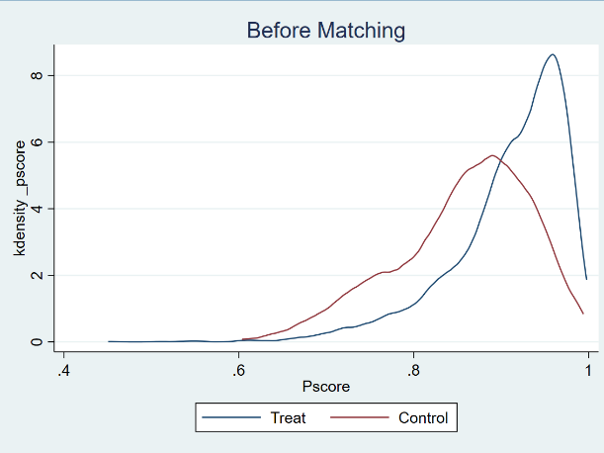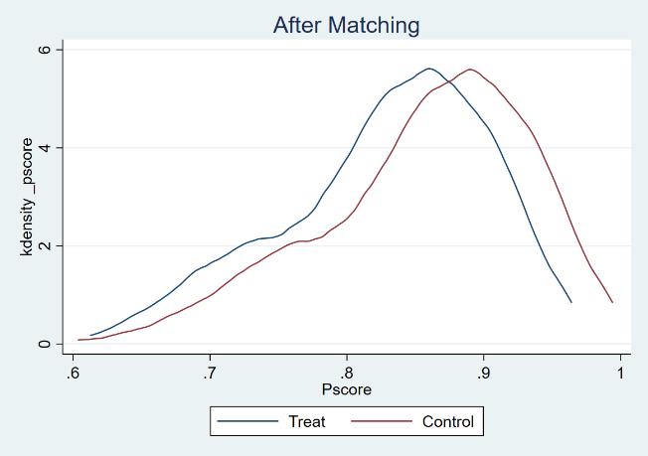

Table S3. Balance test of PSM for long COVID cases and non-long COVID cases.
Variable | Before PSM | Mean |  | bias（%） | reduct  bias（%） | t-test
 |  |  |  |  |  | t | p>t
Variable | After PSM | Long  COVID | Non-long  COVID
Education  level | Before PSM | 0.76868 | 0.6037 | -36.1 | - | -5.44 | 0.000
Education  level | After PSM | 0.76868 | 0.81495 | 10.1 | 72.0 | 1.35 | 0.177
Wearing masks | Before PSM | 1.605 | 1.7835 | 26.5 | - | 4.19 | 0.000
Wearing masks | After PSM | 1.605 | 1.5552 | -7.4 | 72.1 | -0.93 | 0.354
Sufficient sleeping | Before PSM | 2.1815 | 1.9928 | -28.0 | - | -4.51 | 0.000
Sufficient sleeping | After PSM | 2.1815 | 2.1957 | 2.1 | 92.5 | 0.25 | 0.805
Note.
95% CI, confidence interval.

