Supplementary figures and their legends
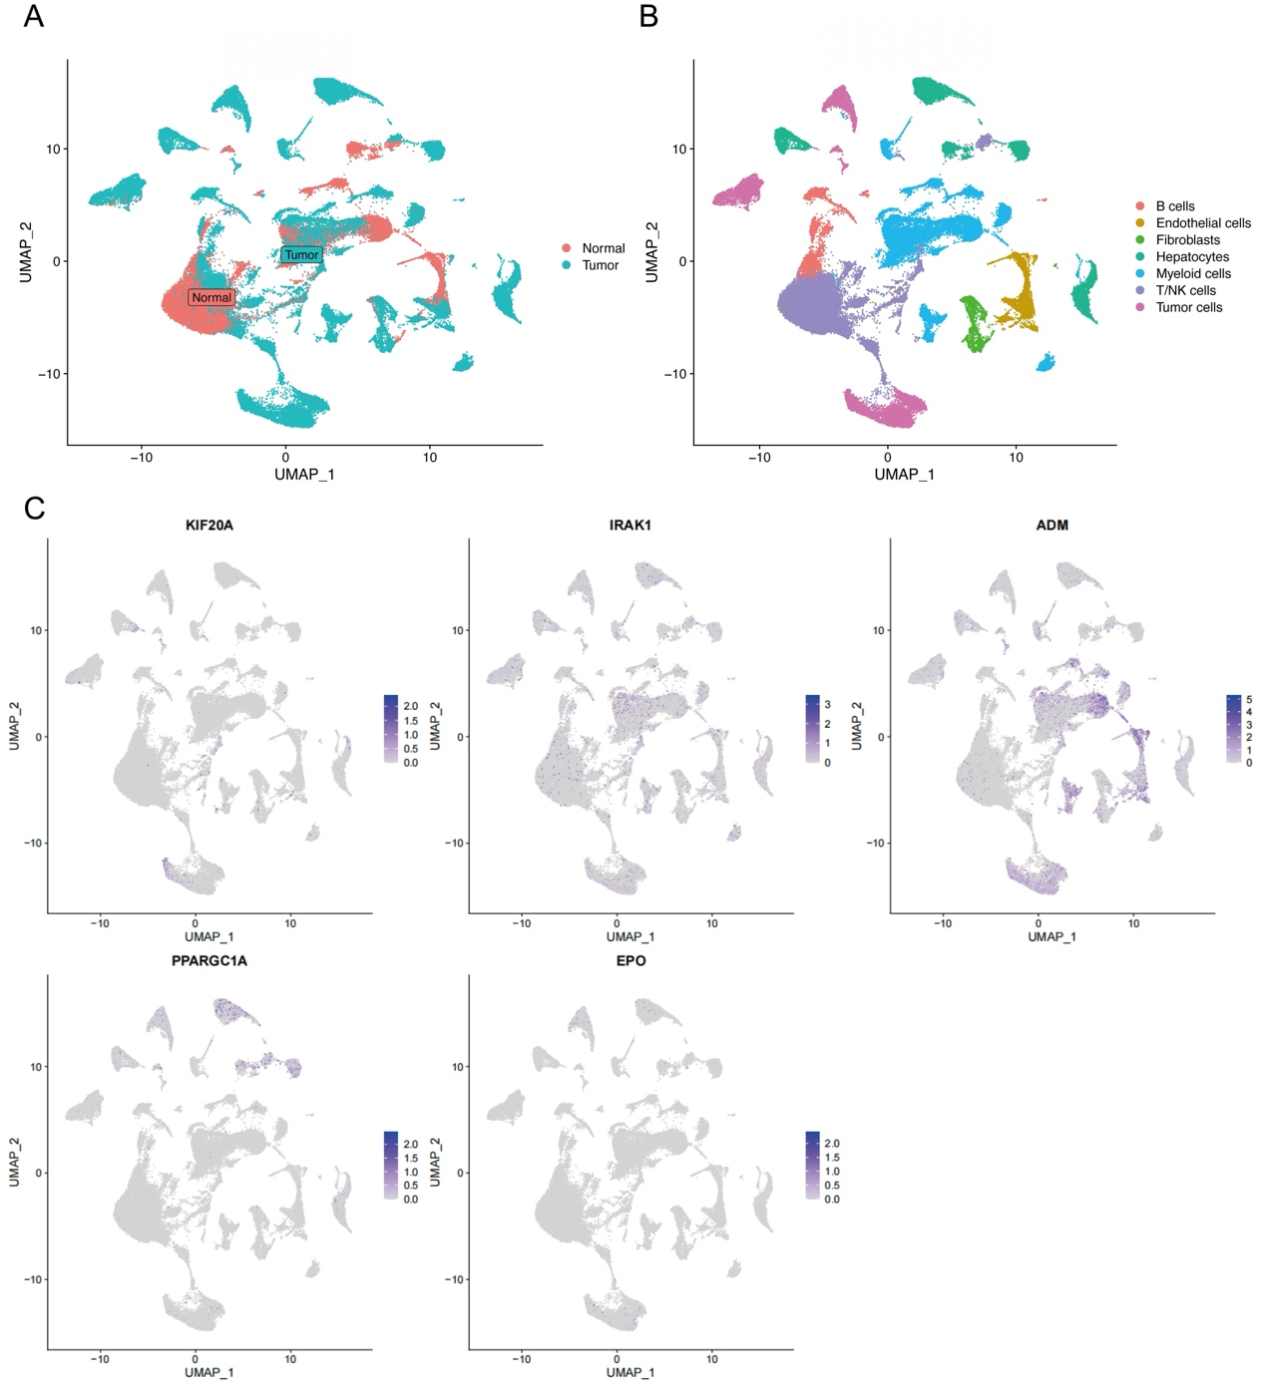
Figure S1 Expression of the five differentially expressed hypoxia- and lactate metabolism-related genes in GSE149614 cohort. (A, B) Uniform manifold approximation and projection (UMAP) plots of single-cell RNA sequencing. (C) Expression of KIF20A, IRAK1, ADM, PPARGC1A and EPO.
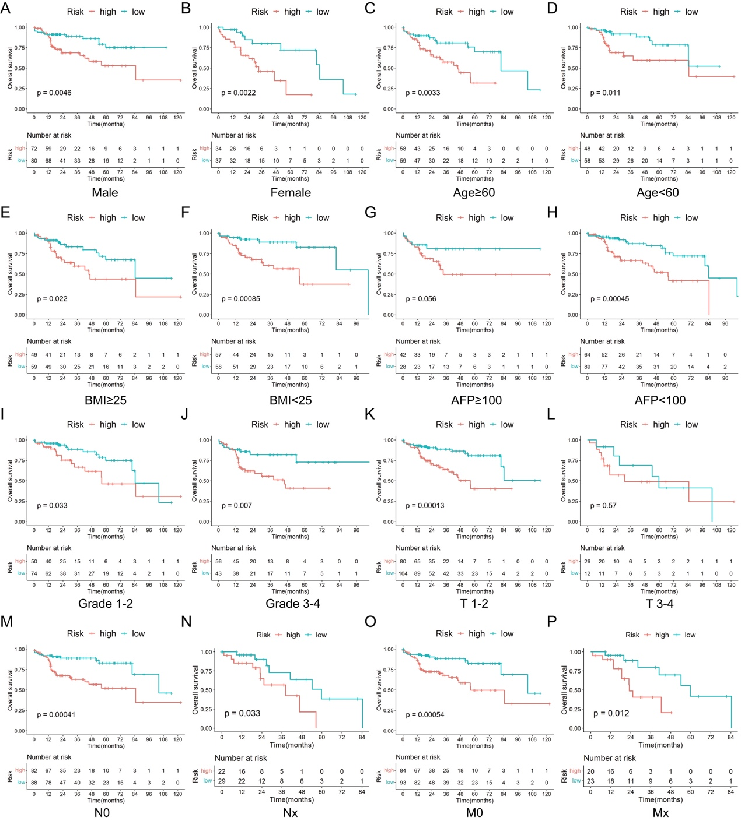
Figure S2 KM survival analysis between the two risk groups in subgroups stratified by clinical characteristics. (A) Male. (B) Female. (C) Age ≥ 60 years. (D) Age < 60 years. (E) BMI ≥ 25. (F) BMI < 25. (G) AFP ≥ 100. (H) AFP < 100. (I) Grade 1-2. (J) Grade 3-4. (K) T 1-2. (L) T 3-4. (M) N0. (N) Nx. (O) M0. (P) Mx.

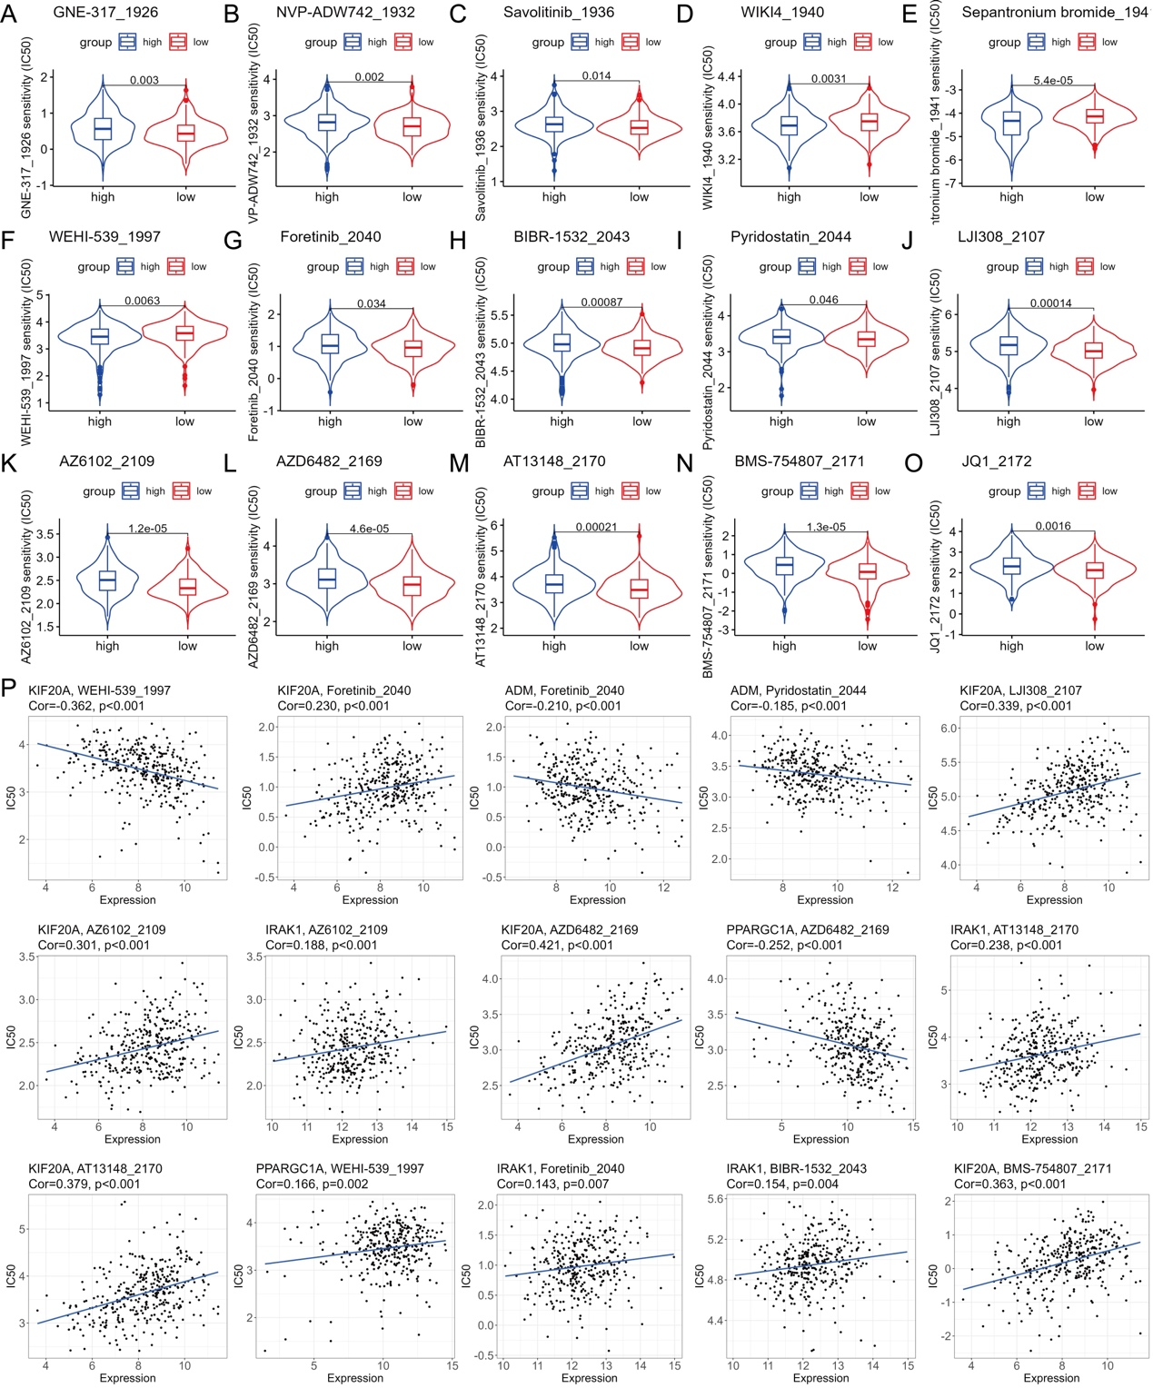
Figure S3 The assessment of the response to systemic therapeutic agents. (A-O) Comparison of the IC50 values of chemotherapeutic agents in two risk groups, including GNE-317, NVP-ADW72, savolitinib, WEHI-539, WIIKI4, sepantronium bromide, foretinib, BIBR-1532, pyridostatin, BMS-754807, LJI308, AZ6102, AZD6482, AT13148 and JQ1. (P) The correlation between IC50 values of chemotherapeutic agents and expression of HLRGs. Cor, correlation coefficient.
Supplementary Tables and their legends
Table S1 The primer sequences used in the study.
mRNA | Forward primer (5′-3′) | Reverse primer (5′-3′)
KIF-20A | 5'‐TGCTGTCCGATGACGATGTC‐3' | 5'‐AGGTTCTTGCGTACCACAGAC‐3'
IRAK1 | 5'‐GCACCCACAACTTCTCGGAG‐3' | 5'‐CACCGTGTTCCTCATCACCG‐3'
ADM | 5'‐CCGAGTGTTTGCCAGGCTTA‐3' | 5'‐GGTGACACGCCGTGAGAAAT‐3'
PPARGC1A | 5'‐TCTGAGTCTGTATGGAGTGACAT‐3' | 5'‐CCAAGTCGTTCACATCTAGTTCA‐3'
EPO | 5'‐GGAGGCCGAGAATATCACGAC‐3' | 5'‐CCCTGCCAGACTTCTACGG‐3'
ACTIN | 5'‐CACCATTGGCAATGAGCGGTTC‐3' | 5'‐AGGTCTTTGCGGATGTCCACGT‐3'

