Validation Items
<Droplet Prevention>
1 | I cover my nose and mouth with a tissue, handkerchief, sleeves etc. when coughing or sneezing.
2 | I discard the used tissue immediately after coughing or sneezing.
3 | I try to turn my head away from others when coughing or sneezing.
4 | I prepare a mask when going out.
5 | I wear a mask when going out in public places.
6 | I wear a mask when I have respiratory symptoms.
7 | I cover my nose, mouth, and chin completely when wearing a mask.
8 | I do not reuse the masks that have been used once.
<Contact Prevention>
9 | I try not to have physical contacts such as shaking hands or hugging others.
10 | I try not to touch my eyes, nose, and mouth with unwashed hands.
11 | I do not touch things right after they were touched by others.
12 | I try to use personal tablewares when having meals with others.
13 | I try to take a shower after returning home.
14 | I try to wash the contaminated laundry after returning home.
15 | I avoid going to crowded places.
16 | I refrain from participating social gatherings.
17 | I try to refrain from eating out.
18 | I try to refrain from traveling within the country or abroad.
19 | I stay home when I have symptoms(fever, cough, rash etc).
20 | I would be cautious not to have close contact with others who have symptoms.
21 | I would be cautious not to visit the affected areas.
22 | I wash my hands with water and soap when my hands are contaminated.
23 | I cleam my hands(washing hands, using sanitizer) after coughing, sneezing, or nose-blowing.
24 | I clean my hands(washing hands, using sanitizer) before having a meal.
25 | I wash my hands with water and soap after using restroom.
26 | I clean my hands(washing hands, using sanitizer) first, right after entering home.
27 | I clean my hands using hand sanitizer when I am not able to wash my hands with water and soap.
28 | I wear protective gloves when there is a risk of contact transmission.
<Airborne Prevention>
29 | I ventilate my home regulary.
30 | I ventilate confined spaces regularly.
31 | I would be cautious not to enter a place where it is not equipped with ventilation.
32 | I leave the place as soon as possible when it is judged hard to be ventilated.
33 | I use air cleaner/air sterlizer/air purifier to maintain the quality of the indoor air.
Table 1. Supplementary 1. Validation Items

Validation Items
<Bloodborne Prevention>
35 | I wear long sleeves when going out to the forest or mountain.
36 | I use mosquito repellent when going out to a place where there is a risk of pest or mosquito bites.
37 | I open the window only when the mosquito protective screens are installed.
38 | I try to control the pest using the bug catcher (including electronic) /household pest control. etc.
39 | I wash in running water when exposed to other's blood.
40 | I try not to be infected when using injection needle(self-injection, blood transfusion, blood donation, blood draw etc.)
41 | I try to use condom for a safe sexual life.
<Environmental Prevention>
42 | I clean my house regularly.
43 | I use disinfectants to maintain the hygiene of my home.
44 | I clean or disinfect objects or surfaces that are frequently touched.
45 | I would be cautious not to pollute the environment with an animal excrement.
33 | I use air cleaner/air sterlizer/air purifier to maintain the quality of the indoor air.
34 | I would be cautious controlling temperature and humidity of the indoor.
<Daily life Prevention>
46 | I try not to eat raw food(except vegetables and fruits).
47 | I drink boiled water or bottled water.
48 | I try to have a balanced diet.
49 | I excersise regularly.
50 | I try to take a rest.
51 | I avoid going out on days with heavy fine dust.
52 | I take health supplement(viatamins, protein etc.) for immunity enhancement.
53 | I get medical check-ups regularly.
54 | I try to get vaccinated against the Emerging Infectious Diseases.
55 | I check my body temperature with a thermometer when I have fever symptoms.
<Psychological Coping>
56 | I try to have a positive mind.
57 | I try to have an attitude of acceptance.
58 | I try to cope with the Emerging Infectious Diseases.
59 | I try to be considerate of others to prevent others from getting infected.
60 | I try to maintain relationship with others through communications.
61 | I try to get information about Emerging Infectious Diseases.
62 | I try to comply the preventing behaviors when I acquire information regarding Emerging Infectious Diseases.
63 | I comply preventive behaviors with a confidence in medical staff.
64 | I have confidence in the government’s quarantine policy.

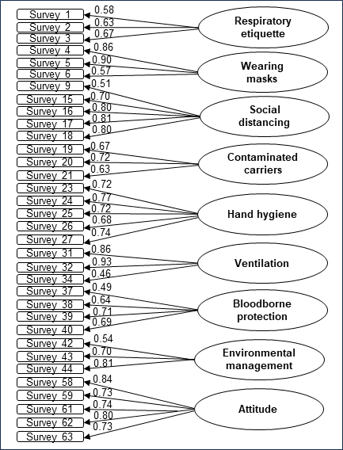
Supplementary 2. Standardized coefficient of the nine-factor model

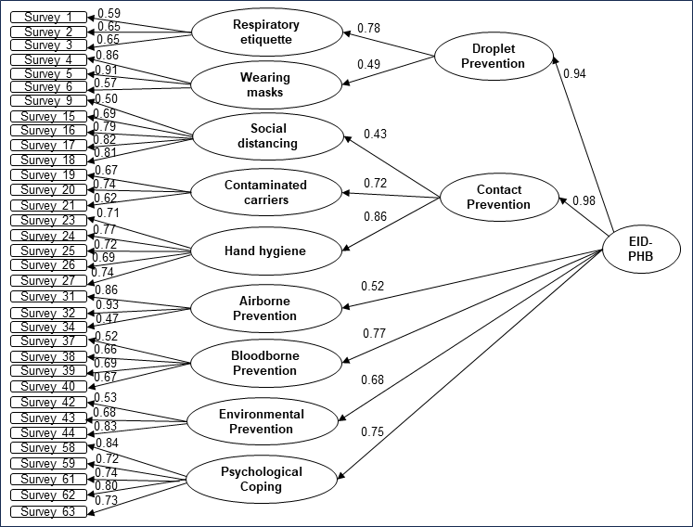
Supplementary 3. Standardized coefficient of the six-factor model
Abbreviations: EID-PHB= Emerging Infectious Diseases Preventive Health Behavior.

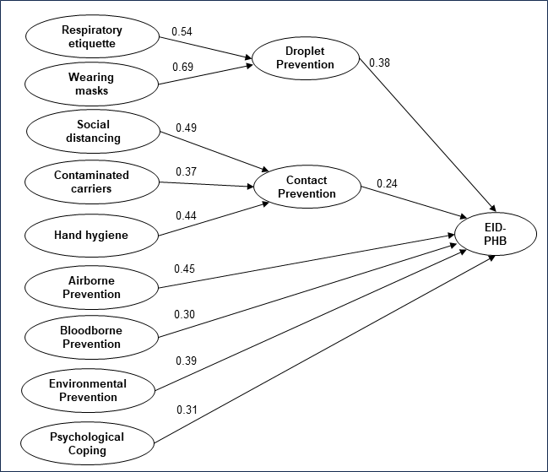
Supplementary 4. Standardized coefficient of the Preventive Health Behaviors
Abbreviations: EID-PHB= Emerging Infectious Diseases Preventive Health Behavior.

Supplementary 5. Exploratory Factor Analysis of Daily Life Prevention
Factor | No | Items | Com. | F | CR | AVE | α＊ | Cor. (r)  <p>
Factor 7 Daily life prevention |  |  |  |  | 0.82 | 0.61 | 0.67 | 0.35~0.45 <0.001>
Health care | 49 | I excersise regularly. | 0.64 | 0.80
Health care | 48 | I try to have a balanced diet. | 0.63 | 0.79
Health care | 53 | I get medical check-ups regularly. | 0.55 | 0.74
Eigen value |  |  | 1.8
Explained variance (%) |  |  | 60.7
Cumulative variance (%) |  |  | 60.7
Kaiser-Meyer-Olkin: 0.66, Bartlett’s test of sphericity: χ²=152.49 (p < 0.001)
Abbreviations: Com.= Communality; F= Factor loading; CR= Construct Reliability; AVE= Average Variance Extracted;
α＊= Cronbach's α; Cor.= Correlation coefficienct.

