N. Nafee et al., International Journal of Nanomedicine
Supplementary Materials

Enzyme-linked lipid nanocarriers for coping pseudomonal pulmonary infection. Would nanocarriers complement biofilm disruption or pave its road?
Noha Nafee ^{1,2,*}
Dina M. Gaber ³
Alaa Abouelfetouh ^{4,5}
Mustafa Alseqely ⁴
Martin Empting ⁶
Marc Schneider ⁷
¹ Department of Pharmaceutics, College of Pharmacy, Kuwait University, 13110 Safat, Kuwait; ² Department of Pharmaceutics, Faculty of Pharmacy, Alexandria University, 21521 Alexandria, Egypt; ³ Department of Pharmaceutics, Division of Pharmaceutical Sciences, College of Pharmacy, Arab Academy for Science, Technology and Maritime Transport, 1029 Alexandria, Egypt; ⁴ Department of Microbiology and Immunology, Faculty of Pharmacy, Alexandria University, 21521 Alexandria, Egypt; ⁵ Department of Microbiology and Immunology, Faculty of Pharmacy, Alamein International University, 5060335 Alamein, Egypt; ⁶ Helmholtz-Institute for Pharmaceutical Research Saarland (HIPS), Department of Antiviral and Antivirulence Drugs (AVID), Saarland University, 66123 Saarbrücken, Germany; ⁷ Department of Pharmacy, Biopharmaceutics and Pharmaceutical Technology, Saarland University, 66123 Saarbrücken, Germany

Methods
- Preparation of SLNs
  - Preparation of plain SLNs with different surface properties
SLNs were prepared via hot homogenization technique using Gelucire 43/1 as lipid and poloxamer 407 as stabilizer. Briefly, the solid lipid was melted at 80 °C and then the aqueous phase (PX407, 2% w/v) maintained at the same temperature was added dropwise onto the molten lipid while sonication at 80 °C. The mixture was homogenized at 13.000 rpm for 15 min at the same temperature, followed by stirring at room temperature for 30 min to allow particle solidification.
Positively charged particles were prepared by adding chitosan (0.05 %w/v) to PX407 solution during particle preparation. Different formulations are depicted in Table 1.

  - Preparation of QSI-loaded SLNs
SLNs loaded with the QSI (equivalent to 50 µg/ml SLNs) were prepared by adding QSI solution in methanol: DMSO (2:1 volume ratio) to the molten lipid then proceed as mentioned above (Table 1).

  - Preparation of SLNs surface modified with alginate lyase (AL)
AL-modified SLNs, either plain or QSI/cou-loaded, were obtained by adding AL aqueous solution to preformulated SLN dispersion (25 U/ml SLNs) under gentle stirring at room temperature for 1h (Table 1).

  - Preparation of fluorescently labeled solid lipid nanoparticles
For uptake experiments and biofilm penetration studies, coumarin-labeled SLNs (with and without AL) were prepared as detailed above by substituting QSI with coumarin-6 equivalent to 30 µg coumarin per ml SLNs, Table 1.

- In vitro characterization of SLNs
  - Determination of physicochemical properties
Colloidal properties. The size, polydispersity index (PdI) and ƺ-potential of SLNs were determined via photon correlation spectroscopy and laser doppler electrophoresis, respectively, using Malvern Zetasizer NanoZS, Malvern Instruments, Worcestershire, UK. Plain, QSI-loaded SLNs as well as Cou-SLNs (with and without AL) were diluted 1:100 (v/v) in MilliQ water (Millipore, Billerica, USA) prior to measurements (n = 3).
Morphology. Particle morphology was examined by transmission electron microscopy (TEM, JEOL JEM 1200Ex II, Tokyo, Japan) following negative staining with uranyl acetate.
Yield and pH. Predetermined volumes of SLNs were freeze dried then weighed to determine particle yield. The pH of the undiluted formulations was measured using a pre-calibrated pH-meter (DM-22, Digimed, Campo Grande, Brazil).
Differential scanning calorimetry (DSC). The thermal properties of SLN formulations as well as individual components were investigated by differential scanning calorimetry (DSC). Freeze-dried samples (3-5 mg) were hermetically sealed in aluminum pans and heated over a temperature range of 25-400 °C, at a rate of 10 °C/min in DSC 6 (Perkin Elmer Instruments, California, USA). The instrument calibration was carried out using indium and dry nitrogen as a carrier gas at a flow rate of 40 ml/min. The main transition temperature was recorded, and the enthalpy values were automatically calculated.

  - Confirmation of AL functionalization
Surface functionalization with alginate lyase was verified by Fourier-transform infrared spectroscopy (FT-IR spectrometer, Agilent Technologies Inc., CA, USA). IR spectra for plain, QSI-loaded SLNs were scanned within the spectral region of 4000 and 400 cm⁻¹ with a resolution of 4 cm⁻¹; the effect of chitosan and AL on IR spectra was studied.

- Entrapment of QSI and in vitro release
  - Quantification of QSI
The concentration of QSI in SLNs was quantified by liquid chromatography coupled with tandem mass spectroscopy (LC-MS/MS) as previously described.¹ The system was operated by the standard software Xcalibur®. A reverse phase C18 Accucore RP-MS (150 x 2.1 mm) column (Thermo Scientific, Waltham, MA, USA) was used as stationary phase. The mobile phase was composed of solvent A (acetonitrile containing 0.1% v/v trifluoroacetic acid, TFA) and solvent B (ammonium acetate 10 mM containing 0.1% v/v TFA, pH 2.75) with a 4.2 min gradient at a flow rate 700 µl/min using HPLC Pump (Accela 1250 Pump). Standard curve was obtained for QSI concentrations (31.25 – 1000 nM) in methanol in presence of amitriptyline as internal standard. The analysis was performed using a TSQ Quantum AccessMax mass spectrometer equipped with an electrospray ionization (ESI) source and a triple quadrupole mass detector (Thermo Finnigan, San Jose, CA). The MS detection was carried out in positive mode at a spray voltage of 1500 V, a nitrogen sheath gas pressure of 35 (arbitrary unit), an auxiliary gas pressure of 17 (arbitrary unit), a capillary temperature of 250 °C, a tube lens offset of 101 V, and a collision gas pressure of 1.5 mTorr.
  - Entrapment efficiency (EE) and loading efficiency (LE)
The amount of QSI entrapped in SLNs was determined after extraction of the payload from purified loaded particles in methanol/dichloromethane. The aforementioned LC-MS/MS procedure was conducted to quantify the entrapped payload. The EE (as percentage of the original drug concentration) and LE (as percentage per formulation weight) were calculated.

  - In vitro release from SLNs
The release of QSI from positively- and negatively-charged SLNs was investigated in 50 ml simulated lung fluid (SLF) pH 7.4 at physiological temperature for 24 h. Simulated lung fluid was prepared as previously reported² using a mixture of magnesium chloride hexahydrate (0.2033 g/L), sodium chloride (6.019 g/L), potassium chloride (0.298 g/L), sodium sulphate anhydrous (0.071 g/L), calcium chloride dihydrate (0.367 g/L), sodium acetate trihydrate (0.953 g/L), sodium hydrogen carbonate (2.6 g/L), sodium citrate dihydrate (0.097 g/L) and sodium phosphate monobasic monohydrate (0.142 g/L). At predetermined intervals, samples were withdrawn and filtered using Millex-LG syringe filter units containing low protein binding hydrophilic LCR (PTFE membrane, 0.2 µm, EMD-Millipore Co., Tokyo, Japan) prior to quantification with LC-MS/MS. The dissolution rate was determined at sink conditions according to the method developed by Nafee et al. (2014)¹, and release profiles were fitted to different kinetic models to check the relevant release mechanism.

- Cell viability (MTT assay)
The effect of plain and QSI-loaded SLNs (± CS, ± AL) on human alveolar lung carcinoma, A549 and bronchial Calu-3 cell lines, was investigated.
Cell culture. A549 cells (CCL-185; ATCC, Manassas, VA, USA) maintained in Dulbecco’s modified Eagle medium (DMEM), supplemented with 10 % heat-inactivated fetal bovine serum (FBS), were seeded at a density of 1 × 10⁴ cell/ml in 96-well plates (Corning, New York, USA) and allowed to adhere to the plate overnight in CO₂ incubator (5% CO₂ at 37 °C).
Calu-3 cells (HTB- 55; ATCC, Manassas, VA, USA) at a density of 1 × 10⁵ cell/ml were suspended in DMEM supplemented 10 % FBS and 1% (v/v) Penicillin/Streptomycin and allowed reach 80-90% confluency in 96-well plates for 72h.
MTT assay. QSI-SLNs and AL-QSI-SLNs containing 2.4 – 75 μM QSI were diluted with DMEM and incubated with A549/Calu-3 cells for 6 and 24h (n = 3). Equivalent amounts of plain SLNs (6.4 – 200 μg/ml) were tested for comparison. Untreated cells in DMEM and those treated with Triton X (1 % w/v) served as positive (100% viability) and negative (0% viability) controls, respectively (n = 7). Following the incubation period, samples were washed, replaced with fresh medium, and then MTT solutions (5 mg/ml in PBS, pH 7.4) were added for 3 h. The precipitated formazan crystals formed through the metabolic active cells were dissolved with DMSO and quantified by measuring the absorbance at 550 nm (Multiwell plate reader Infinite 200, Sunrise, TECAN Ltd., Männedorf, Switzerland). The percentage cell viability was determined using the following equation:
% Cell viability = $[ \frac{A \left(Test\right) - A (Negative control)}{A \left(Positive control\right) - A (Negative control)}$] * 100,
where A_{(Test)} represents the absorbance of cells treated with the test sample, A_{(Negative control)} is the absorbance of cells treated with Triton X, and A_{(Positive control)} denotes the absorbance of untreated cells.
The CC₅₀ representing the concentration required to kill 50 % of the cells was defined.

- Uptake of SLNs in pulmonary cell lines
To examine the effect of particle charge and surface modification with AL on the cellular uptake of SLNs, qualitative and quantitative in vitro uptake experiments were performed using fluorescently labelled SLNs (Cou-SLNs).
Qualitative uptake experiment by CLSM.
A549 cells (1 × 10⁴ cell/ml) were seeded overnight on IbiTreat chamber slides (Ibidi, Martinsried (Munich), Germany). Calu-3 cells (1 × 10⁵ cell/ml) were grown in 12-well Transwell® plates ((Costar, Corning Inc., Corning, NY, USA), 0.4 µm pore size and 12 mm internal diameter) for 2 weeks till the formation of a tight monolayer. Cells were then incubated with Cou-SLNs, AL-Cou-SLNs or Cou-6 solution in DMSO (50 µg/ml) pre-diluted with culture medium for 6 and 24 h. After two washing steps with PBS, cells were fixed with formalin solution and the cell membrane was stained red with Alexa Fluor-WGA, while the nuclei were stained blue with DAPI. Fluorescence imaging was performed using confocal laser scanning microscopy (CLSM, LSM710, Zeiss, Oberkochen, Germany). Particle internalization was monitored by 3D-time laps imaging of z-stacks (14 µm). Data evaluation and 3D reconstruction were performed using ZEN software (Zeiss, Germany).

Quantitative determination of uptake efficiency. The study was carried out following the preset protocol by Chi et al.³. A549 cells (1 × 10⁴ cell/ml) were seeded on 96-well plate as mentioned above. After 24 h, the medium was replaced with fluorescently labelled SLNs formulations diluted in DMEM. Fluorescent samples without cells and non-fluorescent particles incubated with cells served as positive and negative controls, respectively. Following incubation for 6 and 24 h, the cells were washed and then lysed with lysis solution (150 mM NaCl, 1% Triton X, 0.1% SLS, 50 mM Tris pH 7). The uptake efficiency was determined in terms of fluorescence intensity (I) at λ_{ex} = 485 nm and λ_{em} = 542 nm (Multiwell plate reader Infinite 200, Sunrise, TECAN Ltd, Männedorf, Switzerland).
% Fluorescence Intensity = $[ \frac{I \left(Test\right) - I (Negative control)}{I \left(Positive control\right) - I (Negative control)}$] * 100

- Penetration of SLNs in artificial biofilm-sputum model (ABSM)
Preparation of biofilm-sputum model. Artificial sputum medium (ASM) comprising (porcine mucin, DNA, essential and non-essential amino acids, egg yolk, KCl, and NaCl) was prepared as previously reported by Kirchner et al.⁴. ASM was supplemented with hydroxyethyl cellulose (1 % w/v) to impart high viscosity⁵ in addition to sodium alginate (1.5 % w/v) to mimic the biofilm extracellular matrix, and to investigate the effect of alginate lyase on particle penetration.
The diffusion of SLNs was evaluated by Transwell permeation study and 3D-time laps imaging using CLSM (LSM710, Zeiss, Oberkochen, Germany).
  - Transwell permeation study
The diffusion of coumarin-labelled SLNs versus free coumarin through the artificial biofilm-sputum model (ABSM) was monitored over 48 h. The Transwell setup introduced by Friedl et al.⁶ and Torge et al.⁷ was modified. Briefly, polyester membrane Transwell inserts (Costar 12 mm diameter, 3 µm pore size, Corning Inc., Corning, NY, USA) were applied. Appropriate amounts of artificial biofilm-sputum model were evenly placed on the inserts to form a barrier layer around 1.8 mm thickness. Labelled SLNs were first mixed with equal volume of the ABSM and then carefully distributed on the top of the ABSM barrier (donor compartment). Diluted ABSM samples without any dye were used as control. The setup was allowed to shake softly at 37 °C. At predetermined intervals, aliquots (100 µl) from the acceptor compartments (PBS, 2 ml) were withdrawn and reconstituted with PBS. The dye concentration was determined by measuring the fluorescence at λ_{ex} = 485 nm and λ_{em} = 542 nm (Multiwell plate reader Infinite 200, Sunrise, TECAN Ltd., Männedorf, Switzerland).

  - 3D-time laps confocal imaging
The technique was established in-house as previously described by Nafee et al.⁵. The aforementioned biofilm-sputum model was stained red with Alexa Fluor-WGA and evenly distributed in multicompartment chamber slides (IbiTreat, Ibidi, Martinsried (Munich), Germany). Appropriate volumes of coumarin-labelled SLNs were gently added on the top of ABSM. At a fixed plane within the sputum sample, Z-stacks (images of 21 planes) were recorded along 20 μm by 3D-time laps confocal imaging (LSM710, Zeiss, Oberkochen, Germany). Alexa Fluor-WGA and Cou-6 were excited with l_{ex} = 633 nm (helium-neon laser) and l_{ex} = 458 nm (argon-laser), respectively. The procedure was repeated for the same fixed area over 1-2 h.

- Preparation and characterization of respirable SLN-embedded microparticles (MPs)
  - MP formation by spray drying
In an attempt to prepare inhalable microparticles, cationic and anionic coumarin-labeled SLNs were spray-dried in presence of carrier system blends of mannitol, maltodextrin and leucine at a carrier: SLNs ratio of 3:1 (w:w) using B290 Spray dryer (Büchi Labortechnik, Flawil, Switzerland) equipped with a high-performance cyclone, two component nozzles and co-current flow). Following spray drying at an inlet temperature of 85 °C, pump rate of 15% and a flow rate of 320 L/h, the spray-dried MPs were collected and stored in a desiccator on CaCl₂ at 25 °C for further characterization.

  - Determination of MP yield
Recovered MP yield was determined as percentage of the total mass of solid applied according to the equation underneath:
% Yield= [ $\frac{Mass of SD powder recovered}{Total mass of solid used for preparation }$ ]*100

  - Determination of dye content
Accurately weighed amounts of MPs (n = 3) were mixed with methanol : water mixture to extract coumarin. The latter was quantified by measuring fluorescence intensity at λ_{ex} = 565 nm and λ_{em} = 625 nm, respectively using Multiwell plate reader (Infinite 200, Sunrise, TECAN Ltd., Männedorf, Switzerland). The percentage of dye content was determined as % of the original dye concentration.
% Recovery = [ $\frac{Mass of dye in SD powder }{Mass of dye used in formulation }]$ * 100

  - Microparticle morphology
The surface morphology of nano-embedded MP formulations was examined by scanning electron microscopy (SEM) (EVO HD15, Zeiss, Oberkochen, Germany) at an accelerating voltage of 10 kV following gold sputtering (Sputter coater, Quorum Q150R ES, Quorum Technologies, East Sussex, UK).

  - In vitro deposition of microparticles using next generation impactor (NGI)
The aerodynamic behavior of the spray-dried MPs was investigated using the next generation impactor (NGI, Copley Scientific Ltd, Nottingham, UK). Predetermined weights of MPs (20 mg containing 18.75 µg % coumarin 6) were filled in hard gelatin capsules (size 3, EPA Apothekenbedarf GmbH & Co K, Hillscheid, Germany), and placed in the Handihaler as the inhaler device attached to the throat of the NGI, which was then operated at a flow rate of 28.3 L/min. The powder deposited in throat, pre-separator and on each of the eight stages of the NGI (Stages 1-8) was collected using methanol : water (1:1 v/v) as solvent and the amount of coumarin-6 deposited was measured fluorometrically as described above. The relevant in vitro aerosolization parameters were determined including the mass median aerodynamic diameter (MMAD), the emitted dose (ED), the emitted dose fraction (EF), the fine particle dose (FPD), and the fine particle fraction (FPF) in addition to the geometric standard deviation (GSD) as detailed elsewhere.⁸⁻⁹

- Antimicrobial activity of SLNs
  - Antimicrobial activity of SLNs on P. aeruginosa strains
Four reference strains of P. aeruginosa were used for studying the growth inhibition effect of plain and QSI-loaded SLNs in presence and absence of AL. P. aeruginosa strains included the wild type PAO1, the highly virulent strain PA14, the non-mucinolytic strain RP37, and the stable mucoid NH57388A strains. The organisms were grown in either LB medium or ASM to investigate the effect of nutrients and environmental conditions on microbial growth and biofilm formation.
    - Effect of SLNs on growth of planktonic P. aeruginosa
Two-fold serial dilution of the free or nanoencapsulated QSI was executed to prepare different concentrations (4.7 - 75 μM). Similar dilutions of plain nanocarriers were tested. In addition, the effect of alginate lyase solution was investigated. Each prepared concentration was added to an equal volume of double strength nutrient broth containing 10⁵ CFU/ml of P. aeruginosa strains in flat-bottom 96-well plates. Positive controls (untreated bacteria), in addition to negative controls (the corresponding un-inoculated medium: LB/ASM) and blank (tested samples in absence of microorganism) were carried out alongside the experiment. Following overnight incubation at 37 °C, the optical density, OD_{600,} was measured using FLUOstar Omega microplate reader (BMG Labtech, Ortenberg, Germany). The experiment was done in quadruplicates. Percentage microbial growth inhibition was determined according to the following equation:
% Growth inhibition = $[ 1-\frac{OD \left(Sample\right) - OD (Blank)}{OD \left(Positive control\right) - OD (Negative control)}$] * 100

    - Effect of SLNs on P. aeruginosa biofilm formation
As described in the previous section, bacteria were grown in flat-bottom 96-well plates in presence of (2-fold serial dilution) either free QSI, QSI-SLNs or plain SLNs. Following overnight aerobic incubation at 37 °C, non-adherent cultures were discarded, the plates were washed and then inverted to dry. Adherent biofilms were fixed and stained with crystal violet (1% w/v). Measured OD₆₀₀ was used to determine the % inhibition of biofilm formation as described above. The experiment was performed in quadruplicates and data were represented as mean ± SD.

    - Anti-biofilm activity on established P. aeruginosa biofilms
P. aeruginosa cultures were allowed to form biofilm in either LB or ASM as previously described. Following incubation for 48 h, the culture supernatants were discarded, and the wells were washed to remove any unbound cells. Free and nanoencapsulated QSI samples in the aforementioned concentrations were added to established biofilms and incubated overnight at 37 ̊C. The OD₆₀₀ of crystal violet-stained biofilms was recorded and the % inhibition was calculated as previously described. The experiment was carried out in quadruplicates.

  - Antimicrobial activity of SLNs on P. aeruginosa clinical isolates
P. aeruginosa clinical isolates (17 isolates) collected from patients presenting to Alexandria Main University Hospital (Alexandria, Egypt) were screened for their potential to form biofilm via crystal violet adherence assay described above. Biofilm forming isolates were those having OD values higher than the cut off OD (ODc) taken as three standard deviations above the OD of the negative control. Five isolates (P10, P11, P13, P20 and P21) proved potential to form biofilm and were selected for further investigations. As detailed above, particles in different concentrations were incubated with planktonically grown bacteria and corresponding biofilms to determine the % growth inhibition and antibiofilm activity, respectively.

- Assessment of P. aeruginosa viability via Live/Dead assay
P. aeruginosa reference strains were allowed to form biofilms overnight in LB medium in the presence of plain and QSI-SLNs (at concentration equivalent to 9.4 μM QSI) in LB medium. Biofilm cell viability was investigated by Live/Dead staining using SYTO-9 and propidium iodide (PI) to stain live and dead bacteria, respectively (BacLight viability kit, ThermoFisher Scientific, Waltham, MA, USA). Confocal images were captured (λ_{ex} / λ_{em} for SYTO-9: 485⁄498, PI: 520⁄620 nm) and analyzed using Zen Software (Zeiss, Oberkochen, Germany).

- The effect of SLNs on biofilm extracellular matrix
The impact of SLNs on biofilm matrix was verified using Calcofluor-White dye that stains the extracellular polysaccharide matrix in blue in combination with staining of living cells with SYTO-9 (green) as described above. Optical sections were collected via 3D-time laps imaging (z-stacks, 20 μm thickness) using CLSM.

- Uptake of SLNs in P. aeruginosa biofilm
P. aeruginosa biofilms were formed overnight in LB medium at 37 °C as described above. Coumarin-labeled SLNs were incubated with P. aeruginosa biofilms for 3h. Following washing steps, biofilms were stained with PI, and then fixed for microscopical examination by CLSM.

- Statistical analysis
Data were expressed as mean ± standard deviation (SD). Statistical analyses were performed by t-test, One-way/two-way ANOVA using SPSS software. Values of p < 0.05 were considered as statistically significant.

Results and discussion
- Thermal properties of SLNs
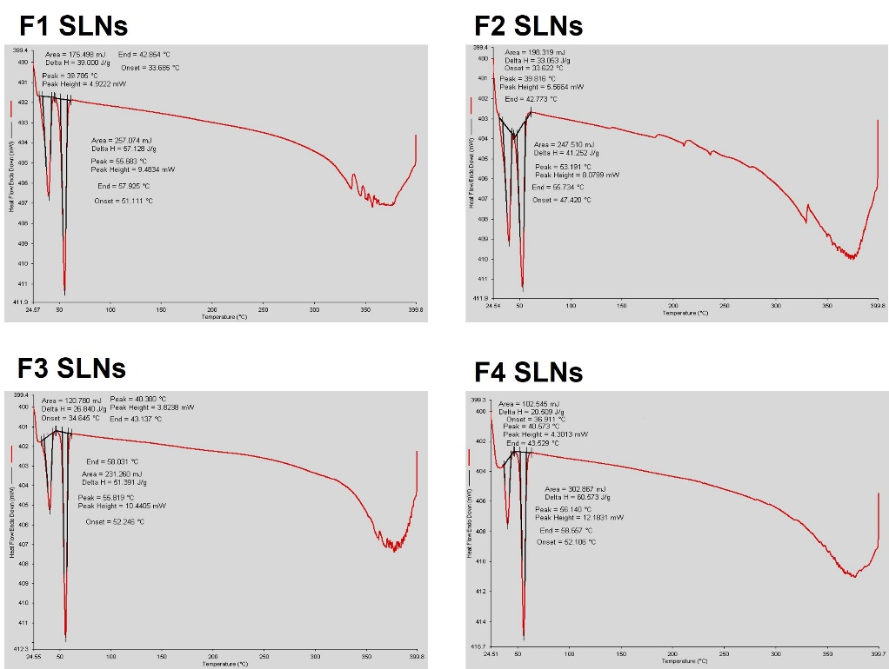
Thermograms for F1, F2, F3 & F4 SLNs (Figure S1) showed that all excipients used were completely in crystalline form, where the two sharp peaks around 40 ± 1 and 54.5 ± 1.5 °C correspond to the lipid and emulsifier, respectively. Gelucire 43/01 is a hard fat with reported HLB value of 1 and melting point of 43 °C.³⁴ The peak for QSI can be recognized as small notch in F2 SLNs, while was not visible in F4 SLNs presumably being solubilized in the nano-lipid system or in a concentration below the detection limit. We previously reported the melting peak (T_{m}) for pure QSI of 238.41 °C.²⁷ As well, chitosan could not be observed although a broad endothermic peak was reported between 90 – 110 °C.³⁵ The thermal properties of SLNs including T_{m} and corresponding enthalpies are presented in Table S1. Data depicts a melting peak at 39.8 – 40.6 °C for Gelucire and 53.2 – 56.1 °C for poloxamer with enthalpies in the range of 20.5 – 39 and 41.5 – 60.6 J/g, respectively (Table S1).

Figure S1 DSC thermograms of: F1 SLNs, F2 SLNs, F3 SLNs, and F4 SLNs
SLNs | Parameter | Lipids | Poloxamer
F1 | Tm (°C) | 39.79 | 55.68
F1 | Enthalpy (J/g) | 39.0 | 53.13
F2 | Tm (°C) | 39.82 | 53.19
F2 | Enthalpy (J/g) | 33.05 | 41.25
F3 | Tm (°C) | 40.38 | 55.82
F3 | Enthalpy (J/g) | 26.84 | 51.39
F4 | Tm (°C) | 40.57 | 56.14
F4 | Enthalpy (J/g) | 20.51 | 60.57
Table S1. Thermal properties of SLNs as determined by DSC

- Confirmation of AL functionalization via FTIR spectroscopy
Chitosan spectrum showed sharp peaks at 1031 and 1062 cm^{–1} (C–O–C stretching), 2865 cm⁻¹ (CH₂ stretching), and 3594 cm^{–1} (−OH stretching). Vibrational mode of amide C═O stretching can be observed at 1604, 1598, and 1592 cm^{–1}. In comparison, CS-coated SLNs (F3 SLNs) displayed absorption bands at 1420 and 1556 cm⁻¹ apparently assigned to the vibrations of C–O–H stretching of the primary alcoholic group and N–H bending of chitosan, respectively, Figure S2. FT-IR spectrum of pure alginate lyase (Figure S2) illustrates the broad bands at 2860–3000 cm⁻¹ and at 3100–3600 cm⁻¹ related to the vibrations of C–H stretching, and the overlap of vibrations of O–H and N–H stretching, respectively. A band at 834 cm⁻¹ and 926 cm⁻¹ could be attributed to the C–O–C and C–H stretching vibrations of the enzyme (Figure S2).

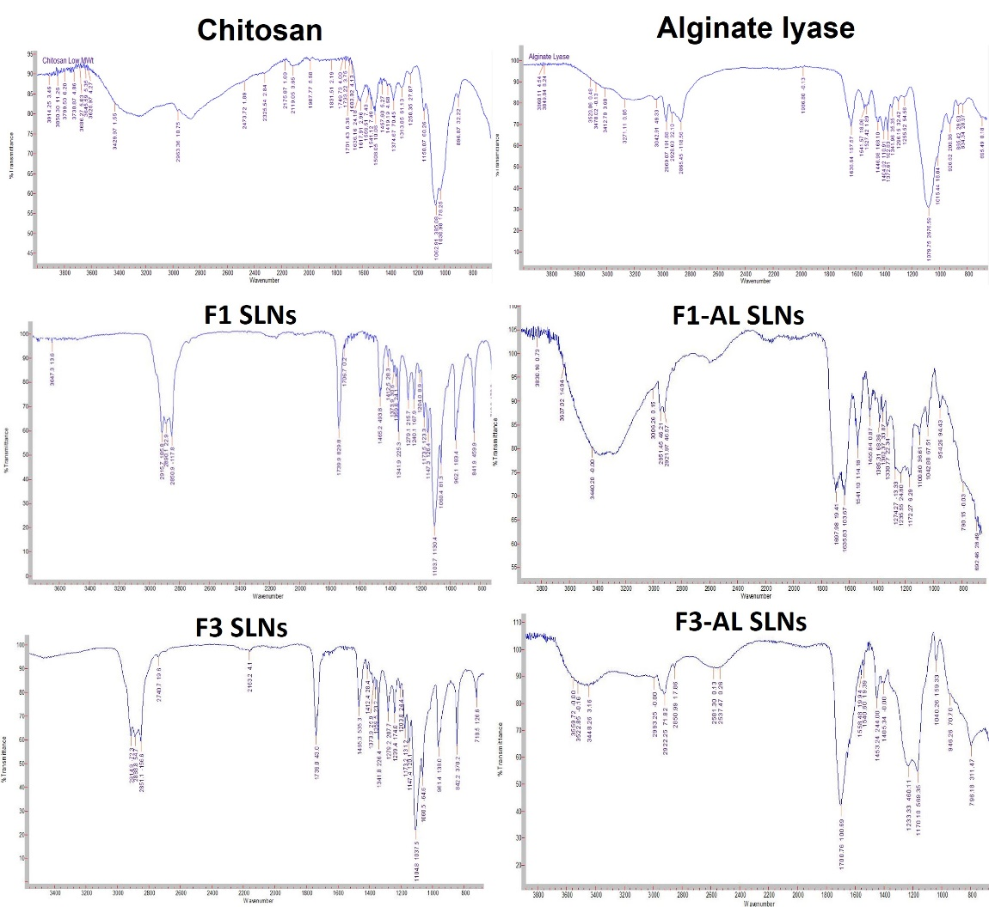

Figure S2: FT-IR spectra of chitosan, alginate lyase, F1 SLNs, F1-AL SLNs, F3 SLNs, and F3-AL SLNs

- Viability assay
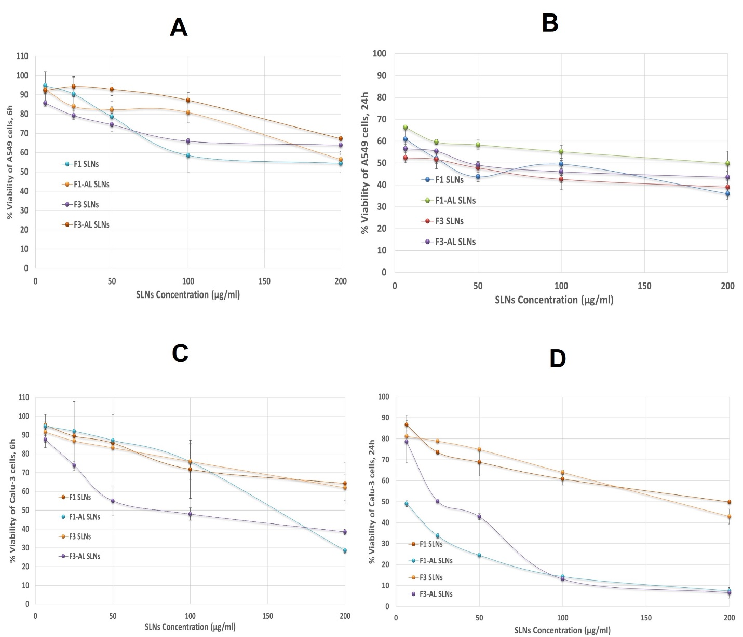

Figure S3: Viability of A549 cells after incubation with plain SLNs for (A) 6h and (B) 24h; Viability of Calu-3 cells after incubation with plain SLNs for (C) 6h and (D) 24h

- Antimicrobial activity of different concentrations of SLNs on planktonic P. aeruginosa reference strains
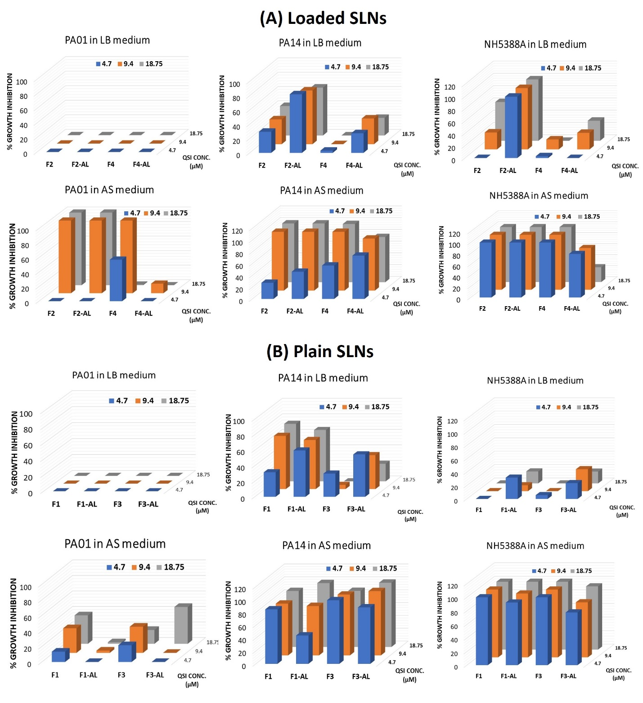
Figure S4: Percentage growth inhibition of planktonically grown P. aeruginosa reference strains (PA01, PA14, NH57388A) following incubation with (A) Loaded, and (B) Plain SLNs at different concentrations, in LB and ASM media
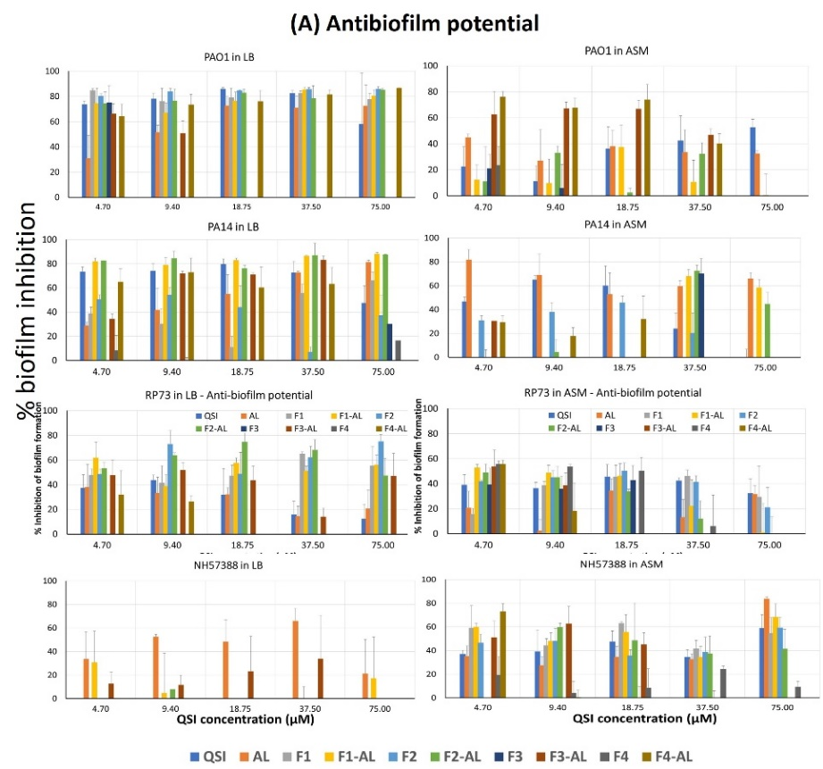
- Antibiofilm activity of different concentrations of SLNs on P. aeruginosa reference strains
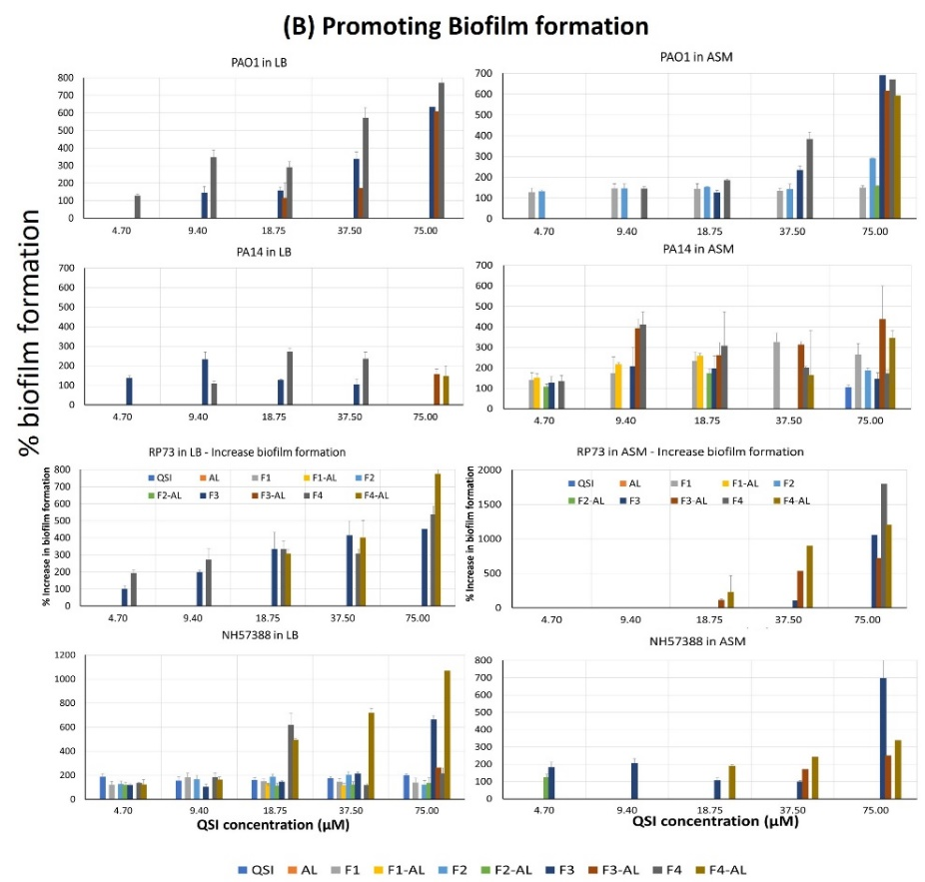

Figure S5: (A) Antibiofilm efficacy of different SLNs, QSI and AL at different concentrations tested on P. aeruginosa reference strains (PA01, PA14, NH57388A); (B) Promotion of biofilm formation following exposure to SLNs
- Antimicrobial activity of different concentrations of SLNs on P. aeruginosa isolates
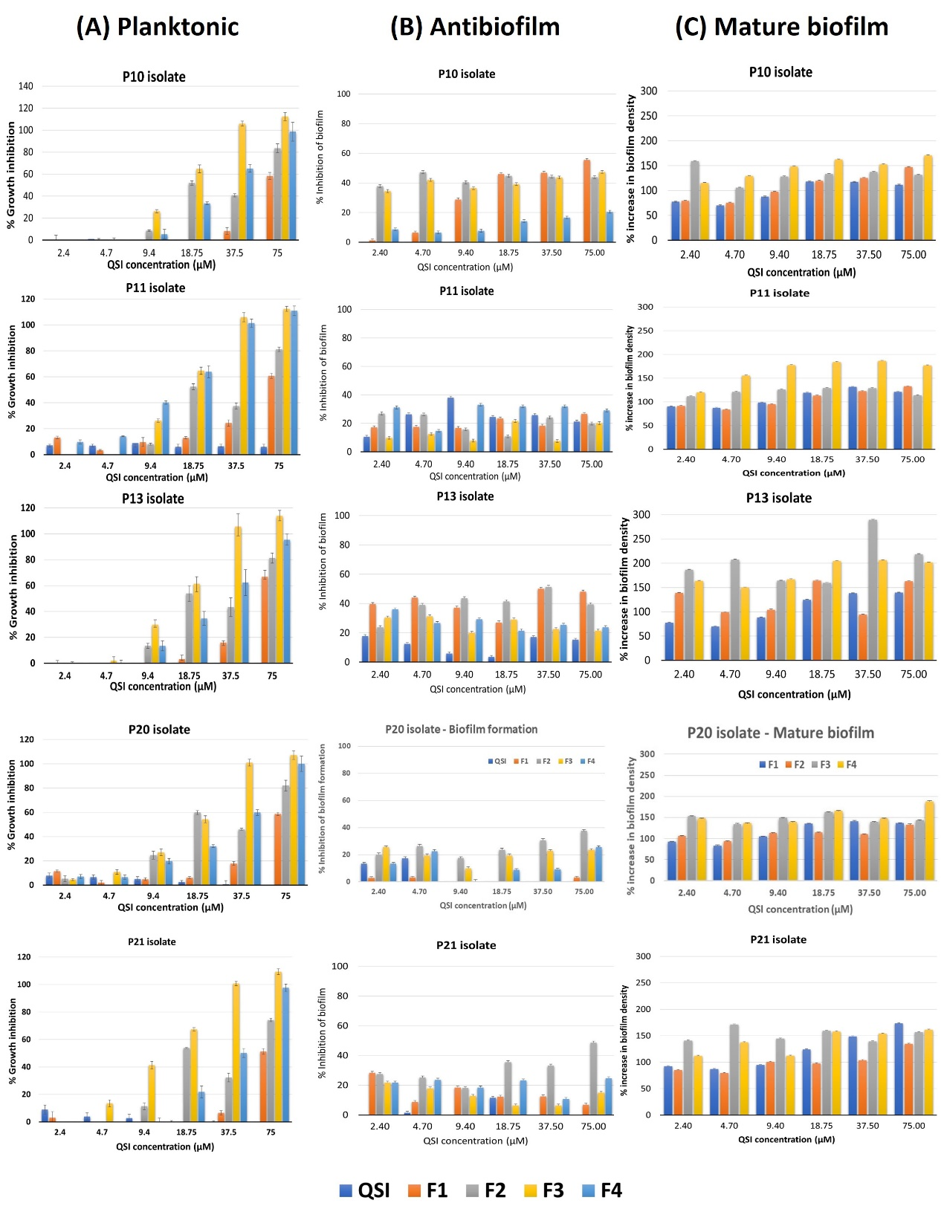
Figure S6: Antipseudomonal activity of free and nanoencapsulated QSI at different concentrations on P. aeruginosa isolates (P10, P11, P13, P21): (A) % Growth inhibition of planktonic cells; (B) % Inhibition of biofilm formation; (C) % increase in mature biofilms

REFERENCES

1. Nafee, N.; Husari, A.; Maurer, C. K.; Lu, C.; de Rossi, C.; Steinbach, A.; Hartmann, R. W.; Lehr, C. M.; Schneider, M., Antibiotic-free nanotherapeutics: ultra-small, mucus-penetrating solid lipid nanoparticles enhance the pulmonary delivery and anti-virulence efficacy of novel quorum sensing inhibitors. Journal of controlled release : official journal of the Controlled Release Society 2014, 192, 131-40.
2. Marques, M. R. C.; Loebenberg, R.; Almukainzi, M., Simulated Biological Fluids with Possible Application in Dissolution Testing. Dissolution Technologies 2011, August, 15-28.
3. Shi, C.; Ahmad Khan, S.; Wang, K.; Schneider, M., Improved delivery of the natural anticancer drug tetrandrine. Int J Pharm 2015, 479 (1), 41-51.
4. Kirchner, S.; Fothergill, J. L.; Wright, E. A.; James, C. E.; Mowat, E.; Winstanley, C., Use of artificial sputum medium to test antibiotic efficacy against Pseudomonas aeruginosa in conditions more relevant to the cystic fibrosis lung. Journal of visualized experiments : JoVE 2012, (64), e3857.
5. Nafee, N.; Forier, K.; Braeckmans, K.; Schneider, M., Mucus-penetrating solid lipid nanoparticles for the treatment of cystic fibrosis: Proof of concept, challenges and pitfalls. European Journal of Pharmaceutics and Biopharmaceutics 2018, 124, 125-137.
6. Friedl, H.; Dünnhaupt, S.; Hintzen, F.; Waldner, C.; Parikh, S.; Pearson, J. P.; Wilcox, M. D.; Bernkop-Schnürch, A., Development and Evaluation of a Novel Mucus Diffusion Test System Approved by Self-Nanoemulsifying Drug Delivery Systems. Journal of Pharmaceutical Sciences 2013, 102 (12), 4406-4413.
7. Torge, A.; Wagner, S.; Chaves, P. S.; Oliveira, E. G.; Guterres, S. S.; Pohlmann, A. R.; Titz, A.; Schneider, M.; Beck, R. C. R., Ciprofloxacin-loaded lipid-core nanocapsules as mucus penetrating drug delivery system intended for the treatment of bacterial infections in cystic fibrosis. International Journal of Pharmaceutics 2017, 527 (1–2), 92-102.
8. Stöber, W., A note on the aerodynamic diameter and the mobility of non-spherical aerosol particles. Journal of Aerosol Science 1971, 2 (4), 453-456.
9. Makled, S.; Boraie, N.; Nafee, N., Nanoparticle-mediated macrophage targeting—a new inhalation therapy tackling tuberculosis. Drug Delivery and Translational Research 2021, 11 (3), 1037-1055.

