Article Title: The association of hematological parameters in early and middle pregnancy with the risk of gestational diabetes mellitus

Yanbei Duo, Shuoning Song, Xiaolin Qiao, Yuemei Zhang, Jiyu Xu, Jing Zhang, Zhenyao Peng, Yan Chen, Xiaorui Nie, Qiujin Sun, Xianchun Yang, Ailing Wang, Wei Sun, Yong Fu, Yingyue Dong, Zechun Lu, Tao Yuan*, Weigang Zhao*

Correspondence: Tao Yuan, t75y@sina.com; Department of Endocrinology, Key Laboratory of Endocrinology of Ministry of Health, Peking Union Medical College Hospital, Chinese Academy of Medical Science and Peking Union Medical College, Beijing, People’s Republic of China; Weigang Zhao, xiehezhaoweigang@163.com; Department of Endocrinology, Key Laboratory of Endocrinology of Ministry of Health, Peking Union Medical College Hospital, Chinese Academy of Medical Science and Peking Union Medical College, Beijing, People’s Republic of China
* Tao Yuan and Weigang Zhao contributed equally to this work.

Supplemental Figure 1. Restricted cubic splines for the associations of blood cell counts at different gestational ages with GDM.
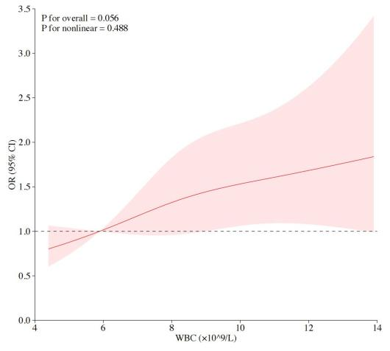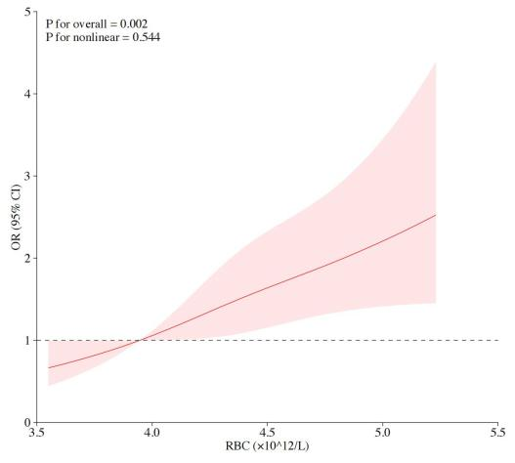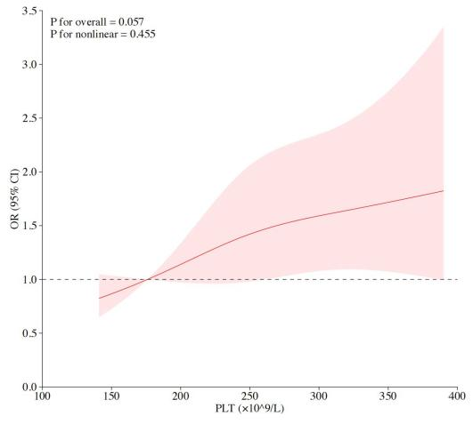
(a)
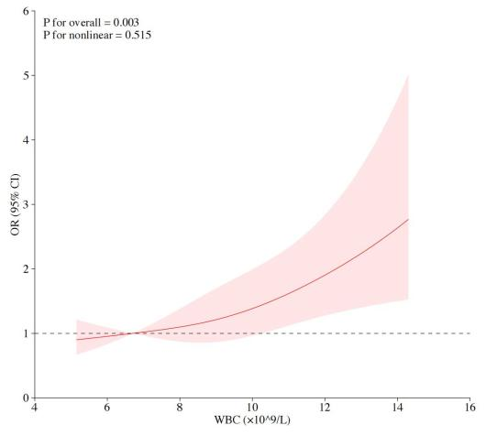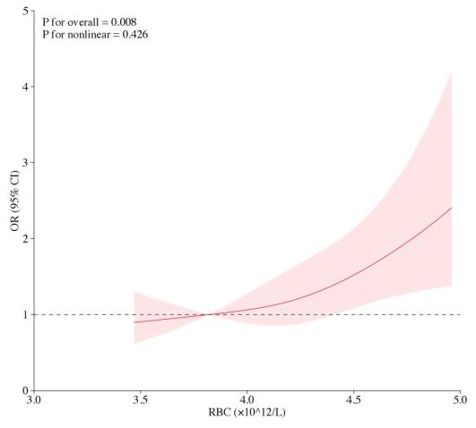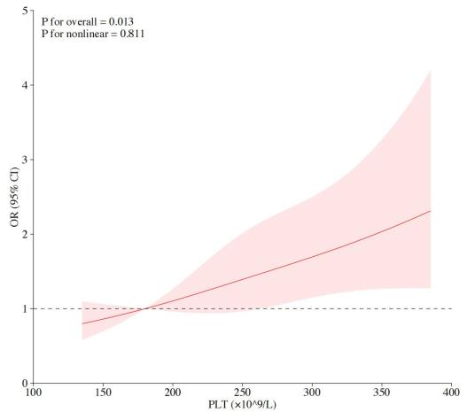
(b)
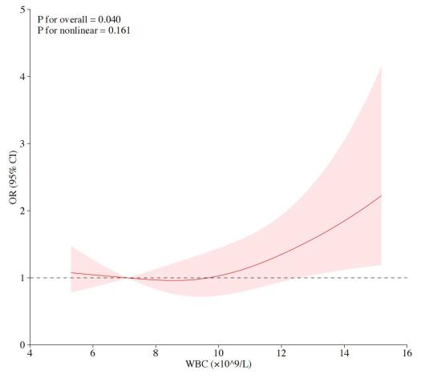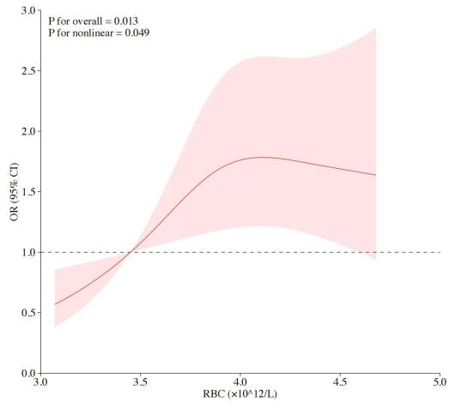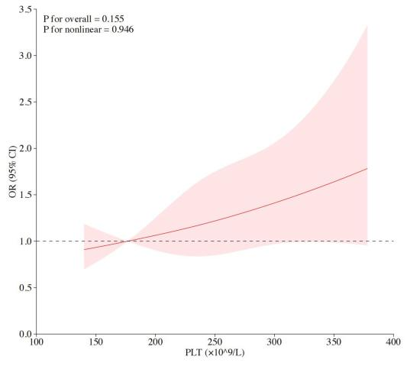
(c)
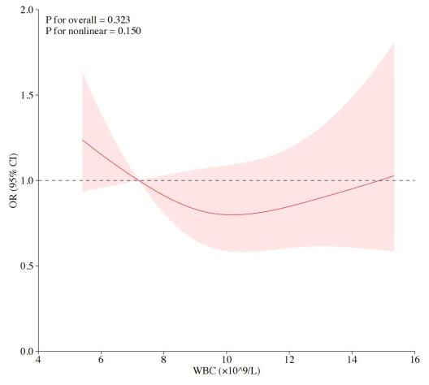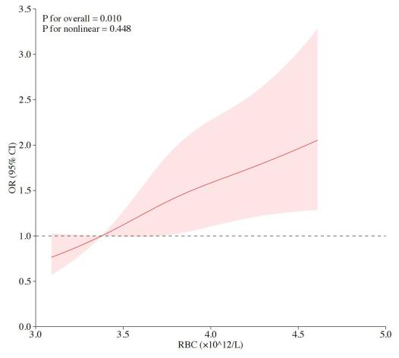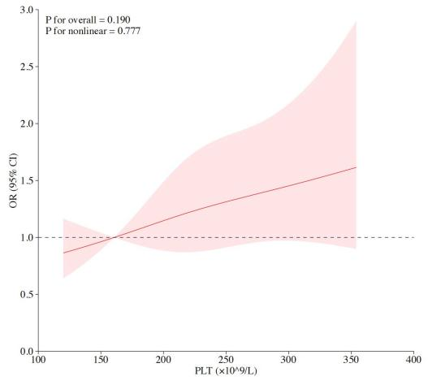
(d)
- , gestational age 1; (b), gestational age 2; (c), gestational age 3; (d), gestational age 4.
The models were adjusted for maternal age, preBMI, family history of diabetes, and history of adverse pregnancy.

Supplemental Table 1. The ability of blood cell counts in early pregnancy combined with other parameters for the prediction of GDM.

 | ROC-AUC (95% CI) | P values in the separate models | P values between the three models
 | ROC-AUC (95% CI) | P values in the separate models | 1 vs 2 | 1 vs 3 | 2 vs 3
Model 1 | 0.624 (0.584, 0.664) | <0.001 | <0.001 | <0.001 | 0.003
Model 2 | 0.684 (0.646, 0.722) | <0.001 | <0.001 | <0.001 | 0.003
Model 3 | 0.724 (0.689, 0.759) | <0.001 | <0.001 | <0.001 | 0.003

Model 1: WBC, RBC, and PLT at gestational age 1 and 2;
Model 2: Model 1 + maternal age, preBMI, family history of diabetes, and history of adverse pregnancy;
Model 3: Model 2 + FBG and FINS in the first trimester.

