SUPPLEMENTAL MATERIALS
Supplemental Table 1. Baseline demographics and clinical characteristics in the main cohort overall and stratified by stage at index, line setting of cemiplimab, and sex
 | Main cohort overall  (N = 622) | Stage at index |  |  | Line setting of cemiplimab |  | Sex
 | Main cohort overall  (N = 622) | Locally advancedª  (n = 225) | Regional metastatic^{b}  (n = 274) | Distant metastatic  (n = 123) | 1  (n = 528) | 2+  (n = 94) | Female  (n = 138) | Male  (n = 484)
Age at index, median (Q1–Q3), y | 78  (70–83) | 79  (71–83) | 78  (70–83) | 75  (67–83) | 79  (70–83) | 73  (66–79) | 79  (72–83) | 77  (69–83)
Months of follow–up, median (95% CI) | 16.6  (14.9–18.7) | 14.0  (10.8–18.5) | 16.6  (14.2–20.2) | 20.5  (15.9–22.8) | 15.8  (14.0–18.2) | 22.8  (16.2–25.7) | 13.2  (9.4–18.6) | 18.0  (15.3–19.8)
Age at index, n (%)
18–59 y | 49 (7.9) | 16 (7.1) | 22 (8.0) | ≤11 | 37 (7.0) | 12 (12.8) | 12 (8.7) | 37 (7.6)
60–69 y | 101 (16.2) | 31 (13.8) | 46 (16.8) | 24 (19.5) | 81 (15.3) | 20 (21.3) | 16 (11.6) | 85 (17.6)
70–79 y | 201 (32.3) | 72 (32.0) | 87 (31.8) | 42 (34.1) | 162 (30.7) | 39 (41.5) | 44 (31.9) | 157 (32.4)
≥80 y | 272 (43.6) | 106 (47.1) | 119 (43.4) | 46 (37.4) | 248 (47.0) | 23 (24.5) | 66 (47.8) | 205 (42.4)
Sex, n (%)
Male | 484 (77.8) | 151 (67.1) | 231 (84.3) | 102 (82.9) | 413 (78.2) | 71 (75.5) | NA | 484 (100)
Female | 138 (22.2) | 74 (32.9) | 43 (15.7) | 21 (17.1) | 115 (21.8) | 23 (24.5) | 138 (100) | NA
Race, n (%)
White | 448 (72.0) | 153 (68.0) | 204 (74.5) | 91 (74.0) | 378 (71.6) | 70 (74.5) | 107 (77.5) | 341 (70.5)
Other Race^{c} | 121 (19.5) | 46 (20.4) | 55 (20.1) | 20 (16.3) | 101 (19.1) | 20 (21.3) | 19 (13.8) | 102 (21.1)
Missing | 53 (8.5) | 26 (11.6) | 15 (5.5) | 12 (9.8) | 49 (9.3) | ≤11 | 12 (8.7) | 41 (8.5)
Ethnicity, n (%)
Non-Hispanic or Latino | 606 (97.4) | 218 (96.9) | 269 (98.2) | 119 (96.7) | 515 (97.5) | 91 (96.8) | 134 (97.1) | 472 (97.5)
Hispanic or Latino | 16 (2.6) | ≤11 | ≤11 | ≤11 | 13 (2.5) | ≤11 | ≤11 | 12 (2.5)
Region, n (%)
Midwest | 50 (8.0) | 21 (9.3) | 19 (6.9) | ≤11) | 39 (7.4) | ≤11 | 13 (9.4) | 37 (7.6)
Northeast | 42 (6.8) | 17 (7.6) | 19 (6.9) | ≤11 | 38 (7.2) | ≤11 | 11 (8.0) | 31 (6.4)
South | 300 (48.2) | 109 (48.4) | 129 (47.1) | 62 (50.4) | 260 (49.2) | 40 (42.6) | 58 (42.0) | 242 (50.0)
Unknown/Other | 166 (26.7) | 54 (24.0) | 82 (29.9) | 30 (24.4) | 138 (26.1) | 28 (29.8) | 39 (28.3) | 127 (26.2)
West | 64 (10.3) | 24 (10.7) | 25 (9.1) | 15 (12.2) | 53 (10.0) | 11 (11.7) | 17 (12.3) | 47 (9.7)
Practice type, n (%)
Academic | 128 (20.6) | 41 (18.2) | 66 (24.1) | 21 (17.1) | 106 (20.1) | 22 (23.4) | 28 (20.3) | 100 (20.7)
Community | 494 (79.4) | 184 (81.8) | 208 (75.9) | 102 (82.9) | 422 (79.9) | 72 (76.6) | 110 (79.7) | 384 (79.3)
Insurance type, n (%)
Commercial | 424 (68.2) | 153 (68.0) | 189 (69.0) | 82 (66.7) | 362 (68.6) | 62 (66.0) | 91 (65.9) | 333 (68.8)
Medicare or Medicaid | 112 (18.0) | 43 (19.1) | 45 (16.4) | 24 (19.5) | 98 (18.6) | 14 (14.9) | 31 (22.5) | 81 (16.7)
Other | 63 (10.1) | 21 (9.3) | 29 (10.6) | 13 (10.6) | 48 (9.1) | 15 (16.0) | ≤11 | 52 (10.7)
Missing | 23 (3.7) | ≤11 | ≤11 | ≤11 | 20 (3.8) | ≤11 | ≤11 | 18 (3.7)
ECOG performance status, n (%)
0 to 1 | 407 (65.4) | 139 (61.8) | 184 (67.2) | 84 (68.3) | 345 (65.3) | 62 (66.0) | 97 (70.3) | 310 (64.0)
≥2 | 111 (17.8) | 38 (16.9) | 48 (17.5) | 25 (20.3) | 96 (18.2) | 15 (16) | 20 (14.5) | 91 (18.8)
Missing | 104 (16.7) | 48 (21.3) | 42 (15.3) | 14 (11.4) | 87 (16.5) | 17 (18.1) | 21 (15.2) | 83 (17.1)
Stage at index, n (%)
Locally advanced not amenable to curative intent surgery or radiation | 225 (36.2) | 225 (100) | NA | NA | 203 (38.4) | 22 (23.4) | 74 (53.6) | 151 (31.2)
Regional metastatic | 274 (44.1) | NA | 274 (100) | NA | 227 (43.0) | 47 (50.0) | 43 (31.2) | 231 (47.7)
Distant metastatic | 123 (19.8) | NA | NA | 123 (100) | 98 (18.6) | 25 (26.6) | 21 (15.2) | 102 (21.1)
Cemiplimab line setting, n (%)
1 | 528 (84.9) | 203 (90.2) | 227 (82.8) | 98 (79.7) | 528 (100) | NA | 115 (83.3) | 413 (85.3)
2+ | 94 (15.1) | 22 (9.8) | 47 (17.2) | 25 (20.3) | NA | 94 (100) | 23 (16.7) | 71 (14.7)
Index year, n (%)
2018 | 39 (6.3) | 13 (5.8) | 16 (5.8) | ≤11 | 29 (5.5) | ≤11 | ≤11 | 30 (6.2)
2019 | 212 (34.1) | 81 (36.0) | 85 (31.0) | 46 (37.4) | 173 (32.8) | 39 (41.5) | 51 (37.0) | 161 (33.3)
2020 | 213 (34.2) | 65 (28.9) | 104 (38.0) | 44 (35.8) | 187 (35.4) | 26 (27.7) | 36 (26.1) | 177 (36.6)
2021 | 158 (25.4) | 66 (29.3) | 69 (25.2) | 23 (18.7) | 139 (26.3) | 19 (20.2) | 42 (30.4) | 116 (24)
Immunocompromised status, n (%)
None | 489 (78.6) | 182 (80.9) | 209 (76.3) | 98 (79.7) | 417 (79.0) | 72 (76.6) | 114 (82.6) | 375 (77.5)
Hematological malignancy | 101 (16.2) | 30 (13.3) | 50 (18.2) | 21 (17.1) | 86 (16.3) | 15 (16.0) | 17 (12.3) | 84 (17.4)
Other immunodeficiency | 21 (3.4) | ≤11 | ≤11 | ≤11 | 19 (3.6) | ≤11 | ≤11 | 14 (2.9)
Transplant | ≤11 | ≤11 | ≤11 | ≤11 | ≤11 | ≤11 | 0 (0) | ≤11
Primary location of CSCC, n (%)
Head and neck only | 345 (55.5) | 150 (66.7) | 134 (48.9) | 61 (49.6) | 303 (57.4) | 42 (44.7) | 58 (42.0) | 287 (59.3)
Extremities only | 91 (14.6) | 25 (11.1) | 41 (15.0) | 25 (20.3) | 70 (13.3) | 21 (22.3) | 38 (27.5) | 53 (11.0)
Trunk only | 30 (4.8) | ≤11 | 21 (7.7) | ≤11 | 26 (4.9) | ≤11 | ≤11 | 22 (4.5)
Other | 31 (5.0) | ≤11 | 18 (6.6) | ≤11 | 28 (5.3) | ≤11 | ≤11 | 23 (4.8)
Multiple sites | 125 (20.1) | 38 (16.9) | 60 (21.9) | 27 (22.0) | 101 (19.1) | 24 (25.5) | 26 (18.8) | 99 (20.5)
ªLocally advanced not amenable to curative intent surgery or radiation.
^{b}Regional lymph node metastatic.
^{c}Other race includes people who selected Asian or Black or African American.
Abbreviations: CI, confidence interval; CSCC, cutaneous squamous cell carcinoma; ECOG, Eastern Cooperative Oncology Group; LN, lymph node; LOT, line of therapy; n, number; NA, not applicable; Q, quartile; y, years.

Supplemental Figure 1: Study design.
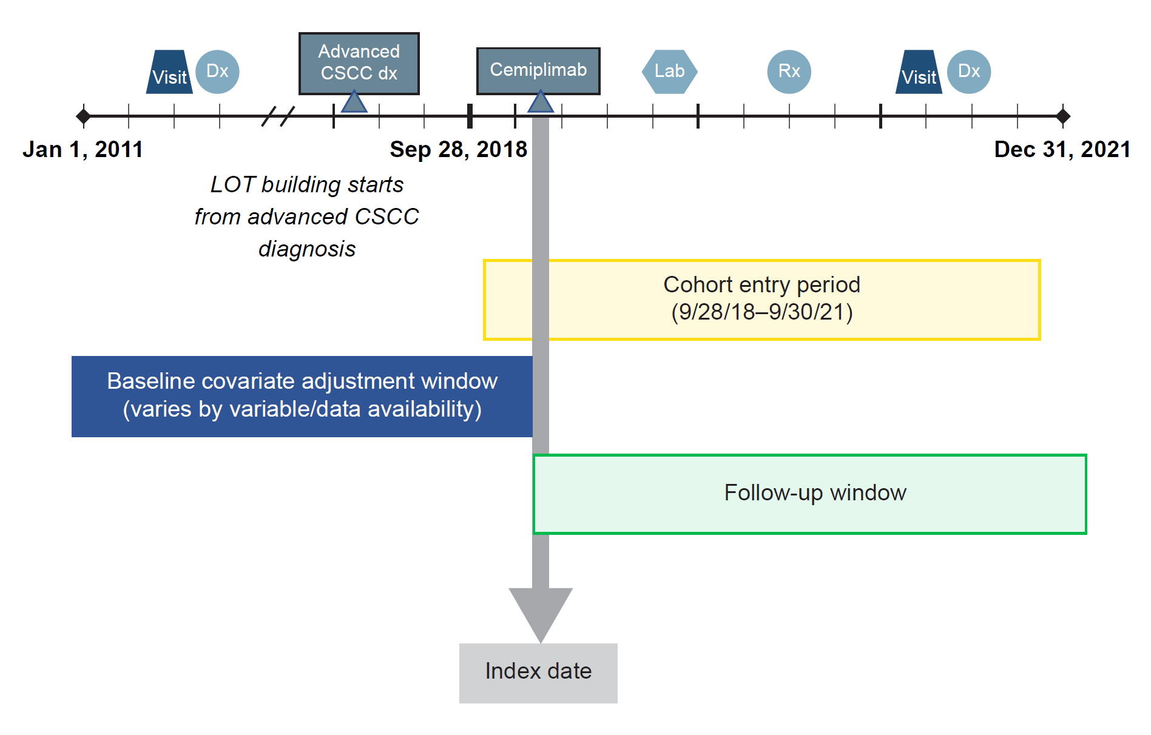
Abbreviations: CSCC, cutaneous squamous cell carcinoma; dx, diagnosis; LOT, line of therapy; Rx, prescription.
Supplemental Figure 2: OS in main cohort stratified by index year.
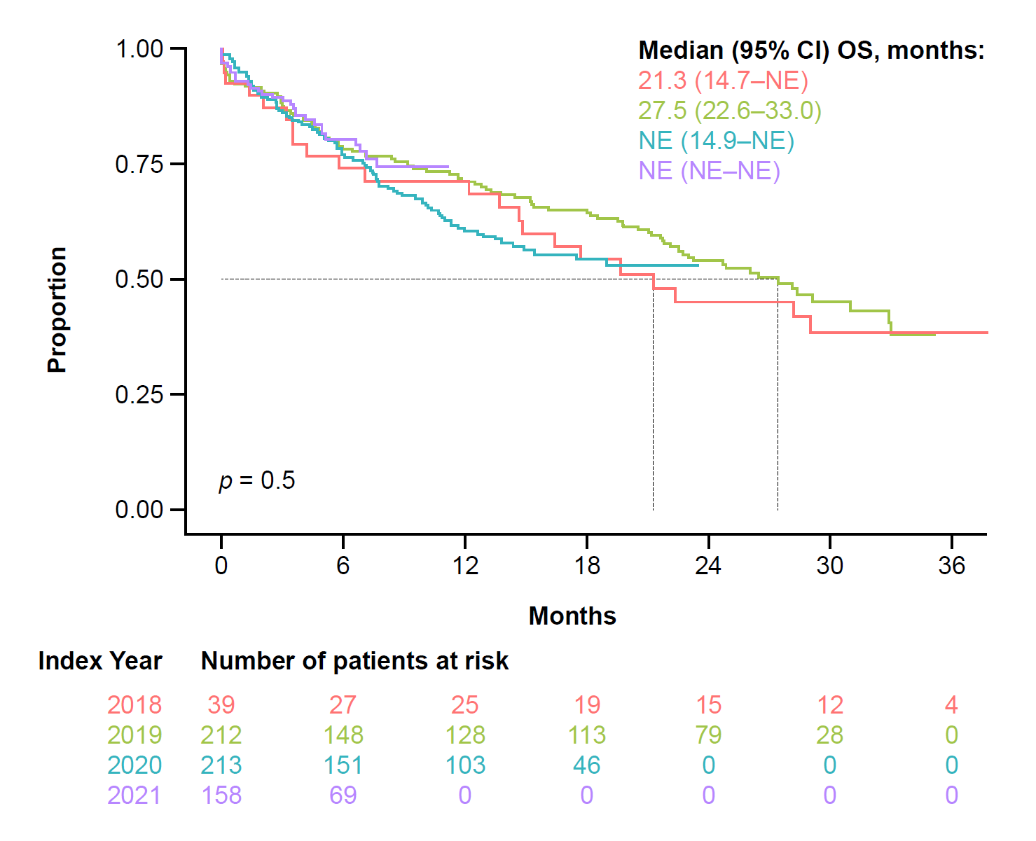
Abbreviations: NE, not estimable; OS, overall survival.
Supplemental Figure 3: Cox results.
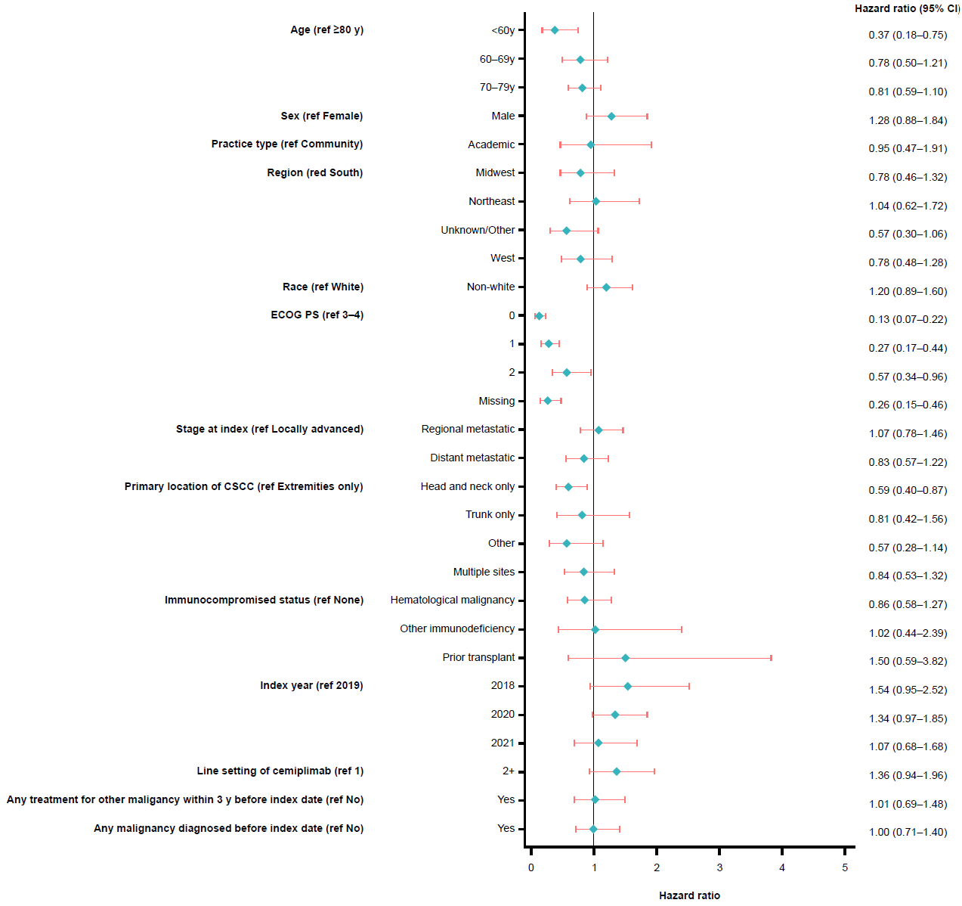
Abbreviations: CSCC, cutaneous squamous cell carcinoma; ECOG PS, Eastern Oncology Cooperative Group performance status.

