Supplementary file
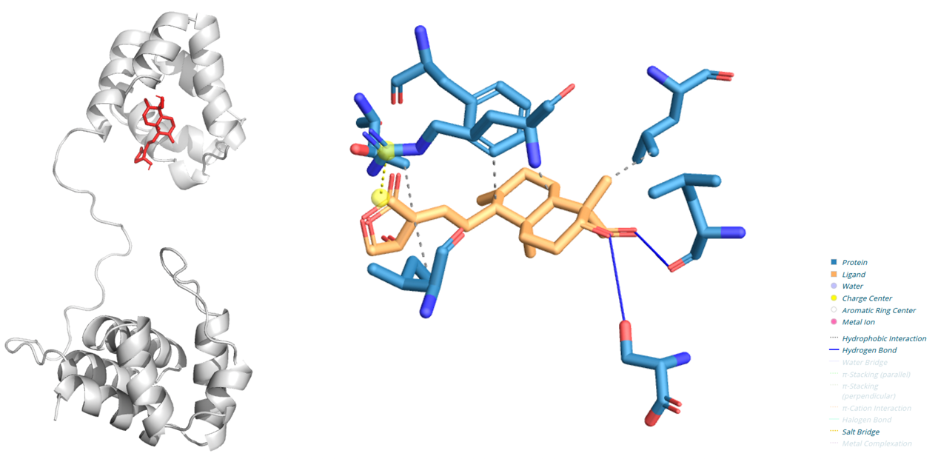
Figure S1 Representative 3D binding model and 2D model of AGP to ASC.

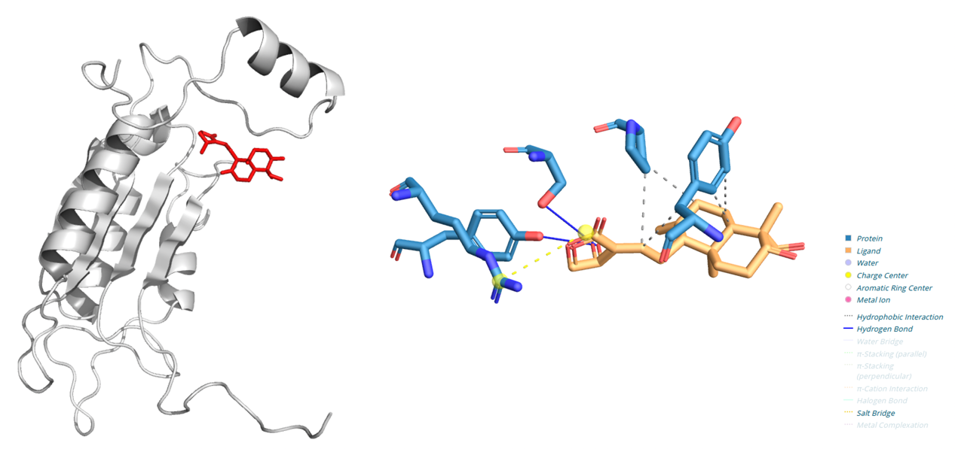
Figure S2 Representative 3D binding model and 2D model of AGP to Caspase-1.

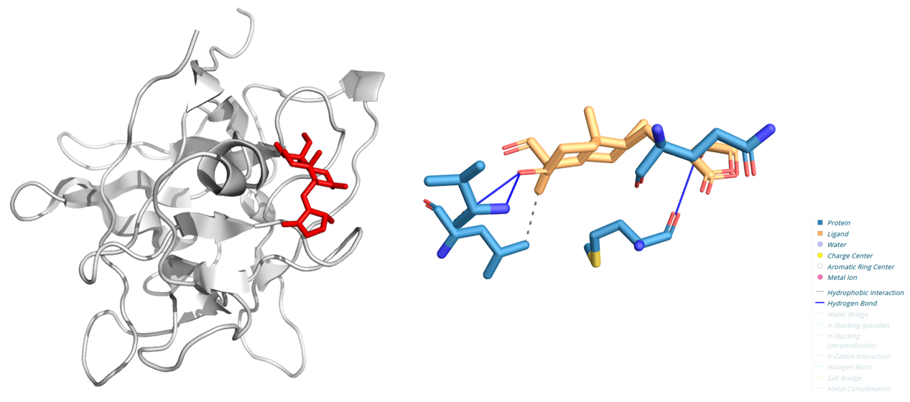
Figure S3 Representative 3D binding model and 2D model of AGP to IL-1β.

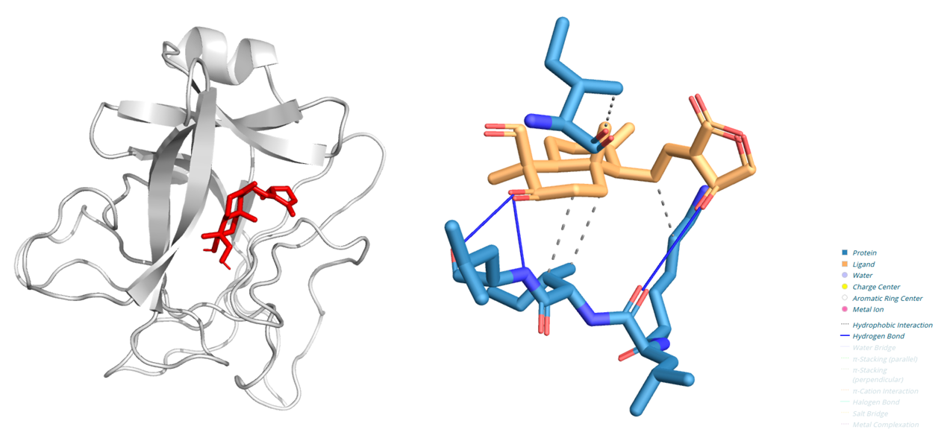
Figure S4 Representative 3D binding model and 2D model of AGP to IL-18.

