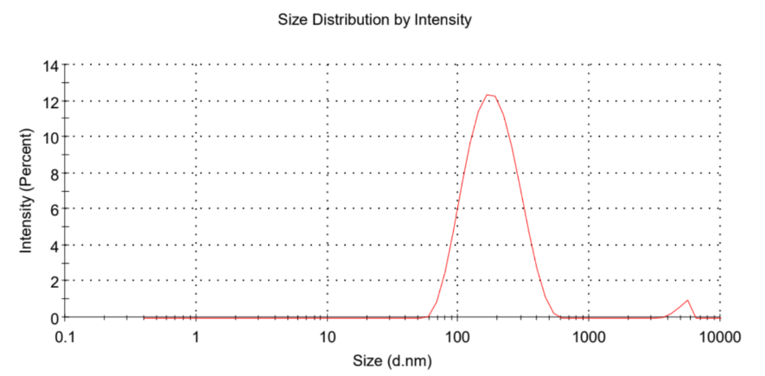
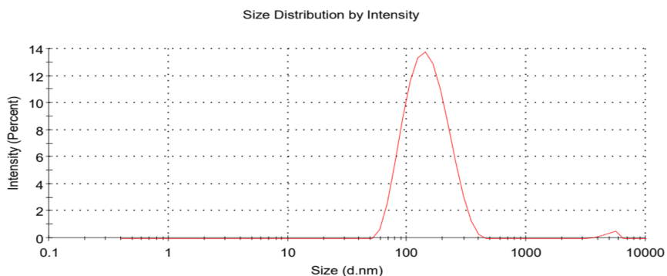
- ECNPs
- C7-3 CNPs
- C7-3m1 CNPs
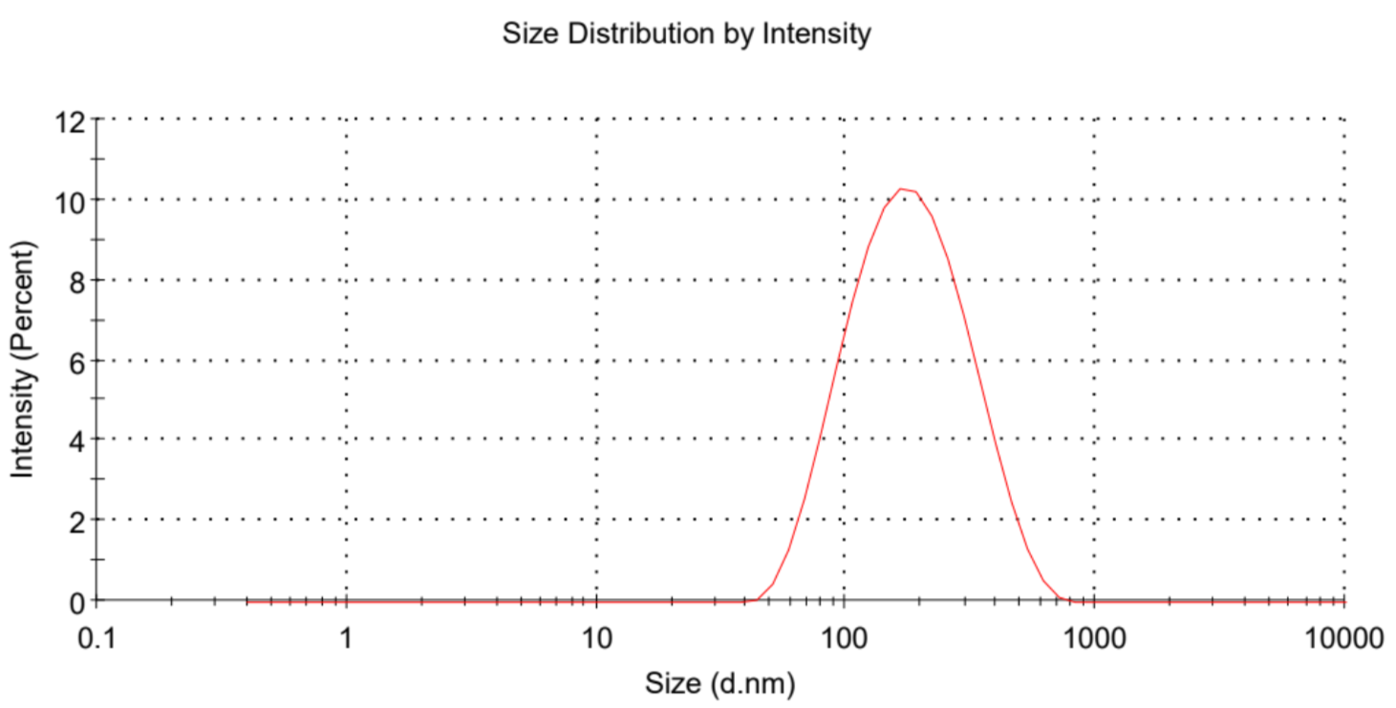
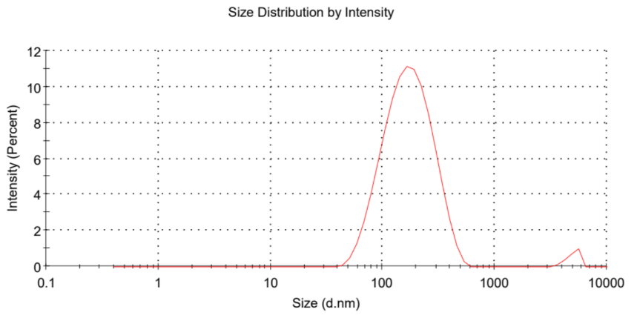
- C7-3m2 CNPs
Figure S1. The size distribution of ECNPs (A), C7-3 CNPs (B), C7-3m1 CNPs (C), and C7-3m2 CNPs (D).

- ECNPs
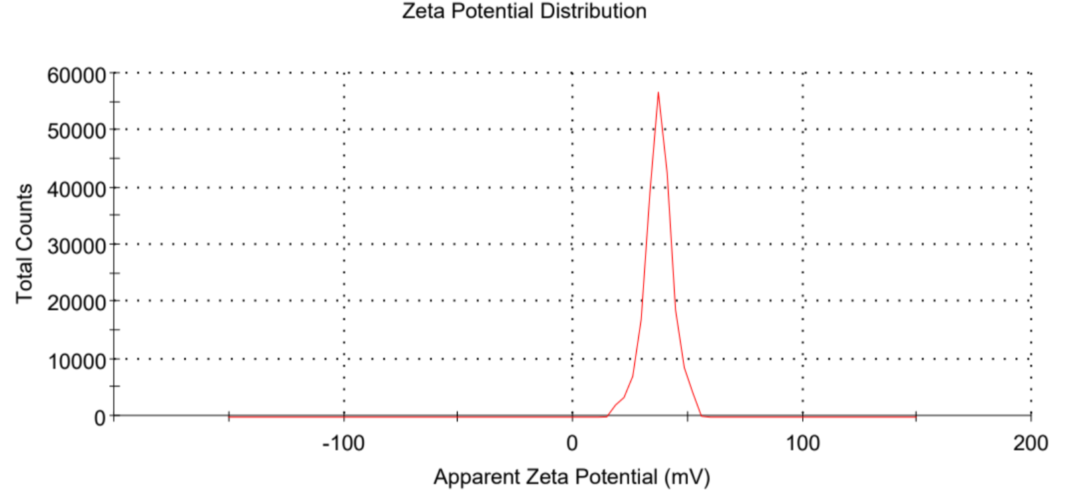
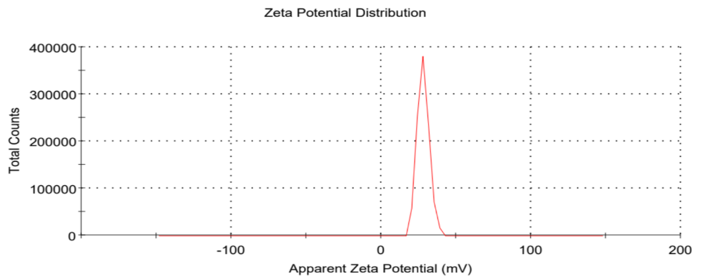
- C7-3 CNPs

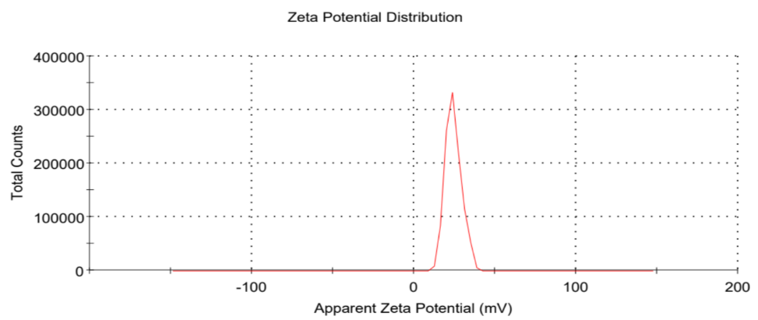
- C7-3m1 CNPs

- C7-3m2 CNPs
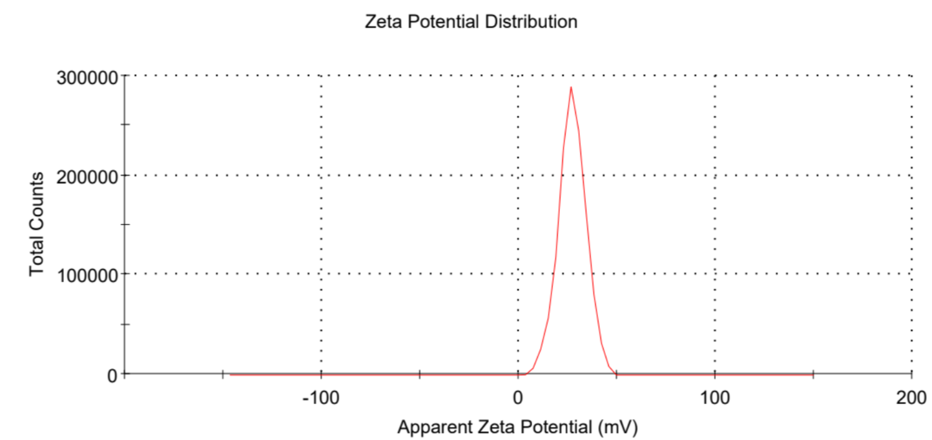
Figure S2. The zeta potential of ECNPs (A), C7-3 CNPs (B), C7-3m1 CNPs (C), and C7-3m2 CNPs (D).

Figure S3. The calibration curves of C7-3, C7-3m1, and C7-3m2 peptides using HPLC.

