Supplementary Material

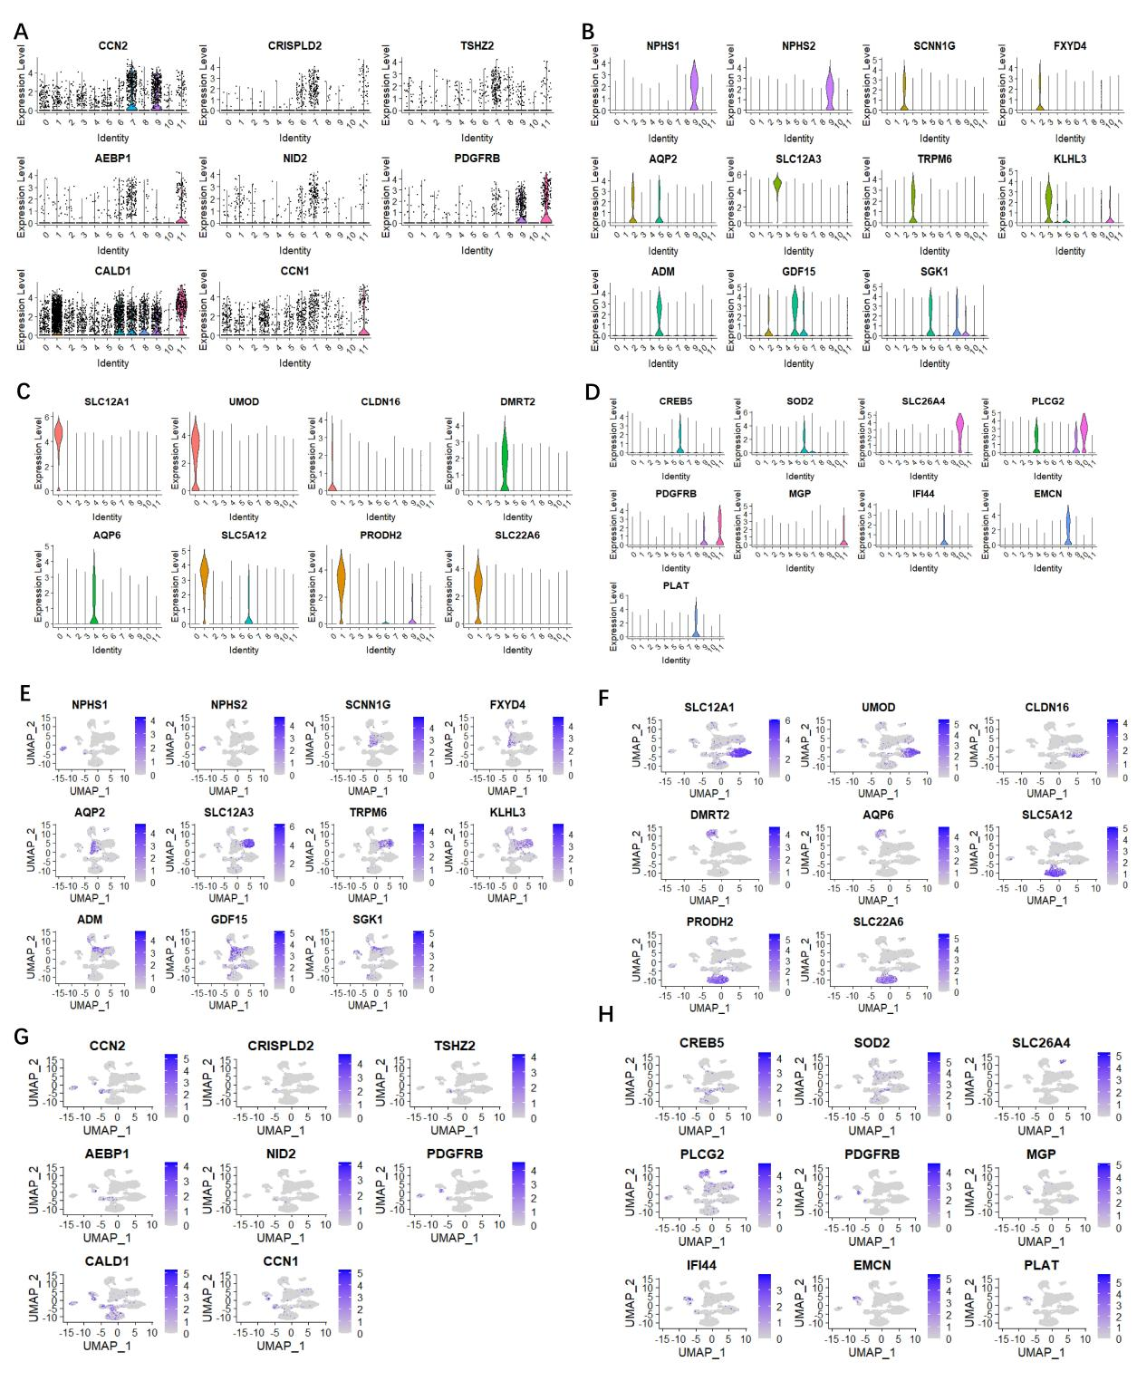

Supplementary Figure S1: Umap and violin plots showing expression of canonical marker genes for 12 cell clusters from GSE131882. (A-D) Violin plots showing (A) markers for Fibroblasis (CCN2, CRISPLD2, TSHZ2, NID2, PDGFRB, CALD1 and CCN1); (B) podocytes (NPHS1, NPHS2), Intercalated cells (SLC12A3, TRPM6, KLHL3), Collecting duct cells (SLC12A3, TRPM6, KLHL3) and Epithelial cells (ADM, GDF15, SGK1); (C) markers for Proximal tubular cells (SLC5A12, PRODH2, SLC22A6) and Distal tubular cells (SLC12A1, UMOD, CLDN16, DMRT2, AQP6); (D) markers for B cells (SLC26A4, PLCG2), neutrophil (CREB5, SOD2) and kidney endothelial cells(PDGFRB, MGP, IFI44, EMCN, PLAT); (E-H) UMAP plots showing (E) Fibroblasis markers shown in (A); (F-G) Podocytes, Intercalated cells, tubular and Epithelial cell markers shown in (B) and (C); (H) immune cell markers shown in (D). 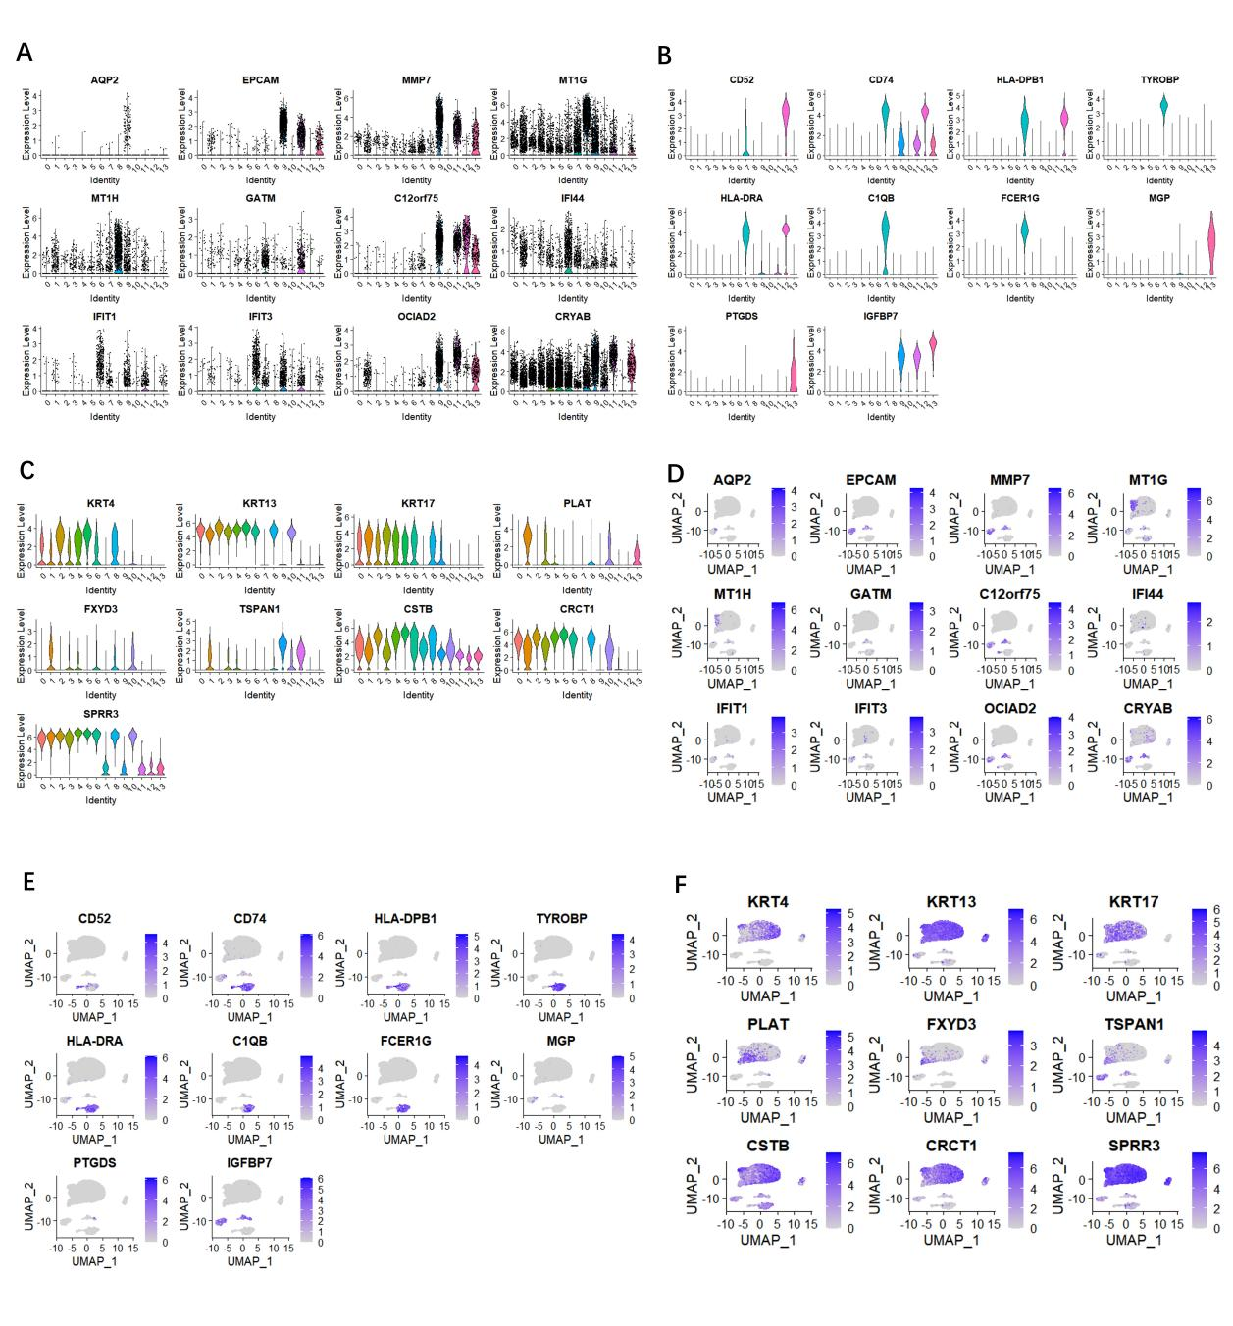
Supplementary Figure S2: Umap and violin plots showing expression of canonical marker genes for 14 cell clusters from GSE157640. (A-C) Violinplots showing (A) markers for proximal tubular tubules (MT1G, MT1H, GATM, C12orf75), collecting duct cells (AQP2, EPCAM, MMP7) and kidney endothelial cells (IFI44, IFIT1, IFIT3'，OCIAD2, CRYAB ) (B) markers for Macrophages (TYROBP, HLA-DRA, C1QB, FCER1G), B cells (CD52, CD74, HLA-DPB1), and Fibroblasts (MGP, PTGDS, IGFBP7); (C) markers for umbrella cells (PLAT, FXYD3, TSPAN1), urothelial cells (KRT4, KRT13, KRT17) and Epithelial cells (CSTB, CRCT1, SPRR3). (D-F) Violin plots showing (D) Tubular and endothelial cell markers shown in (A), (E) immune cell markers shown in (B). (F) Epithelial cell markers shown in (D).

