Supplemental Table 1. Associations between SIRT3 expression level and baseline clinical characteristics in TBNC
Clinical Characteristics | SIRT3-Low (n=64) | SIRT3-High (n=62) | p-value
Age at diagnosis |  |  | 1.0
≥50 | 40 (62.5%) | 39 (62.9%)
<50 | 24 (37.5%) | 23 (37.1%)
Median | 53.0 | 53.5
IQR | 45-59 | 48-62
RACE |  |  | 0.52
Black | 15 (23.4%) | 19 (30.6%)
Asia | 5 (7.8%) | 3 (4.8%)
White | 39 (60.1%) | 38 (61.3%)
Other | 5 (7.8%) | 2 (3.2%)
AJCC T-category |  |  | 0.13
T1 | 13 (20.3%) | 17 (27.4%)
T2 | 45 (70.3%) | 32 (51.6%)
T3 | 5 (7.8%) | 9 (14.5%)
T4 | 1 (1.6%) | 4 (6.4%)
AJCC N-category |  |  | 1.0
N- | 39 (60.9%) | 38 (61.3%)
N+ | 25 (39.1%) | 24 (38.7%)
AJCC M-category |  |  | 0.21
M- | 59 (100%) | 48 (96.0%)
M+ | 0 (0%) | 2 (4.0%)
Stage at diagnosis |  |  | 0.14
I | 7 (11.3%) | 14 (23.3%)
II | 44 (71.0%) | 35 (58.3%)
III | 11 (17.7%) | 9 (15.0%)
IV | 0 (0.0%) | 2 (3.3%)
AJCC: The American Joint Committee on Cancer

Supplemental Figure 1. The Kaplan–Meier curves of SIRT1-7 for TCGA-BRCA cohort
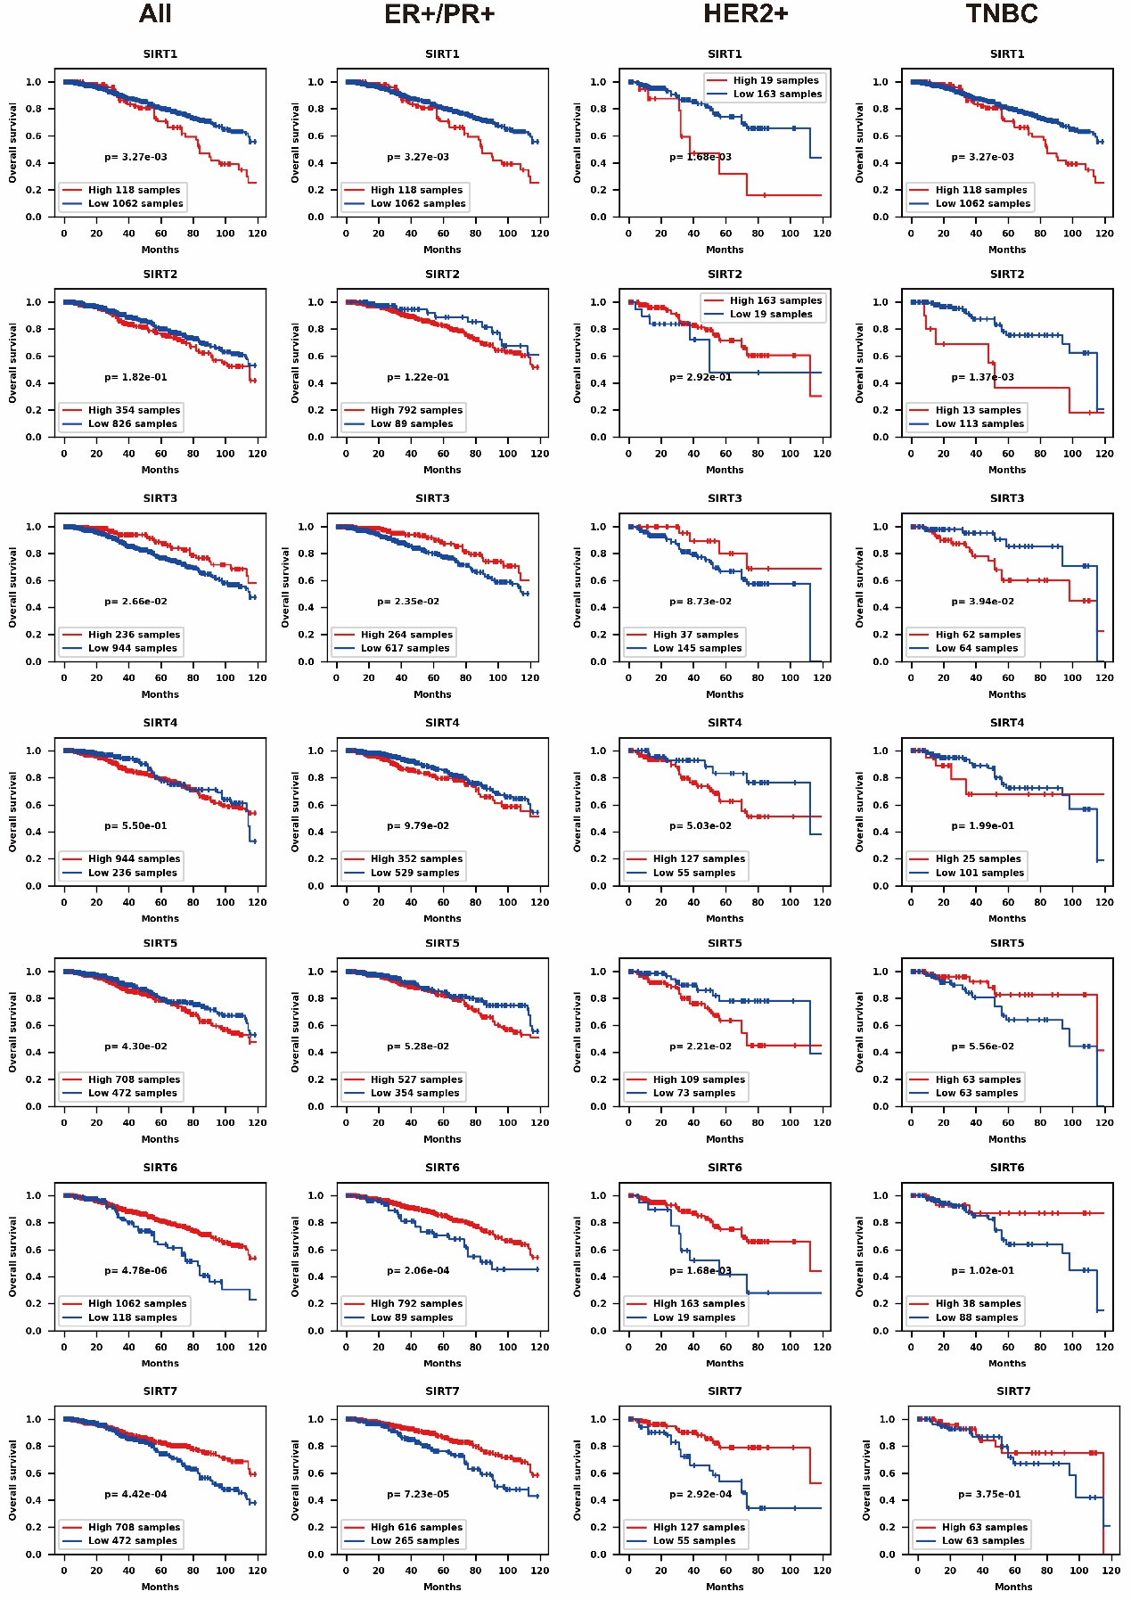

Supplemental Figure 2. The Kaplan–Meier curves of SIRT1-7 for METABRIC cohort

