ORIGINAL RESEARCH
Zhongxu Jing, Wenqing Li
Fructus Xanthii and Magnolia liliiflora volatile oils liposomes-loaded thermosensitive in situ gel for allergic rhinitis management
Zhongxu Jing ¹ *
Wenqing Li ¹ *
Wei Liao ¹
Ying Lv ¹
Yuwei Liu ¹
Haibo Jiang ¹
Yufei Feng ¹
* These authors contributed equally to this work
¹ Key Laboratory of Basic and Application Research of Beiyao (Heilongjiang University of Chinese Medicine), Ministry of Education, Harbin 150040, China.
Correspondence: Yufei Feng
Key Laboratory of Basic and Application Research of Beiyao (Heilongjiang University of Chinese Medicine), Ministry of Education, Harbin 150040, China.
Tel +86-18503653988
Email fuf-002@163.com

Gas chromatography-mass spectrometry (GC-MS) conditions to determine the concentration of camphor and linoleic acid
Elit-5MS capillary column (0.25 mm×30 m, 0.25 μm); Helium as carrier gas; The volume flow rate was 1.0 mL·min⁻¹; Injection port temperature 250℃; The injection volume was 5μL, and the split ratio was 10:1. The temperature was initially raised at 170℃(maintained for 7min), then increased to 200℃ at 5℃·min⁻¹, and then increased to 240℃ at 2℃·min⁻¹ (maintained for 1min). Mass spectrometry conditions: GC-MS interface temperature 250℃; Ionization mode: electron impact ionization (EI), ionization energy 70eV; The ion source temperature was 250℃. Acquisition mode MS Scan; Scanning quality range m/z 40-450; The scanning time was 4.5-30 min, Spectral map retrieval. The chromatograms of the blank methanol solution, control solution, and solution samples are shown in Figure S1 A-C. As shown in Figure S1, the MS analysis had no impurity peak at the peak position of camphor and linoleic acid, and the peak shape of camphor and linoleic acid was good.

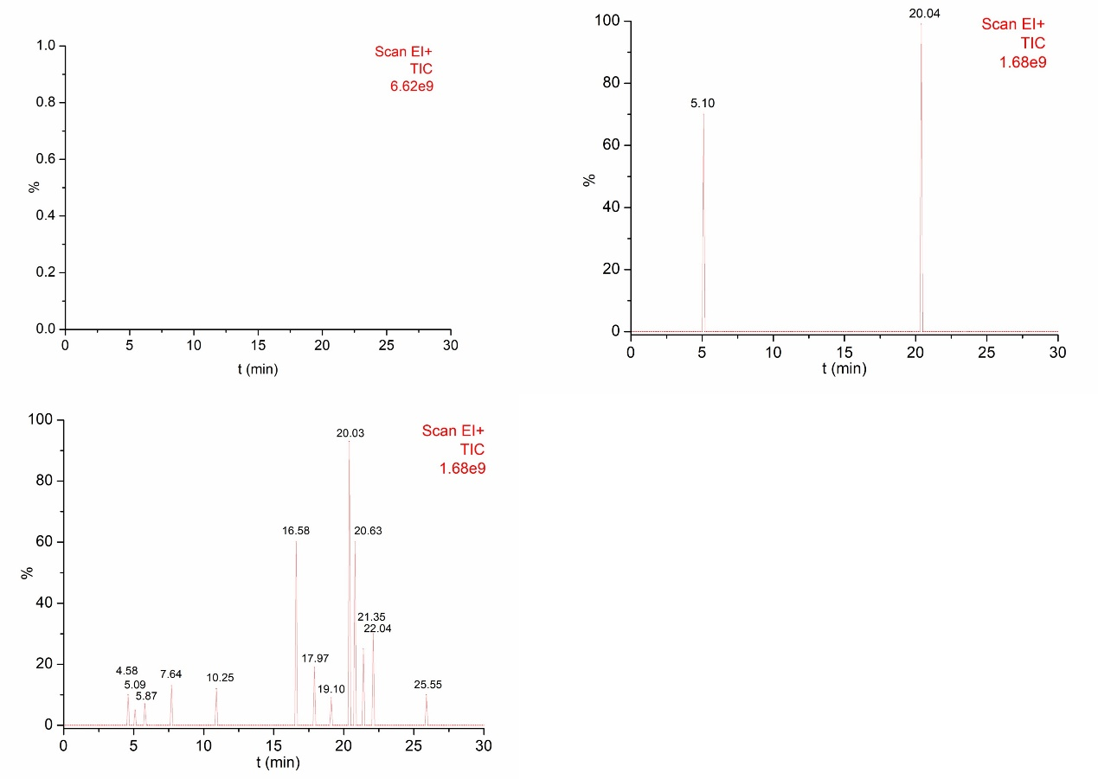
Figure S1 Chromatogram of the blank methanol solution (A); Blank methanol solution contained camphor and linoleic acid (B); Mass spectrum of sample (C).
Table S1
Evaluation parameters for gel/LIP/Volatile oil (mean±SD, n=3)
Formulation | P407  (w/v, %) | P188 (w/v, %) | HPMC (w/v, %) | Gelation temperature | Gelation temperature after dilution | Gelation time | Gelation gel strength | Adhesion Strength | Adhesion Duration
gel/LIP/Volatile oil | 14.015 | 7.681 | 0.5 | 34℃ | 34.03 ℃ | 190.3$±$8.43 s | 43.6$±$9.07 s | 30±1.74 g/cm² | 5.9±1.12 h

