Supplemental material
supplementary methods
Criteria for terminating the stress tests
The examination procedure shall be overseen by proficient medical practitioners. In conjunction with adhering to the research methodology, they shall possess proficiency in identifying indications of safety apprehensions and hold certification in cardiopulmonary resuscitation. The criteria for absolute termination encompass a range of indicators, including a systolic blood pressure decrease of at least 10 mm Hg in conjunction with other indications of myocardial ischemia, a systolic blood pressure of 220 mm Hg or higher, the presence of obvious angina pectoris, symptoms such as dizziness, presyncope, or more severe neurological signs, cyanosis or paleness, ventricular tachycardia that persists for more than 30 seconds, supraventricular tachyarrhythmia that results in negative hemodynamic effects, ST-segment elevation of at least 1 mm or depression greater than 2 mm in two or more contiguous leads, and the patient's expressed desire to discontinue the activity. The relative termination criteria encompassed a range of indicators, such as a decrease in systolic blood pressure of at least 10 mm Hg in the absence of other signs of myocardial ischemia, diastolic blood pressure exceeding 110 mm Hg, significant alterations in the electrical axis as evidenced by electrocardiogram readings, second-degree or third-degree atrioventricular block, multifocal or frequent paired ventricular extrasystole, and bradyarrhythmia.
Positron emission tomography CT
The collection of images will be executed in list mode utilizing a Siemens Biograph-16 TruePoint PET-CT (Siemens Healthcare, Knoxville, Tennessee, USA) equipped with the TrueV option, which enables a 21.6 cm axial field of view. This tri-dimensional system comprises a 16-slice CT, a PET scanner, and four-ring lutetium orthosilicate detectors. Following the acquisition of a topographic map (110 kVp and 25 mAs) for patient localization, a CT transmission scan will be obtained (130 kVp, 25 mAs (ref.) and pitch 0.95). Subsequently, the patient will receive an injection of 700-900 MBq of 13NH3 (5 mL of 13NH3, administered as a bolus injection, followed by flushing with 10 mL of NaCl, where 1 mCi is equivalent to 37 MBq). Image acquisition will be conducted over a 20-minute period at rest. Following the stress imaging, a second CT transmission scan will be immediately performed (130 kVp, 25 mAs (ref.) and pitch 0.95). The list mode data will be utilized to generate static, dynamic, and 16-bin ECG-gated images. The iterative reconstruction technique with a 168×168 matrix, zoom 2, a Gaussian filter with a full width at half-maximum of 5 mm, 2 iterations and 24 subsets will be employed to reconstruct the acquired emission data. Additionally, CT-based attenuation, scatter, decay and random corrections will be applied to the reconstructed images. The reconstructed images will comprise dynamic, static and gated images from each of the acquisitions. The reconstruction of dynamic rest images will be performed utilizing a subset of the dataset obtained immediately following the initial injection of 13NH3, consisting of 21 frames with varying durations of 10, 30, 60, and 180 seconds. In order to generate gated and static rest images, the first 3 minutes of rest acquisition data will be excluded to account for blood pool clearance, with the subsequent 12 minutes of data being utilized for reconstruction purposes. The assessment of left ventricular ejection fraction and regional wall motion abnormalities will be conducted through the utilization of gated images, while the analysis of myocardial perfusion will be performed using static images. The stress images will be reconstructed from a specific portion of the dataset, which is obtained 30 seconds prior to the initiation of the second 13NH3 injection (15 minutes after the commencement of each scan), and will consist of 21 frames for stress: 12×10, 6×30, 2×60, and 1×180 seconds. The gated stress and static images will be reconstructed from the last 12 and 17 minutes of the acquisition data, respectively.
Perfusion evaluation
The interpretation of images will adhere to the guidelines of the American Society of Nuclear Cardiology and will be conducted by two proficient readers who will be blinded to the stress conditions (mental or adenosine). Prior to interpretation, the exclusion of errors such as patient movement, attenuation, reconstruction artefacts, and low count density will be ensured. The assessment of perfusion will be performed using commercially available and previously validated Cedars-Sinai software, utilizing a 17-segment, 5-point scale (0=normal, 1=mildly reduced uptake, 2=moderately reduced uptake, 3=severely reduced uptake, and 4=no uptake).
Diagnostic MSIMI criteria
MSIMI is characterized as the emergence of new or deteriorating perfusion defects during the mental stress test in contrast to the resting baseline images. The diagnostic tool employed to identify MSIMI/PSIMI involves the utilization of 99mTcsestamibi myocardial perfusion imaging and the computation of a summed difference score (SDS) over the 17-segment model. This score is determined by the disparity between the summed stress score and the summed rest score. The definition of MSIMI entails an SDS of ≥3. In conjunction with the SDS diagnostic criterion, the evaluation of perfusion defects will also incorporate the assessment of total perfusion deficit and ischemia.
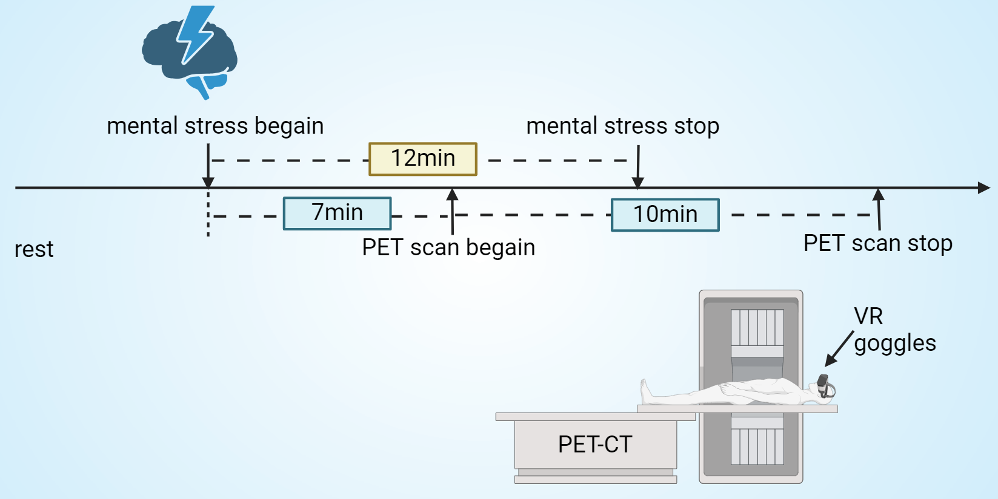
Supplemental Figure 1. The schematic representation of the mental stress and PET scan procedure.

Supplemental Table 1. The Correlation between Sleep Apnea Monitoring and Myocardial Perfusion
 | HI | REI | ODI | Hb
SRS | 0.048 | 0.071 | -0.024 | -0.194
SSS | 0.305* | 0.279* | 0.257* | 0.205
SDS | 0.293* | 0.261* | 0.261* | 0.263*
HI | — | — | — | 0.274*
REI | — | — | — | 0.209
ODI | — | — | — | 0.249*
Notes: Pearson correlation test, * P < 0.05.
Abbreviations: HI: hypopnea index; REI: respiratory event index; ODI: oxygen desaturation index. Hb: hemoglobin; SRS: summed rest score; SSS: summed stress score; SDS: summed difference score.

