Supplementary material

Development and validation of a META-algorithm to identify the indications of use of biological drugs approved for the treatment of immune-mediated inflammatory diseases from claims databases: insights from the VALORE Project
Andrea Spini, Luca L’Abbate, Ylenia Ingrasciotta, Giorgia Pellegrini, Massimo Carollo, Valentina Ientile, Olivia Leoni, Martina Zanforlini, Domenica Ancona, Paolo Stella, Anna Cavazzana, Angela Scapin, Sara Lopes, Valeria Belleudi, Gianluca Trifirò

Table S1. ATC and national drug codes of drugs included in the study
Drug | ATC | National drug code
Abatacept | L04AA24 | Every national drug code
Acido Salicilico | S01BC08 | Every national drug code
Acitretina | D05BB02 | Every national drug code
Anakinra | L04AC03 | Every national drug code
Auranofina | M01CB03 | Every national drug code
Azathioprine | L04AX01 | Every national drug code
Balsalazide | A07EC04 | UC: 033858010, 033858034, 033858046, 033858059, 033858061, 033858073
Baricitinib | L04AA3 | Every national drug code
Betametasone | D07XC01 | Every national drug code
Brodalumab | L04AC12 | Every national drug code
Budesonide | A07EA06 | CD: 036507046, 034734018, 044798027  UC: 043461021
Calcipotriolo | D05AX52 | Every national drug code
Certolizumab pegol | L04AB05 | Every national drug code
Ciclosporina | L04AD01 | Every national drug code
Filgotinib | L04AA45 | Every national drug code
Golimumab | L04AB06 | Every national drug code
Hydroxychloroquine | P01BA02 | Every national drug code
Leflunomide | L04AA13 | PsA: Every national drug code  RA: 040985083. 040985095. 040985069
Mesalazine | A07EC02 | UC: 026416091
Methotrexate | L04AX03 | CD: 039153996. 039153743
Risankizumab | L04AC18 | Every national drug code
Rituximab | L01XC02 | Every national drug code
Sarilumab | L04AC14 | Every national drug code
Sodio aurotiosolfato | M01CB02 | RA: 009333055. 009333093. 009333042
Sulfasalazine | A07EC01 | Every national drug code
Tacalcitolo | D05AX04 | Every national drug code
Tazarotene | D05AX05 | Every national drug code
Tildrakizumab | L04AC17 | Every national drug code
Tocilizumab | L04AC07 | Every national drug code
ATC: anatomical therapeutic chemical; CD: Chron’s disease; PsA psoriatic arthritis; RA: Rheumatoid arthritis; UC: Ulcerative colitis
Figure S1. Validation analysis according to the number of indications found by the META-Algorithm
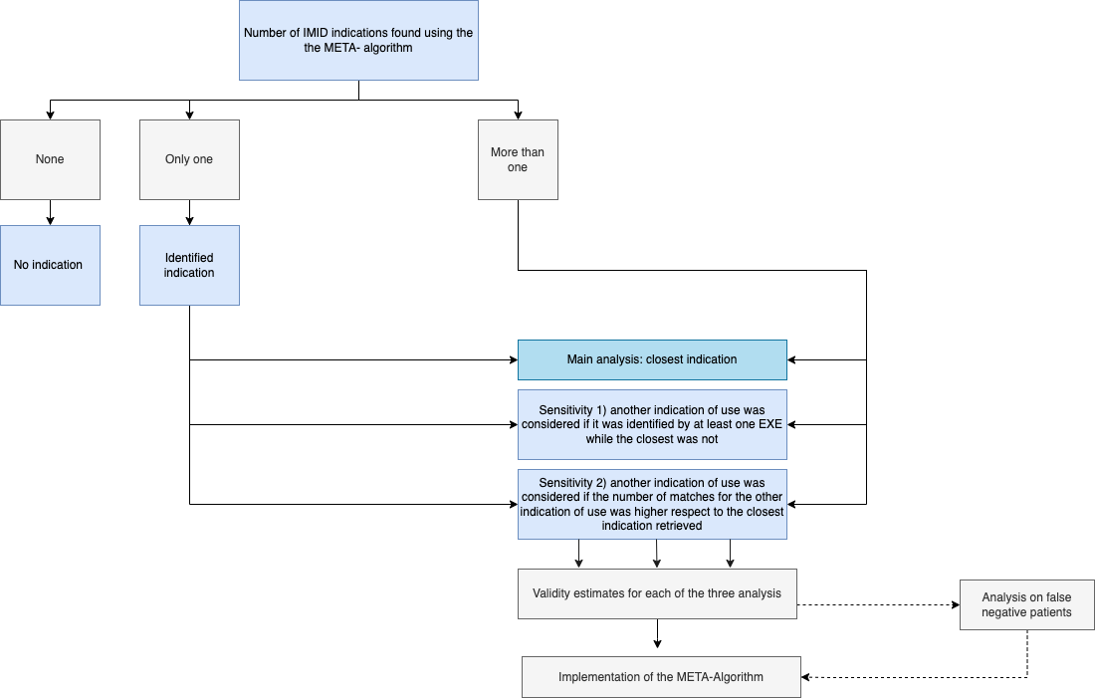

Table S2. Validity estimates according to the first sensitivity analysis: in case of more than one indication it was primarily considered the indication found using exemption from co-payment codes
 | Accuracy | Se | Sp | PPV | NPV | Youden index | F-score
CD | 0.95 | 0.74 | 0.97 | 0.79 | 0.96 | 0.71 | 0.76
UC | 0.94 | 0.79 | 0.96 | 0.74 | 0.97 | 0.76 | 0.77
RA | 0.95 | 0.86 | 0.98 | 0.94 | 0.95 | 0.84 | 0.88
PsO | 0.89 | 0.75 | 0.92 | 0.61 | 0.95 | 0.67 | 0.67
PsA | 0.86 | 0.66 | 0.94 | 0.81 | 0.88 | 0.60 | 0.72
SpA | 0.97 | 0.77 | 0.98 | 0.83 | 0.98 | 0.76 | 0.80
HS | 0.99 | 0.37 | 1 | 1 | 0.99 | 0.37 | 0.54
Uveitis | 0.99 | 0.13 | 0.99 | 0.66 | 0.99 | 0.13 | 0.22
Legend: Red: lesser than 0.05 respect to the main analysis; green: higher than 0.05 respect to the main analysis. CD: Crohn's disease; NPV: Negative predictive value. PPV: Positive predictive value; PsO: Psoriasis; PsA: Psoriatic arthritis; RA: Rheumatoid arthritis; Se: Sensitivity; Sp: Specificity; SpA: Spondylarthritis; UC: Ulcerative colitis

Table S3. Validity estimates according to the second sensitivity analysis: in case of more than one indication it was primarily considered the indication with the higher number of matches
 | Accuracy | Se | Sp | PPV | NPV | Youden index | F-score
CD | 0.94 | 0.88 | 0.95 | 0.72 | 0.98 | 0.83 | 0.79
UC | 0.95 | 0.63 | 0.99 | 0.85 | 0.95 | 0.62 | 0.73
RA | 0.91 | 0.73 | 0.98 | 0.92 | 0.91 | 0.71 | 0.81
PsO | 0.75 | 0.93 | 0.72 | 0.37 | 0.98 | 0.65 | 0.53
PsA | 0.77 | 0.24 | 0.97 | 0.78 | 0.77 | 0.22 | 0.37
SpA | 0.96 | 0.62 | 0.99 | 0.86 | 0.97 | 0.61 | 0.72
HS | 0.99 | 0.25 | 1 | 1 | 0.99 | 0.25 | 0.40
Uveitis | 0.99 | 0.13 | 1 | 1 | 0.99 | 0.13 | 0.23
Legend: Red: less than 0.05 respect to the main analysis; green: higher than 0.05 respect to the main analysis. CD: Crohn's disease; NPV: Negative predictive value. PPV: Positive predictive value; PsO: Psoriasis; PsA: Psoriatic arthritis; RA: Rheumatoid arthritis; Se: Sensitivity; Sp: Specificity; SpA: Spondylarthritis; UC: Ulcerative colitis

Figure S2. Median look-back (red) and follow-up (grey) by each stratified cohort: 2011-2013, 2014-2016, 2017-2019 (calendar years)
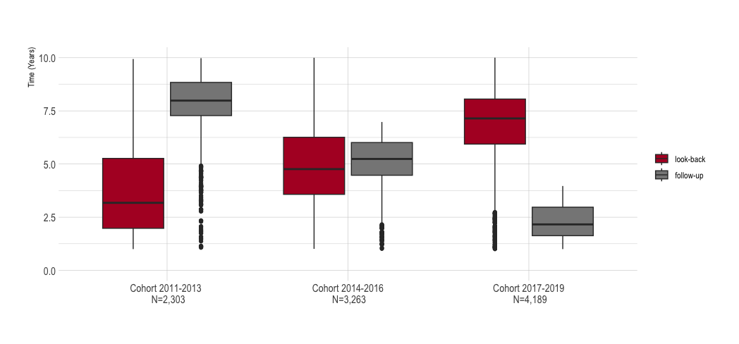

Table S4. Validity estimates values according to index year stratified by indication
 | CD |  |  | UC |  |  | AR |  |  |  | PsO/PsA |  |  |  | SpA
 | ‘11-‘13 | ‘14-‘16 | ‘17-‘19 | ‘11-‘13 | ‘14-‘16 | ‘17-‘19 | ‘11-‘13 | ‘14-‘16 | ‘17-‘19 | ‘11-‘13 |  | ‘14-‘16 | ‘17-‘19 | ‘11-‘13 |  | ‘14-‘16 | ‘17-‘19
Accurancy | 0.97 | 0.96 | 0.96 | 0.97 | 0.96 | 0.96 | 0.92 | 0.92 | 0.94 | 0.92 |  | 0.92 | 0.91 | 0.98 |  | 0.97 | 0.97
Se | 0.9 | 0.88 | 0.81 | 0.77 | 0.81 | 0.81 | 0.78 | 0.74 | 0.76 | 0.92 |  | 0.93 | 0.9 | 0.8 |  | 0.79 | 0.69
Sp | 0.98 | 0.97 | 0.97 | 0.98 | 0.98 | 0.98 | 0.99 | 0.98 | 0.99 | 0.9 |  | 0.9 | 0.91 | 0.99 |  | 0.99 | 0.99
PPV | 0.87 | 0.85 | 0.77 | 0.79 | 0.87 | 0.85 | 0.96 | 0.94 | 0.95 | 0.85 |  | 0.84 | 0.81 | 0.84 |  | 0.85 | 0.85
NPV | 0.98 | 0.98 | 0.98 | 0.98 | 0.97 | 0.97 | 0.91 | 0.91 | 0.93 | 0.87 |  | 0.87 | 0.89 | 0.98 |  | 0.99 | 0.97
Youden index | 0.87 | 0.86 | 0.79 | 0.75 | 0.79 | 0.78 | 0.77 | 0.73 | 0.75 | 0.96 |  | 0.95 | 0.92 | 0.79 |  | 0.77 | 0.68
F-score | 0.88 | 0.86 | 0.79 | 0.77 | 0.84 | 0.83 | 0.87 | 0.83 | 0.85 | 0.91 |  | 0.9 | 0.89 | 0.82 |  | 0.82 | 0.76

Cohort 2011-2013: n= 2303; Cohort 2014-2016: n= 3263; Cohort 2017-2019: n= 4189; Red: values with a difference of the estimate values among the three cohorts of ≥ 0.10. CD: Crohn's disease; NPV: Negative predictive value. PPV: Positive predictive value; PsO: Psoriasis; PsA: Psoriatic arthritis; RA: Rheumatoid arthritis; Se: Sensitivity; Sp: Specificity; SpA: Spondylarthritis; UC: Ulcerative colitis

Figure S3. Contour plots for accuracy, sensitivity and specificity by indication based on the combinations of length of follow-up (y axis) and length of look-back (x axis) in the cohort 2014-2016
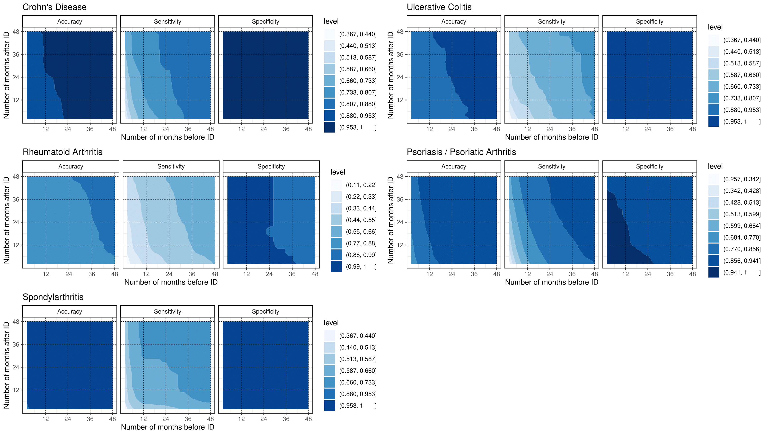
ID: Index date

Figure S4. Contour plot for the percentage of missing indication from claims data after META-algorithm application according to the length of follow-up and look-back period

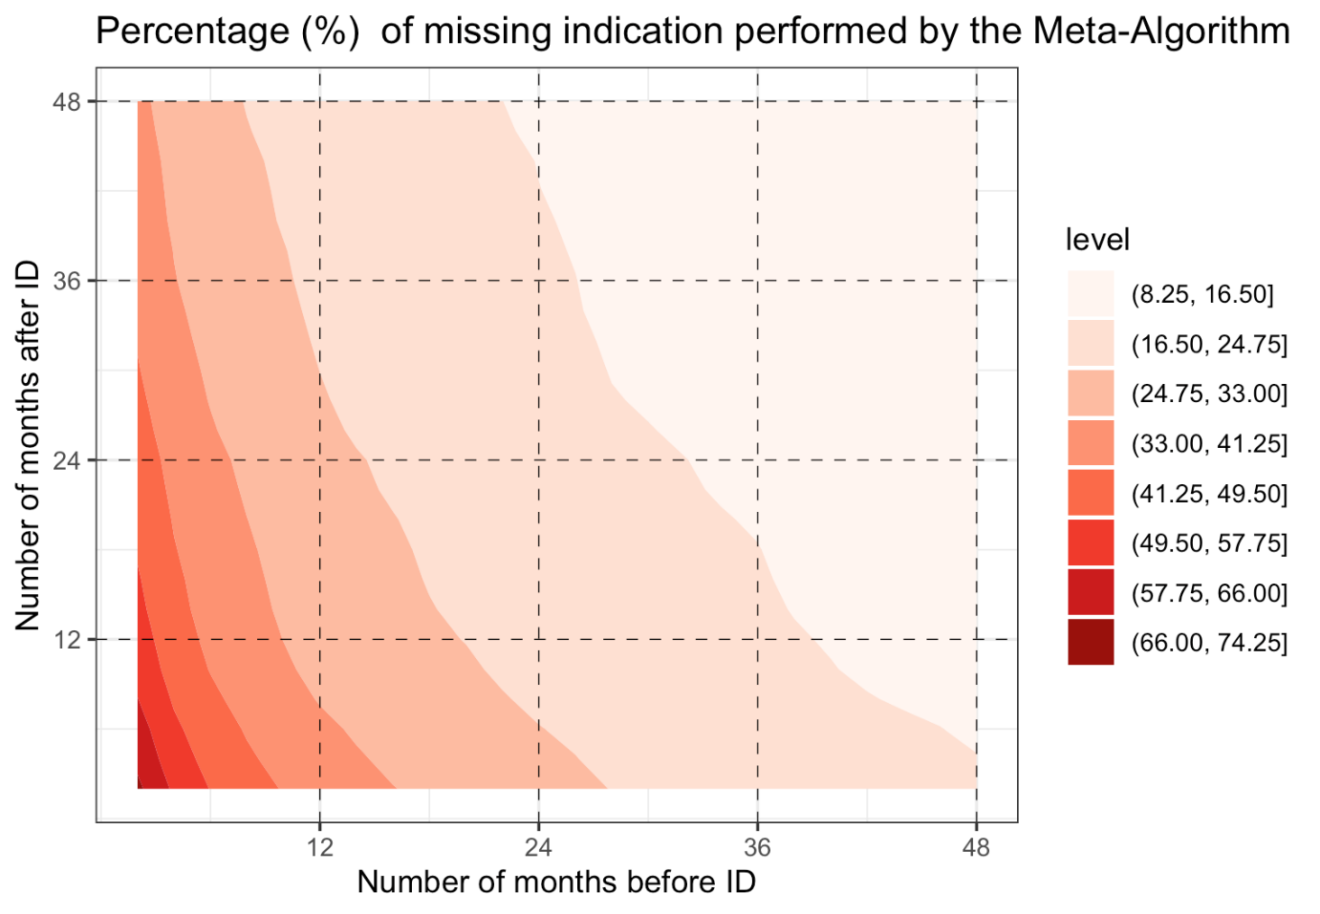
ID: Index date

Table S5. Validity estimates by censoring patients after treatment discontinuation/switch.

 | Accuracy | Se | Sp | PPV | NPV | Youden Index | F-Score | Missing (%)
CD | 0.96 | 0.86 | 0.97 | 0.83 (+0.01) | 0.98 | 0.84 | 0.85 (+0.01) | 0.9
UC | 0.96 | 0.81 (+0.01) | 0.98 | 0.85 | 0.97 | 0.79 (+0.01) | 0.83 (+0.01) | 0.7 (+0.1)
RA | 0.93 | 0.75 (-0.01) | 0.99 | 0.95 | 0.92 | 0.74 (-0.01) | 0.84 | 7.6 (+0.7)
PsO | 0.84 | 0.88 (-0.01) | 0.83 | 0.49 (+0.01) | 0.98 | 0.72 | 0.63 | 5.4 (+0.3)
PsA | 0.82 | 0.49 (+0.01) | 0.95 | 0.79 (+0.01) | 0.83 | 0.43 | 0.60 (+0.01) | 4.6 (+0.3)
SpA | 0.97 | 0.75 | 0.99 | 0.86 (+0.01) | 0.98 | 0.74 | 0.80 (+0.01) | 10.6 (+0.8)
HS | 0.99 | 0.31 (-0.02) | 1.00 | 1.00 | 0.99 | 0.31 (-0.02) | 0.48 (-0.02) | 48.7
Uveitis | 0.99 | 0.13 | 1.00 | 1.00 | 0.99 | 0.13 | 0.23 | 53.3
CD: Crohn's disease; NPV: Negative predictive value. PPV: Positive predictive value; PsO: Psoriasis; PsA: Psoriatic arthritis; RA: Rheumatoid arthritis; Se: Sensitivity; Sp: Specificity; SpA: Spondylarthritis; UC: Ulcerative colitis; The variation of the validity estimates in relation to the main analysis was reported in brackets per single indication. If no bracket is present in the single cell, no difference was observed in relation to the main analysis.

Supplementary Figure Legends

Figure S1. The image shows the validation process in case the META-algorithm found more than one IMID indication of use for the index biological drug: in the main analysis only the closest indication to the index drug was considered. Then, two sensitivity analysis were conducted: 1) the priority was given to the indication identified by an exemption from co-payment record; 2) the priority was given to the indication with the highest number of matches.

Figure S2. The figure reported the Median look-back (red) and follow-up (grey) by each stratified cohort: 2011-2013 (long follow-up and short look-back), 2014-2016 (long-follow up and long look-back period), 2017-2019 (short follow-up and long look-back period).

Figure S3. The contour plots show the accuracy, sensitivity and specificity by indication according to the length of follow-up and look-back in the 2014-2016 cohort. Levels of Sp and accuracy at least over 0.70 each combination of length of follow-up and look-back were found for each indication. At the same time, sensitivity changed dramatically according to the length of the timeframe.

Figure S4. The contour plot shows the percentage of missing indication from claims data after META-algorithm application according to the length of follow-up and look-back period. Having 24 months of look-back and 24 of follow-up ensures to find an indication of use in at least 75% of cases.

